Trading Session Structure
Concept

Financial markets operate continuously, but activity is often grouped into major trading sessions: Asia, London, and New York.
Each session reflects periods when different regions are most active in the market.

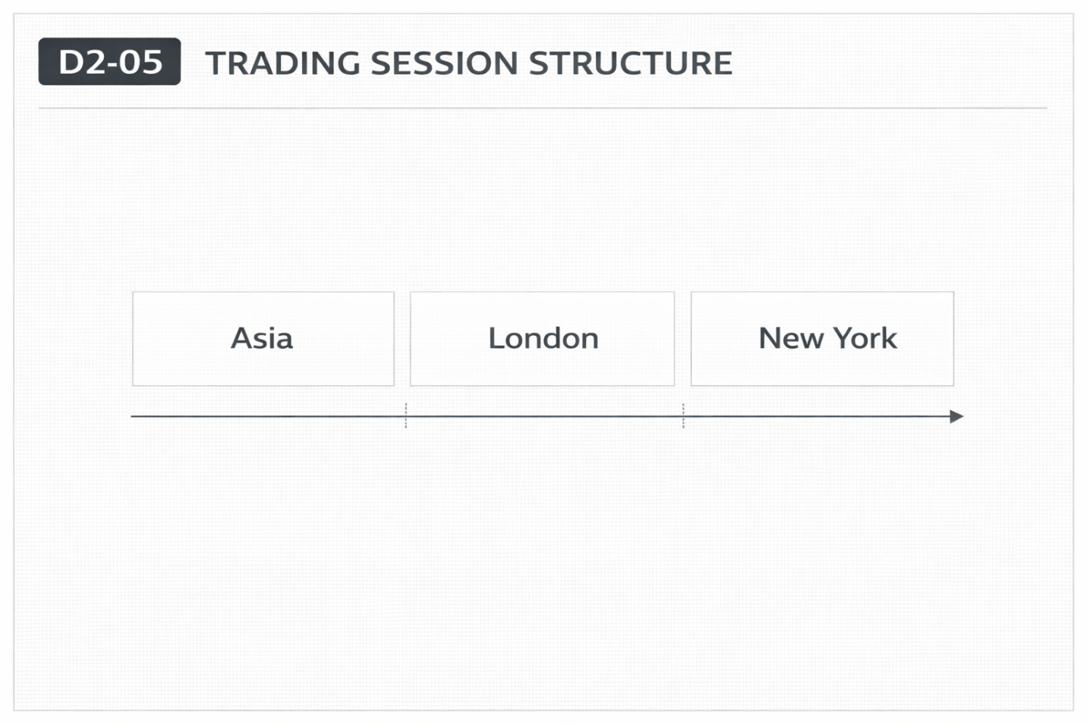

Why It Matters
Market activity varies throughout the day depending on which participants are active.
Understanding sessions helps explain changes in activity levels, not predict price direction.

Professional Perspective

Sessions represent shifts in participation, not guaranteed behavior.
Different regions contribute varying levels of liquidity and activity during their operating hours.
Overlaps between sessions often increase activity due to simultaneous participation.

Practical Insight

Sessions do not determine what price will do—they describe when activity may change.
Assuming fixed behavior for sessions leads to incorrect expectations.
Clarity comes from observing how participation changes over time.

