Volatility Behavior Across Sessions
Concept

Volatility refers to the degree of price movement within a given period.
It reflects how much price fluctuates, not the direction of movement.

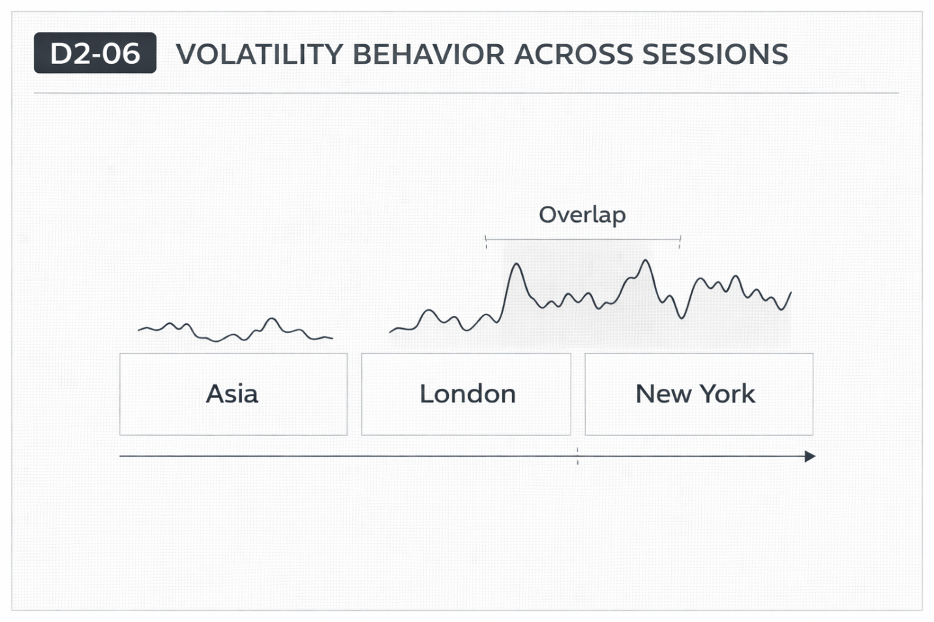

Why It Matters
Market activity varies across trading sessions, leading to differences in how much price moves.
Understanding volatility helps explain the intensity of movement—not predict direction.

Professional Perspective

Volatility is influenced by participation, liquidity, and timing.
Higher activity periods often show larger price fluctuations, while lower activity periods show smaller movements.
However, volatility does not indicate where price will go—only how much it is moving.

Practical Insight

High volatility increases movement range but also increases uncertainty.
Low volatility reduces movement but does not eliminate risk.
Volatility describes conditions—it does not provide direction.

