Price Delivery Mechanism
Concept

Price delivery refers to how price moves over time as a result of continuous interaction between buying and selling orders.
It reflects how price is formed, updated, and displayed across different time intervals and conditions.

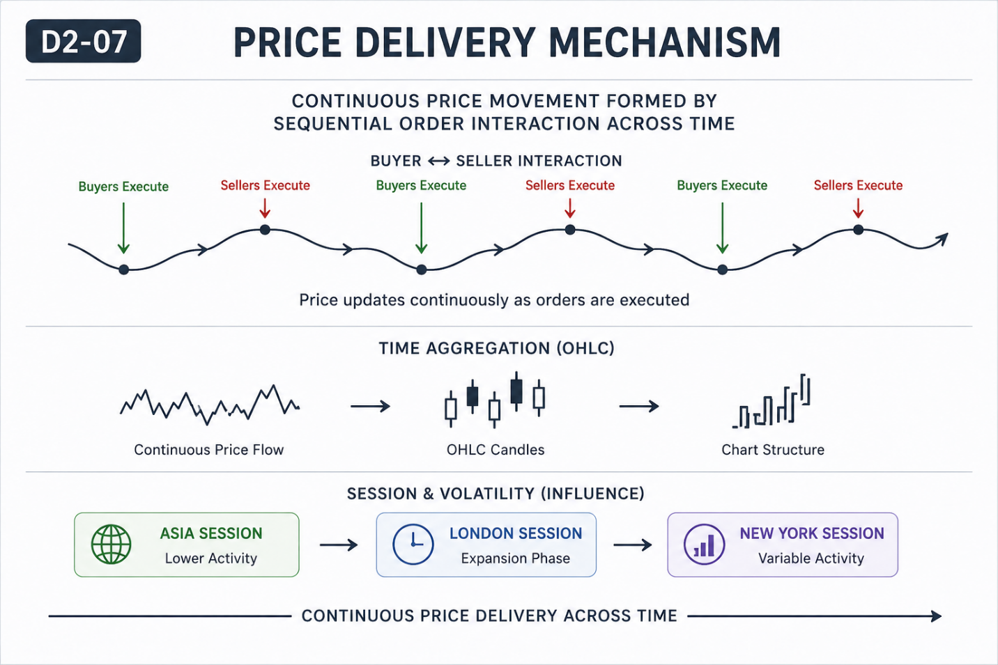

Why It Matters
Price does not move randomly or in isolation.
It is continuously delivered through order interaction, shaped by time, liquidity, and participation.
Understanding this prevents fragmented interpretation of charts.

Professional Perspective

Price delivery is a continuous process.
Each movement reflects executed orders, aggregated into OHLC data and displayed across timeframes.
Sessions and volatility influence how this delivery appears, but do not control its direction.

Practical Insight

Charts do not show isolated events—they show continuous price delivery.
Breaking price into disconnected pieces leads to misunderstanding.
Clarity comes from viewing price as an ongoing process, not individual signals.

