Swing Points (Highs & Lows)
Concept

A swing point is a structural turning point where price stops moving in one direction and begins moving in the opposite direction.
A swing high forms when upward movement transitions into downward movement.
A swing low forms when downward movement transitions into upward movement.

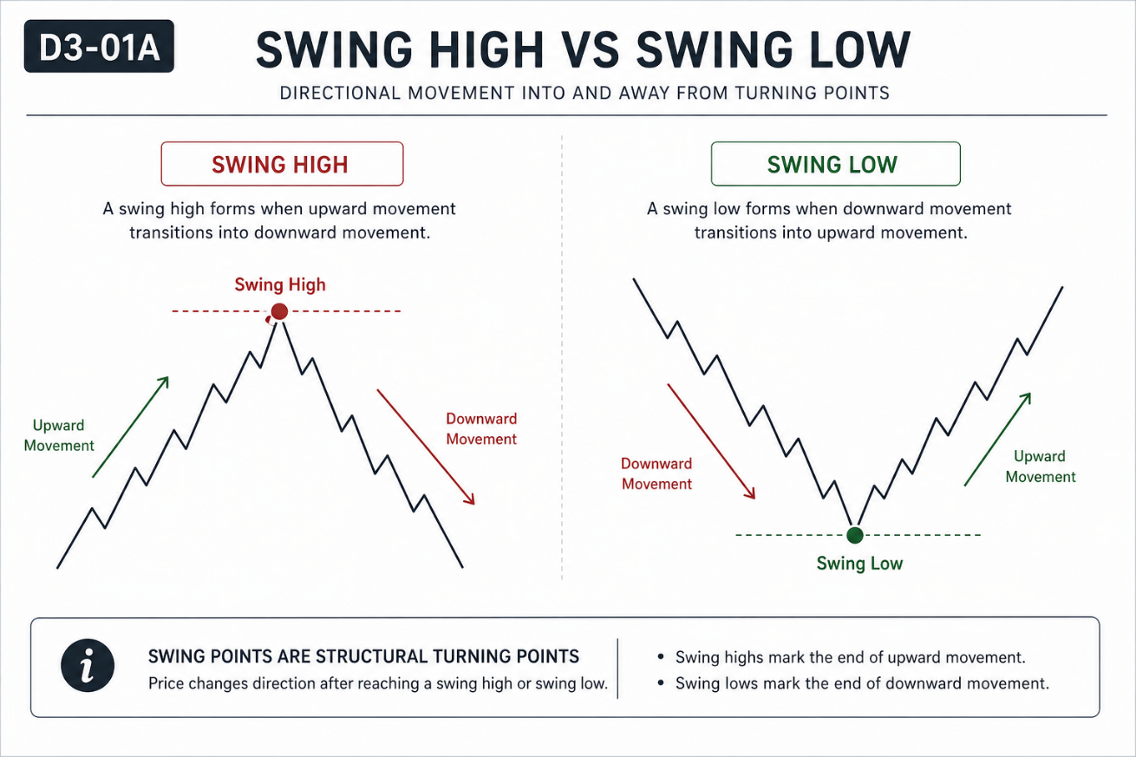

Why It Matters
Swing points form the foundation of market structure.
Without correctly identifying swings, all structural analysis becomes inconsistent and subjective.

Professional Perspective

A swing represents a temporary shift in order flow where opposing liquidity interrupts directional movement.
It reflects interaction between buyers and sellers, not a predictive signal.
Swings describe what has occurred, not what will occur next.

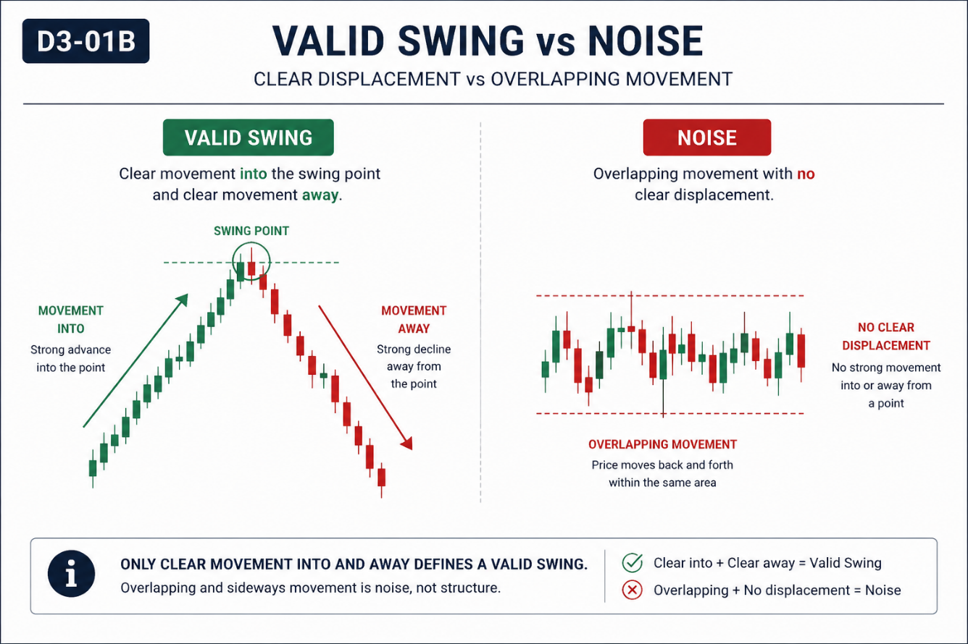

Practical Insight

Not every price fluctuation is a valid swing.
A valid swing requires clear movement into the point and clear movement away from it.
Small overlapping movements represent noise, not structure.

