Structural Sequencing (HH, HL, LL, LH)
Concept

Market structure forms through sequences of swing highs and swing lows.
An upward sequence forms when price creates higher highs (HH) and higher lows (HL).
A downward sequence forms when price creates lower highs (LH) and lower lows (LL).

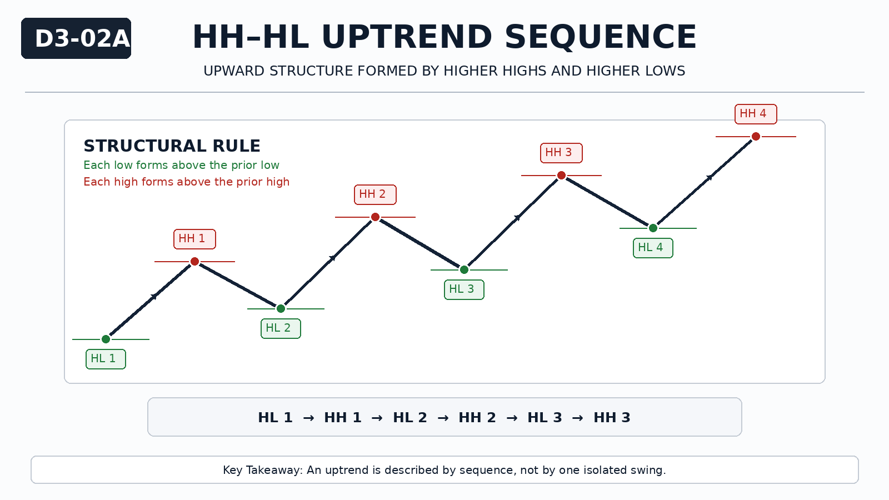

Why It Matters
Individual swing points provide limited information.
Structure becomes meaningful when swings are observed in sequence.
Without sequencing, direction cannot be described objectively.

Professional Perspective

Structural sequencing reflects how price progressively displaces in one direction.
Higher highs and higher lows indicate upward displacement.
Lower highs and lower lows indicate downward displacement.
This describes directional behavior, not future outcome.

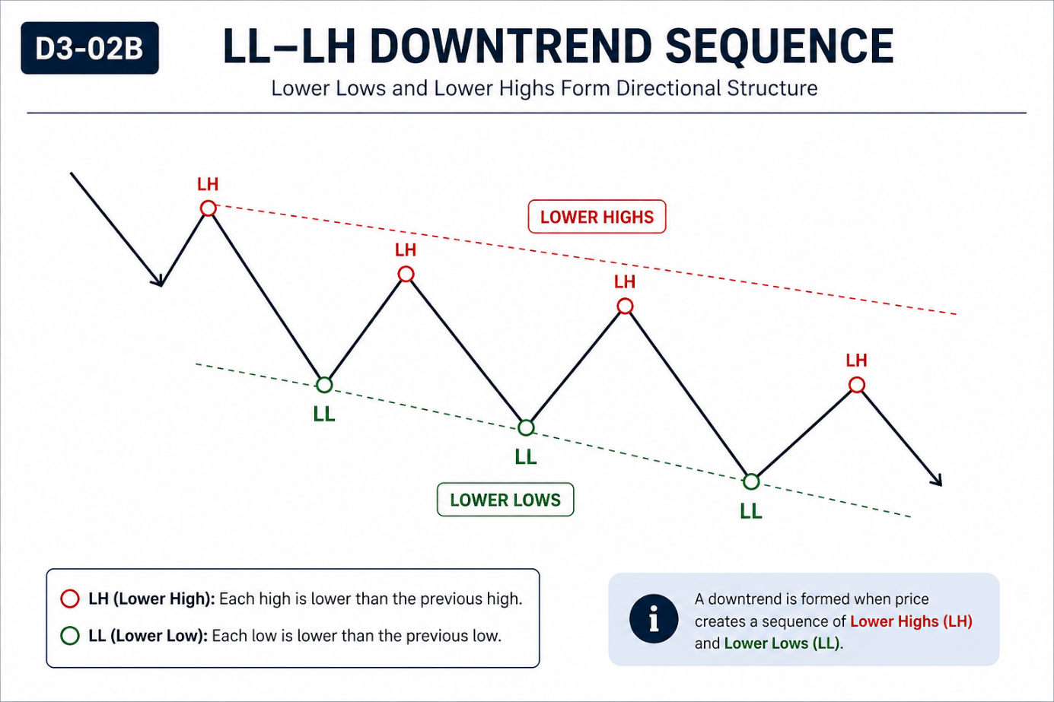

Practical Insight

A single higher high does not define an uptrend.
A sequence is required.
Structure must be observed across multiple swings, not isolated points.

