Trend vs Range
Concept

Market structure can be classified into two primary conditions: trend and range.
A trend forms when price produces a consistent sequence of higher highs and higher lows (uptrend), or lower highs and lower lows (downtrend).
A range forms when price moves between boundaries without a clear directional sequence.

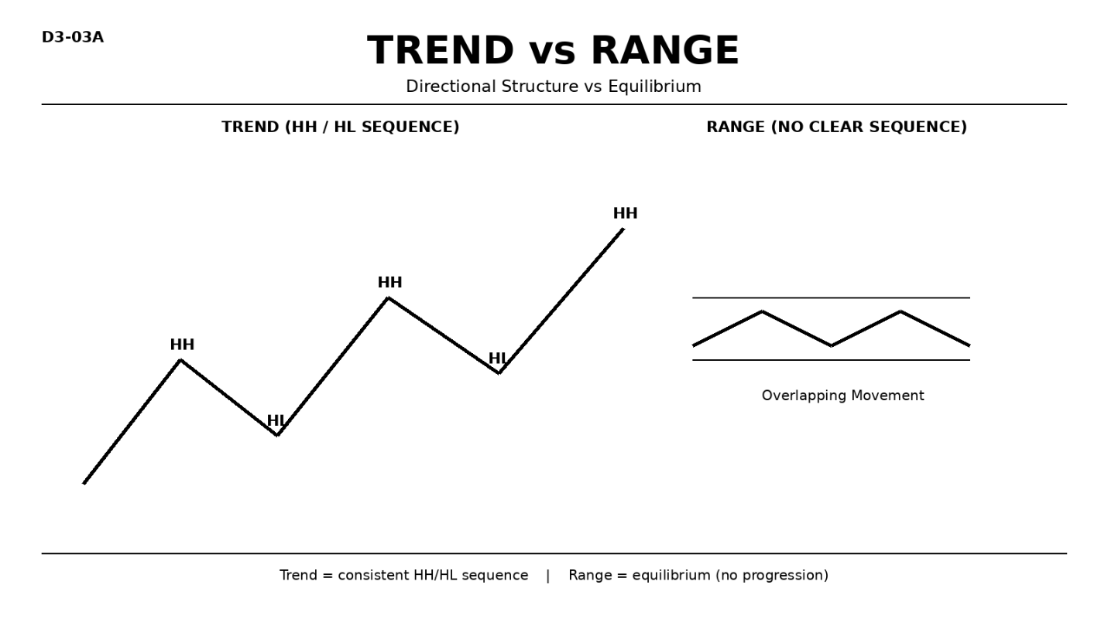

Why It Matters
Not all market conditions are directional.
Misclassifying a range as a trend leads to poor decision-making and overreaction to normal price fluctuations.

Professional Perspective

A trend reflects sustained directional displacement.
A range reflects equilibrium, where buyers and sellers are relatively balanced.
Both conditions represent valid market behavior, not opportunity or bias.

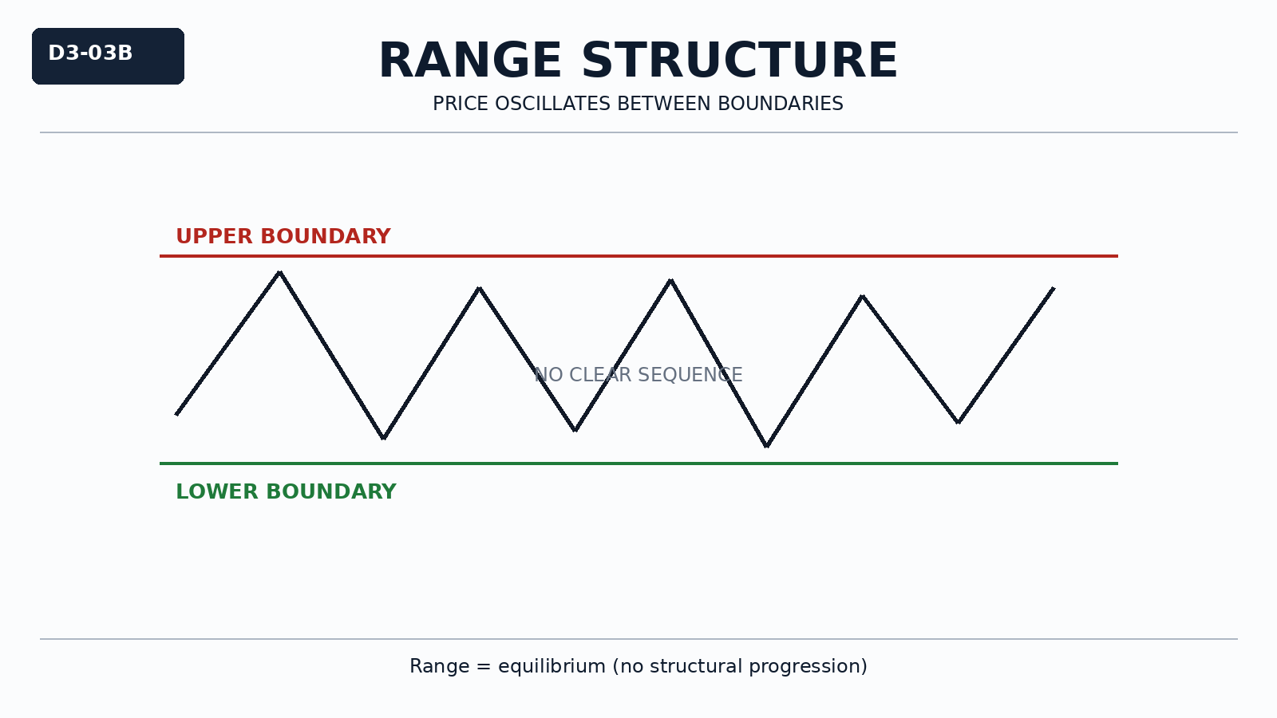

Practical Insight

A few higher highs or lower lows do not define a trend.
If structure lacks consistency, the market is likely ranging.
Correct classification reduces emotional reactions to normal price movement.

