Break of Structure (BOS)
Concept

A break of structure occurs when price moves beyond a previously established swing high or swing low, disrupting the existing structural sequence.
This represents a change in how price is organizing, not a guaranteed directional outcome.

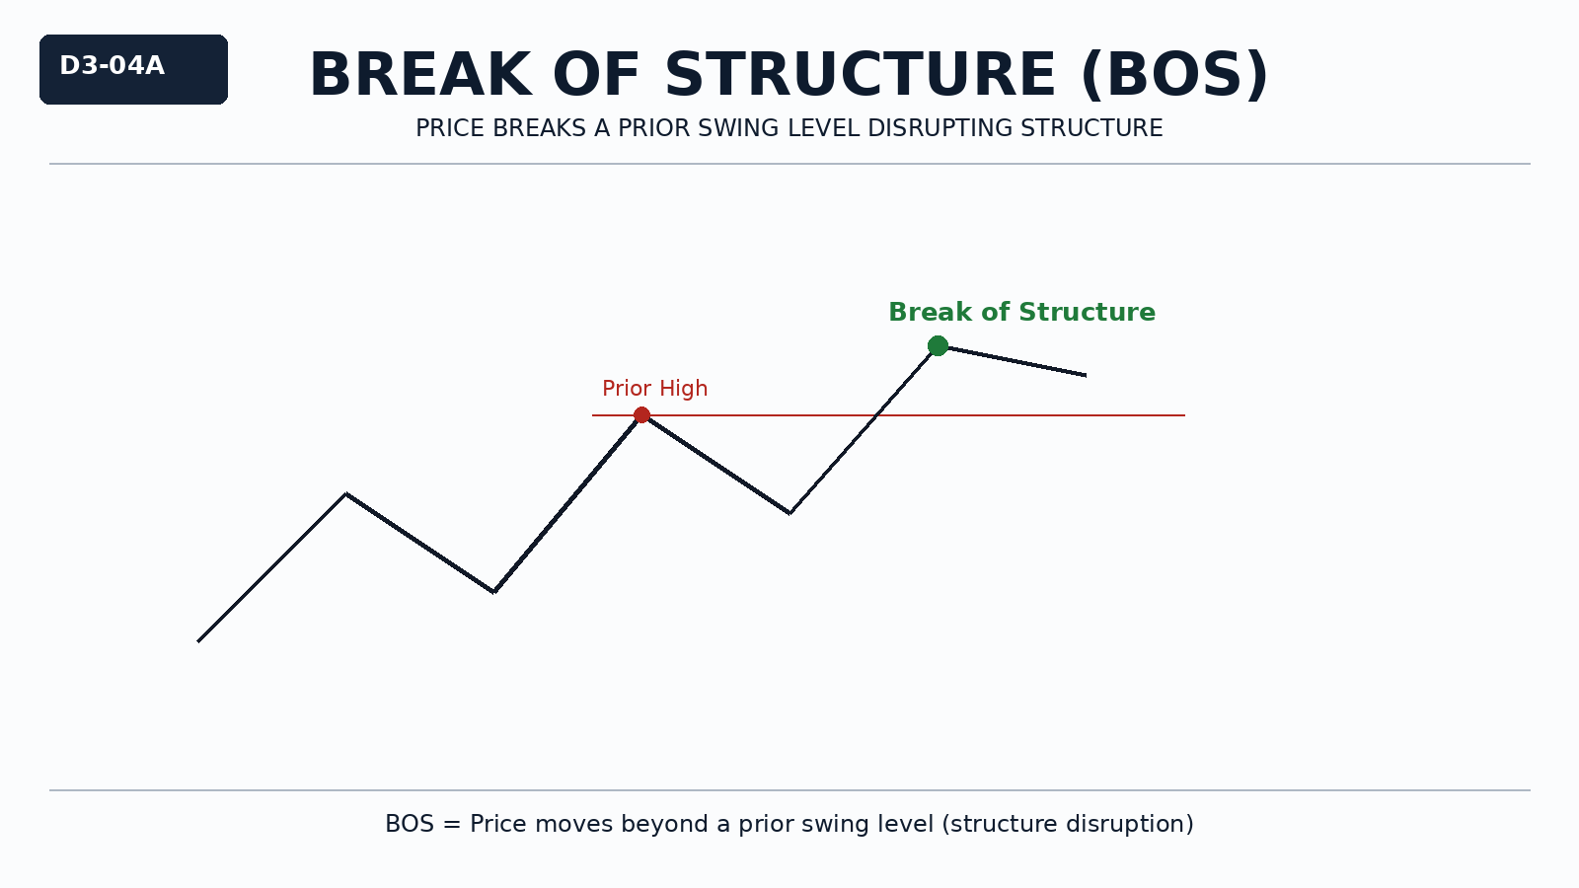

Why It Matters
Structure is defined by sequences.
When a key swing point is broken, the existing sequence is no longer intact.
Recognizing this allows traders to identify structural change without assuming what happens next.

Professional Perspective

A break of structure reflects a shift in order flow interaction where previous structural boundaries are no longer respected.
It indicates change in behavior, not confirmation of reversal or continuation.
The break must be evaluated within broader structural context.

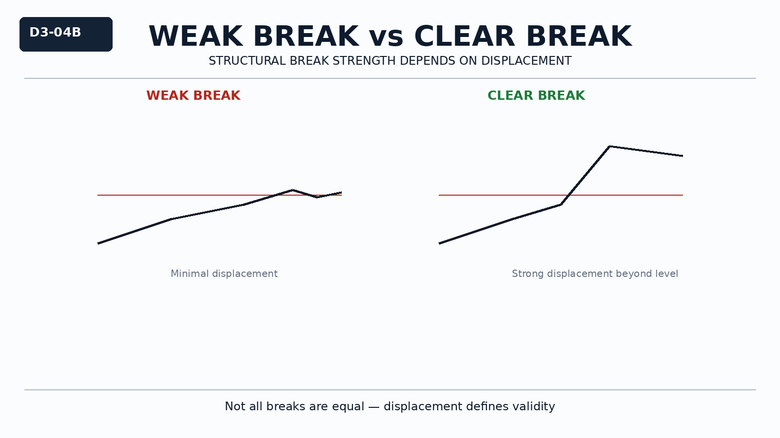

Practical Insight

Not every break is meaningful.
Weak breaks with minimal displacement may reflect temporary liquidity interaction.
A valid structural break requires clear movement beyond a prior swing, not just a brief price excursion.

