Structural Continuation
Concept

Structural continuation occurs when price maintains its existing sequence of higher highs and higher lows, or lower highs and lower lows, despite temporary pullbacks or minor disruptions.
Continuation reflects sustained directional organization within the market.

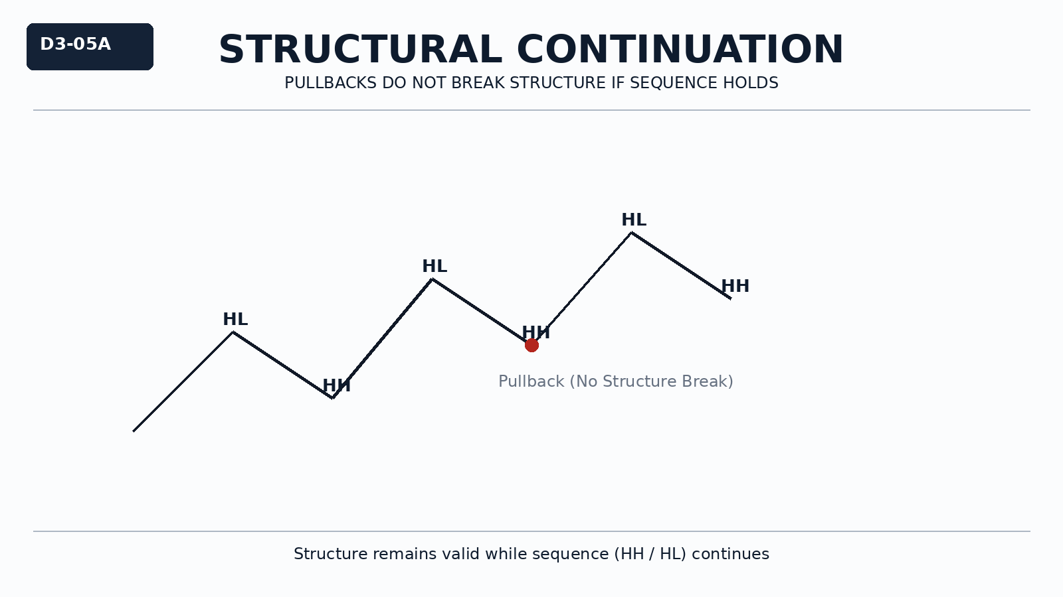

Why It Matters
Not every movement against the current direction represents a reversal.
Misinterpreting normal pullbacks as structural change leads to poor decisions and overreaction.

Professional Perspective

Continuation reflects sustained order flow dominance in one direction.
Pullbacks represent temporary opposing liquidity, not structural failure.
Structure remains valid as long as the sequence is maintained.

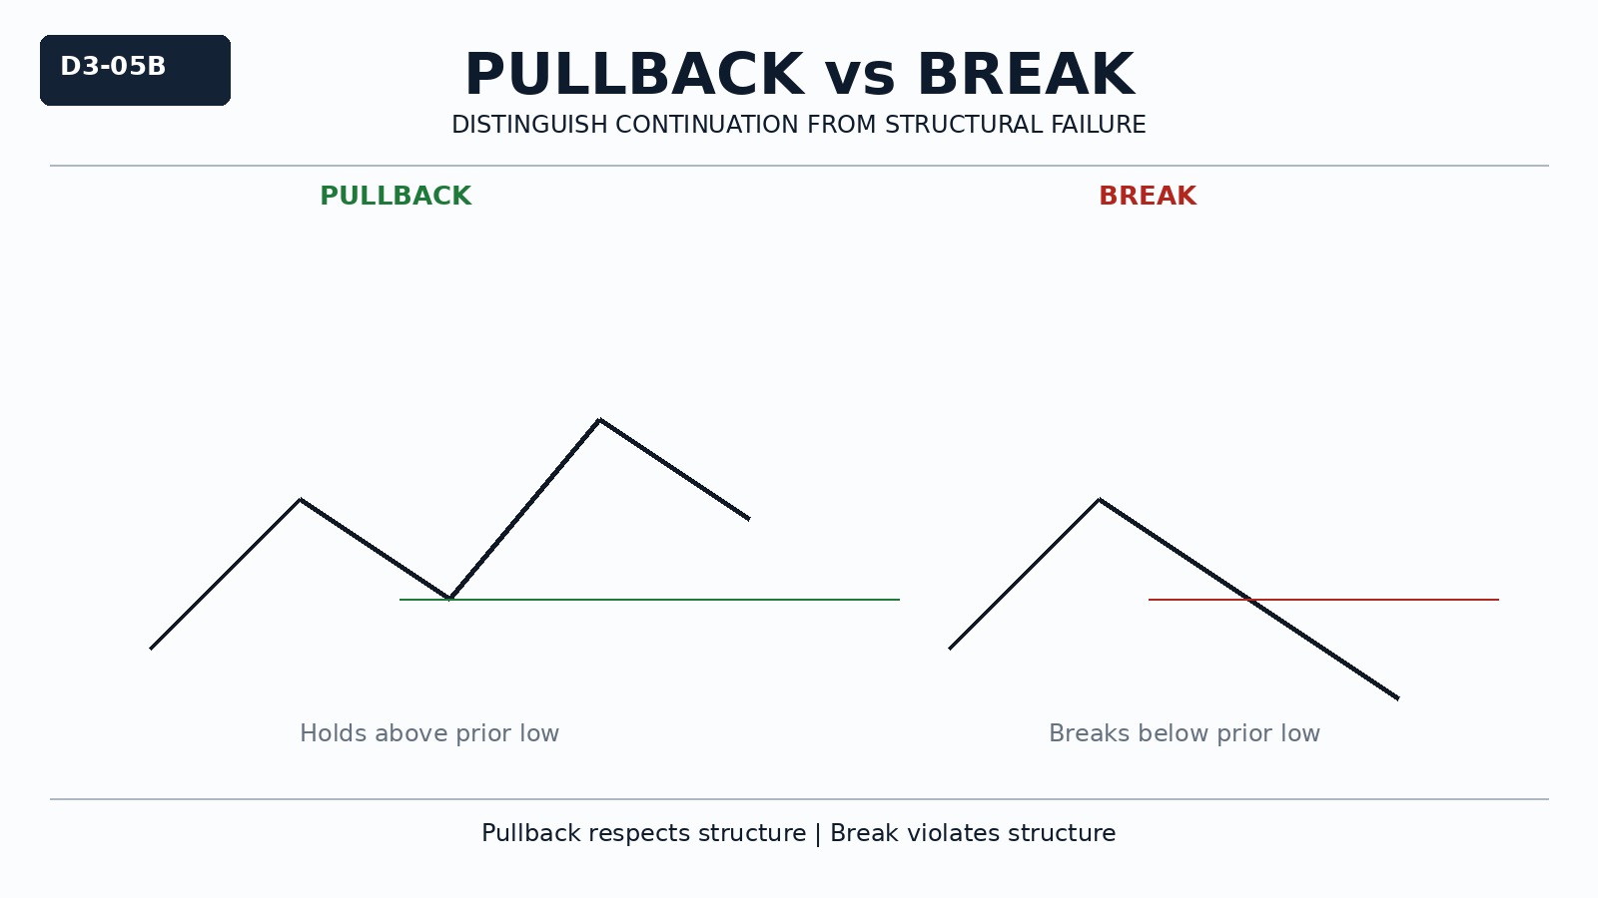

Practical Insight

A pullback that respects previous structure is part of continuation.
Structure is only invalidated when the sequence is broken.
Understanding continuation reduces emotional reactions to normal market behavior.

