Structural Failure
Concept

Structural failure occurs when an existing sequence of higher highs and higher lows, or lower highs and lower lows, is no longer maintained.
This represents a breakdown in the current structural organization.

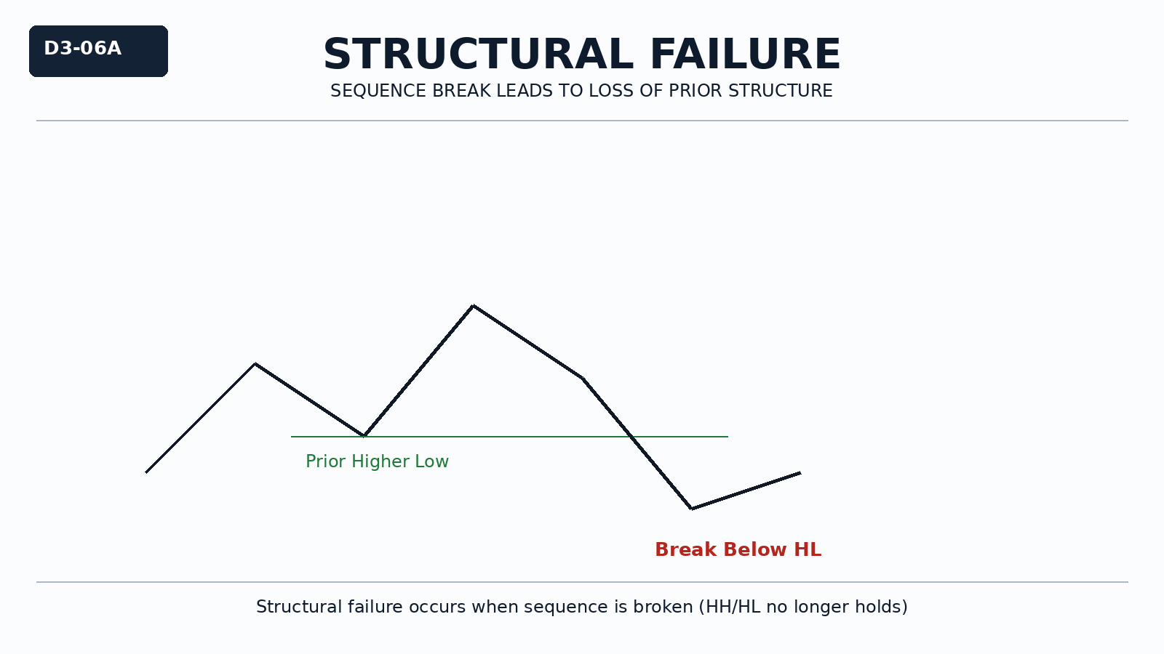

Why It Matters
Not all structural changes are equal.
Understanding failure helps distinguish between normal pullbacks and actual breakdown of structure.
Misidentifying failure leads to premature decisions and incorrect bias shifts.

Professional Perspective

Structural failure reflects a loss of control from the dominant side of the market.
It indicates that the existing sequence is no longer being preserved.
Failure does not guarantee reversal—it only confirms that prior structure is no longer intact.

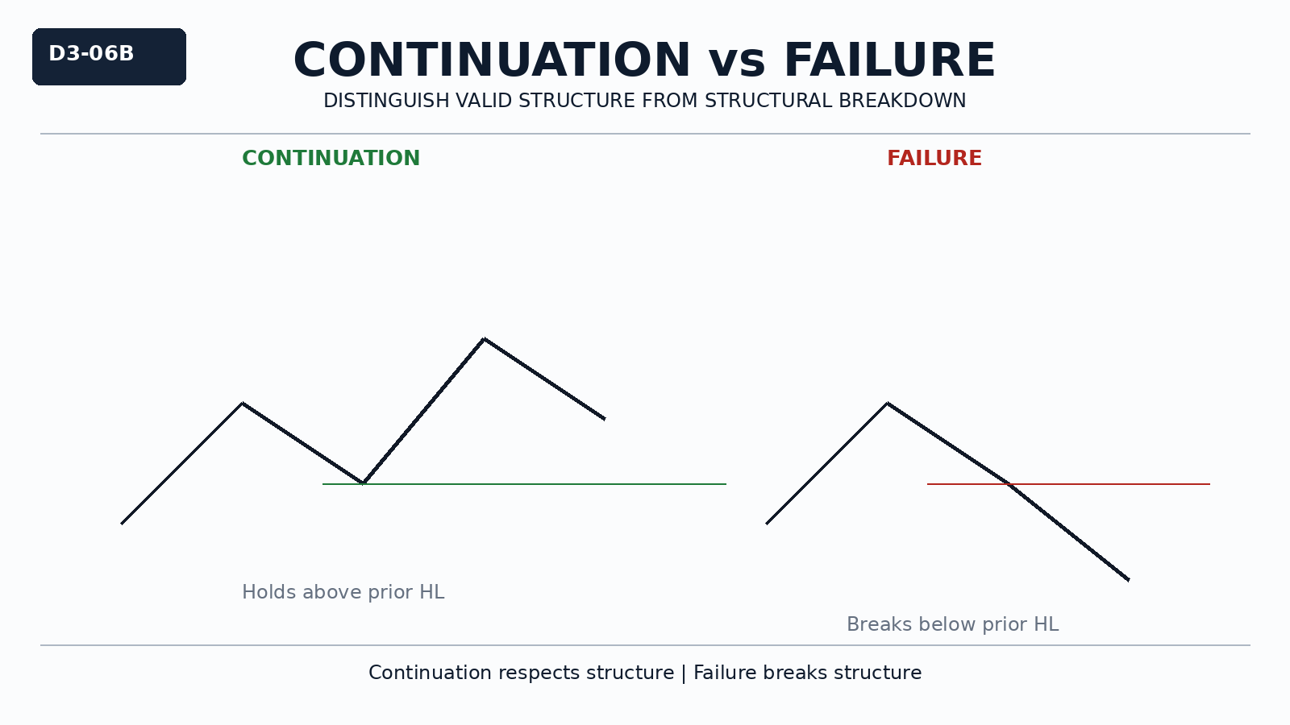

Practical Insight

A structure fails when a key swing level is violated and the sequence cannot continue.
Failure must be confirmed by structural disruption, not minor fluctuation.
Distinguishing failure from pullback is essential for disciplined analysis.

