Structural Context Integration
Concept

Structural context integration is the process of analyzing market structure by combining swing points, sequencing, trend or range classification, break of structure, continuation, and failure into a unified framework.
It represents a complete structural interpretation of price behavior.

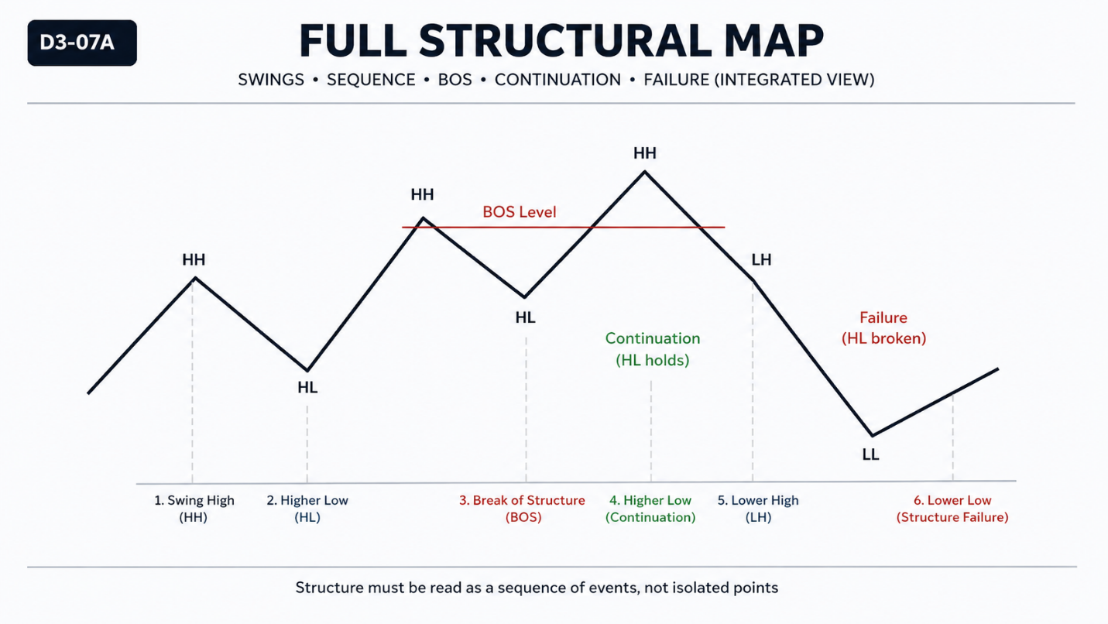

Why It Matters
Individual concepts provide partial understanding.
Without integration, analysis becomes fragmented and inconsistent.
Effective market interpretation requires combining all structural elements into a single coherent view.

Professional Perspective

Institutional analysis does not rely on isolated observations.
It evaluates how structure evolves over time through interaction between swings, sequences, and structural changes.
Context defines meaning—not individual events.

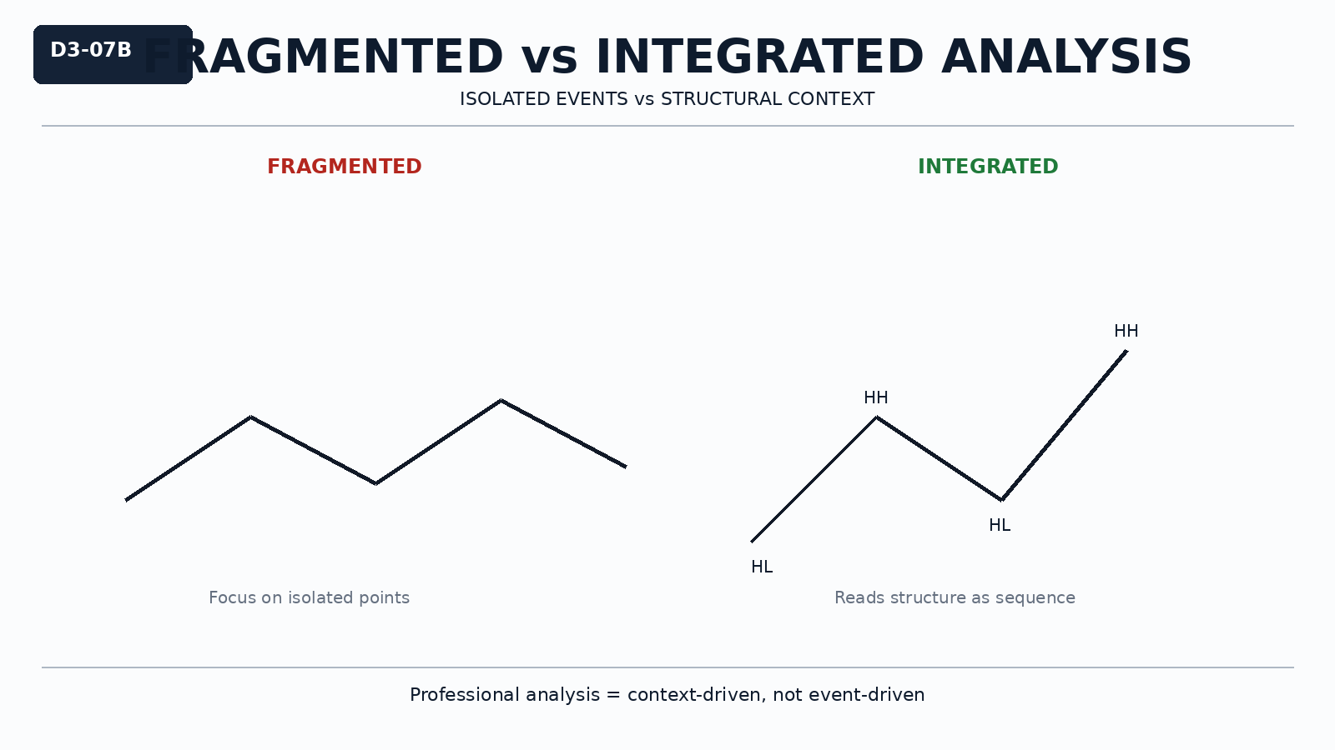

Practical Insight

A single structural event does not define the market.
Structure must be interpreted as a sequence of interactions.
Consistency in reasoning is more important than isolated correctness.

