Liquidity Map
Concept

A liquidity map is a structural view of where orders are most likely concentrated on a price chart.
These areas commonly form around visible swing highs, swing lows, equal highs, equal lows, and other obvious structural reference points.

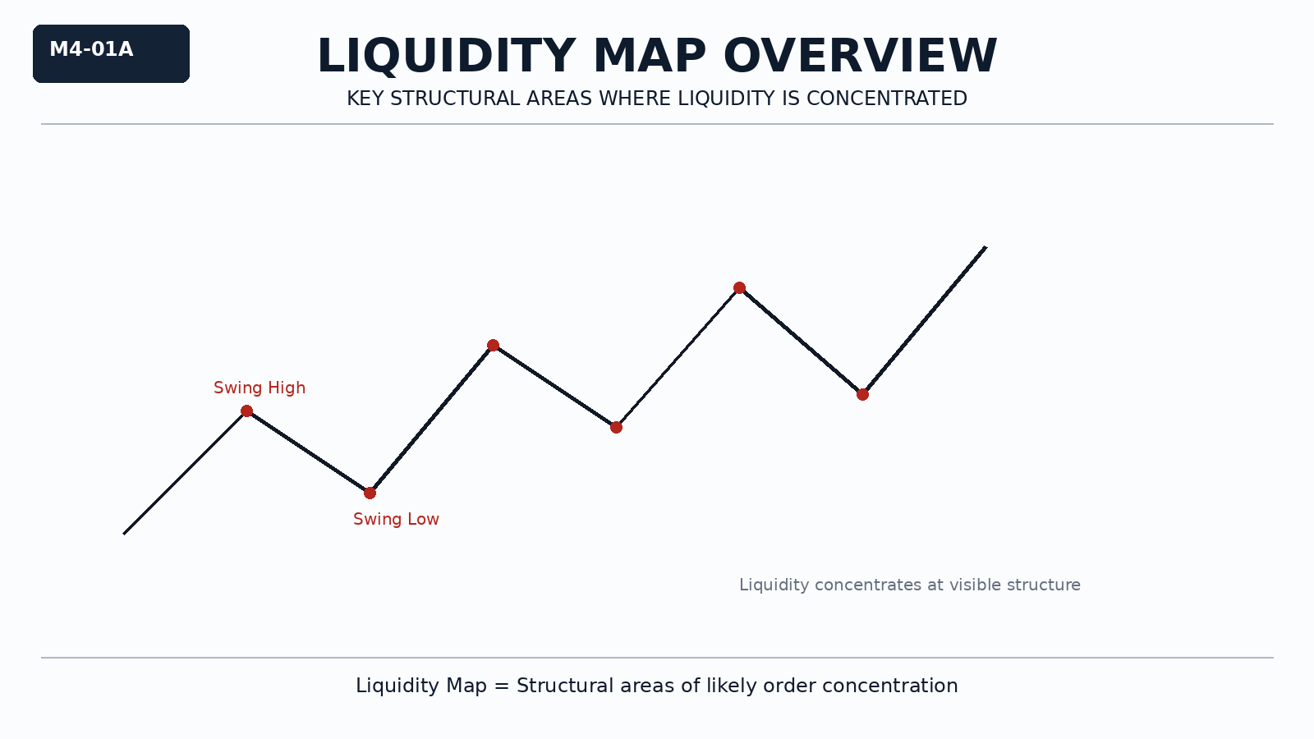

Why It Matters
Price does not move randomly across the chart.
It interacts with areas where liquidity is concentrated.
Understanding where liquidity is likely resting helps students interpret why price is drawn toward certain locations.

Professional Perspective

Institutional traders view the chart as a map of liquidity interaction.
Visible structural points often attract price because those areas contain resting orders, stop orders, or pending participation.
A liquidity map describes where interaction is likely to occur, not what price must do next.

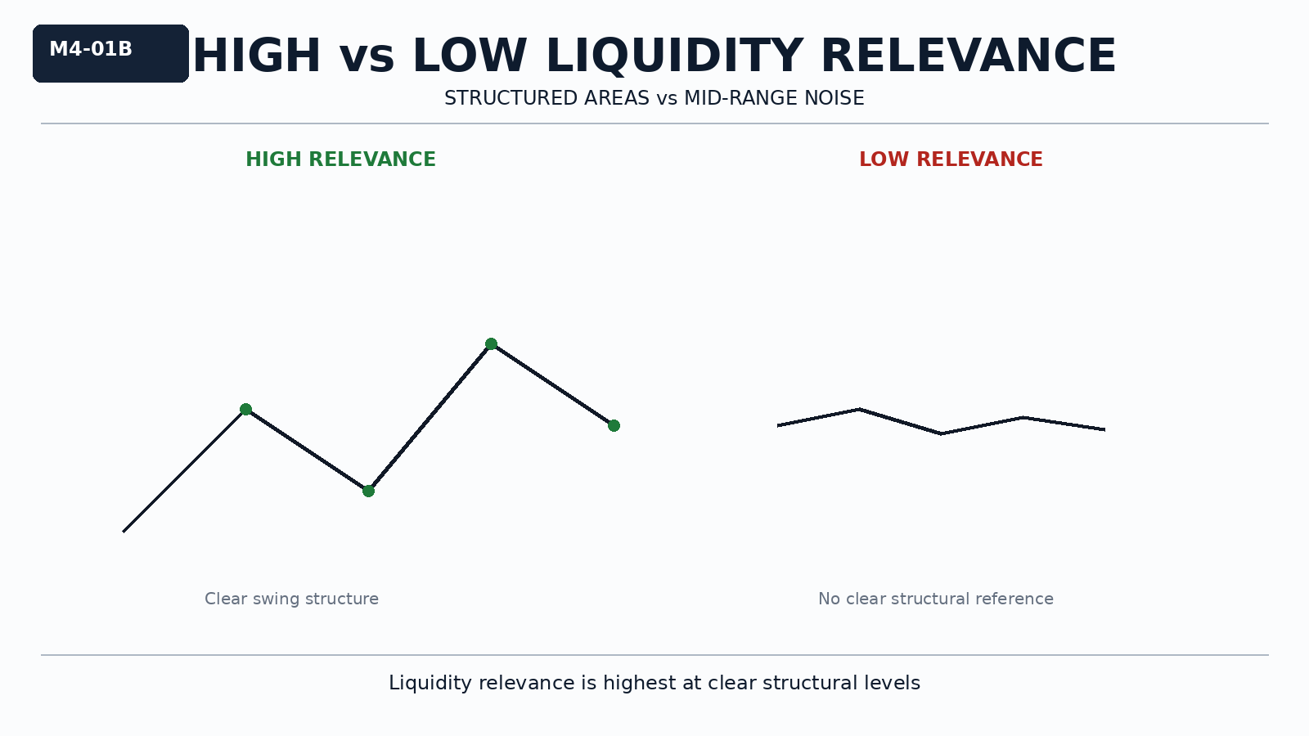

Practical Insight

Not every part of the chart carries equal liquidity relevance.
The most important locations are usually the most visible structural areas.
A liquidity map helps organize the chart into meaningful zones of interaction.

