Liquidity Pools
Concept

A liquidity pool is a concentration of orders clustered around specific price levels.
These pools typically form where many participants place similar orders, such as around swing highs, swing lows, or repeated price levels.

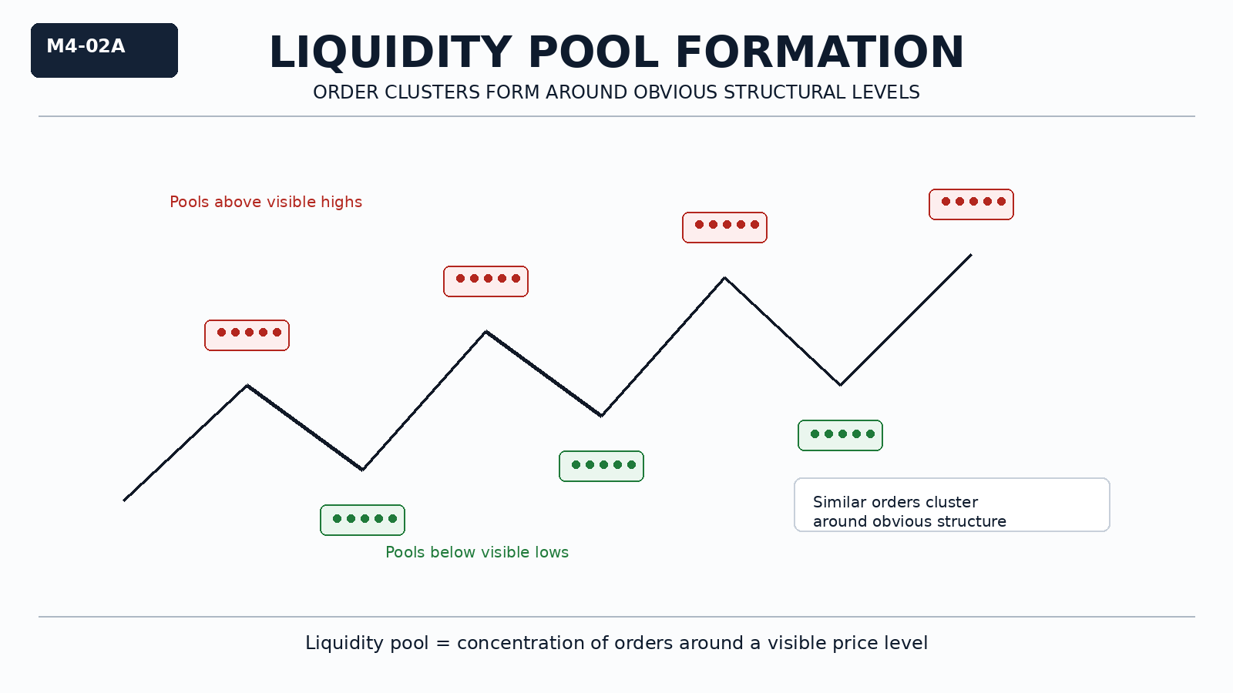

Why It Matters
Liquidity does not exist evenly across the chart.
It accumulates in areas where many market participants act similarly.
Understanding this explains why price often moves toward certain levels.

Professional Perspective

Liquidity pools form because traders place orders at obvious structural locations.
These include stop orders, breakout orders, and pending entries.
Price interaction with these pools reflects order matching, not intentional targeting or manipulation.

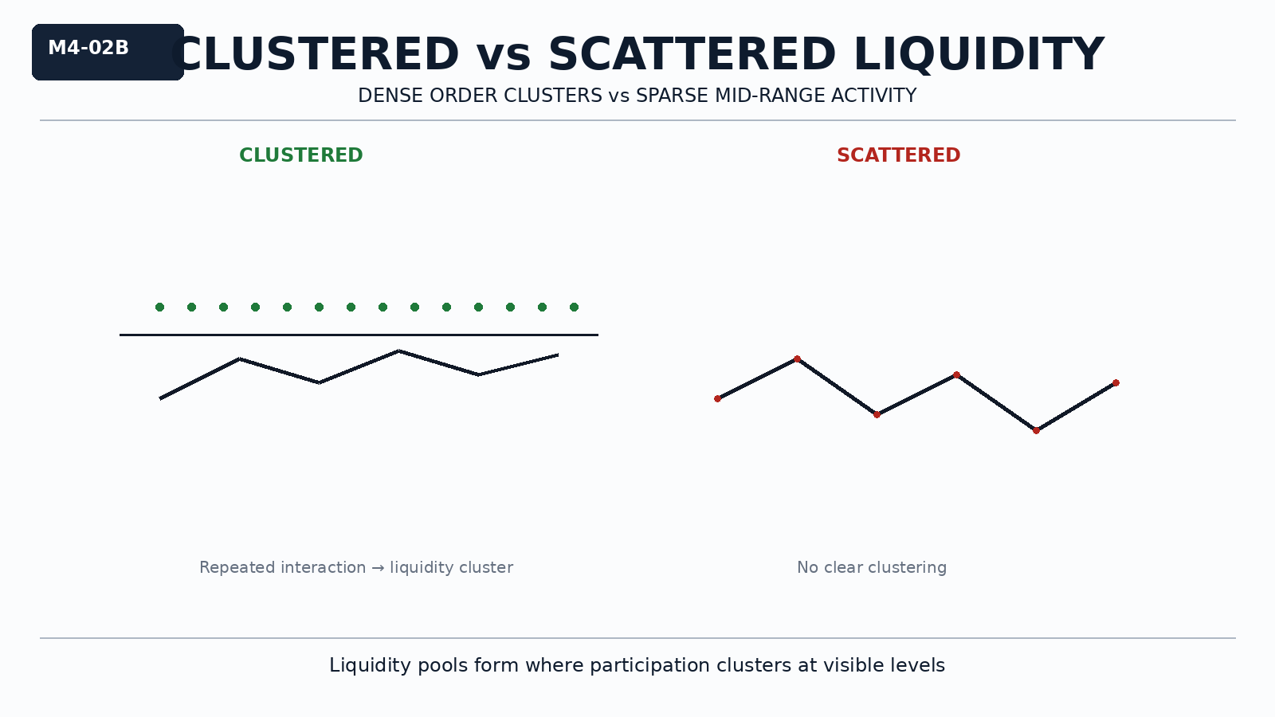

Practical Insight

The most visible levels often contain the highest concentration of liquidity.
Liquidity pools are not signals—they are areas where interaction is more likely.
Recognizing clustering helps explain price movement without assuming direction.

