Equal Highs & Equal Lows
Concept

Equal highs and equal lows occur when price reaches the same or very similar levels multiple times.
These levels often represent areas where liquidity is concentrated due to repeated market
interaction.

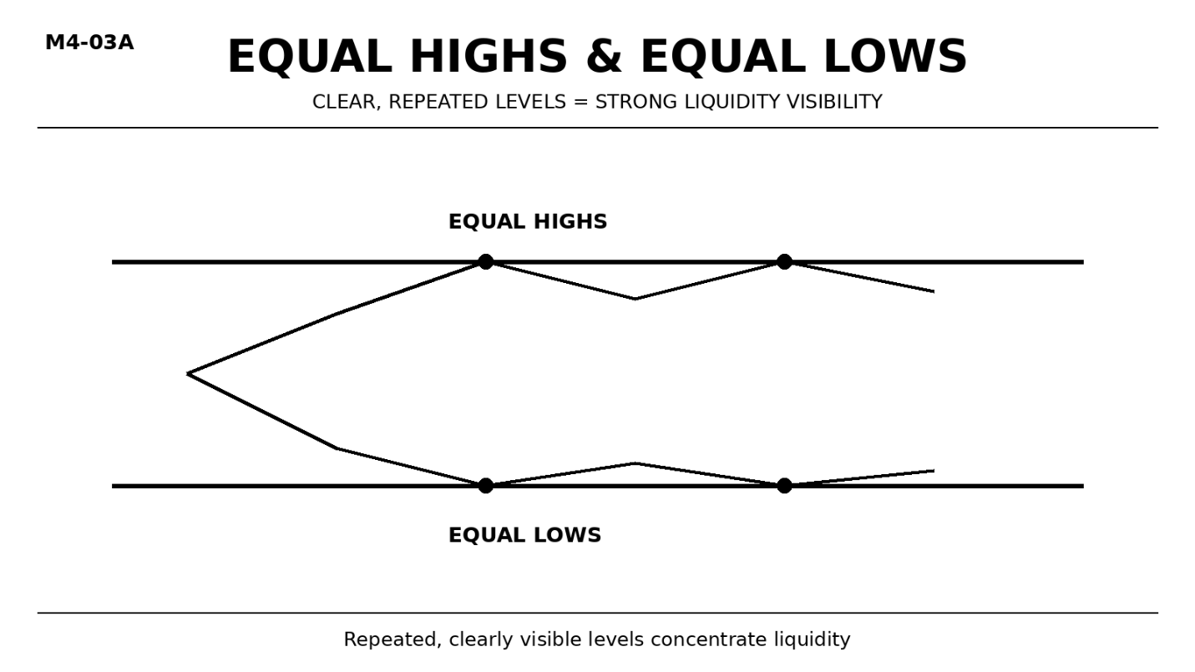

Why It Matters
Equal highs and equal lows are highly visible to market participants.
Because of this visibility, many traders place orders around these levels, creating concentrated liquidity.

Professional Perspective

Equal highs and equal lows represent areas of repeated interaction where liquidity accumulates.
These levels attract attention because they are easy to identify.
Price interaction with these areas reflects liquidity engagement, not guaranteed reversal or breakout.

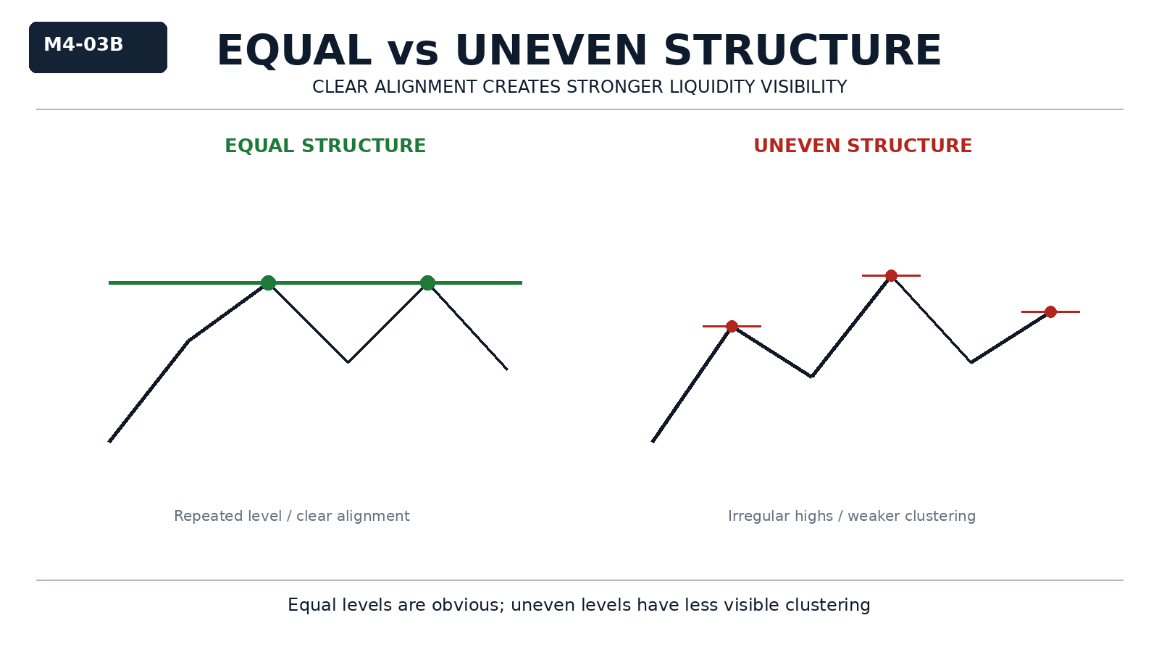

Practical Insight

The more visible and repeated a level is, the more likely it is to contain clustered liquidity.
Equal highs and lows are not signals—they are areas where interaction is likely.
Interpreting them as guaranteed turning points leads to incorrect assumptions.

