M1L1
WHAT IS A FINANCIAL MARKET?

1. Learning Objectives
By the end of this lesson, the learner will be able to:
- Define a financial market as a risk transfer and price discovery system
- Explain why every transaction requires a counterparty
- Describe how price changes through order interaction
- Distinguish between a broker and the financial market itself
- Identify structural limitations of price visibility within MT5
Primary Outcome:
Students should understand that price movement is mechanical, not emotional.
Markets move through liquidity interaction, not prediction.

2. Concept: What is a Financial Market?
Concept
A financial market is a structured system where participants exchange financial instruments through a continuous price discovery process.

Why It Matters
Without financial markets:
- capital cannot be allocated efficiently
- risk cannot be transferred
- assets cannot be priced dynamically
Markets allow participants to transfer risk to other participants.

Professional Perspective
Professional traders do not attempt to predict price.
They analyze:
- where liquidity exists
- how orders interact
- where risk is transferring between participants
Retail traders ask:
“Where will price go?”
Professionals ask:
“Where is liquidity interacting?”

Practical Insight
Every transaction requires:
Buyer
Seller
One participant must take the opposite side of risk.
No counterparty → no trade.

3. Decision Implication — Market Reality
Because markets operate through order interaction:
- Price movement is reactive, not predictive
- Outcomes are uncertain, but conditions are observable

“You cannot predict order flow, but you can observe its effects through structure and liquidity.”
- If you are trying to predict → you are operating without structure
- If you are observing → you are operating within market reality
“Every price move represents resolved imbalance—not intention.”

4. The Continuous Auction Mechanism
Modern financial markets operate using a continuous auction system.
Orders arrive continuously and are matched immediately if price conditions allow.

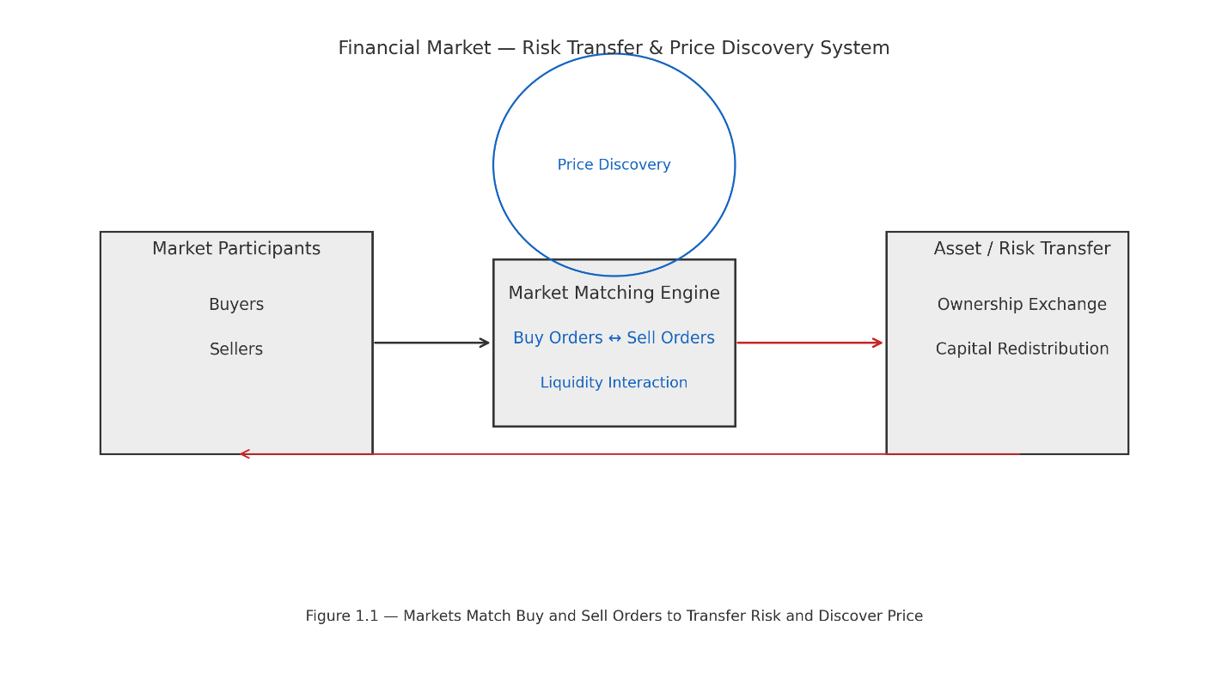
Core Components
a. Order Book
A real-time ledger of buy and sell orders.
Two sides:
Bid — buyers willing to purchase
Ask — sellers willing to sell

b. Matching Engine
The exchange software that pairs buyers and sellers.
Most exchanges operate using Price-Time Priority.
Best price is filled first.
If prices are equal, the earliest order is filled first.

c. Price Discovery
Price is not decided by an authority.
Price emerges from the interaction between supply and demand orders.

d. Mechanical Example of Price Movement
Assume the order book shows:
Bid: 1.1000 (5 million)
Ask: 1.1002 (3 million)
A market participant sends a buy order for 4 million.
Execution sequence:
3 million filled at 1.1002
Remaining 1 million moves to next available ask
Next liquidity at 1.1004
Result:
Price moves upward.
Important principle:
Price did not move because traders were emotional.
Price moved because sell-side liquidity was consumed.
This process is called liquidity consumption.

5. Structural Components of a Market
A functioning financial market requires:
Participants
Tradable instruments
Pricing mechanism
Liquidity providers
Execution infrastructure
Regulatory oversight
Without liquidity → no transactions.
Without opposing interests → no price discovery.
Charts represent the visual record of resolved opposing interests.

6. Broker vs Market
Many new traders believe their broker is the market.
This is incorrect.

Financial Market
The global liquidity network where price is formed.

Broker
A broker provides access to that liquidity network.
Your trading platform only displays a portion of available price information.

MT5 Displays
Bid price
Ask price
Spread
Historical price movement

MT5 Does NOT Display
Total global liquidity
Institutional order flow
Full order book depth
Large institutional inventory
Understanding this prevents confusion during:
- spread expansion
- slippage
- volatility spikes

7. MT5 Observation Exercise
Open MT5 and select EURUSD.
Observe:
- Bid/ask movement
- Spread behavior
- Price updates across timeframes
Switch between:
M1
H1
Answer the following:
Does price move continuously or in increments?
Does spread remain constant?
When does spread widen?
Observation rule:
No indicators.
The objective is to train your eye to observe market mechanics.

8. Risk Implications
Misunderstanding market structure leads to:
- emotional interpretation of price
- blaming brokers for liquidity events
- poor execution timing
- misunderstanding spreads and slippage

Spread Expansion
Occurs when:
- liquidity providers widen quotes
- volatility increases
- order imbalance rises

Slippage
Occurs when:
- market orders consume liquidity faster than it replenishes
- insufficient volume exists at requested price
These are liquidity events, not necessarily broker manipulation.

Professional principle:
If you misunderstand market structure, you will mismanage risk.

9. Assessment Questions
- What is the primary function of a financial market?
- Why must every trade have a counterparty?
- Is your broker the market itself?
- What causes price movement?
- What structural event causes slippage?

10. Reflection Prompts
Explain why price movement is mechanical rather than emotional.
Describe how misunderstanding liquidity could lead to emotional trading.

