Requirements Document

Table of contents

Section 1: Overall Design
A. Purpose of Product
B. Overall Requirements
C. Bound Cases
D. Design
E. References
Section 2: Implementation
A. Usage Cases
B. Diagrams
C. Class Documentation
D. Contact information
X. Functionality

Introduction
This document pertains the information relevant to recreate one’s own image manipulation program. We have separated this document into two main sections: Overall Design and Implementation. Overall Design’s goal is to give information on an abstract level so that anyone is able to recreate our program while implement their own language and code. Implementation’s goal is to deliver our own personal content and classes required to replicate our own program.

A. Purpose of Product
We are creating a basic image editor/viewer for our Capstone Project for Fall 2009, 49901 class with our professor Mr. Ye Zhao and graduate assistant Ms. Zakia Tamimi. The goal of this software is to give the ability to edit images by means of rotating, resizing, applying filters, additional features, and delivering a cleanly written efficient program.

B. Overall Requirements
1. Requirements to install the software:
- Input means (Mouse and Keyboard)
- Monitor (Any Resolution)
- Operating System: Windows

2. Requirements to run the core components of the software:
I. Upon launch, all buttons and dropdown menus are disabled except for open picture functionality
II. After the user selects an image (Any *.jpg, *.bmp, or *.gif file) the rest of the functions will be enabled until the application is quit at which point the core components will be reset to being disabled upon next launch

C. Bound cases
1. At Launch
As explained in B.2.I of this document, all buttons and dropdown menus are disabled except for open picture functionality.

Once an image has been opened, all buttons and dropdown menus are enabled.

2. Zoom function
Our zoom function maximizes at 200% and only shrink an image to 5% of its original size. This includes both the mousewheel and specific zoom percentage function.

3. Rotate function
Our rotate function will only accept 4 integers ranging from 9999 to -9999. We are able to do this by modular computation. Using a negative integer allows rotation in the opposite direction.

4. Filters
Filters such as Grayscale, Sepia, and Invert do not require values.

However, Brightness and Contrast both accept 4 integers ranging from 255 to - 255 and 100 to -100, respectively.

5. Draw function
The user is able to draw anywhere within an opened image.

The thickness, height, width, and radius is currently allowed 4 integers for input. This is still a work in progress and more bounds will be given as far as ranges go.

6. Window
We have our window setup so that it can fill the entire screen regardless of the size of the image.

7. Scrolling
We have coded this function to only be active when there’s picture cutoff of the window being too small on either X, Y, or both axis.

D. Design
Our overall design has been implemented using Microsoft Visual Studio 2008 provided for us thanks to Kent State University’s College of Mathematics and Science. With this software installed and given to us to use, we have utilized it, Microsoft’s Windows forms for our graphical user interface, and we have only used the C# programming language to implement all of our functions and coding.

E. References
1. Nunit (www.nunit.org)
We have implemented Nunit’s testing harness to assist us in debugging our own code.
2. Nlogger (http://sourceforge.net/projects/nlogger/)
We have used this in our code to save a log file of every function we do when we use our program. This allows us to easily recreate bugs found in general use of the program.
3. Microsoft Visual Studio 2008
As provided for us by Kent, we have been taking advantage of Microsoft Visual Studio 2008. We have been using Windows Forms and utilizing the C# language.
4. The Code Project (www.codeproject.com)
This website helped us getting off our feet in the beginning of our project. They have supplied various C# image manipulating tools that have influenced how we have constructed our program (including filters).
5. Gliffy (www.gliffy.com)
We used this website’s tools to layout our diagrams in G.1 and G.2 of this document.
6. Rotate (http://netcode.ru/dotnet/?lang=&katID=30&skatID=263&artID=7226)
The code found here was more than helpful when it came to solving the issue of rotating in any degree whereas most functions only allow a use to rotate in 90 or 180 degrees.

F. Feature List
Here is a list of features contained in our software that the user can expect to use:
-Opening an image
-Saving an image
-Rotating an image to any degree clockwise or counterclockwise
-Zoom using their mousewheel
-Zoom to a specific percentage
-Applying one of many color filters
-Resize an image
-Return color in hex wherever mouse is hovering on image
-Draw freehand in specific shapes, colors, and sizes
-Draw shapes in specific shapes, colors, and sizes
-Undo or Redo any operation

G. Diagrams
All diagrams can be viewed in a webpage at fullscreen at http://www.cs.kent.edu/~avanek/Capstone/Images/

1. Overall Computing Structure (You can resize this to read it better in MS Word)
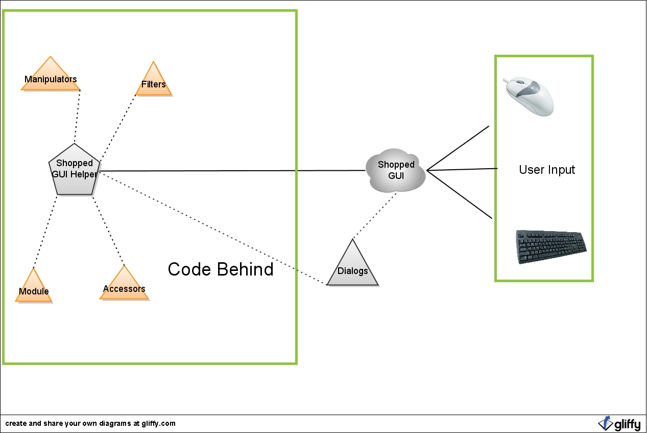

User interacts with the program via a computer mouse and/or keyboard.

Some features in Shopped (i.e. Resize, Rotate) have dialog boxes associated with them.

Either the Dialog or the GUI itself interacts with a Shopped GUI Helper, which acts as the interface between the GUI and the methods for manipulating the image in the GUI.

Shopped GUI Helper uses and acts as a basic form of Inversion of Control, allowing Core methods (i.e. methods that do the work on the image) to "know" about the GUI and its properties (i.e. the current image dimensions, the options the user has selected, etc.).

- This allows the GUI to know how to call upon the worker methods and for the methods to know about the GUI without circular referencing (which you cannot do in C#).

After a method is called upon in Shopped GUI Helper, the result of the method is passed back to the GUI and the result is displayed (i.e. the image was zoomed, the user changed the options for the Draw tool, etc.).

All this is possible due to event handling that occurs in the Shopped GUI. Certain actions of the user cause an event (i.e. mouse button pressed) and a handler in Shopped GUI handles it accordingly by making the appropriate method call.

2. Use Case: Rotate Image (You can resize this to read it better in MS Word)
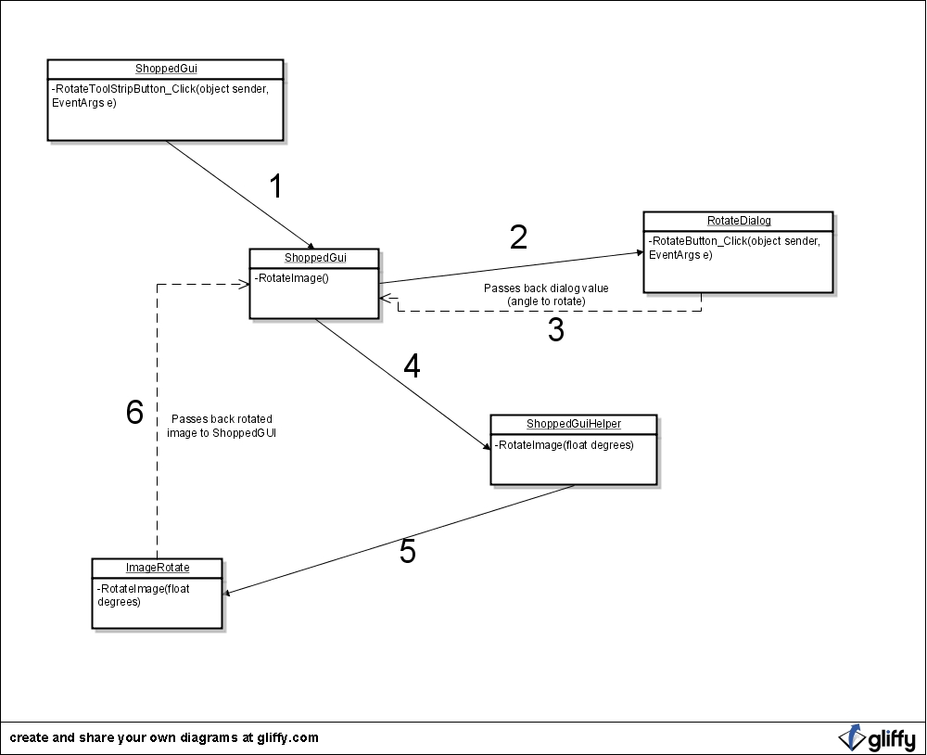

3. Use Case: Undo (You can resize this to read it better in MS Word)
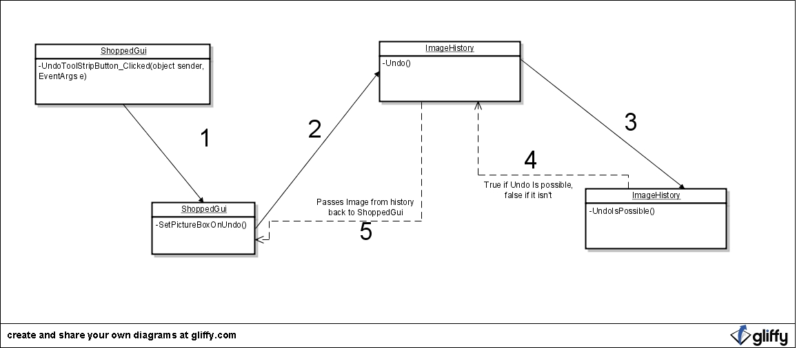

H. Class Documentation
Core.Filters Namespace

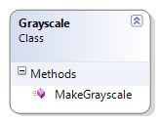

Grayscale Class

A filter that will make an Image object grayscale.

Properties: N/A

Methods:

- public ShoppedImage MakeGrayscale(ShoppedImage shoppedImage)
Arguments:
ShoppedImage shoppedImage - The ShoppedImage object in the current context of Shopped GUI.

Returns:
A ShoppedImage object with the appropriate properties set by this method.

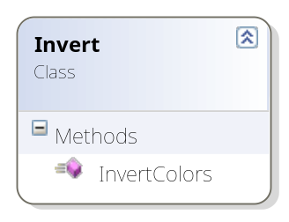

Invert Class

A filter that will make an invert the colors of an image.

Properties: N/A

Methods:

- public ShoppedImage InvertColors(ShoppedImage shoppedImage)
Arguments:
ShoppedImage shoppedImage - The ShoppedImage object in the current context of Shopped GUI.

Returns:
A ShoppedImage object with the appropriate properties set by this method.

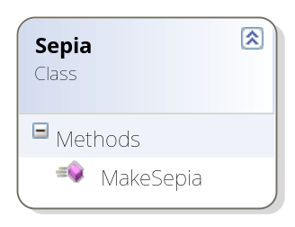

Sepia Class

A filter that will make an give a sepia-enriched hue to an image.

Properties: N/A

Methods:

- public ShoppedImage MakeSepia(ShoppedImage shoppedImage)
Arguments:
ShoppedImage shoppedImage - The ShoppedImage object in the current context of Shopped GUI.

Returns:
A ShoppedImage object with the appropriate properties set by this method.

Core.Images Namespace

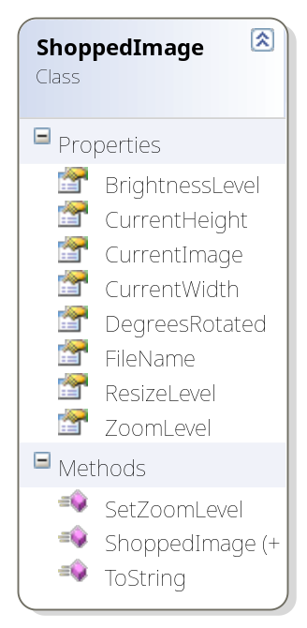

ShoppedImage Class

Holds the current state of the image in the Shopped GUI. Anytime the loaded image is modified (i.e. rotated, resized, etc.), this object gets updated to reflect the modification.

Properties:
FileName - Contains the name of the opened image file
CurrentHeight - Contains the height of the loaded image.
CurrentWidth - Contains the width of the loaded image.
DegreesRotated - Contains how many degrees the image is currently rotated.
ZoomLevel - How far the image is zoomed in or out (1.0f = 100%).
ResizeLevel - The difference in size the resized image is from original (1.0f = 100%)
BrightnessLevel - The level of brightness of the image (-255 to 255)
CurrentImage - Image object that holds the actual Image object.

Methods:

- public void SetZoomLevel(float zoomDelta)
Sets the ZoomLevel parameter if the zoomDelta is within proper bounds.
Arguments:
float zoomDelta - The amount to change the zoom level by.

- public override string ToString()

A custom ToString() method that displays information about the ShoppedImage object.
Arguments: N/A

Returns:
A string containing the height, width, degrees rotated, zoom and resize levels of the current ShoppedImage object.

Core.Manipulators Namespace

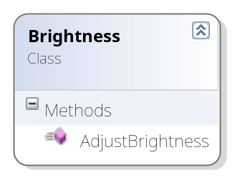

Brightness Class

A manipulator that will adjust the brightness of each pixel in an image.

Properties: N/A

Methods:

- public ShoppedImage AdjustBrightness(ShoppedImage shoppedImage, float brightnessLevel)
Arguments:
ShoppedImage shoppedImage - The ShoppedImage object in the current context of Shopped GUI.
float brightnessLevel - The level of brightness to adjust each pixel to.

Returns:
A ShoppedImage object with the appropriate properties set by this method.

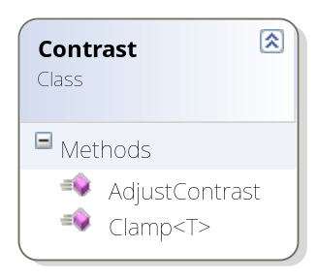

Contrast Class

A manipulator that will adjust the constrast of each pixel in an image.

Properties: N/A

Methods:

- public static T Clamp<T>(T value, T max, T min)
A generic clamp class that make sure the RBG values lie in the specified range. If it is greater than the max value, it is replaced by the max value.
Arguments:
value - The value being compared
max - The maximum allowed value
min - The minimum allowed value

Returns:
The "clamped" value that is guaranteed to be within the given bounds.
- public ShoppedImage AdjustContrast(ShoppedImage shoppedImage, float contrastLevel)
Takes the given shoppedImage object and applies the contrast level to it.
Arguments:
shoppedImage - The ShoppedImage object in the current context of Shopped GUI

Returns:
A ShoppedImage object with the appropriate properties set by this method.

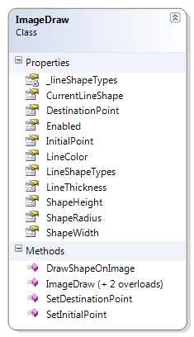

ImageDraw Class

A manipulator that will adjust the constrast of each pixel in an image.

Properties:
LineColor - The color of the line to be drawn.
LineThickness - How wide the line to be drawn will be.
ShapeHeight - The height of a given shape to be drawn.
ShapeWidth - The Width of a given shape to be drawn.
ShapeRadius - The Radius of a circle to be drawn.
CurrentLineShape - Holds the current shape to be drawn (Square, Rectangle, Triangle, Circle, Line).
Enabled - Holds whether or not the drawing functionality is enabled.
InitialPoint - The x and y coordinates of the mouse for the start point of a line draw.
DestinationPoint - The x and y coordinates of the mouse for the end point of a line draw.
_lineShapeTypes - The private backing field for LineShapeTypes (can be set).
LineShapeTypes - The public-facing list of possible line shapes (read-only).

Methods:

- public Image DrawShapeOnImage(Image image, MouseEventArgs mouse)

Gets the current position of the cursor over the PictureBox and sets the pixels around the cursor to the specified color and LineShape.
Arguments:
image - The image from PictureBox.
mouse - Contains the current status of the mouse.

Returns:
The new image that has been drawn on.

- public void SetInitialPoint(int xCoordinate, int yCoordinate)
Sets the initial point for Line draw based on mouse position.

Arguments:
xCoordinate - The X-value of where the mouse cursor is on screen.
yCoordinate - The Y-value of where the mouse cursor is on screen.

Returns: N/A

- public void SetDestinationPoint(int xCoordinate, int yCoordinate)
Sets the end point for Line draw based on mouse position.

Arguments:
xCoordinate - The X-value of where the mouse cursor is on screen.
yCoordinate - The Y-value of where the mouse cursor is on screen.

Returns: N/A

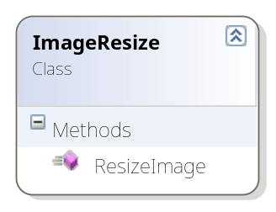
ImageResize Class

Handles the resizing of an image.

Properties: N/A

Methods:

- public ShoppedImage ResizeImage(ShoppedImage shoppedImage, float resize)

Resizes the image in the Shopped GUI to the specified resize level.
Arguments:
resize - The amount to resize the image to.
shoppedImage - The ShoppedImage object in the current context of Shopped GUI

Returns:
A ShoppedImage object with the appropriate properties set by this method.

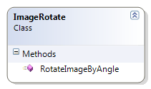

ImageRotate Class

Handles the rotating of an image.

Properties: N/A

Methods:

- public ShoppedImage RotateImageByAngle(ShoppedImage shoppedImage, float angle)

Given a certain angle (in degrees), this method will take the CurrentImage object and rotate it by the given angle.
Arguments:
angle - The angle (in degrees) to rotate the image.
shoppedImage - The ShoppedImage object in the current context of Shopped GUI.

Returns:
A ShoppedImage object with the appropriate properties set by this method.

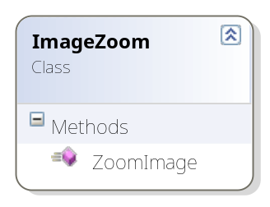

ImageZoom Class

Handles the zooming in and out of an image.

Properties: N/A

Methods:

- public Image ZoomImage(Image image, float zoom)

Zooms the image in the Shopped GUI to the specified zoom level.
Arguments:
zoom - The amount of zoom to use on the image (1.0f == 100%).
image - The image to be zoomed.

Returns:
The zoomed Image object.

Core Namespace

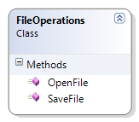

FileOperations Class

Handles the opening and saving of images from file.

Properties: N/A

Methods:

- public ShoppedImage OpenFile()

Opens a file dialog to select an image, then opens the file inside the Shopped main GUI.
Arguments: N/A

Returns:
A shoppedImage object with the opened image inside it.

- public void SaveFile(ShoppedImage shoppedImage)

Opens a save file dialog to save the image that is open in the Shopped main GUI.
Arguments:
shoppedImage - The shoppedImage object in the current context of Shopped GUI that we will save.

Returns: N/A

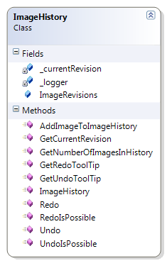

ImageHistory Class

Manages the list of ImageHistoryItems (to do undo and redo) as well as carry out the undo and redo operations.

Properties:
ImageRevisions - A list of ImageHistoryItem objects (which contain a ShoppedImage object and a string detailing the operation performed).
_currentRevision - Keeps track of where we are currently in the ImageRevisions list.
_logger - Writes debug statements to file for testing purposes.

Methods:

- public void AddImageToImageHistory(ShoppedImage image, string operation)

Appends the Image object and string passed in to the end of the ImageRevisions list.
Arguments:
image - The ShoppedImage object to add to the list.
operation - A string detailing what operation was just performed.

Returns: N/A

- public ShoppedImage Undo()

Attempts an undo operation by checking if an object exists before the CurrentRevision iterator, then returning that ImageHistoryItem node if it does exist.
Arguments: N/A

Returns:
A ShoppedImage object (if it exists).
- public ShoppedImage Redo()

Attempts an redo operation by checking if an object exists before the CurrentRevision iterator, then returning that ImageHistoryItem node if it does exist.
Arguments: N/A

Returns:
A ShoppedImage object (if it exists).
- public int GetNumberOfImagesInHistory()

Returns the number of ImageHistoryItem objects on the ImageRevisions list.
Arguments: N/A

Returns:
The current number of items in the list.

- public int GetCurrentRevision()

Returns the value of the iterator (essentially where we are in the ImageRevisions list).
Arguments: N/A

Returns:
The value of the iterator for the list.

- public bool RedoIsPossible()

Returns whether or not there exists an image to redo in the history.
Arguments: N/A

Returns:
Whether or not ImageHistory can perform a redo.

- public bool UndoIsPossible()

Returns whether or not there exists an image to undo in the history.
Arguments: N/A

Returns:
Whether or not ImageHistory can perform a undo.

- public string GetRedoToolTip()

Returns the tooltip for the next item in the history.
Arguments: N/A

Returns:
The tooltip for the next item.

- public string GetUndoToolTip()

Returns the tooltip for the previous item in the history.
Arguments: N/A

Returns:
The tooltip for the previous item.

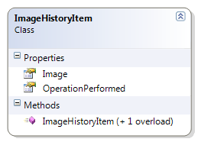

ImageHistoryItem Class

A simple class that contains an ShoppedImage object and a string that details the operation performed.

Properties:
Image - A ShoppedImage object to store in history.
OperationPerformed - A string that describes the actions performed on the ShoppedImage.

Methods: N/A

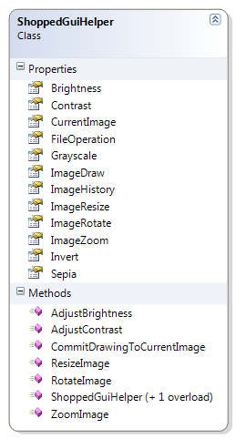

ShoppedGuiHelper Class

A class that contains the initialized objects of the classes in Core. This is a "poor man's" implementation of Inverion of Control.

Properties:
CurrentImage - A ShoppedImage object.
ImageRotate - An ImageRotate object.
FileOperation - A FileOperations object.
ImageHistory - An ImageHistory object.
ImageZoom - An ImageZoom object.
ImageResize - An ImageResize object.
Grayscale - A Grayscale object.
Sepia - A Sepia object.
Invert - An Invert object.
Brightness - A Brightness object.
Contrast - A Contrast object.
ImageDraw - An ImageDraw object.

Methods:

- public void RotateImage(float angle)

Handles the call from the GUI to rotate an image.
Arguments:
angle - The angle to rotate the image by.

Returns: N/A

- public void ResizeImage(float resizeLevel)
Handles the call to resize an image from the GUI.
Arguments:
resizeLevel - The amount to resize the image by.

Returns: N/A

- public Image ZoomImage(Image image, float zoomLevel)

Handles the call to zoom an image from the GUI.
Arguments:
image - The image to be zoomed.
zoomLevel - The amount to zoom the image by.

Returns: N/A

- public void AdjustContrast(float amount)

Handles the call from the GUI to adjust the contrast of an image.
Arguments:
amount - The amount to adjust the contrast by.

Returns: N/A

- public void AdjustBrightness(float amount)

Handles the call from the GUI to adjust the brightness of an image.
Arguments:
amount - The amount to adjust the brightness by.

Returns: N/A

- public void CommitDrawingToCurrentImage(Image image)

Called after a drawing event occurred in the GUI. Checks if the image is different from the CurrentImage and adds it to history if it is.
Arguments:
image - The current image being displayed in the gui.

Returns: N/A

UI Namespace
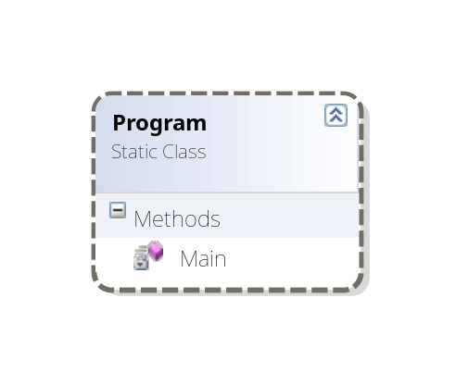
Program Class

The main class that has Main method, starts program.

Properties: N/A

Methods:

- static void Main()

Calls the ShoppedGui class and initiates the GUI.
Arguments: N/A

Returns: N/A

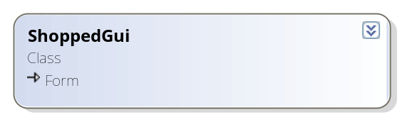

ShoppedGui Class

The class that loads, runs and handles events of the Shopped main GUI.

Properties:

_shoppedGuiHelper - An instance of ShoppedGuiHelper that provides access to the manipulators, filters, etc.
_logger - A debug tool that allows debug statements to be written to a log file.

Methods:

- private void Form1_Load(object sender, EventArgs e)

Initial loading of the Shopped program. Disables certain features/options that should not be available until an image is loaded into the program.
Arguments: N/A

Returns: N/A

- private void exitToolStripMenuItem_Click(object sender, EventArgs e)

Handles the event of clicking File->Exit menu item. Exits the program.

Arguments: N/A

Returns: N/A

- private void aboutToolStripMenuItem_Click(object sender, EventArgs e)

Handles the event of clicking Help->About menu item. Displays message box containing information about Shopped (developer names, program info).

Arguments: N/A

Returns: N/A

- private void openPictureButton_Click(object sender, EventArgs e)

Handles the event of clicking "Open Image" icon.

Arguments: N/A

Returns: N/A

- private void saveImageButton_Click(object sender, EventArgs e)

Handles the event of clicking "Save Image" icon.

Arguments: N/A

Returns: N/A

- private void openPictureToolStripMenuItem_Click(object sender, EventArgs e)

Handles the event of clicking File->Open Picture menu item.

Arguments: N/A

Returns: N/A

- private void savePictureToolStripMenuItem_Click(object sender, EventArgs e)

Handles the event of clicking File->Save Picture menu item.

Arguments: N/A

Returns: N/A

- public void EnableGuiItems()

Called upon once an image is loaded from file, this enables the features/options that can now be used.

Arguments: N/A

Returns: N/A

- private void grayscaleMenuItem_Click(object sender, EventArgs e)

Handles the event of clicking the Tools->Grayscale menu item.

Arguments: N/A

Returns: N/A

- private void grayscaleToolStripMenuItem_Click(object sender,
EventArgs e)

Handles the event of clicking the Grayscale toolstrip button.

Arguments: N/A

Returns: N/A

- private void sepiaMenuItem_Click(object sender, EventArgs e)

Handles the event of clicking the Tools->Sepia menu item.

Arguments: N/A

Returns: N/A

- private void sepiaToolStripMenuItem_Click(object sender, EventArgs e)

Handles the event of clicking the Sepia toolstrip button.

Arguments: N/A

Returns: N/A

- private void invertMenuItem_Click(object sender, EventArgs e)

Handles the event of clicking the Tools->Invert menu item.

Arguments: N/A

Returns: N/A

- private void invertToolStripMenuItem_Click (object sender, EventArgs e)

Handles the event of clicking the Invert toolstrip button.

Arguments: N/A

Returns: N/A

- private void brightnessMenuItem_Click(object sender, EventArgs e)

Handles the event of clicking the Tools->Brightness menu item.

Arguments: N/A

Returns: N/A

- private void brightnessToolStripMenuItem_Click(object sender, EventArgs e)

Handles the event of clicking the Brightness toolstrip button.

Arguments: N/A

Returns: N/A

- private void contrastMenuItem_Click(object sender, EventArgs e)

Handles the event of clicking the Tools->Contrast menu item.

Arguments: N/A

Returns: N/A

- private void contrastToolStripMenuItem_Click(object sender, EventArgs e)

Handles the event of clicking the Contrast toolstrip button.

Arguments: N/A

Returns: N/A

- private void zoomImageToolStripMenuItem_Click(object sender, EventArgs e)

Handles the event of clicking the View->Zoom Image menu item.

Arguments: N/A

Returns: N/A

- private void ZoomToolStripButton_Click(object sender, EventArgs e)

Handles the event of clicking the Zoom Image button.

Arguments: N/A

Returns: N/A

- private void ResizeToolStripButton_Click(object sender, EventArgs e)

Handles the event of clicking the Resize Image button.

Arguments: N/A

Returns: N/A

- private void resizeToolStripMenuItem_Click(object sender, EventArgs e)

Handles the event of clicking the Tools->Resize menu item.

Arguments: N/A

Returns: N/A

- private void UndoToolStripButton_Click(object sender, EventArgs e)

Handles the event of clicking the Undo button.

Arguments: N/A

Returns: N/A

- private void undoToolStripMenuItem_Click(object sender, EventArgs e)

Handles the event of clicking the Edit->Undo menu item.

Arguments: N/A

Returns: N/A

- private void RedoToolStripButton_Click(object sender, EventArgs e)

Handles the event of clicking the Redo button.

Arguments: N/A

Returns: N/A

- private void redoToolStripMenuItem_Click(object sender, EventArgs e)

Handles the event of clicking the Edit->Redo menu item.

Arguments: N/A

Returns: N/A

- private void RotateToolStripButton_Click(object sender, EventArgs e)

Handles the event of clicking the Rotate Image button.

Arguments: N/A

Returns: N/A

- private void RotateToolStripMenuItem_Click(object sender, EventArgs e)

Handles the event of clicking the Tools -> Rotate menu item.

Arguments: N/A

Returns: N/A

- private void PictureBox_MouseMove(object sender, MouseEventArgs e)

Handles the event of the cursor moving around on the PictureBox.

Arguments: N/A

Returns: N/A

- private void PictureBox_MouseUp(object sender, MouseEventArgs e)

Handles the event of a mouse button being released on the PictureBox.

Arguments: N/A

Returns: N/A

- private void PictureBox_MouseDown(object sender, MouseEventArgs e)

Handles the event of a mouse button being pressed on the PictureBox.

Arguments: N/A

Returns: N/A

- private void PictureBox_MouseWheelScroll(object sender, MouseEventArgs e)

Handles the event of the mouse scroll wheel being used on the PictureBox.

Arguments: N/A

Returns: N/A

- private void drawingToolStripMenuItem_Click(object sender, EventArgs e)

Handles the event of the user selecting "Drawing" from the Tools menu. Opens up a DrawingDialog and sets the values to ImageDraw object accordingly.

Arguments: N/A

Returns: N/A

- private void RotateImage()

Pops up a dialog box for the user to input a number to rotate the picture by. Calls RotateImage of ShoppedGuiHelper and updates the Gui with the new image.

Arguments: N/A

Returns: N/A

- private void ZoomImage()

Pops up a dialog box for the user to input a number to zoom the picture. Calls ZoomImage of ShoppedGuiHelper and updates the Gui with the new image.

Arguments: N/A

Returns: N/A

- private void ZoomImageOnScroll(int mouseWheelDelta)

Detects the scroll wheel movement on the mouse and translates that into zooming the image in the GUI 5% in or out.

Arguments:
mouseWheelDelta - The measure of the mouse wheel moving.

Returns: N/A

- private void ResizeImage()

Pops up a dialog box for the user to input a number to resize the picture by. Calls ResizeImage of ShoppedGuiHelper and updates the Gui with the new image.

Arguments: N/A

Returns: N/A

- private void AdjustContrast()

Pops up a dialog box for the user to input a number adjust image contrast. Calls AdjustContrast of ShoppedGuiHelper and updates the Gui with the new image.

Arguments: N/A

Returns: N/A

- private void AdjustBrightness()

Pops up a dialog box for the user to input a number adjust image brightness. Calls AdjustBrightness of ShoppedGuiHelper and updates the GUI with the new image.

Arguments: N/A

Returns: N/A

- private void ApplyGrayscaleFilterToImage()

Makes the call to ShoppedGuiHelper to apply the grayscale filter on the current image.

Arguments: N/A

Returns: N/A

- private void ApplySepiaFilterToImage()

Makes the call to ShoppedGuiHelper to apply the sepia filter on the current image.

Arguments: N/A

Returns: N/A

- private void InvertImage()

Makes the call to ShoppedGuiHelper to apply the invert image filter on the current image.

Arguments: N/A

Returns: N/A

- private void SetUndoAndRedo()

Called upon when the event of clicking Undo/Redo in the Shopped GUI, this will enable or disable the Undo/Redo buttons and menu items in the GUI. This will also set the tooltip text for the undo/redo GUI items.

Arguments: N/A

Returns: N/A

- private void SetAdditionalInfo()

Sets the information about the PictureBox image that is located at the bottom of the Shopped GUI. Information includes height, width and the name of the image.

Arguments: N/A

Returns: N/A

- private string GetCoordinates()

Gets the current coordinates of the mouse in the PictureBox and returns them as an ordered pair.

Arguments: N/A

Returns:
A string representation of the coordinates as an ordered pair.

- private string GetPixelColor()

Takes the cursor's current position on the image and attempts to get the color of that pixel.

Arguments: N/A

Returns:
The hexadecimal representation of the pixel's color.

- private void OpenImage()

Uses FileOperation instance to prompt user to open an image file. Sets the image in the editor once image is opened.

Arguments: N/A

Returns: N/A

- private void UpdatePictureBoxInfo(string operation)

Sets the PictureBox to the image passed to this method.

Arguments:
operation - A brief description of the operation just performed to the Shopped GUI image.

Returns: N/A

- private void SetPictureBoxOnUndo()

Given an Image object from the ImageHistory class, set the ShoppedGUI
PictureBox (image being currently displayed) to that Image object.

Arguments: N/A

Returns: N/A

- private void SetPictureBoxOnRedo()

Given an Image object from the ImageHistory class, set the ShoppedGUI
PictureBox (image being currently displayed) to that Image object.

Arguments: N/A

Returns: N/A

- private void DrawOnPictureBox(MouseEventArgs mouse)

Calls upon ImageDraw class to draw on the current PictureBox

Arguments:
mouse - Contains the current status of the mouse.
Returns: N/A

UI.Dialogs Namespace

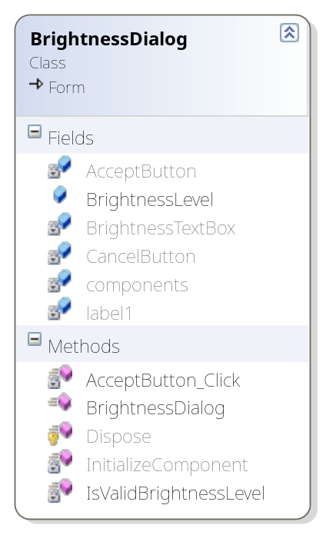

BrightnessDialog Class

A dialog that prompts the user to input a level for the Brightness filter.

Properties:
BrightnessLevel - The level of brightness to apply in the filter.

Methods:

- private void AcceptButton_Click(object sender, EventArgs e)

Once the user hits the "Accept" button, this grabs the value from the dialog box.
Arguments: N/A

Returns: N/A

- private bool IsValidBrightnessLevel()

Checks the user's input to make sure it is valid.
Arguments: N/A

Returns:
True if input is valid, false if it is not valid.

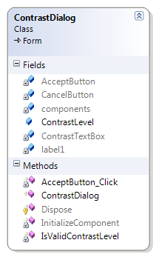

ContrastDialog Class

A dialog that prompts the user to input a level for the Contrast filter.

Properties:
ContrastLevel - The level of contrast to apply in the filter.

Methods:

- private void AcceptButton_Click(object sender, EventArgs e)

Once the user hits the "Accept" button, this grabs the value from the dialog box.
Arguments: N/A

Returns: N/A

- private bool IsValidContrastLevel()

Checks the user's input to make sure it is valid.
Arguments: N/A

Returns:
True if input is valid, false if it is not valid.

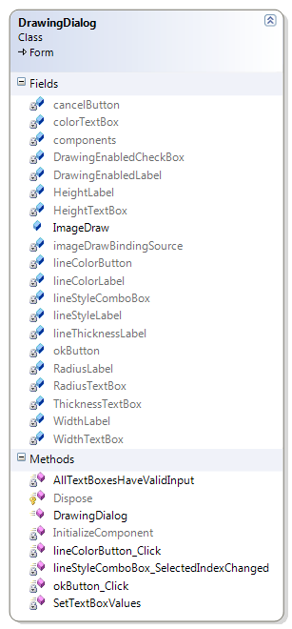

DrawingDialog Class

Performs the actions necessary to grab the drawing info from the dialog box and set the ImageDraw properties accordingly.

Properties:
ImageDraw - A new instance of ImageDraw class that will contain the new values.

Methods:

- private void lineColorButton_Click(object sender, EventArgs e)

Opens up a color dialog for the user to choose a new color for the draw utility.
Arguments: N/A

Returns: N/A

- private void okButton_Click(object sender, EventArgs e)

The handler for when the OK button is clicked in the dialog. Grabs the value out of the line thickness text box.
Arguments: N/A

Returns: N/A

- private bool AllTextBoxesHaveValidInput()

Makes sure that each textbox has a positive integer value inside it.
Arguments: N/A

Returns:
Whether or not the above statement is true.

- private void SetTextBoxValues()

Grabs the property values from the ImageDraw object and sets the textboxes.
Arguments: N/A

Returns: N/A

- private void lineStyleComboBox_SelectedIndexChanged(object sender, EventArgs e)

Handler for the changing of the selection in the drop-down list for the shape of the draw object.
Arguments: N/A

Returns: N/A

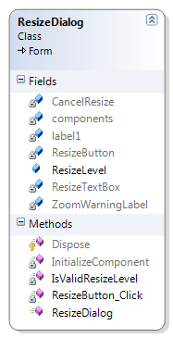

ResizeDialog Class

A dialog that prompts the user to input a level for the ResizeImage Manipulator.

Properties:
ResizeLevel - The amount to resize the image by.

Methods:

- private void ResizeButton_Click(object sender, EventArgs e)

Once the user hits the "Resize" button, this grabs the value from the dialog box.
Arguments: N/A

Returns: N/A

- private bool IsValidResizeLevel()

Checks the user's input to make sure it is valid.
Arguments: N/A

Returns:
True if input is valid, false if it is not valid.

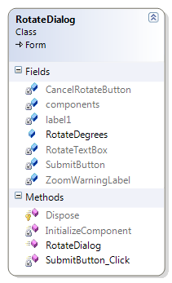

RotateDialog Class

A dialog that prompts the user to input a level for the RotateImage Manipulator.

Properties:
RotateDegrees - The amount to rotate the image by (in degrees).

Methods:

- private void SubmitButton_Click(object sender, EventArgs e)

Once the user hits the "Rotate" button, this grabs the value from the dialog box.
Arguments: N/A

Returns: N/A

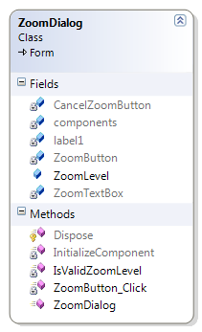

ZoomDialog Class

A dialog that prompts the user to input a level for the ZoomImage Manipulator.

Properties:
ZoomLevel - The amount to zoom the image by.

Methods:

- private void ZoomButton_Click(object sender, EventArgs e)

Once the user hits the "Zoom" button, this grabs the value from the dialog box.
Arguments: N/A

Returns: N/A

- private bool IsValidZoomLevel()

Checks the user's input to make sure it is valid.
Arguments: N/A

Returns:
True if input is valid, false if it is not valid.

I. Contact
E-mails:
Andy Vanek: avanek@kent.edu
Daniel Sheaffer: dsheaffe@kent.edu
Greg Beca: gbeca@kent.edu

Websites:
http://code.google.com/p/capstone2009
This has been our repository and means of launching installable software. We also have a wiki here that has referenced other websites to help us code our program.

http://www.cs.kent.edu/~avanek/Capstone/ShoppedDocumentation/
This has hosts all of our Doxygen Comments.

environment, languae, libraries, (functionality)

Need to add Functionality: What we can open, what filters we can apply, what images we can open, etc.

