Requirements Document

Table of contents

A. Purpose of Product
B. Overall Requirements
C. Bound Cases
D. Design
E. References
F. Usage Cases
G. Diagrams
H. Contact information

A. Purpose of Product
We are creating a basic image editor/viewer for our Capstone Project for Fall 2009, 49901 class with our professor Mr. Ye Zhao and graduate assistant Ms. Zakia Tamimi. The goal of this software is to give the ability to edit images by means of rotating, resizing, applying filters, a few more features, and delivering a cleanly written efficient program.

B. Overall Requirements
1. Requirements to install the software:
- Input means (Mouse and Keyboard)
- Monitor (Any Resolution)
- Operating System: Windows

2. Requirements to run the core components of the software:
I. Upon launch, all buttons and dropdown menus are disabled except for open picture functionality
II. After the user selects an image (Any *.jpg, *.bmp, or *.gif file) the rest of the functions will be enabled until the application is quit at which point the core components will be reset to being disabled upon next launch

C. Bound cases
1. At Launch
As explained in B.2.I of this document, all buttons and dropdown menus are disabled except for open picture functionality.

Once an image has been opened, all buttons and dropdown menus are enabled.

2. Zoom function
3. Rotate function
4. Filters
5. Draw function
6. Window
We have our window setup so that it can fill the entire screen regardless of the size of the image.
7. Scrolling
We have coded this function to only be active when there’s picture cutoff of the window being too small on either X, Y, or both axis.
D. Design
Our overall design has been implemented using Microsoft Visual Studio 2008 provided for us thanks to Kent State University’s College of Mathematics and Science. With this software installed and given to us to use, we have utilized it, Microsoft’s Windows forms for our graphical user interface, and we have only used the C# programming language to implement all of our functions and coding.

E. References
1. Nunit (www.nunit.org)
We have implemented Nunit’s testing harness to assist us in debugging our own code.
2. Nlogger (http://sourceforge.net/projects/nlogger/)
We have used this in our code to save a log file of every function we do when we use our program. This allows us to easily recreate bugs found in general use of the program.
3. Microsoft Visual Studio 2008
As provided for us by Kent, we have been taking advantage of Microsoft Visual Studio 2008. We have been using Windows Forms
4. The Code Project (www.codeproject.com)
This website helped us getting off our feet in the beginning of our project. They have supplied various C# image manipulating tools that have influenced how we have constructed our program.
5. Gliffy (www.gliffy.com)
We used this website’s tools to layout our diagrams in G.1 and G.2 of this document.
6. Rotate (http://netcode.ru/dotnet/?lang=&katID=30&skatID=263&artID=7226)
The code found here was more than helpful when it came to solving the issue of rotating in any degree whereas most functions only allow a use to rotate in 90 or 180 degrees.
F. Feature List
Here is a list of features contained in our software that the user can expect to use:
-Opening an image
-Saving an image
-Rotating an image to any degree clockwise or counterclockwise
-Zoom using their mousewheel
-Zoom to a specific percentage
-Applying one of many color filters
-Resize an image
-Return color in hex wherever mouse is hovering on image
-Draw freehand in specific shapes, colors, and sizes
-Draw shapes in specific shapes, colors, and sizes
-Undo or Redo any operation

G. Diagrams
1. Sequence Diagram Flowchart (You can resize this to read it better in MS Word)
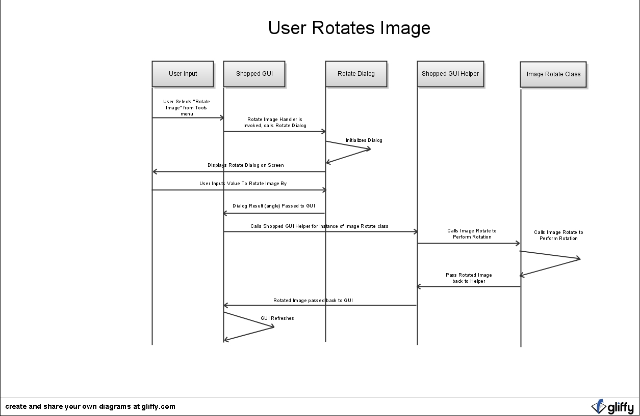

2. Overall Computing Structure (You can resize this to read it better in MS Word)
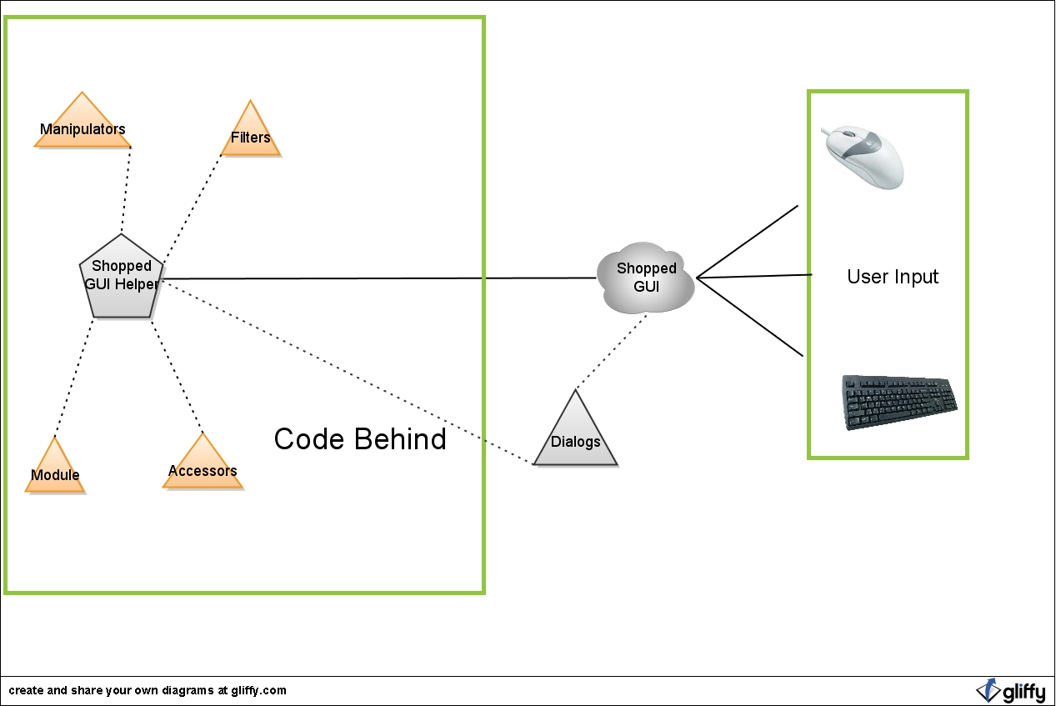

H. Contact
E-mails:
Andy Vanek: avanek@kent.edu
Daniel Sheaffer: dsheaffe@kent.edu
Greg Beca: gbeca@kent.edu

Websites:
http://code.google.com/p/capstone2009
This has been our repository and means of launching installable software. We also have a wiki here that has referenced other websites to help us code our program.

http://www.cs.kent.edu/~avanek/Capstone/ShoppedDocumentation/
This has hosts all of our Doxygen Comments.

Overall Requirements (product specification)
Specific Details (Bound Cases)
References (code that helped is, Nlogger/Nunit)
Usage cases (feature list, what the user can expect)

