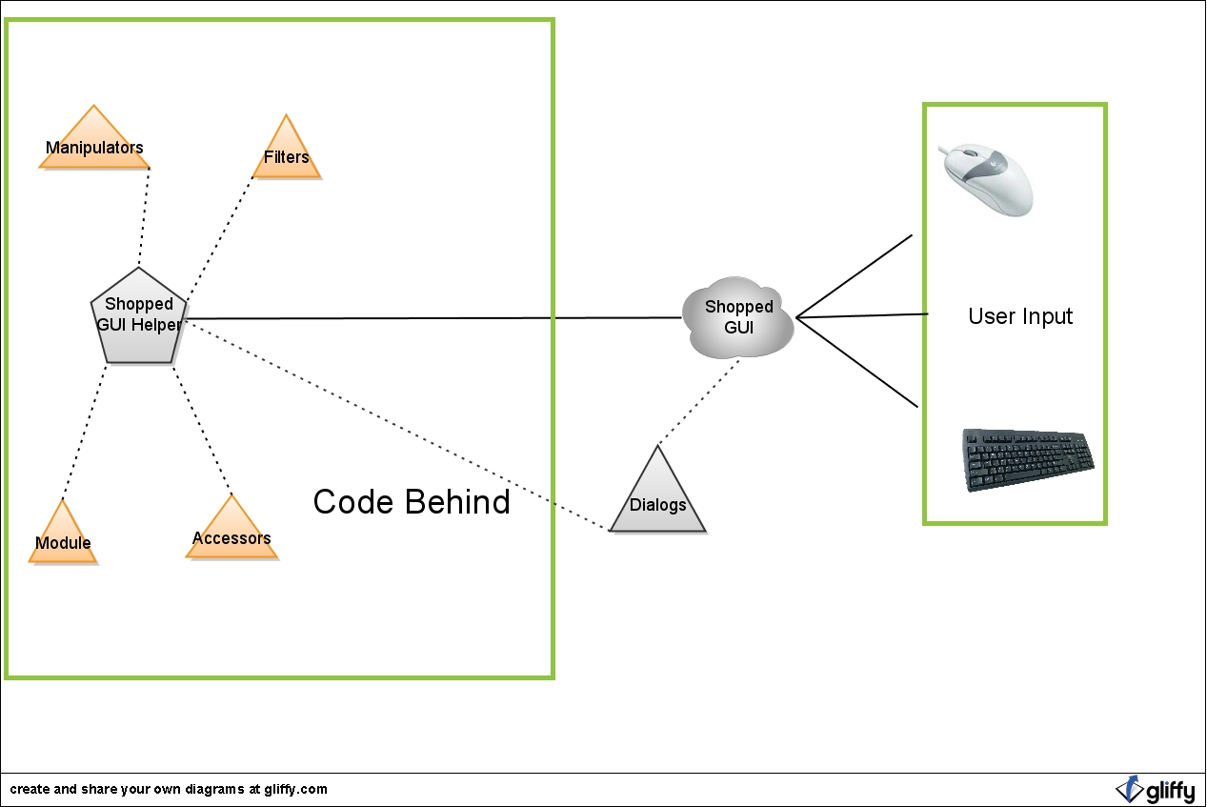
General Interaction with Shopped
- User interacts with the program via a computer mouse and/or keyboard.

- Some features in Shopped (i.e. Resize, Rotate) have dialog boxes associated with them.

- Either the Dialog or the GUI itself interacts with a Shopped GUI Helper, which acts as the interface between the GUI and the methods for manipulating the image in the GUI.

- Shopped GUI Helper uses and acts as a basic form of Inversion of Control, allowing Core methods (i.e. methods that do the work on the image) to "know" about the GUI and its properties (i.e. the current image dimensions, the options the user has selected, etc.).
  - This allows the GUI to know how to call upon the worker methods and for the methods to know about the GUI without circular referencing (which you cannot do in C#).

- After a method is called upon in Shopped GUI Helper, the result of the method is passed back to the GUI and the result is displayed (i.e. the image was zoomed, the user changed the options for the Draw tool, etc.).

- All this is possible due to event handling that occurs in the Shopped GUI. Certain actions of the user cause an event (i.e. mouse button pressed) and a handler in Shopped GUI handles it accordingly by making the appropriate method call.

