**Context:**

**Where does the data come from?**

**BeeOmonitoring:**

**Aim**: measure the concentrations of pollutants (here heavy metals and pesticides) in the environment.

**How**: With bees! Bees gather pollen within a 1.5 km radius, we collect and analyse the pollen.

**When**: between 2017 and 2020 – 4 times a year (4 periods: P1, P2, P3, P4) -> 16 periods

**Where**: on 63 sites in Belgium and France - each with a unique ID

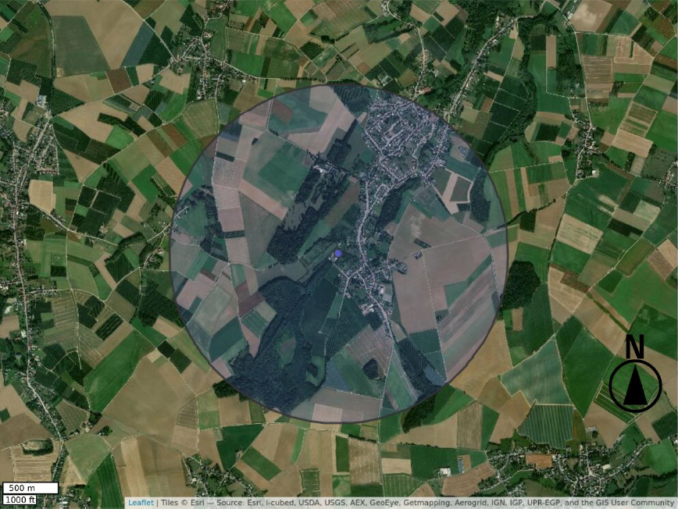

The playing ground of bees is occupied by complex land use patterns as illustrated by the Corine Land Cover (CLC):

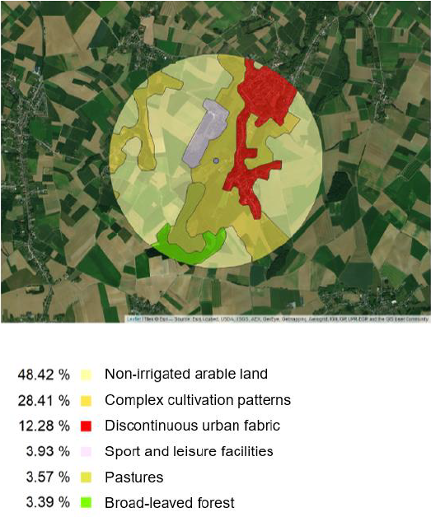

In order to characterise the environment, we can use

1. the surface of each type of land use
2. the distance from the hive (centre of the circle) to each polygon.

**You’ll need:**

1. **A list of the references of the sites**
2. **The land use on the different sites (as area of each CLC class)**
3. **The distance from the centre to each polygon of each type**
4. **Information about CLC classes**
5. **The measured concentrations of heavy metals over time**
6. **Characteristics of heavy metals (Maximum Residue Levels)**
7. **The measured concentrations of pesticides over time**
8. **Characteristics of pesticides (Maximum Residue Levels + type)**

**Geographical data:**

- **absSurfs.xlsx**: contains the area (in m²) for all the sites (column A, “Site” **[1]**) for each class (columns B to AS) of the Corine Land Cover (CLC) level 3 classes. These classes are represented by a three-digit number (code_clc) and used as column header. The surfaces are calculated in a circle with a radius of 1500m from a point, hence they all sum up to pi*r². **[1 - 2]**

**Column A is the exhaustive list of the sites considered (63 sites).**

- **distsOneSheet.xlsx**: contains the distance between the centre of the circle and each polygon in the circle with radius of 1500m.

Columns are:

- Site: Reference of the site **[link to 1]**

- polyID: Unique ID of the polygon to which the distance is calculated, as referred in CLC

- classCLC: level 3 code_clc of the polygon

- dist: distance in meter from the centre of the circle to the polygon. This column contains 63 0’s **[3]**

- **clc-nomenclature-c.xls**: contains three sheets with the names of the CLC classes (column “libelle_en” in each sheet) and their code_clc (code_clc_LEVEL, in each sheet) for the three levels of classification.

Concerning the classification levels: the smaller the number of the level, the coarser the classification.

The code_clc adapts accordingly: level one: one digit, level two: two digits, level three: three digits.

Exemple:

Level1:

Code_clc_level_1 = 2 -> Agricultural areas

Code_clc_level_2 = 22 -> Permanent crops

Code_clc_level_3 = 221 -> Vineyards

Hence, code 221 in the level 3, is within code 22 in the level 2 and within level 2 in the level 1. **[4]**

**Heavy Metals:**

For the heavy metals (HM), the measured concentrations at the sites are stored in the folder:

YEAR/HM/HM_YEAR_PERIOD.xlsx

where YEAR ∊ [2017,2020] and PERIOD ∊ {P1, P2, P3, P4}

Example: 2017/HM/HM_2017_P4.xlsx: concentrations for the 4th period of 2017.

In each of these files:

- only one sheet is present with name YEAR_PERIOD.

- column A: “REF./SUBSTANCE” gives the reference of the sites **[link to 1]**

- column B: PERIOD indicates YEAR/PERIOD

- all the following columns contain the concentration for each of the **7 heavy metals** (headers) in mg/kg.

- a value of 0 means that the heavy metal has been measured at a concentration 0 mg/kg.

**[5]**

**LMR.txt:** Maximum Residue Levels for the 7 heavy metals. All concentrations are given in mg/kg. NA indicates that no MRL is not defined at the European level for that metal. **[6]**

**Pesticides:**

For the pesticides, the measured concentrations at the sites are stored in the folder:

YEAR/Pesticides/Pesticides_YEAR_PERIOD.xlsx

where YEAR ∊ [2017,2020] and PERIOD ∊ {P1, P2, P3, P4}

Example: 2017/Pesticides/Results_Pesticides_2017_P4.xlsx: results for the 4th period of 2017.

In each of these files:

- only one sheet is present with name YEAR_PERIOD.

- column A: “REF./SUBSTANCE” gives the reference of the site **[link to 1]**

- column B: PERIOD indicates YEAR/PERIOD

- all the following columns contain the concentration for each pesticide (in mg/kg), identified at least once in the period. Number of columns depends on the number of pesticides identified within one period.

- a value of 0 means that the pesticide has been measured at a concentration 0 mg/kg.

**[7]**

**- pesticides.xlsx**: gives information about each pesticide

Columns are:

- importName: name of the pesticides as present in the column headers

- name: name of the pesticide (differs from previous column only in two cases)

- statusEN: indicates whether the pesticide is authorised at the European level

- LMR: The Maximal Residue Limit: a concentration given in mg/kg. An empty cell indicates that no MRL is available for that pesticide.

- familyEN: the family to which the pesticide belongs

- typeEN: the type of pesticide (fungicide, etc…). More than one type can be indicated.

Note: the word pesticide is a generic term. Types of pesticides can be herbicides (used against weeds), fungicides (used against mushrooms), insecticides (used against insects), etc.

**Note that this file contains more pesticides than the list of unique pesticides in the files with the measured concentrations.**

**[8]**