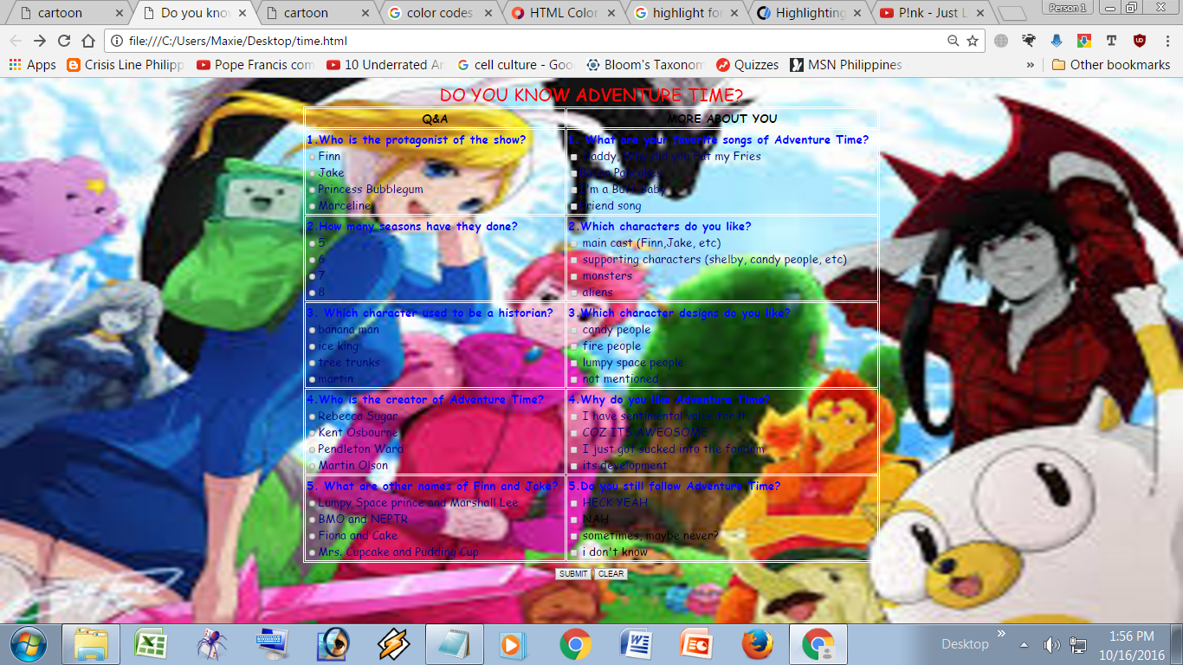

<html>

<head>

<title> Do you know adventure time? </title>

</head>

<body> <center>

<img src='bg.jpg' style='position:fixed;top:0px;left:0px;width:100%;height:100%;z-index:-1;'>

<style>

body {

background-repeat: no-repeat;

}

</style>

<style>

table, th, td {

border: 1px solid white;

}

</style>

<font face="comic sans ms" color="red" size="5">

DO YOU KNOW ADVENTURE TIME? </font>

<form action="adventure.html" method="post">

<font face="comic sans ms">

<table cols="2" rows="6" width="1000" cellpadding="2">

<tr>

<th> Q&A </th>

<th> MORE ABOUT YOU</th>

<tr>

<td><font color="blue"> <b>1.Who is the protagonist of the show?</b> <br> </font>

<font color="navy"> <input type="radio">Finn <br>

<input type="radio">Jake <br>

<input type="radio">Princess Bubblegum <br>

<input type="radio">Marceline </font></td>

<td><font color="blue"><b>1. What are your favorite songs of Adventure Time?</b> <br> </font>

<font color="navy"> <input type="checkbox"> Daddy, Why did you Eat my Fries <br>

<input type="checkbox">Bacon Pancakes <br>

<input type="checkbox">I'm a Buff Baby <br>

<input type="checkbox">Friend song</td> </td>

</font>

</tr>

<tr>

<td><font color="blue"><b>2.How many seasons have they done?</b> <br> </font>

<font color="navy"> <input type="radio">5 <br>

<input type="radio">6 <br>

<input type="radio">7 <br>

<input type="radio">8 </font></td>

<td> <font color="blue"><b>2.Which characters do you like? </b> <br> </font>

<font color="navy"> <input type="checkbox"> main cast (Finn,Jake, etc) <br>

<input type="checkbox"> supporting characters (shelby, candy people, etc) <br>

<input type="checkbox"> monsters <br>

<input type="checkbox"> aliens </td>

</font>

</tr>

<tr>

<td><font color="blue"><b>3. Which character used to be a historian?</b> <br> </font>

<font color="navy"> <input type="radio">banana man <br>

<input type="radio">ice king <br>

<input type="radio">tree trunks <br>

<input type="radio">martin </font></td>

<td><font color="blue"><b>3.Which character designs do you like? </b> <br> </font>

<font color="navy"> <input type="checkbox"> candy people <br>

<input type="checkbox"> fire people<br>

<input type="checkbox"> lumpy space people <br>

<input type="checkbox"> not mentioned </td>

</font>

</tr>

<tr>

<td><font color="blue"><b>4.Who is the creator of Adventure Time?</b> <br>

<font color="navy"> <input type="radio">Rebecca Sugar <br>

<input type="radio">Kent Osbourne <br>

<input type="radio">Pendleton Ward <br>

<input type="radio">Martin Olson </font></td>

<td><font color="blue"><b>4.Why do you like Adventure Time?</b> <br> </font>

<font color="navy"> <input type="checkbox"> I have sentimental value for it <br>

<input type="checkbox"> COZ ITS AWEOSOME<br>

<input type="checkbox"> I just got sucked into the fandom <br>

<input type="checkbox"> its development </td>

</font>

</tr><tr>

<td><font color="blue"><b>5. What are other names of Finn and Jake?</b> <br> </font>

<font color="navy"> <input type="radio">Lumpy Space prince and Marshall Lee <br>

<input type="radio">BMO and NEPTR <br>

<input type="radio">Fiona and Cake <br>

<input type="radio">Mrs. Cupcake and Pudding Cup </font></td>

<td><font color="blue"><b>5.Do you still follow Adventure Time? </b> <br> </font>

<font color="navy"> <input type="checkbox"> HECK YEAH <br> </font>

<input type="checkbox"> NAH <br>

<input type="checkbox"> sometimes, maybe never? <br>

<input type="checkbox"> i don't know </font> </td>

</tr>

</table>

<input type="submit" value="SUBMIT">

<input type="reset" value="CLEAR">

</form>

</center>

</body>

</html>