Demetre Riles

**Watson Project**

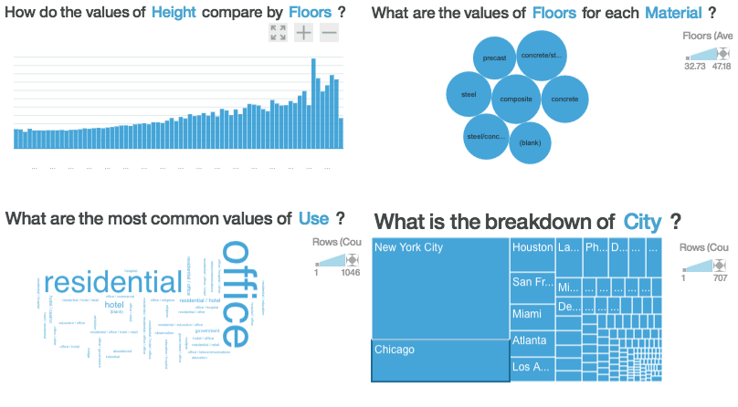

This data consist of the tallest buildings in America. I had found this data on the stats crunch website. It was labeled tallest U.S buildings. In the rows, it has the tallest buildings in order by rank, floors, location, year it was completed, material used, and use for building.

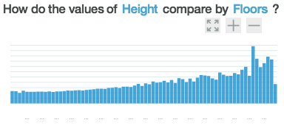

This first discovery shows the relationship between Height and floors. I wanted to see if there were more floors in a building, would the building be taller. According to the data and the graph my assumption was true.

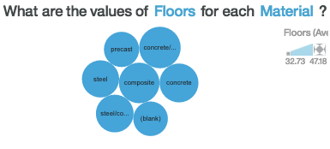

This Is a illustration that shows the material used based on how many floors are in a building. I wanted to see if different material was used to create more floors. Not only does this show which common materials are used, it also ranks materials by how many floors there is in a building from greatest to least. This is measured by the size of the circle, the bigger the circle the higher the rank.

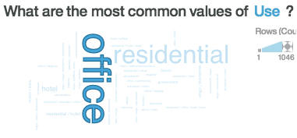

This is an illustration that shows the most common uses for the tallest buildings. This shows that the most common use is for offices since it is bigger and in bold. The second most frequent uses is residential.

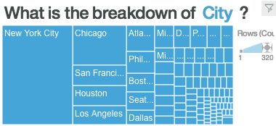

This illustration shows the breakdown of all the cities that have the tallest buildings located in them. Not only does it show which cities have these buildings located in them, it also ranks them. This again is showed by the size of the box with New York being the number city.

**Conclusion**

Watson kind of like a statistics software but has way more features to explore. It can learn from your data and make relationships on its own. You can ask it question and it would provide you answers related to your data. When it gives answers, it also shows its findings related to your question. It also can judge how good your data sample is by percentage. I can see why this could be very helpful when examining data for business or personal reasons.