

Point of Sale (POS) System

Subject Software Engineering

Performed by:
Kaja Szańska
Magdalena Rąpała
Mikołaj Kimak
Natan Brzezinka

Document changelog
Topic | Date | Authors
Initial System Specification | 22.10.2025 | Kaja Szańska  Magdalena Rąpała  Mikołaj Kimak  Natan Brzezinka
Use Case Modelling | 17.11.2025 | Kaja Szańska  Magdalena Rąpała  Mikołaj Kimak  Natan Brzezinka
Structure Modelling | 11.12.2025 | Kaja Szańska  Magdalena Rąpała
Prototype #1 | 11.12.2025 | Magdalena Rąpała

Initial System Specification:
- Acceptance criteria

- Log-in Panel:
  - The employee can log into their account via a login and a password.
- Menu Management Panel:
  - The manager can add a new product with its data (name, price, minimal preparation time) to the menu.
  - The manager can edit an existing product’s data in the menu.
  - The manager can remove an existing product from the menu.
- Order Creation Panel:
  - The waiter can start a new order with automatically assigned ID via the OCP.
  - The waiter can add products to the order from the menu.
  - The waiter can view the order fully with the whole price calculated and minimal preparation time displayed.
  - The waiter can add notes to the order.
  - The waiter can confirm the order and send it to the KPP as an order to be completed.
  - The waiter is able to cancel the order.
- Kitchen Processing Panel:
  - The cook can view all the orders as lists of products with notes, but without prices.
  - The cook can mark an order as ready to be delivered/complete and send it to the PP.
- Payment Panel:
  - The waiter is able to see all the order that were completed by the cook with the indication whether they are ready to be delivered or ready for payment.
  - The waiter can select an order to mark it as delivered (ready for payment).
  - The waiter can select a ready for payment order to display the full price breakdown.
  - The waiter while having a ready for payment order selected can choose an available payment method chosen by the customer.
  - When the order is paid off, it automatically is moved to the archive list available in the OHP.
- Order History Panel:
  - The manager can view all the order made throughout the day with their full prices displayed.
  - The manager is able to generate a report summarizing the day’s work.
Each respective employee can select their panels via the clickable widgets on the screen.

- Formal requirements

This section of the document describes the formal requirements for a Restaurant Point of Sale (POS) System. The system is designed to manage the complete lifecycle of a restaurant order, from creation by a waiter, through kitchen preparation, to final payment and archiving. The goal is to streamline operations, reduce errors, and improve the efficiency of both front-of-house and back-of-house staff.

- User roles:
The system shall interact with the following primary user roles:
- Waiter: Creates and manages customer orders, sends them to the kitchen, and processes payments.
- Cook: Views pending orders and updates their preparation status/
- Manager: Manages the menu, handles reports and has access to order history.
- System Overview
The POS system shall consist of four main functional panels, guiding an order through a defined status flow. The core statuses of an order are: NEW, AWAITING PREPARATION, READY TO BE DELIVERED, READY TO BE PAID, COMPLETED and ARCHIVED.
- Non-Functional Requirements
- The system shall support operation with up to N concurrent users and N concurrent orders.
- All data modifications shall require authentication; only Managers may modify menu or archived data.
- The system shall ensure unique order identifiers to prevent duplication during concurrent order creation.
- Functional Requirements
- Log-in Panel
Purpose: To ensure that only authorized restaurant staff can access the POS system according to their role (Waiter, Cook, Manager).
Requirements:
- The system shall provide a login panel allowing users to authenticate using a valid login and password.
- The system shall verify credentials against stored employee records and grant access to the system only if the provided credentials are valid.
- Menu Management Panel
Purpose: To provide management with a centralized interface for maintaining the restaurant’s product menu.
Requirements:
- The system shall allow authorized users(e.g., Manager) to add a new menu item by specifying at least a Product Name and Price.
- The system shall allow authorized users to edit the details (name, price) of any existing menu item.
- The system shall allow authorized users to remove products from the menu.
- The system shall display the entire menu in a clear and readable format.
- Order Creation Panel
Purpose: To enable Waiters to efficiently create and manage customer orders.
Requirements:
- The system shall automatically generate a unique Order ID when a new order is started.
- The system shall allow the Waiter to add products from the menu to the current order.
- The system shall display a real-time list of all items in the current order.
- The system shall calculate and display the running Total Price for the current order.
- The system shall provide a "Confirm Order" function to finalize the order and send it to the Kitchen Processing Panel. Upon confirmation, the order status shall change from NEW to AWAITING PREPARATION.
- Kitchen Processing Panel
Purpose: To provide the Kitchen Staff with a clear view of orders requiring preparation.
Requirements:
- The system shall display a list of all orders with status AWAITING PREPARATION .
- The kitchen display shall show the order details (products, quantities) but must not display prices.
- The system shall allow Cook to mark an entire order as READY TO BE DELIVERED . This shall change the order status to READY TO BE DELIVERED and move it to the Payment Panel.
- (Future Enhancement)The system shall allow a Cook to revert an order marked as READY TO BE DELIVERED back to AWAITING PREPARATION if an error was made, provided the order has not yet been paid.
- (Future Enhancement) The system should allow a Cook to mark individual items within an order as prepared, providing more granular status updates.
- Payment Panel
Purpose: To finalize the customer transaction after their order is prepared.
Requirements:
- The system shall display a list of all orders with status READY TO PAY or READY TO BE DELIVERED.
- The system shall generate and display a receipt for the selected order, showing a full breakdown of items and the total price.
- The system shall allow the Waiter to select a payment method (e.g., Cash, Card).
- Upon finalizing payment, the system shall mark the order as COMPLETED (paid).
- Completed orders shall be moved to a history/archive for reporting purposes, changing their status to ARCHIVED.
- Core Order Workflow
The system shall enforce the following business workflow:
- Order Creation: A Waiter creates an order (Status: NEW), adds items (e.g., Burger, Fries), and confirms it.
- Kitchen Dispatch: Upon confirmation, the order is sent to the kitchen panel (Status: AWAITING PREPARATION).
- Preparation: The Cook prepares the order and marks it as prepared (Status: READY TO BE DELIVERED).
- Payment: The Waiter selects the ready order, processes the payment via the chosen method, and finalizes it (Status: COMPLETED).
- Archiving: The finalized order is moved to the system's history (Status: ARCHIVED).
- Error Handling
- If a product is unavailable, the system shall prevent adding it to new orders.
- If payment fails, the order remains in READY TO BE PAID state.
- If two orders are created concurrently, the system shall ensure atomic ID generation to prevent conflicts.

- Dictionary

1. MenuItem
Represents a single item available on the menu.
Attributes:
- id: str
- name: str
- price: float
- prep_time_min: int
- active: bool
- course: str
Methods:
- update_details(name, price, prep_time_min, course)

2. Money
Utility class for storing monetary values.
Attributes:
- amount: float
- currency: str
Methods:
- _add_(other)
- _str_()

3. Order
Represents a single customer order.
Attributes:
- id: str
- created_at: datetime
- status: OrderStatus
- is_takeaway: bool
- scheduled_pickup_at: datetime
- estimated_ready_at: datetime
- table_no: str
- notes: str
- waiter: Waiter
- order_items: list[OrderItem]
- payment: Payment
Methods:
- add_item(menu_item, quantity)
- remove_item(item_id)
- set_serving_sequence(rules)
- confirm()
- mark_paid(payment)
- archive()
- total()

4. OrderItem
Represents a single product in an order.
Attributes:
- id: str
- menu_item: MenuItem
- quantity: int
- unit_price: float
- status: OrderStatus
- ready_at: datetime
- course: str
Methods:
- mark_ready()
- subtotal()

5. ServingRule
Defines the order of serving items.
Attributes:
- position: int
- course: str
- items: list[OrderItem]

6. Payment
Represents payment details for an order.
Attributes:
- id: str
- method: str
- amount: Money
- paid_at: datetime
- receipt_number: str
Methods:
- generate_receipt()
- refund()

7. User (Abstract)
Base class for system users.
Attributes:
- id: str
- name: str
- login: str
- role: str

8. Waiter (inherits User)
Handles order creation and payment initiation.
Methods:
- create_order()
- add_product(order, menu_item, qty)
- confirm_order(order)
- finalize_payment(order, method)

9. Cook (inherits User)
Handles kitchen operations.
Methods:
- list_pending_orders()
- mark_item_ready(order_id, item_id)
- update_estimated_times(order_id)

10. Manager (inherits User)
Handles menu and reports.
Methods:
- generate_report(period)
- manage_menu(menu_service)
- view_archived_orders(filter)

11. Receipt
Generated after payment.
Attributes:
- order_id: str
- lines: list
- total: float
- tax: float
Methods:
- to_pdf()
- to_string()

12. Report
Provides summary and analytics.
Attributes:
- period_from: datetime
- period_to: datetime
- total_orders: int
- total_revenue: float
- avg_prep_time_min: int
Methods:
- generate(orders)

13. PreparationTimeEstimator
Utility class for estimating order completion time.
Methods:
- estimate(order)

14. Panels (Controllers)
MenuManagementPanel:
- add_product(), edit_product(), remove_product(), list_menu()

OrderCreationPanel:
- start_order(), add_product(), set_takeaway(), confirm(), set_serving_sequence()

KitchenProcessingPanel:
- list_pending(), mark_item_ready(), mark_order_in_progress()

PaymentPanel:
- list_ready_orders(), show_receipt(), mark_paid()

OrderHistoryPanel:
- list_archived(), filter_by_date(), generate_report()

15. Services (Business Logic Layer)
MenuService:
- add(), update(), remove(), list(), find()

OrderService:
- create(), add_item(), remove_item(), confirm(), set_takeaway(), archive()

KitchenService:
- mark_item_ready(), update_estimates(), list_pending()

PaymentService:
- pay(order, method), prepare_receipt(order)

ReportingService:
- archived_orders(filter), sales_summary(period)
16. OrderStatus(Enum):
[NEW, WAITING_FOR_PREPARATION, IN_PREPARATION, PARTIALLY_READY, READY, PAID, ARCHIVED, CANCELED]

USE CASE MODELLING

Point of Sale (POS) System – Use Case Documentation
Introduction
This document provides an overview of the Point of Sale (POS) system and its main functional interactions. The system supports three key roles—Manager, Waiter, and Cook—each performing specific tasks within the restaurant workflow. The use case diagrams illustrate how these actors interact with the system to manage menu items, create and process orders, prepare meals, and handle payments. The descriptions that follow define each use case, outlining the responsibilities, flows, and expected outcomes to ensure a clear understanding of the system’s behavior and operations.
General Use Cases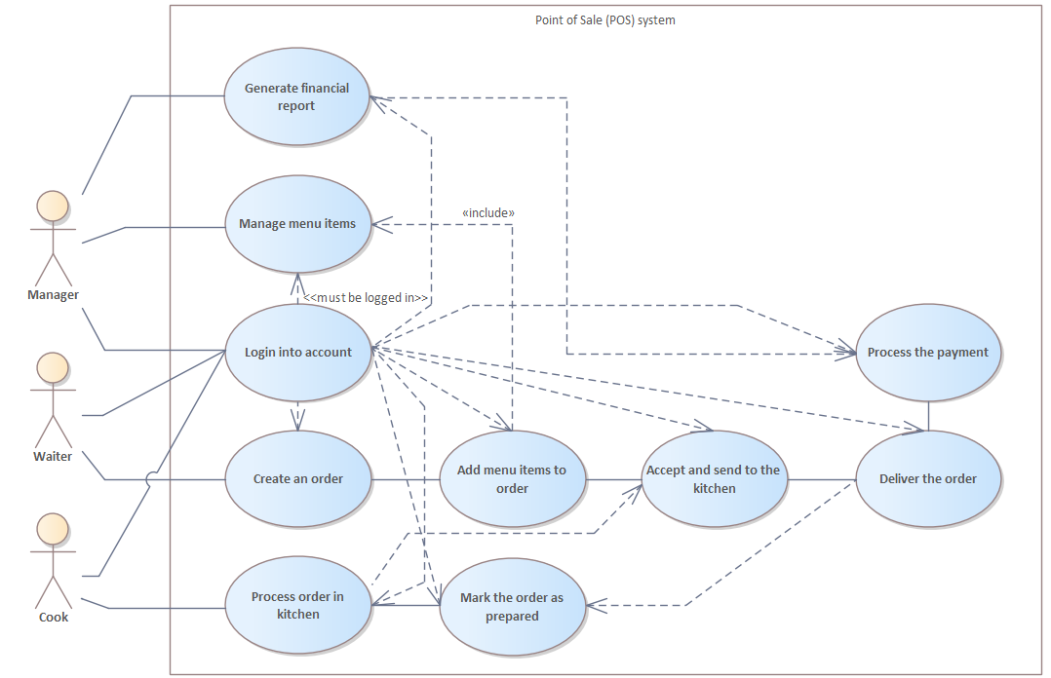
The POS System supports the main operational tasks of the restaurant by connecting the actions of the Manager, Waiter, and Cook. Each actor interacts with the system through specific functionalities that help manage orders, menu items, reports, and food preparation.
- The Manager oversees menu management, reviews archived orders, and generates reports.
- The Waiter creates and manages customer orders, processes payments, and completes delivery steps.
- The Cook receives orders, prepares items, and marks them ready for pickup.
The system ensures smooth communication between all actors, accurate order processing, and efficient workflow inside the restaurant.
1. Manager Use Cases
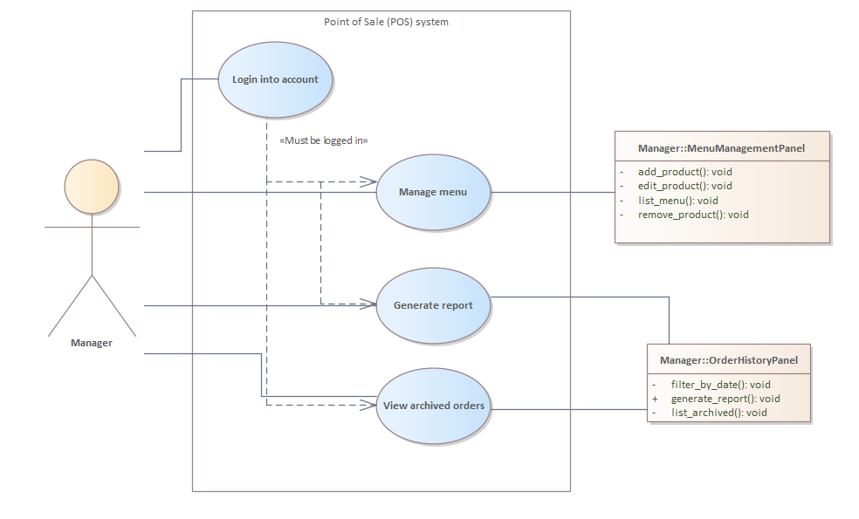
1.1 Login into Account
Manager logs into the POS system using credentials.
- Manager opens POS system.
- Enters username and password.
- System verifies credentials.
- System grants access.
Precondition: Manager must be logged in to perform operations below.
1.2 Manage Menu Items
Manager manages menu items by adding, editing, listing, or removing products.
- Manager opens Menu Management panel.
- Selects an action: add, edit, remove, or view items.
- System displays the corresponding form.
- Manager updates menu details.
- System stores changes.
1.3 Generate Report
Manager generates a sales or financial report from archived orders.
- Manager selects 'Generate Report'.
- System filters orders (by date if needed).
- System calculates totals and statistics.
- Report is displayed and available for export.
1.4 View Archived Orders
Manager reviews previously completed orders.
- Manager selects 'View Archived Orders'.
- System retrieves list of archived orders.
- Manager browses order history.
2. Waiter Use Cases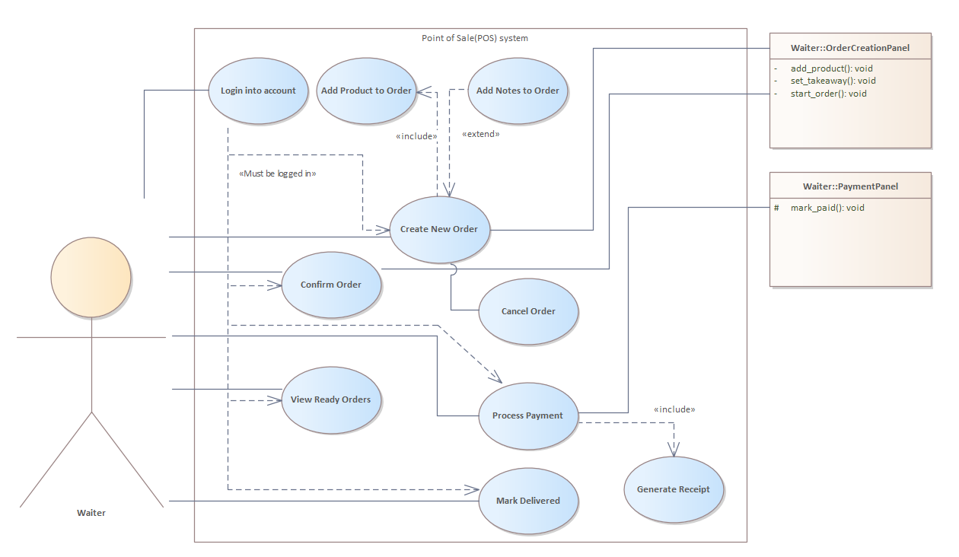
2.1 Login into Account
Waiter logs into the POS system.
- Waiter opens POS system.
- Enters valid credentials.
- System grants access.
Precondition: Waiter must be logged in to perform operations below.
2.2 Create New Order
Waiter creates a new customer order.
- Waiter selects 'Create New Order'.
- Waiter adds products to the order.
- Waiter adds optional notes.
- Waiter saves the order.
2.3 Add Product to Order
Waiter selects menu items to add to the order.
- Waiter browses menu.
- Selects product.
- Quantity is set.
- Product added to order list.
2.4 Add Notes to Order
Waiter adds notes or instructions to the order.
- Waiter enters note text.
- System attaches note to order.
2.5 Confirm Order
Waiter submits order to kitchen.
- Waiter reviews the order.
- Confirms and sends it to kitchen.
- System updates status to 'Pending in Kitchen'.
2.6 Cancel Order
Waiter cancels an order before it is processed.
- Waiter selects cancellation option.
- System verifies order status.
- Order marked as cancelled.
2.7 View Ready Orders
Waiter views orders marked as ready by cook.
- Waiter opens 'Ready Orders'.
- System displays prepared orders.
2.8 Process Payment
Waiter processes customer payment.
- Waiter opens payment screen.
- Waiter selects payment type.
- Customer pays.
- System processes payment.
2.9 Mark Delivered
Waiter marks the completed and paid order as delivered.
- Waiter selects 'Mark Delivered'.
- System updates order status to 'Delivered'.
2.10 Generate Receipt
System generates receipt for completed payment.
- System builds receipt from order data.
- Receipt displayed and optionally printed.

3. Cook Use Cases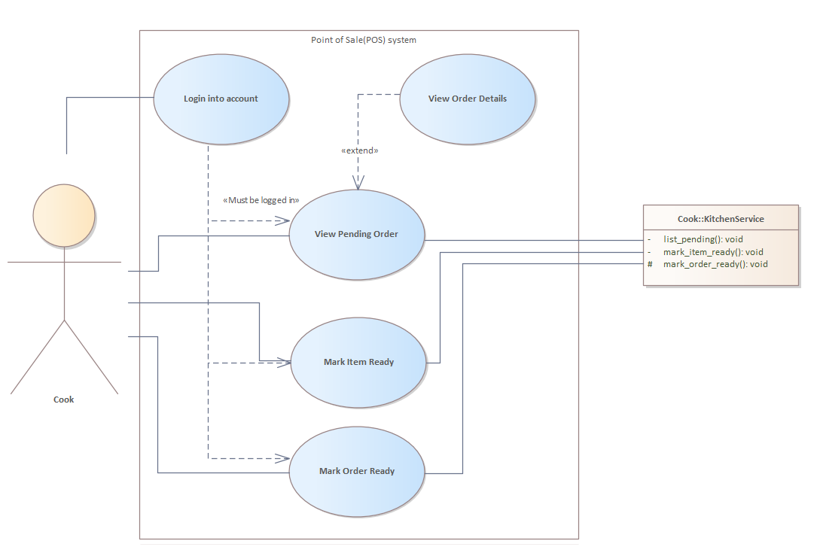
3.1 Login into Account
Cook logs into the kitchen interface.
- Cook opens system.
- Enters credentials.
- System grants access.
Precondition: Cook must be logged in to perform operations below.
3.2 View Pending Order
Cook views orders sent from waiters.
- Cook opens 'Pending Orders'.
- System retrieves all active orders.
- Cook selects an order to view details.

3.3 View Order Details
Cook checks specific order details such as items and notes.
- Cook selects an order.
- System displays items, notes, and quantities.
3.4 Mark Item Ready
Cook marks individual items in the order as ready.
- Cook selects item.
- Marks item ready.
- System updates item status.
3.5 Mark Order Ready
Cook marks entire order ready for pickup.
- Cook ensures all items are ready.
- Selects 'Mark Order Ready'.
- System notifies waiter.

STRUCTURE MODELLING

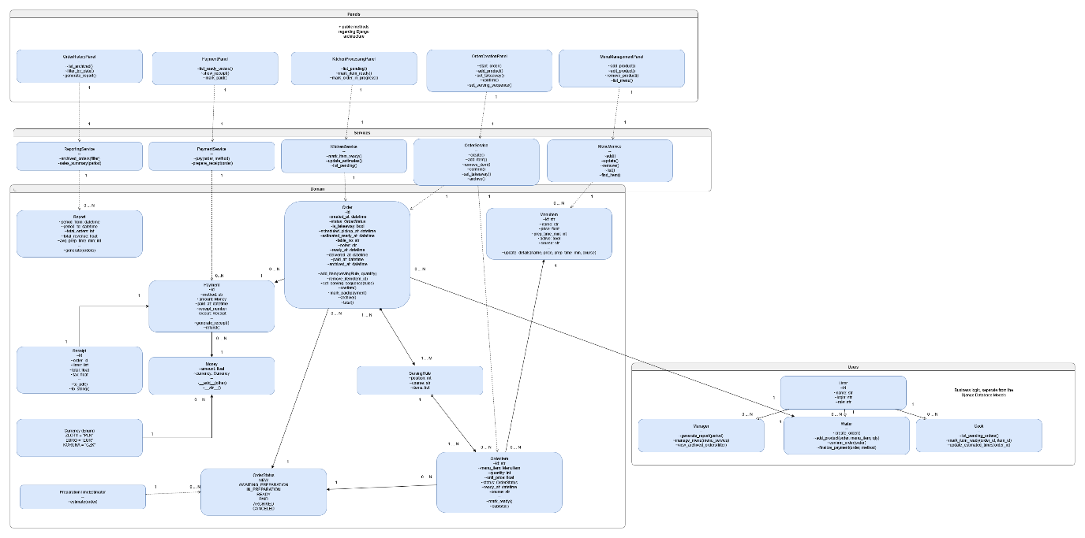
Figure 1 – Class diagram (not including Django based architecture)
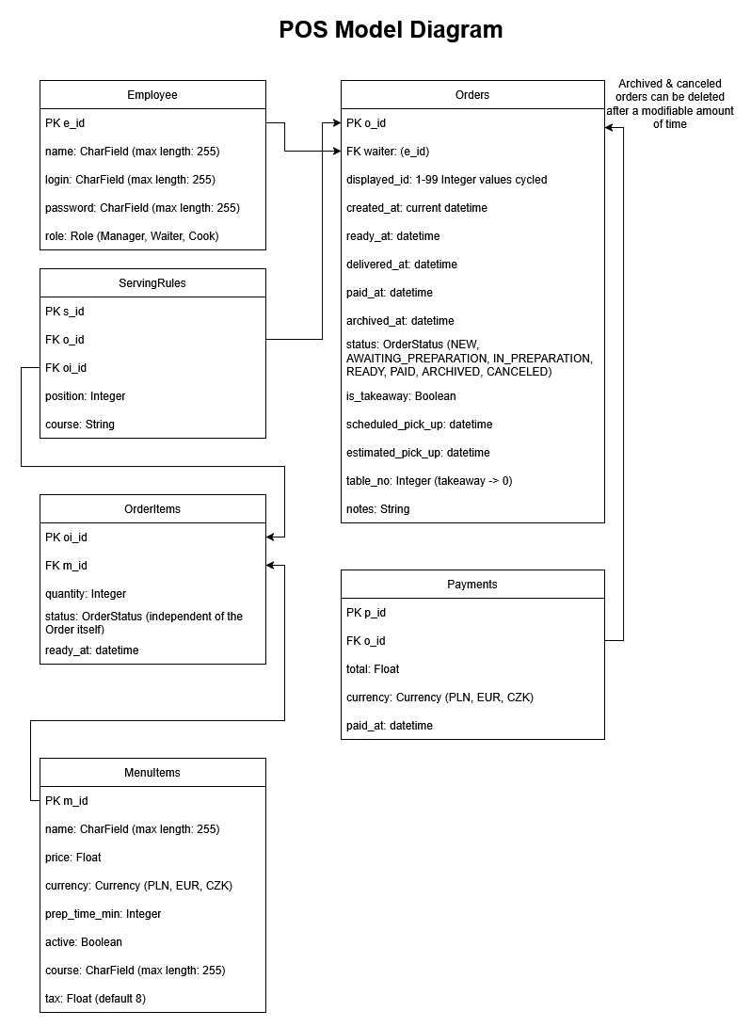
Figure 2 – Model (Database) diagram
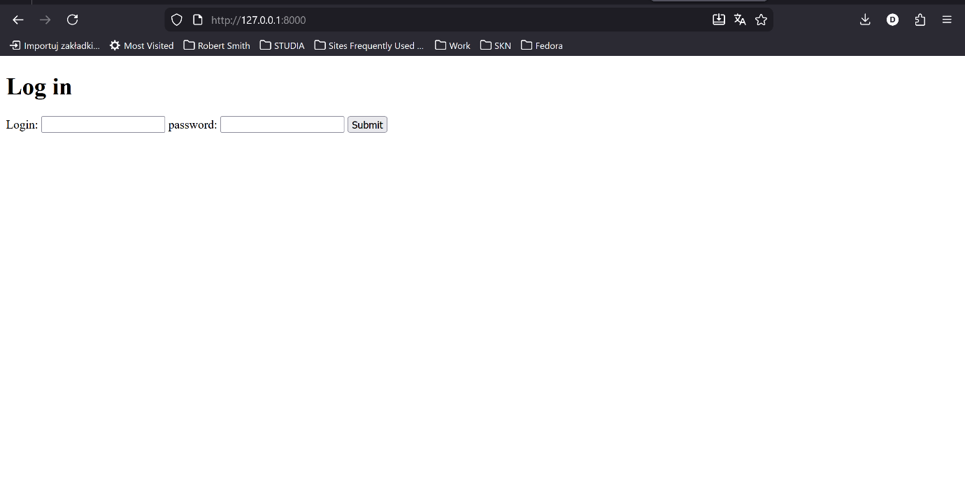
PROTOTYPE #1
Figure 1 – Log in screen

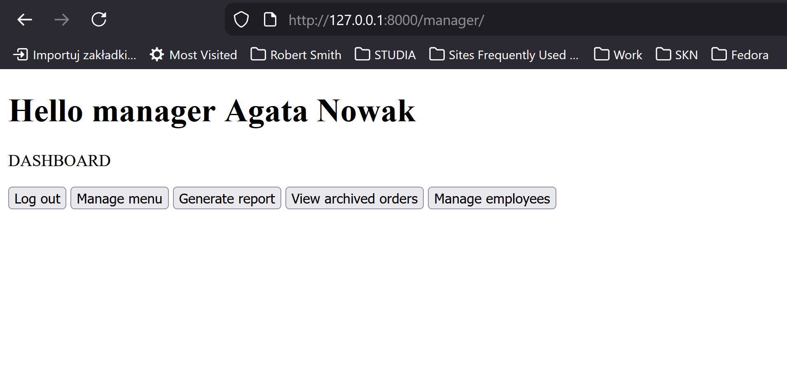

Figure 2 – Manager Dashboard

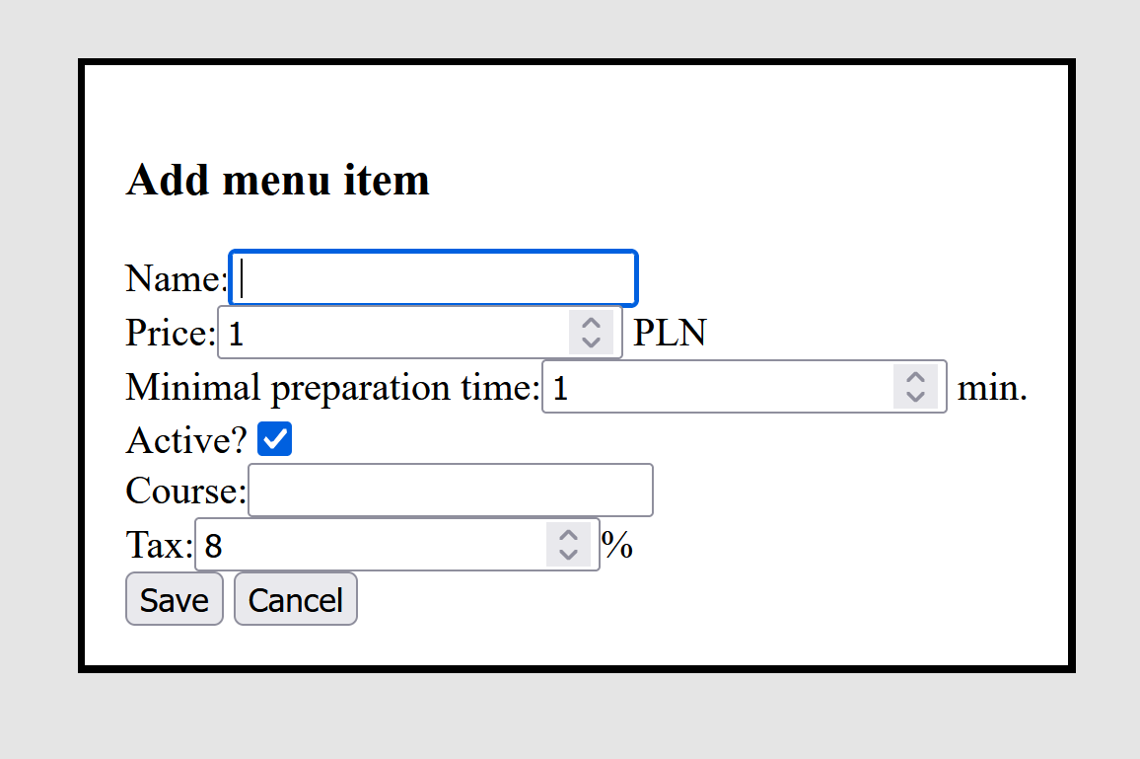
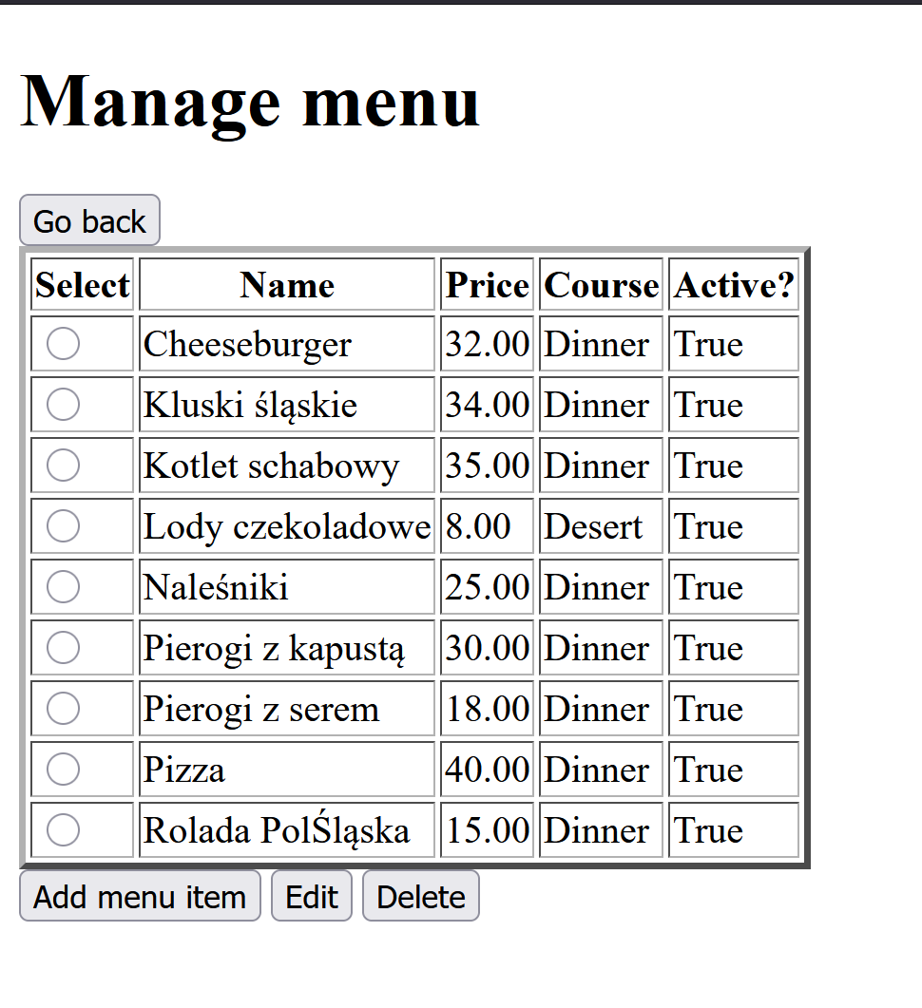
Figure 3 – Manage Menu subsite for the manager

Figure 4: Add new menu item window.
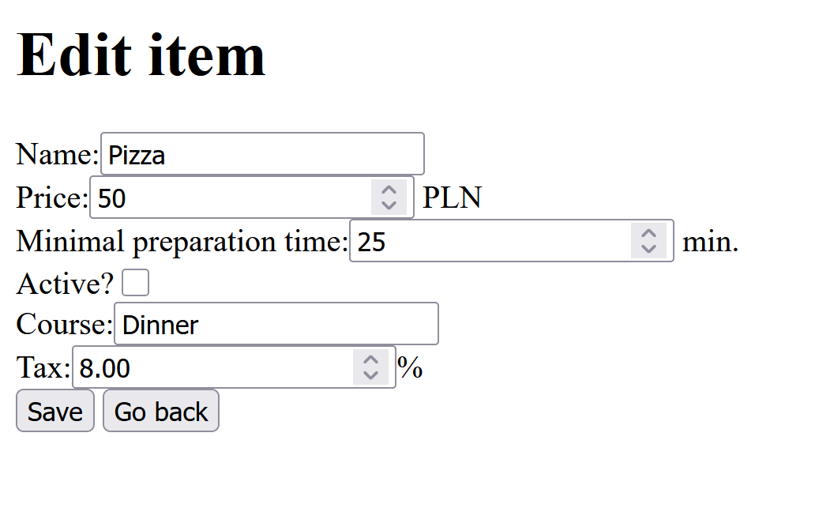
Figure 5 – Edit menu item subsite for manager.
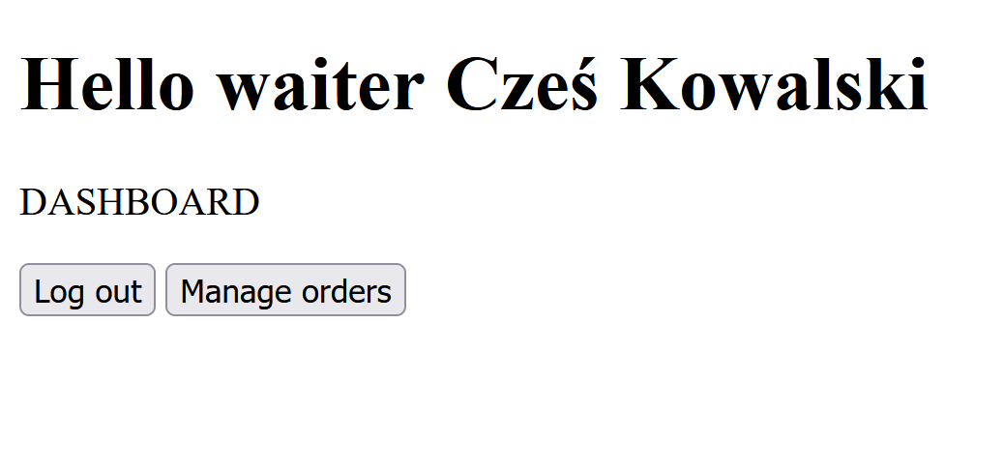
Figure 6: Waiter dashboard

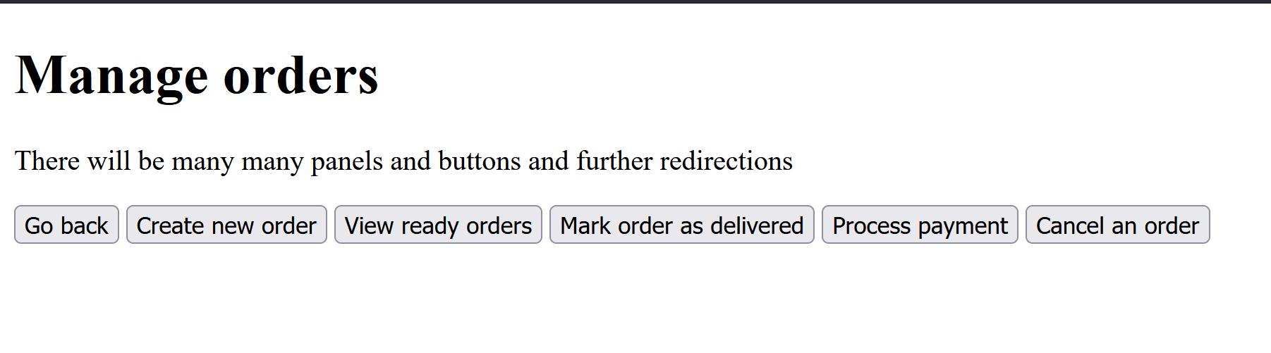
Figure 7: Manage orders subsite for waiter.

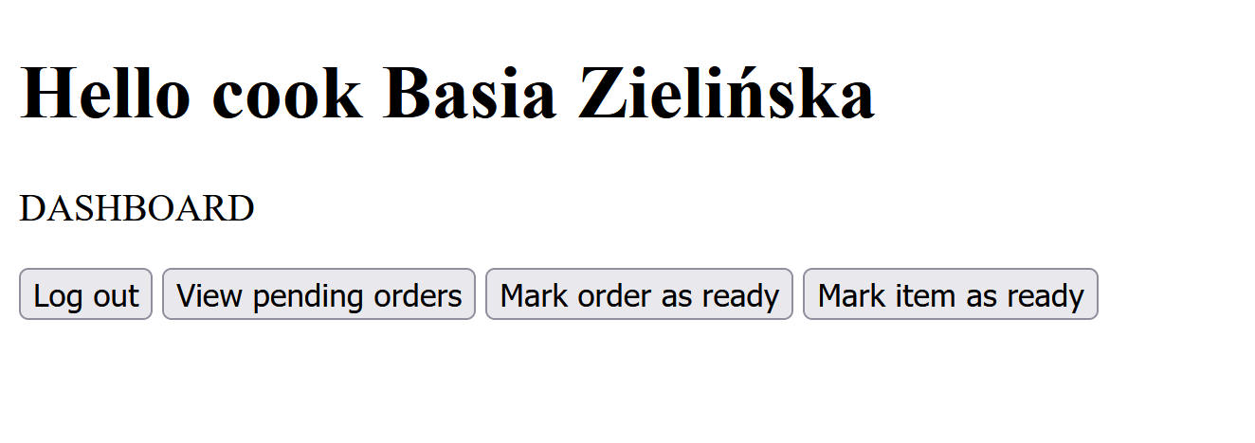

Figure 8: Cook dashboard.

