Point of Sale (POS) System – Use Case Documentation

Introduction
This document provides an overview of the Point of Sale (POS) system and its main functional interactions. The system supports three key roles—Manager, Waiter, and Cook—each performing specific tasks within the restaurant workflow. The use case diagrams illustrate how these actors interact with the system to manage menu items, create and process orders, prepare meals, and handle payments. The descriptions that follow define each use case, outlining the responsibilities, flows, and expected outcomes to ensure a clear understanding of the system’s behavior and operations.

General Use Cases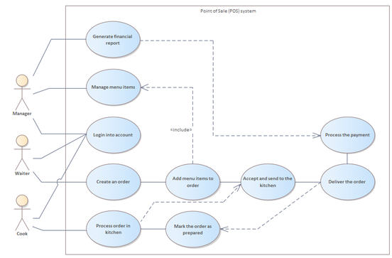
The POS System supports the main operational tasks of the restaurant by connecting the actions of the Manager, Waiter, and Cook. Each actor interacts with the system through specific functionalities that help manage orders, menu items, reports, and food preparation.
- The Manager oversees menu management, reviews archived orders, and generates reports.
- The Waiter creates and manages customer orders, processes payments, and completes delivery steps.
- The Cook receives orders, prepares items, and marks them ready for pickup.
The system ensures smooth communication between all actors, accurate order processing, and efficient workflow inside the restaurant.

1. Manager Use Cases

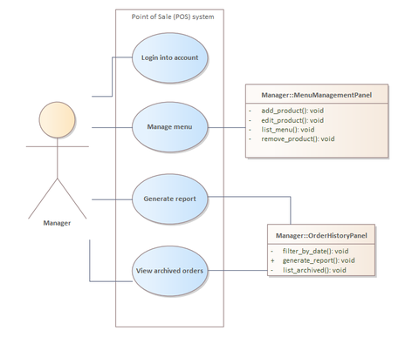

1.1 Login into Account
Manager logs into the POS system using credentials.
- Manager opens POS system.
- Enters username and password.
- System verifies credentials.
- System grants access.

1.2 Manage Menu Items
Manager manages menu items by adding, editing, listing, or removing products.
- Manager opens Menu Management panel.
- Selects an action: add, edit, remove, or view items.
- System displays the corresponding form.
- Manager updates menu details.
- System stores changes.

1.3 Generate Report
Manager generates a sales or financial report from archived orders.
- Manager selects 'Generate Report'.
- System filters orders (by date if needed).
- System calculates totals and statistics.
- Report is displayed and available for export.

1.4 View Archived Orders
Manager reviews previously completed orders.
- Manager selects 'View Archived Orders'.
- System retrieves list of archived orders.
- Manager browses order history.

2. Waiter Use Cases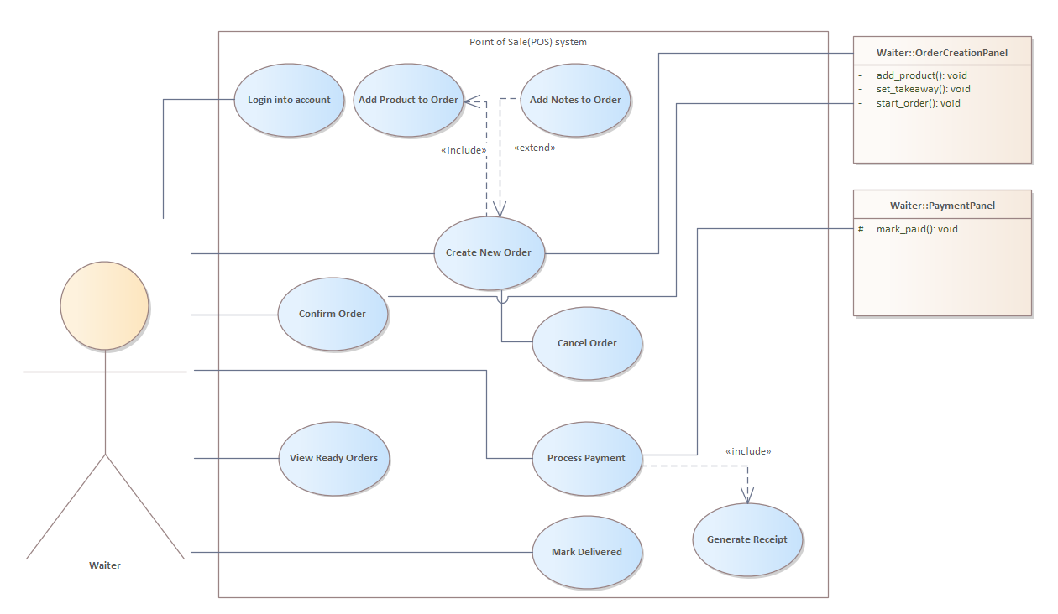

2.1 Login into Account
Waiter logs into the POS system.
- Waiter opens POS system.
- Enters valid credentials.
- System grants access.

2.2 Create New Order
Waiter creates a new customer order.
- Waiter selects 'Create New Order'.
- Waiter adds products to the order.
- Waiter adds optional notes.
- Waiter saves the order.

2.3 Add Product to Order
Waiter selects menu items to add to the order.
- Waiter browses menu.
- Selects product.
- Quantity is set.
- Product added to order list.

2.4 Add Notes to Order
Waiter adds notes or instructions to the order.
- Waiter enters note text.
- System attaches note to order.

2.5 Confirm Order
Waiter submits order to kitchen.
- Waiter reviews the order.
- Confirms and sends it to kitchen.
- System updates status to 'Pending in Kitchen'.

2.6 Cancel Order
Waiter cancels an order before it is processed.
- Waiter selects cancellation option.
- System verifies order status.
- Order marked as cancelled.

2.7 View Ready Orders
Waiter views orders marked as ready by cook.
- Waiter opens 'Ready Orders'.
- System displays prepared orders.

2.8 Process Payment
Waiter processes customer payment.
- Waiter opens payment screen.
- Waiter selects payment type.
- Customer pays.
- System processes payment.

2.9 Mark Delivered
Waiter marks the completed and paid order as delivered.
- Waiter selects 'Mark Delivered'.
- System updates order status to 'Delivered'.

2.10 Generate Receipt
System generates receipt for completed payment.
- System builds receipt from order data.
- Receipt displayed and optionally printed.

3. Cook Use Cases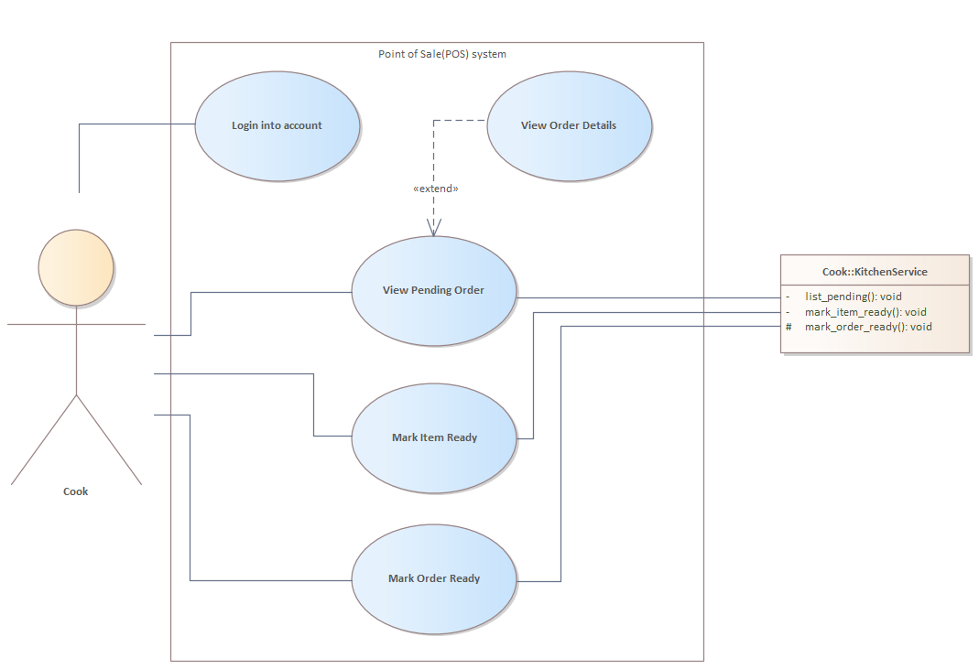

3.1 Login into Account
Cook logs into the kitchen interface.
- Cook opens system.
- Enters credentials.
- System grants access.

3.2 View Pending Order
Cook views orders sent from waiters.
- Cook opens 'Pending Orders'.
- System retrieves all active orders.
- Cook selects an order to view details.

3.3 View Order Details
Cook checks specific order details such as items and notes.
- Cook selects an order.
- System displays items, notes, and quantities.

3.4 Mark Item Ready
Cook marks individual items in the order as ready.
- Cook selects item.
- Marks item ready.
- System updates item status.

3.5 Mark Order Ready
Cook marks entire order ready for pickup.
- Cook ensures all items are ready.
- Selects 'Mark Order Ready'.
- System notifies waiter.

