Biologically Inspired Artificial Intelligence (BIAI)

Final Report

Project Topic:
Tennis

Section:
Iga_Świątek_Funclub

Section members:
Magdalena Rąpała
Miłosz Liniewiecki

Gliwice, 18.06.2026
Introduction
The scope of this project involved training a neural network to play an Atari game using a genetic algorithm. We selected the Atari Tennis game as our target environment. To implement and train the artificial player, we utilized the Arcade Learning Environment (ALE) framework and the PyGad library.
Problem Analysis
To successfully play tennis, the trained neural network must make real-time gameplay decisions based on incoming state data. We considered two distinct types of input representations for the network. The first approach relies on the general observation space provided by the ALE environment, which encompasses the raw pixel data of the game screen. The second approach involves directly accessing the game’s RAM to extract specific telemetry variables of interest.
The pixel-based approach would require a Convolutional Neural Network (CNN) optimized for image recognition rather than a simple multilayer perceptron. However, a CNN significantly increases the model's structural complexity and resource overhead, making it more challenging to train. Consequently, we opted for the RAM-based approach. We extract features such as the opponent's position, the player's position, the ball's position, and its velocity vector directly from the game memory. This provides the network with exact, low-dimensional coordinate values necessary for decision-making, bypassing the computational overhead of image classification.
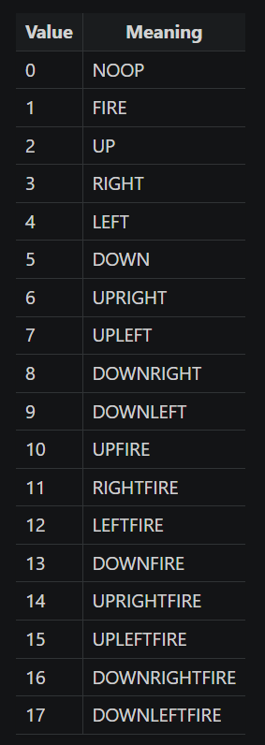
Figure 1 – Actions available to the player in the Tennis Environment. We’ve decided that the neural network will only learn to use the actions 1-9.

Neural Network
The agent evolved by the genetic algorithm is structured as a multilayer perceptron (MLP). The architecture features an input layer with 11 neurons, two hidden layers containing 32 and 16 neurons respectively, and an output layer with 10 neurons.
The 11 network inputs consist of:
- Opponent coordinates $\left(x,y\right)$
- Player coordinates $\left(x,y\right)$
- Opponent score and player score
- Ball coordinates $\left(x,y\right)$
- Ball velocity vector $\left(v_{x},v_{y}\right)$
- The absolute magnitude of the ball velocity vector $v_{b}$
To ensure stable signal propagation and variance throughout the layers during initialization, we applied Xavier initialization to set the network's weights. The final layer applies a softmax activation function to compute a probability distribution over the available actions, which are then mapped to the positional movements from Figure 1.
Genetic Algorithm
We employed the PyGad module to evolve the neural network populations, subsequently isolating the fittest individual for standalone performance testing. Genetic algorithms rely on a highly structured optimization pipeline that requires careful hyperparameter calibration. The configuration code block below highlights the setup used during our training trials.
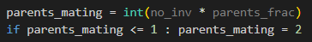
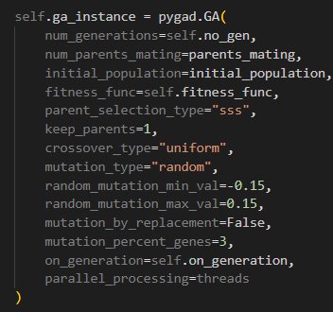
Figure 2 – Hyperparameter setup configuration utilized within our genetic algorithm implementation.
During development, we experimented with the mutation mechanics. Initially, uniform random replacements were applied to mutated genes, but this proved highly detrimental to the structural stability of the networks. Swapping up to 20% of all weights with completely random values disrupted learned behaviour too aggressively. To mitigate this, we shifted our strategy to limit the maximum perturbation amplitude around existing weight values, allowing the network to explore local variations without resetting its parameters entirely.
Fitness Function
The primary objective of the fitness function is to evaluate individual performance and produce a scalar score for selection and comparison. Higher fitness values signify superior performance. Because Atari Tennis features highly sparse reward signals—winning or losing full points happens too infrequently to drive early generations—we designed a multi-objective fitness function. This architecture tracks multiple baseline behaviours and combines their normalized metrics into an aggregate fitness scalar:
$$f= \sum_{i=0}^{N=3}{{n_{i}(o}_{i}}) \\ o_{i}∈\left[0, 1\right], f ∈[0, 3]$$
$o_{i}$ – raw value of a metric.
$n_{i}$ – normalization function of the i-th metric.
The behavioural metrics integrated into our evaluation include: the average Euclidean distance between the player and the ball ($o_{0}$), the average coordinate distance when the player fails to successfully return a shot ($o_{1}$), and the total accumulated match score ($o_{2}$). The specific mathematical expressions for these metrics and their normalization functions are summarized in Table 1.
Table 1- Mathematical formulations of fitness targets and their corresponding normalization functions.
Metric | Normalization function
$$o_{0}= \sqrt{{\left(x_{p}-y_{b}\right)}^{2}+{\left(y_{p}-y_{b}\right)}^{2}}$$ | $$n_{0}\left(x\right)=\frac{x}{DIAGONAL}$$
$$o_{1}=|x_{p}-x_{b}|$$ | $$n_{1}\left(x\right)=\frac{x}{WIDTH}$$
$$o_{2}=PLAYER_POINTS$$ | $$n_{2}\left(x\right)=\frac{x}{PLAYR_POINTS+ ENEMY_POINTS}$$

The complete sequence logic for the fitness evaluation is detailed in the pseudocode section below. Notably, our fitness function is progressive: initially, only the spatial proximity metric ($o_{0}$) is active. Additional optimization layers are systematically unlocked and included in the sum after specific generation milestones are met, guiding the network step-by-step toward advanced gameplay behaviors.
.Conclusions
During this project, we developed an optimization pipeline employing a genetic algorithm to train a multilayer perceptron designed to play the Atari Tennis environment. While the evolved agent did not achieve competitive gameplay and frequently exhibited static behaviour, the project provided critical technical insights into neuroevolutionary training loops, reward engineering, and hyperparameter sensitivity.
Several key engineering takeaways were observed during our experimental trials:
- Hyperparameter Sensitivity and Mutation Dynamics: We observed firsthand how the parameters of a genetic algorithm dictate structural convergence. Unconstrained randomness or excessively high mutation amplitudes (e.g., completely resetting $20\%$ of the network weights) disrupted previously discovered behavioral strategies, validating our decision to switch to localized weight perturbations.
- The Sparse Reward Bottleneck: Reinforcement learning environments like Atari Tennis present severe sparse-reward environments where meaningful game events (scoring or losing a point) happen too infrequently to provide a smooth gradient for early generations. This underscored the necessity of a engineered, progressive multi-objective fitness function to reward foundational behaviours like ball-tracking.

Bibliography
1. [Online] https://ale.farama.org/environments/tennis/.
2. PyGad. [Online] https://pygad.readthedocs.io/en/latest/.

