

Universidad de las Fuerzas Armadas ESPE

DEPARTMENT OF COMPUTER SCIENCE

Object-Oriented Programming

Edison Lascano PhD

NRC: 36862

MEMBERS: Enrique Ayala, Demian Armas, Isaac Acurio

- CsvReportTest
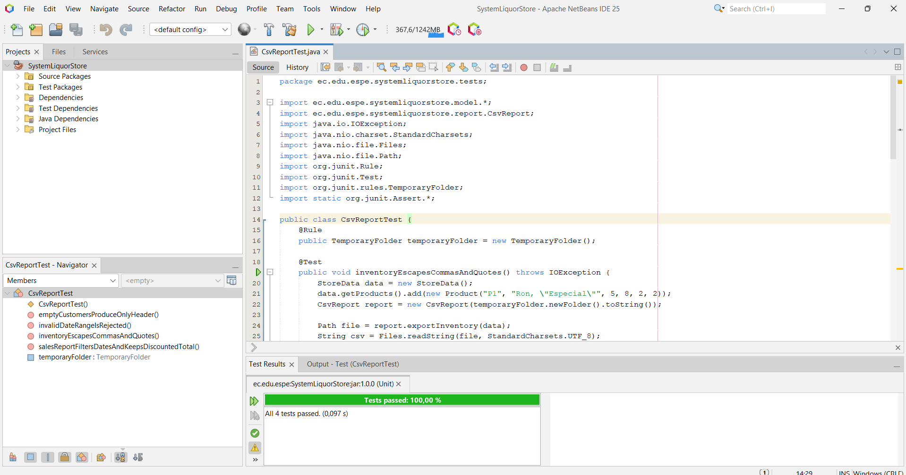
- JsonStageTest
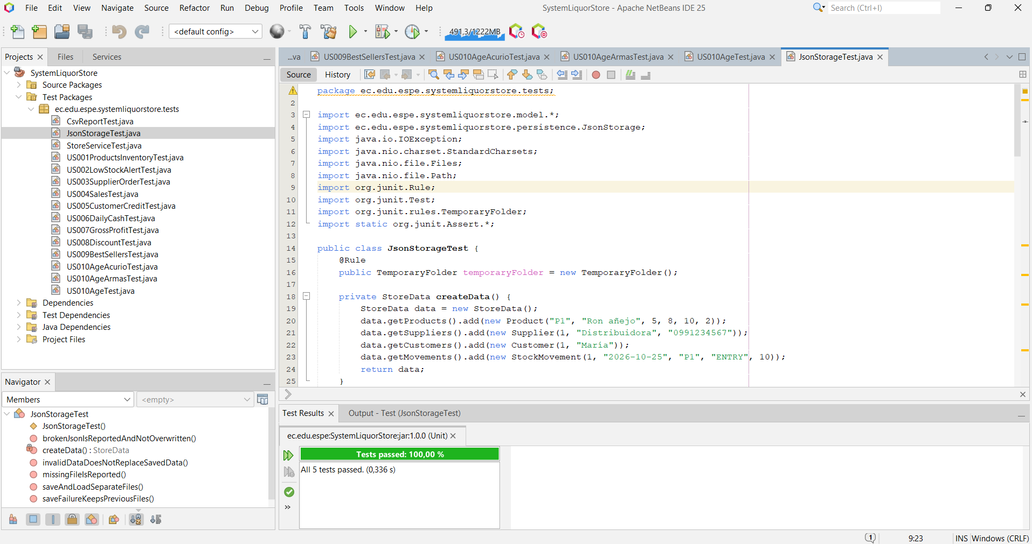- StoreServiceTest
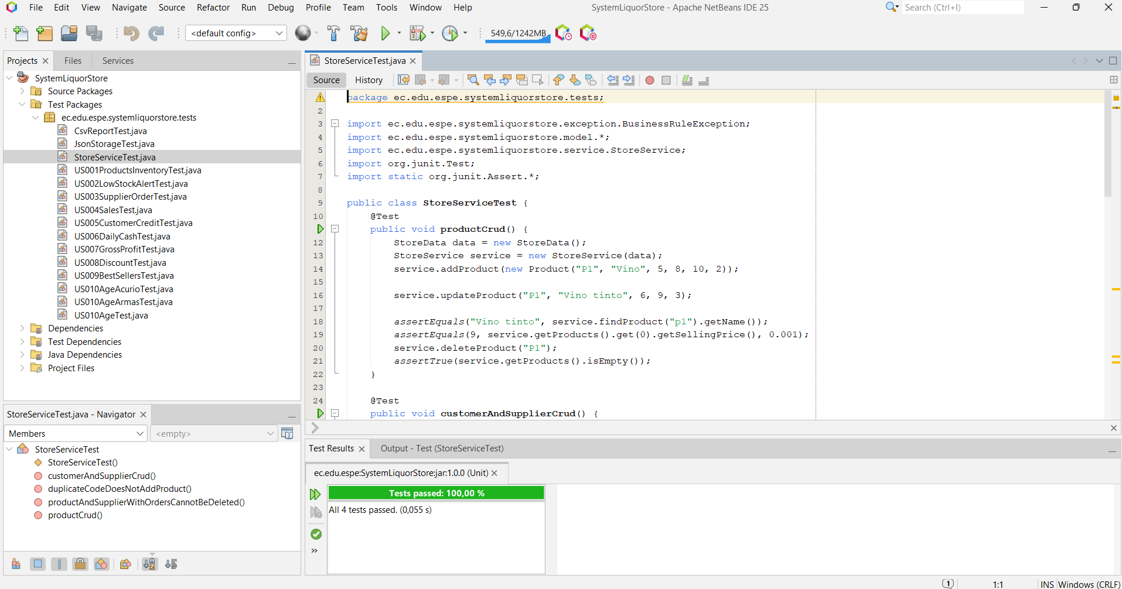
US001ProductsInventoryTest.java
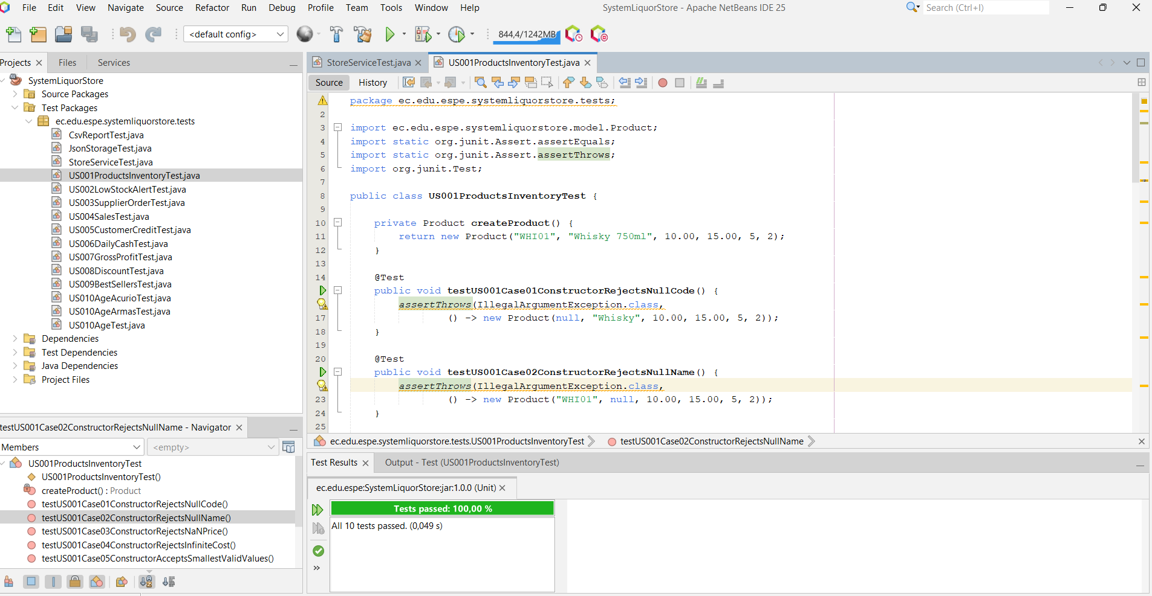
US002LowStockAlertTest.java
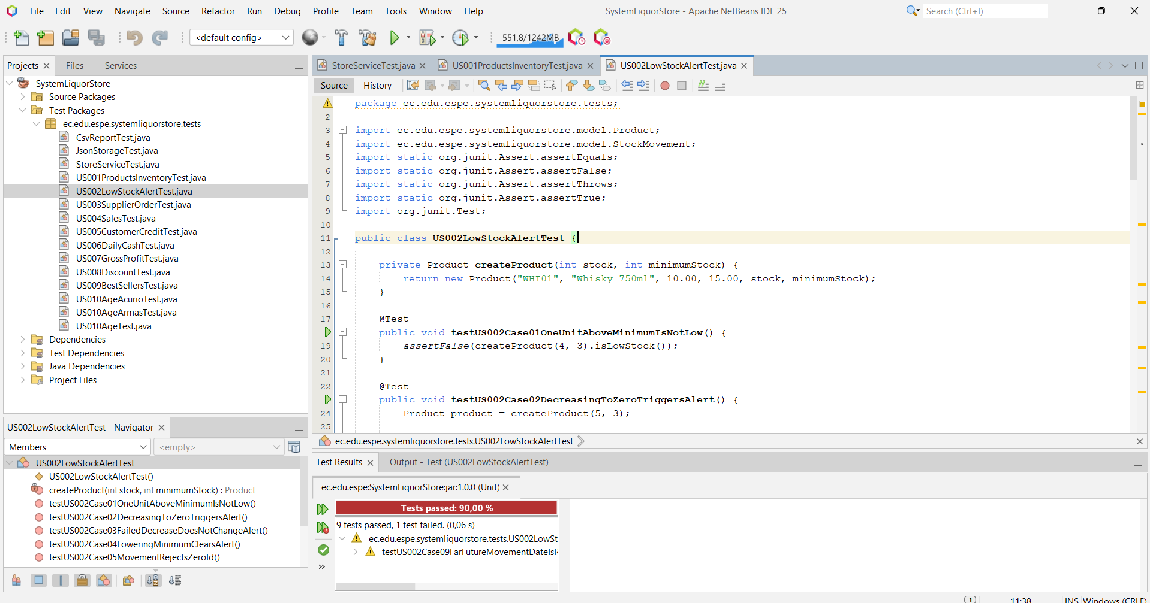
US003SupplierOrderTest.java
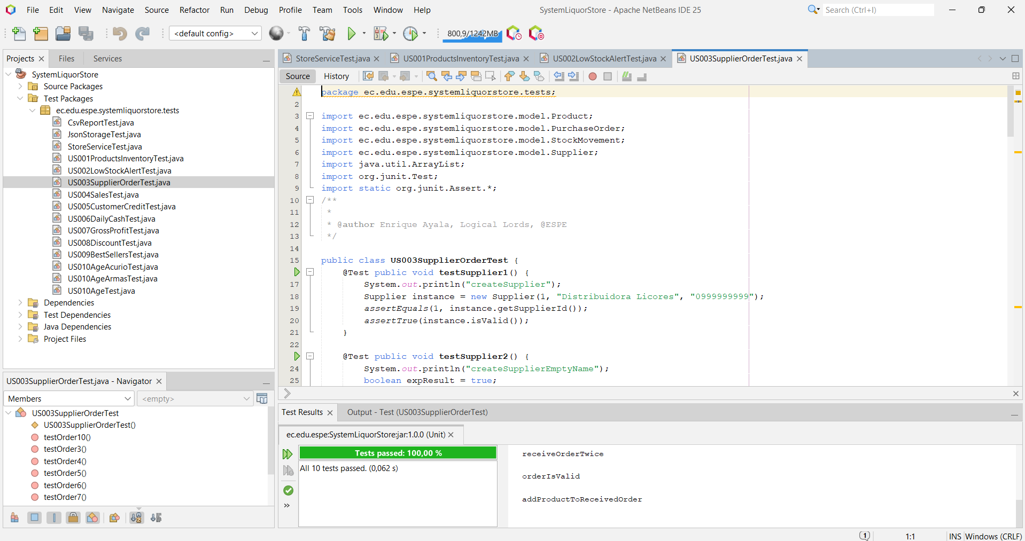
US004SalesTest.java
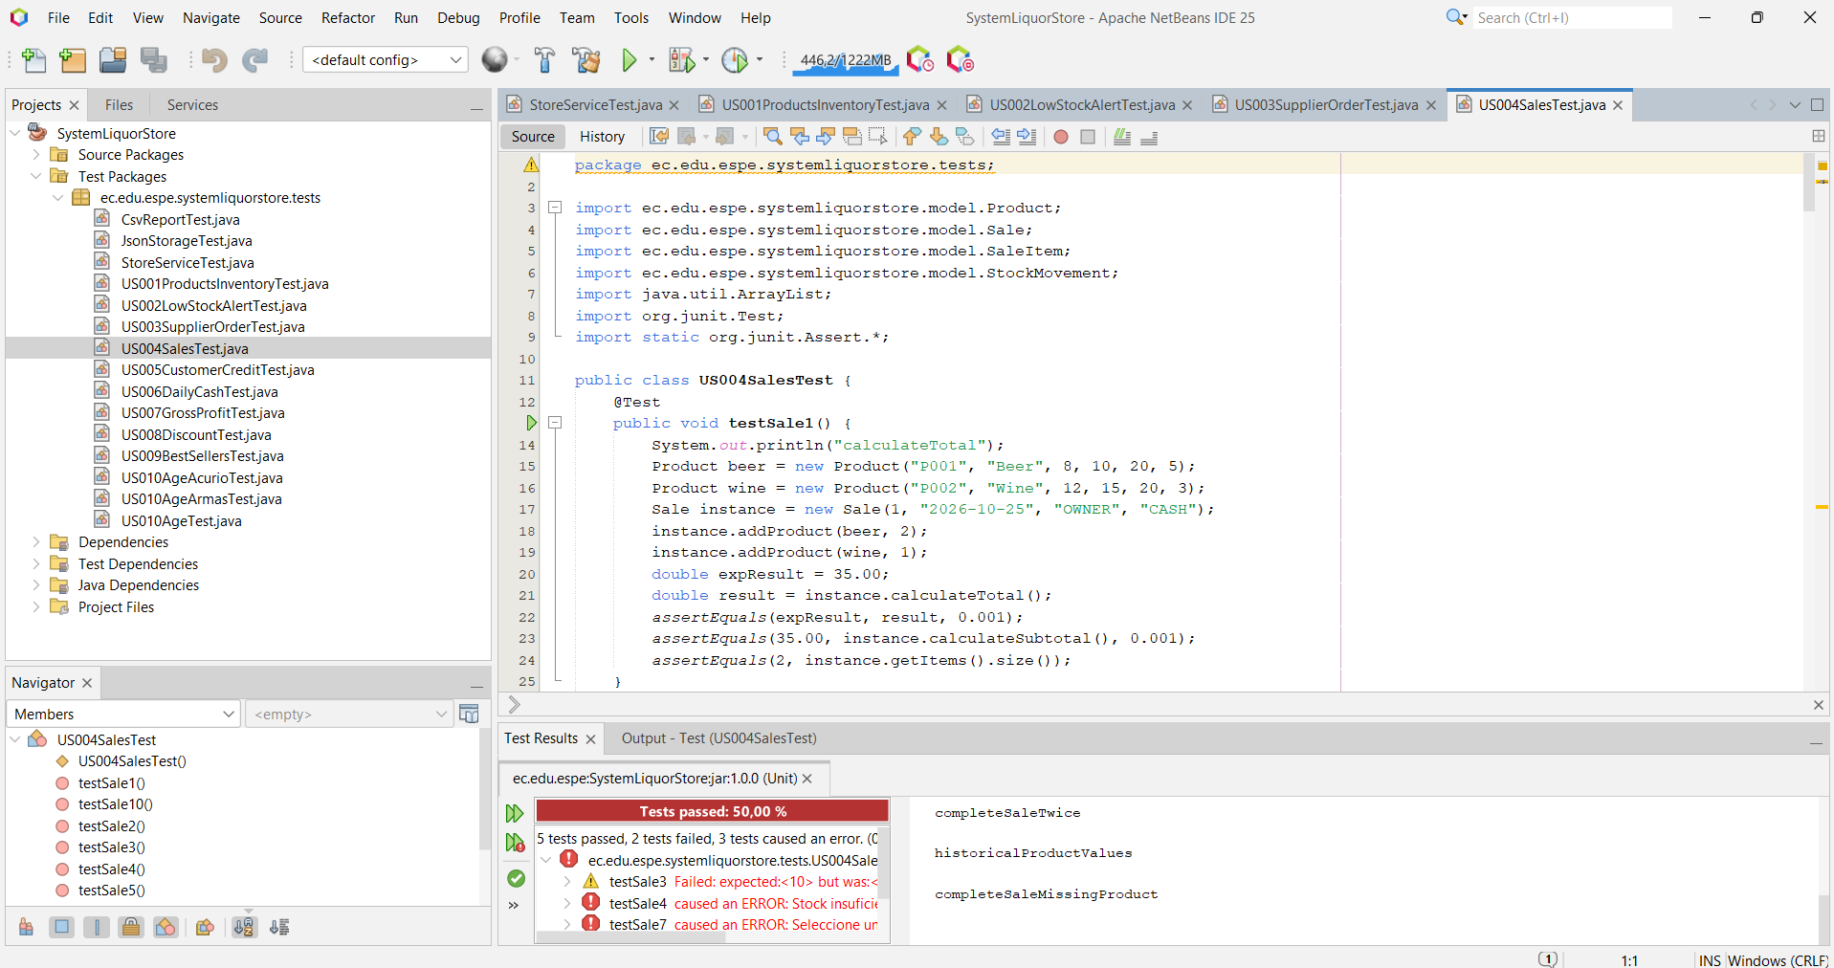
US005CustomerCreditTest.java
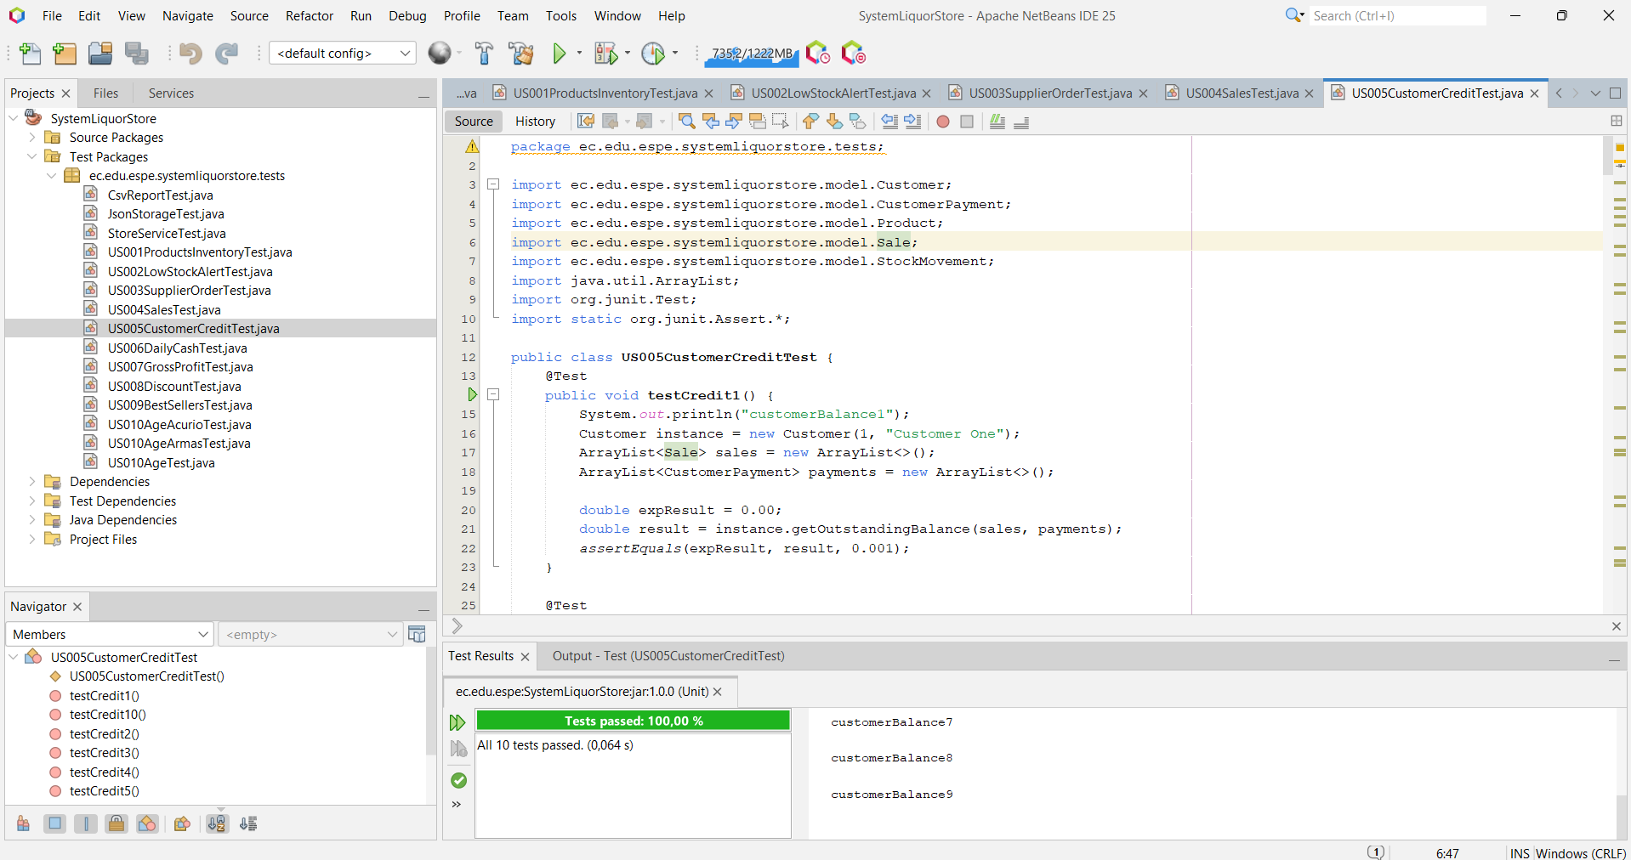
US006DailyCashTest.java
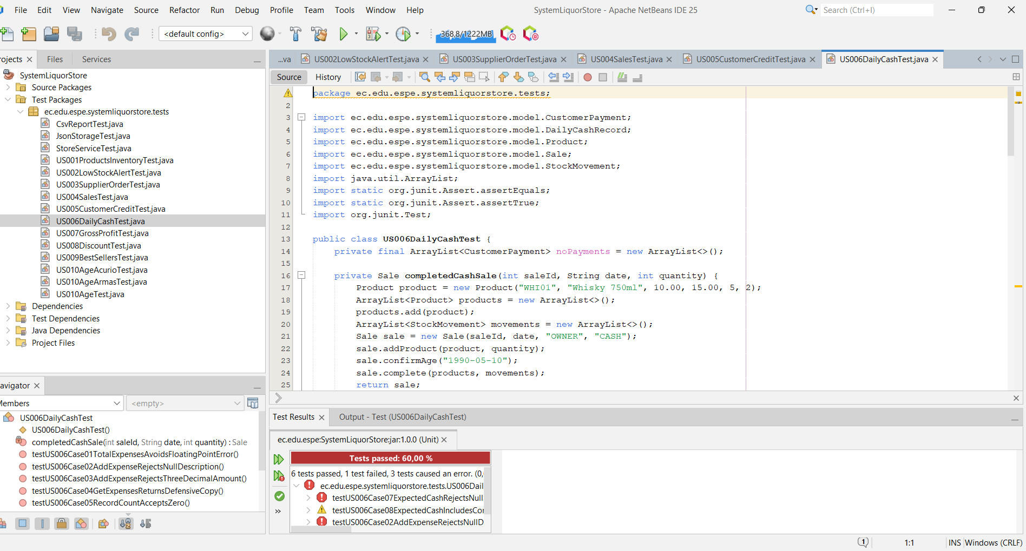
US007GrossProfitTest.java
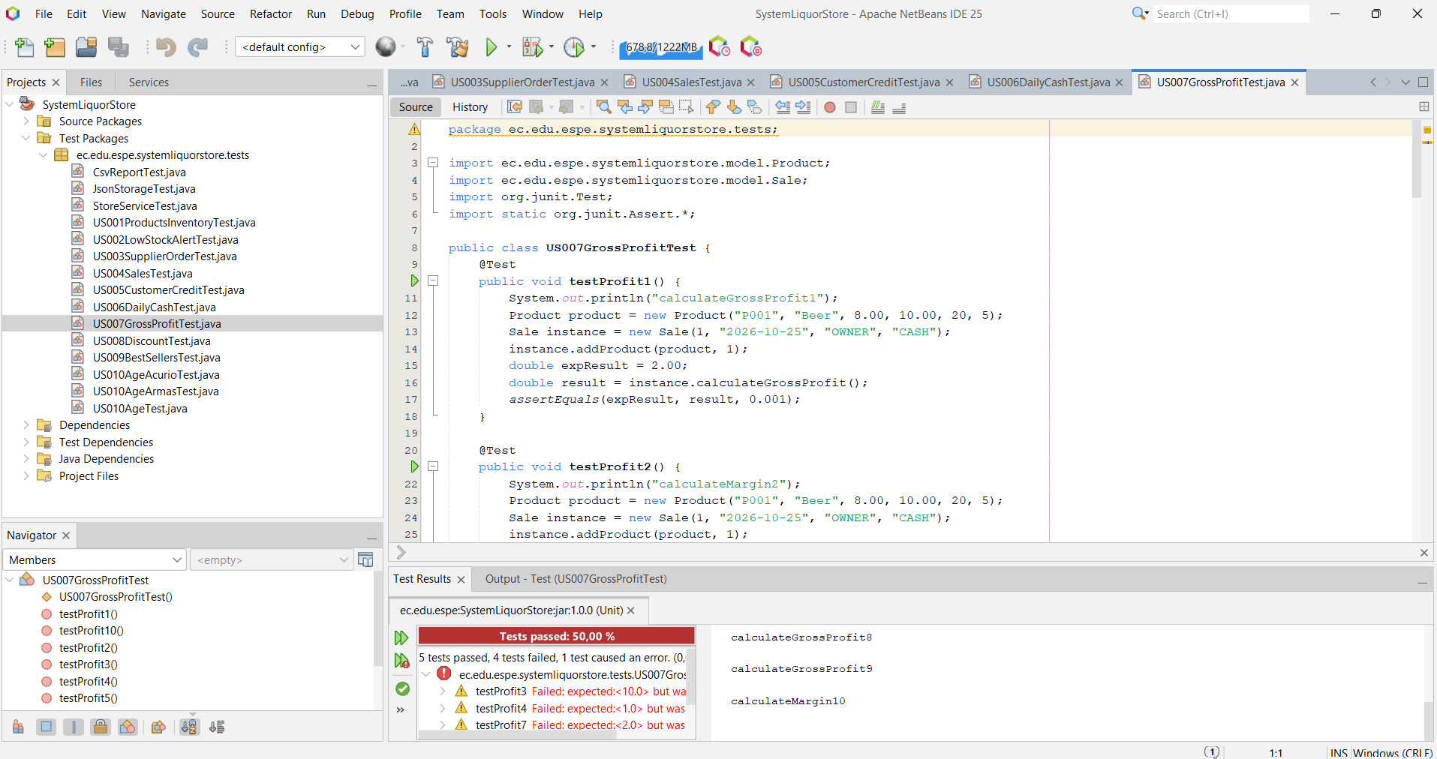
US008DiscountTest.java
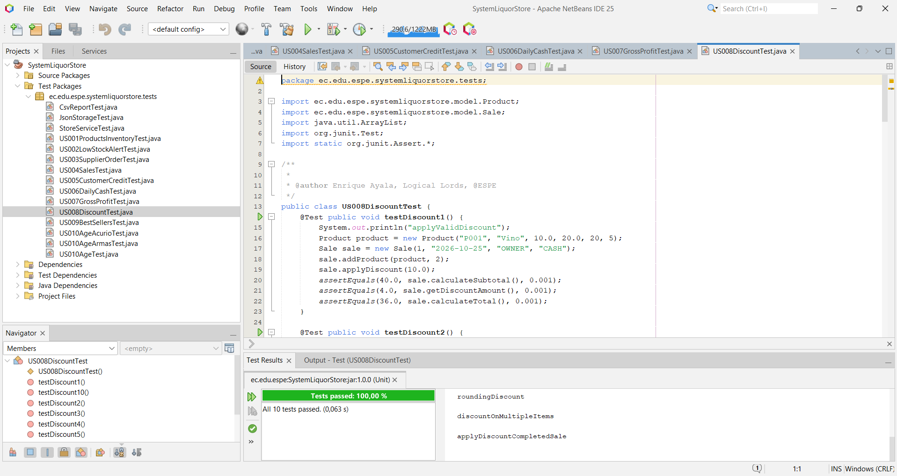
US009BestSellersTest.java
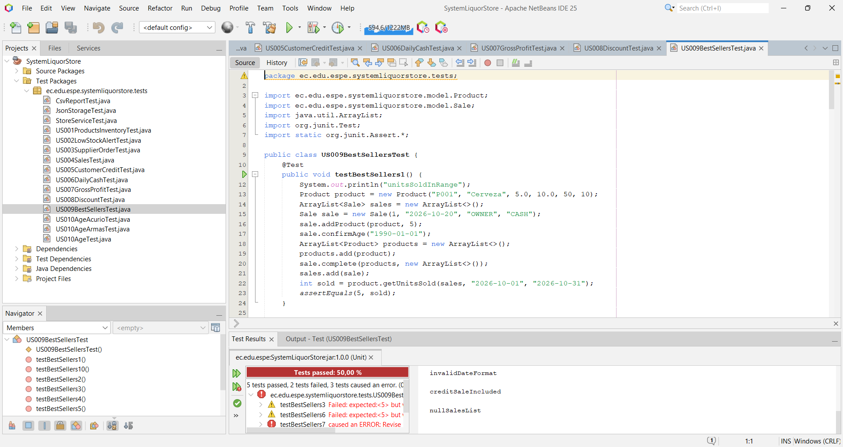
US010AgeAcurioTest.java
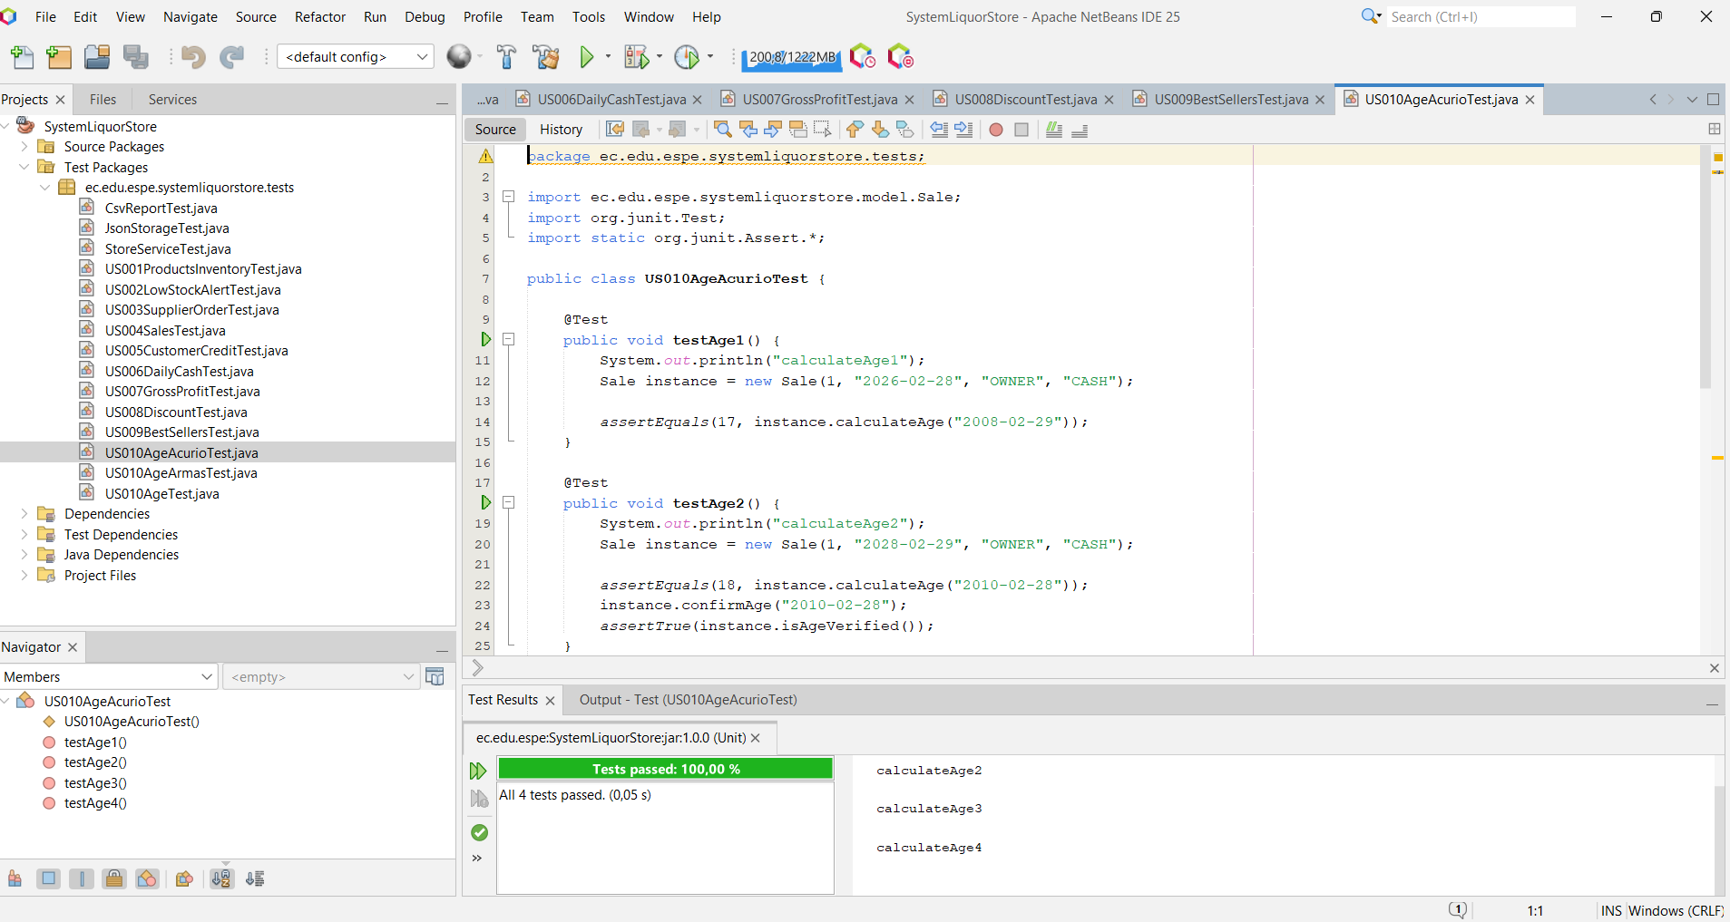
US010AgeArmasTest.java
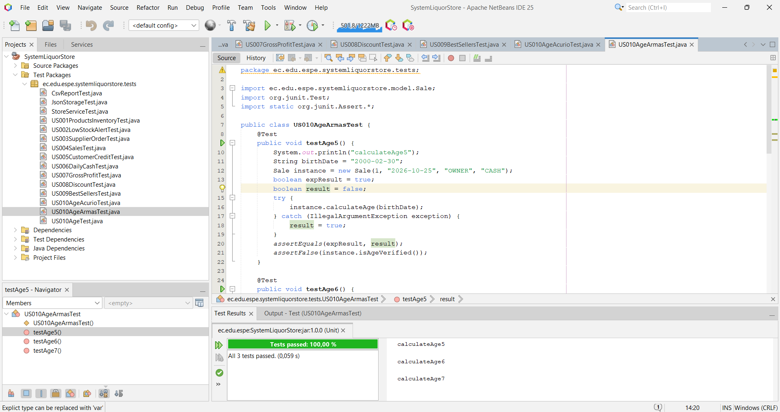
US010AgeTest.java
