Group 5

Author: Zhu WenXuan

Software Requirements

Elevator System

Table of Contents

System Objective 2

Domain Analysis 2

System Architecture 3

Use Cases 3

Software Requirements 4

R1: Outside UI 4

R2: Inside UI 4

R3: Processor 4

## System Objective

In this project, we are developing an elevator system that have fully functions of elevator. User can interact with the interface to request elevator to upstairs and downstairs to certain floor. User can ask for help from the inside of elevator.

## Domain Analysis

The participants of activities in this elevator system can be categorized into User, Elevator, the interface in the elevator and the interface out of elevator.

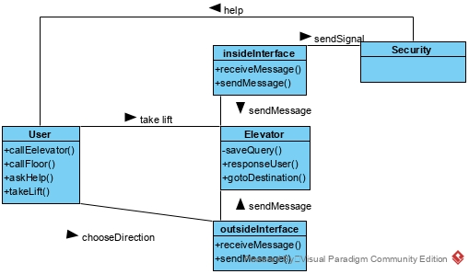

Here is the sequence of events for user normal request and get to certain floor :

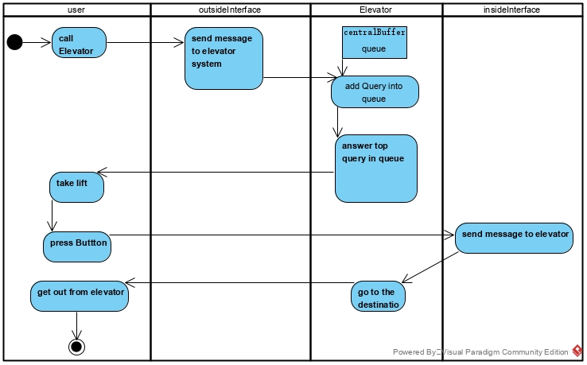

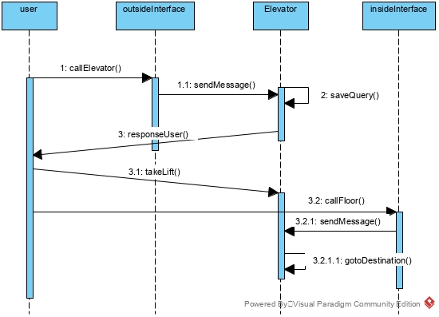

## System Architecture

From the information above, we will design a elevator system that allows user to take a lift safely with the elevator. This system contains two kind of interface and the main processor to deal with request from user.

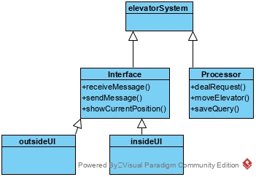

## Use Cases

The system can achieve the following use cases from the user’s perspectives:

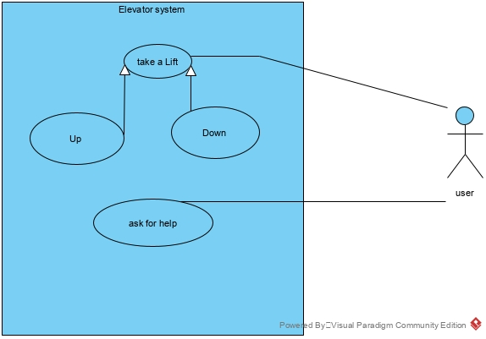

## Software Requirements

### R1: Outside UI

* R1.1: The user should be able to press the button to interact with elevator.
  + R1.1.1: The user should be able to call the elevator to go upstairs or downstairs.
* R1.2: The user should be able to see the current floor of elevator.

### R2: Inside UI

* R2.1: The user should be able to press the button to interact with the elevator.
  + R2.1.1: The user should be able to choose the floor.
  + R2.1.2: The user should be able to open the door of elevator manually.
  + R2.1.3: The user should be able to close the door of elevator manually.
  + R2.1.4: The user should be able to ask for help inside of elevator.
* R2.2: The user should be able to see the current floor of elevator.

### R3: Processor

* R3.1: The elevator should be able to sort the tasks.
* R3.2: The elevator should control the door
  + R3.2.1: The elevator should open the door automatically when reach the floor of user.
  + R3.2.2: The elevator should open the door automatically when reach destination of user.
  + R3.2.3:The elevator should close the door after a period of time.