Group 5

Author: Meng Yixuan

Software Requirements

Painkiller Injection System

Table of Contents

System Objective 2

Domain Analysis 2

System Architecture 4

Use Cases 5

Software Requirements 5

R1: PatientUI 6

R2: PysicianUI 6

R3: OperationProcessor 6

## System Objective

In this project, we are developing a software that can automatically control painkiller injection for patients who suffer from constant pain after surgery and would benefit from certain pain medicine. By providing interconnected interfaces to physicians and patients, the system allows professional physicians set injection limitations and monitor condition of patients.

## Domain Analysis

The Painkiller Injection System is an automatic medication with a computerized pump that safely deliver small amount of pain medicine into veins and permit patients to push a button for a larger injection.

The system set limits on total amount of painkiller injected per day and per hour, ensuring that total injection within a day does not surpass 3ml, and injection in an hour is no more than 1ml. Moreover, set injection baseline to be 0.01-0.1ml per minute, and a bolus to be 0.2-0.5ml per shot, above two intervals avoid extreme mis-inputs of physician. Specifically, the upper limits are related to weights of patients.

|  |  |  |
| --- | --- | --- |
| Children | | |
| Weights | Baseline | Bolus |
| 20kg | 0.01ml/min | 0.2ml |
| 30kg | 0.03ml/min | 0.25ml |
| 40kg | 0.05ml/min | 0.3ml |
| Adults | | |
| Weights | Baseline | Bolus |
| 50kg | 0.07ml/min | 0.4ml |
| 60kg | .0.08ml/min | 0.45ml |
| 70kg | 0.09ml/min | 0.5ml |
| 80kg | 0.1ml.min | 0.5ml |

Programmable parameters of the system that used for painkiller injection therapy are as follows:

|  |  |
| --- | --- |
| Daily Limit | Upper limit of injection amount per day |
| Hourly Limit | Upper limit of injection amount per hour |
| Baseline | Stable speed of painkiller injection |
| Bolus | A relatively larger shot of painkiller injected upon pressing button |

The participants of activities in the painkiller injection system can be categorized into physician and patient.

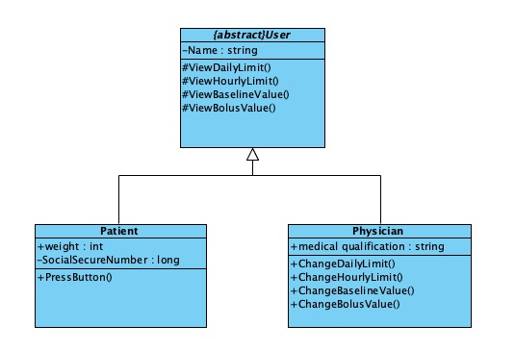

The relationships among different participants are shown as follows:

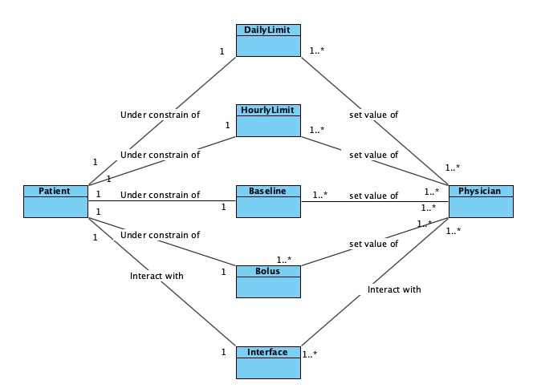

Here is a series of activities for injecting painkiller: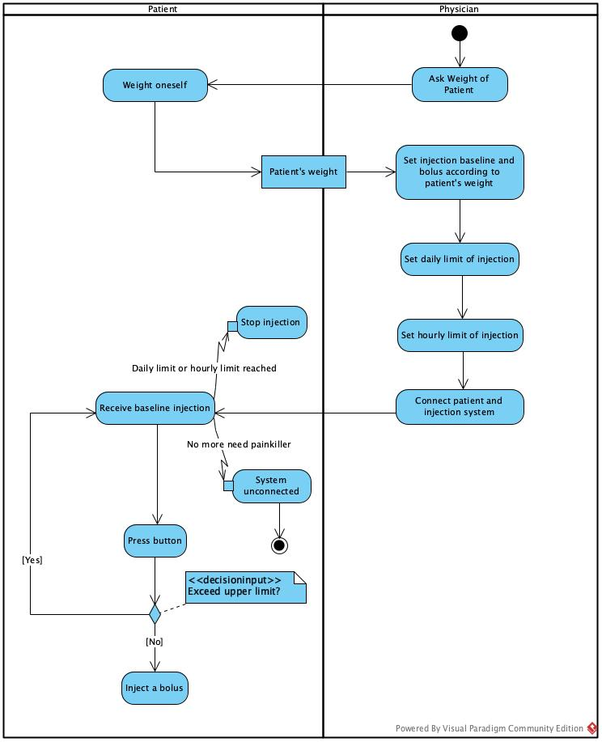

Here is a sequence of events for injecting painkiller.

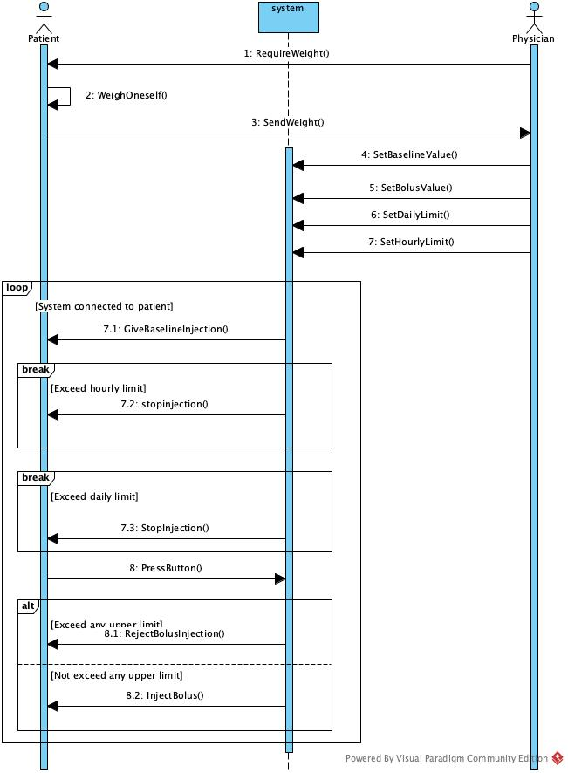

## System Architecture

From the information above, we will design a software system output injected amount over past 24 hours, display current amount of injected medicine from baseline and bolus. The patients should have access to a button that can give a bolus upon pressing. The physician, once whose identity has been validated, should have control over injection upper limits, baseline and bolus. The system architecture is shown below:

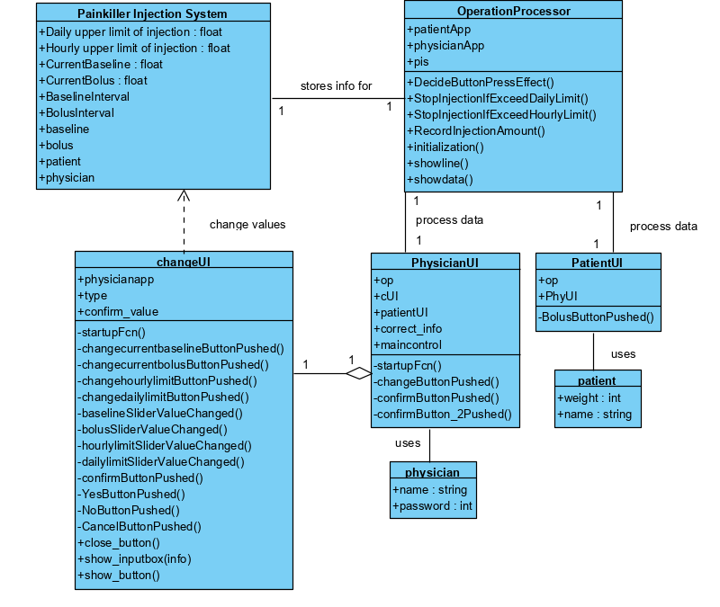

## Use Cases

The system can achieve the following use cases from the patient’s and the physician’s perspectives:

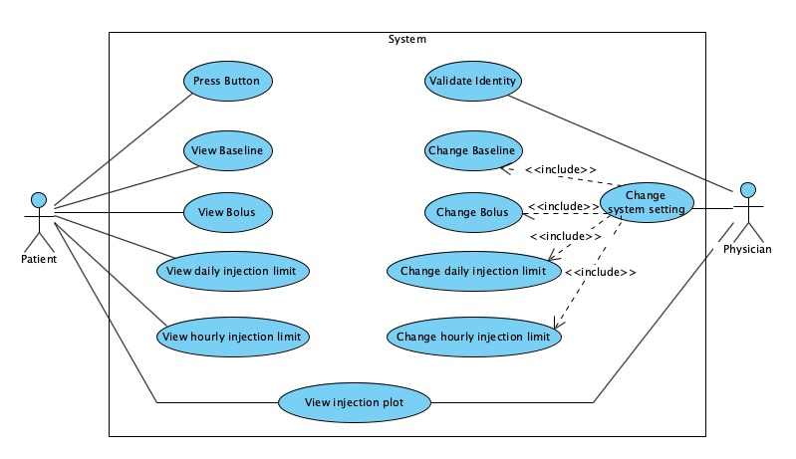

## Software Requirements

### R1: PatientUI

* R1.1: The patient should be able to ask for a bolus by pressing a button
  + R1.1.1: The patient should be able to get a bolus if one’s injection amount does not exceed daily limit or hourly limit.
* R1.2: The patient should be able to view current programmable parameters of the system on his UI
  + R1.2.1: The patient should be able to view current daily upper limit of injection
  + R1.2.2: The patient should be able to view current hourly upper limit of injection
  + R1.2.3: The patient should be able to view current baseline amount
  + R1.2.4: The patient should be able to view current bolus amount
  + R1.2.5: The patient should be able to view line plot of injection amount over past 24 hours.

### R2: PhysicianUI

* R2.1: The physician should be able to change programmable parameters of the system on his UI
  + R2.1.1: The physician should be able to change daily upper limit of injection
  + R2.1.2: The physician should be able to change hourly upper limit of injection
  + R2.1.3: The physician should be able to change baseline amount
  + R2.1.4: The physician should be able to change bolus amount
* R2.2 The physician should be able to view current programmable parameters of the system on his UI
  + R2.2.1: The physician should be able to view current daily upper limit of injection
  + R2.2.2: The physician should be able to view current hourly upper limit of injection
  + R2.2.3: The physician should be able to view current baseline amount
  + R2.2.4: The physician should be able to view current bolus amount
  + R2.2.5: The physician should be able to view line plot of injection amount over past 24 hours.
* R2.3: The physician should be able to validate one’s identity, proving that one has medical certification by inputting a username and password.

### R3: OperationProcessor

* R3.1: The processor should be able to decide whether to give bolus to the patient when button is pressed
* R3.2: The processor should be able to stop injection when injection amount exceed limit
  + R3.2.1: The processor should be able to stop injection when injection amount exceed daily upper limit.
  + R3.2.2: The processor should be able to stop injection when injection amount exceed hourly upper limit
* R3.3: The processor should be able to record injection amount over the past 24 hours for visualization.