Group 5

Author: 孟奕璇

Software Specifications

Elevators

Table of Contents

System Architecture 2

Software Specifications 2

S1: InsideUI implementation 2

S2: OutsideUI Implementation 4

## System Architecture

The system architecture is shown below:

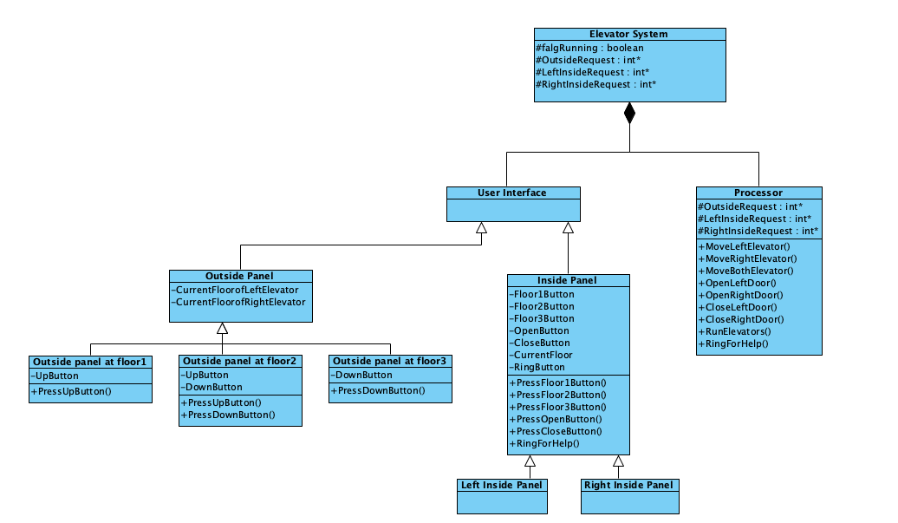

## Software Specifications

### S1: InsideUI implementation

### 

#### S1.1: Take elevator

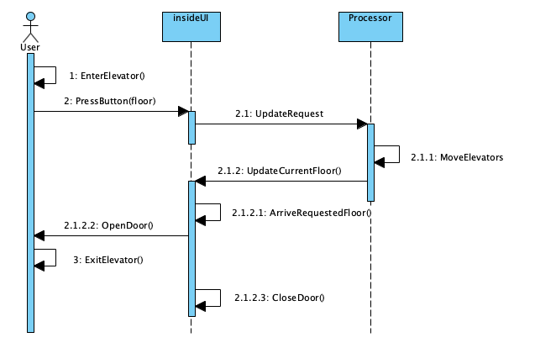

* S1.1.1: Go to another floor

1. Select floor button
2. For all selected floors
   1. If request to target floor is not already exist, update target floor flag from 0 to 1.
   2. If request already exist, let the flag remains 1.
3. Move the elevator to requested floor.
4. Open the door, then close the door after 5 seconds.

### S2: OutsideUI Implementation

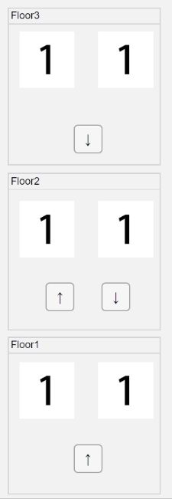

#### S2.1: Enter elevator

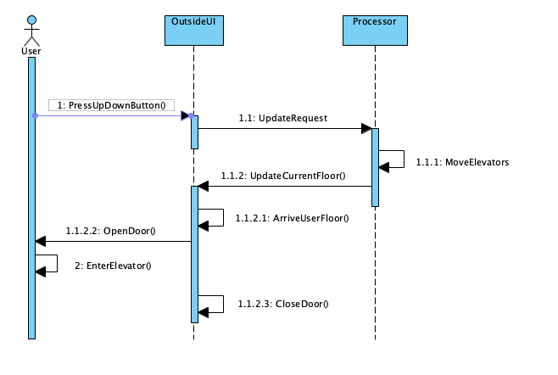

* S2.1.1: Go to another floor

1. Select direction button to go up or down.
2. For both elevators
   1. If any elevator is at the use’s floor, no need to move elevators.
   2. If neither elevator is at the user’s floor, get a free elevator to move to user’s floor.
3. Open the door to let the user in, then close the door after 5 seconds.