Group 5

Author: 龚嘉礼

Software Specifications

Painkiller Injection System

目录

System Architecture 2

Software Specifications 3

S1: Physician UI implementation 3

S1.1: Login 4

S1.2: change values 4

S2: Patient UI Implementation 7

S2.1: Bolus 7

S3: Processor implementation 7

S3.1:decideButtonPressEffect 7

S3.2: recordInjectionAmount 8

S3.3: stopInjection 8

S3.4:showline 8

# System Architecture

The system architecture is shown below:

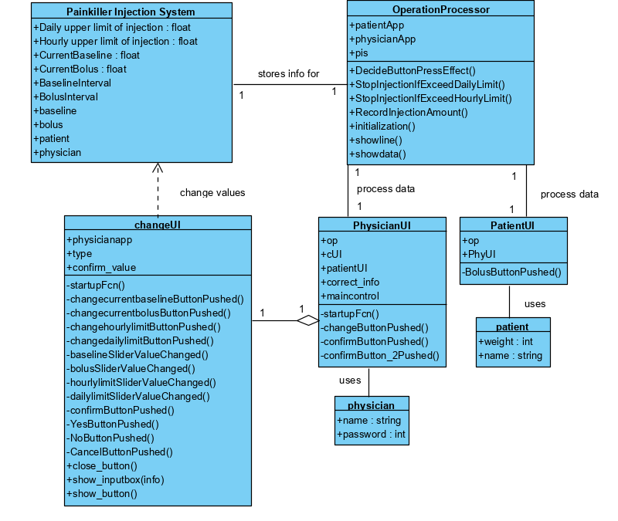

# Software Specifications

## S1: Physician UI implementation

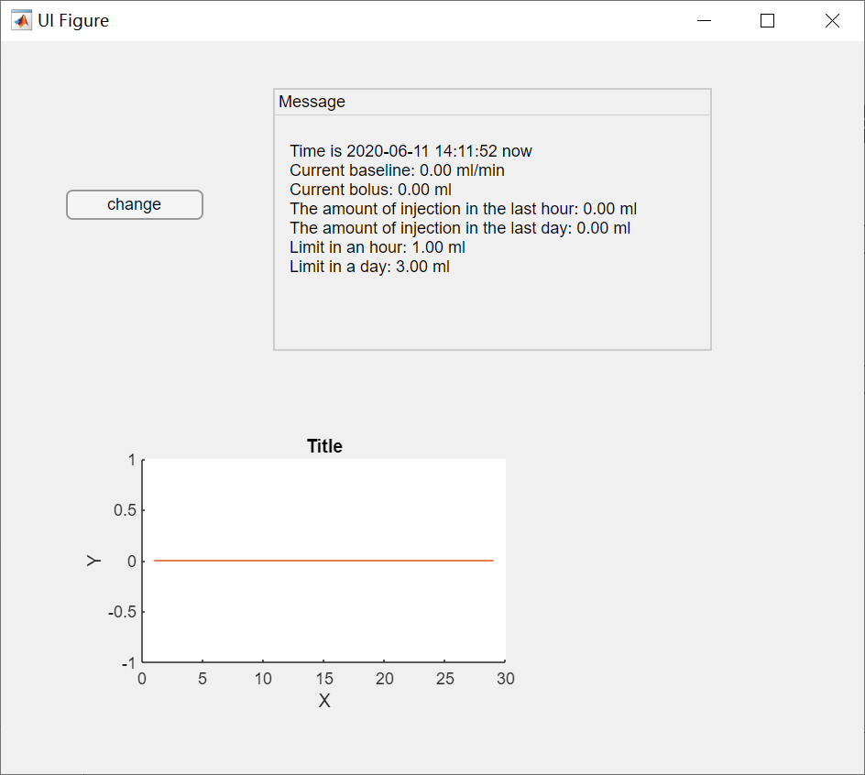

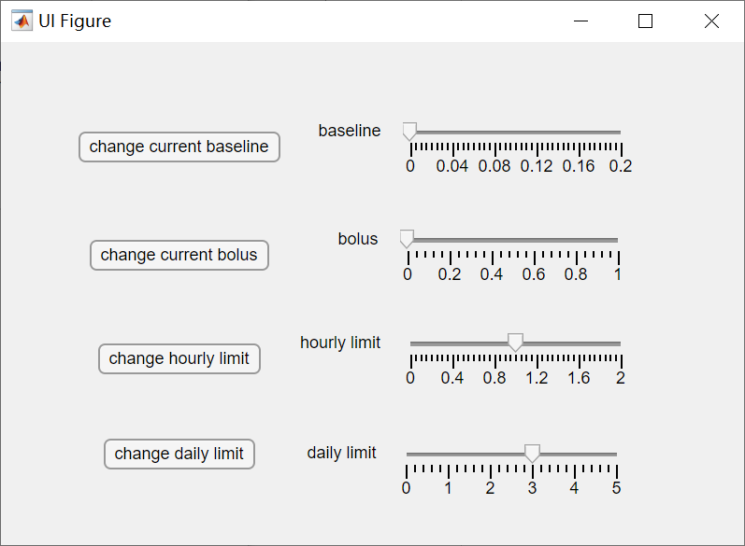

### S1.1: Login

#### 

#### S1.1.1: Login(startupFcn)

1. Input physician’s name and password.
2. Click ‘Confirm’ button.
3. Check if it is correct.
   1. Incorrect: give error and try again.
   2. Correct: go to next step, show next step’s interface.
4. Input patient’s weight and name.
5. Click ‘Confirm’ button(2).
6. Check if it is valid
   1. Invalid(name is empty or weight is not a valid number in 0~600kg): give error message and try again
   2. Valid: show the main interface of physician UI.

### S1.2: change values

The process for changing baseline value or bolus value. When Cancel button is pushed. The process should be terminated, so it’s a terminate message, but not clearly showed on the diagram. Changing limits is similar with changing baseline/ bolus, but there is no comparing with recommended up limit and no warning.

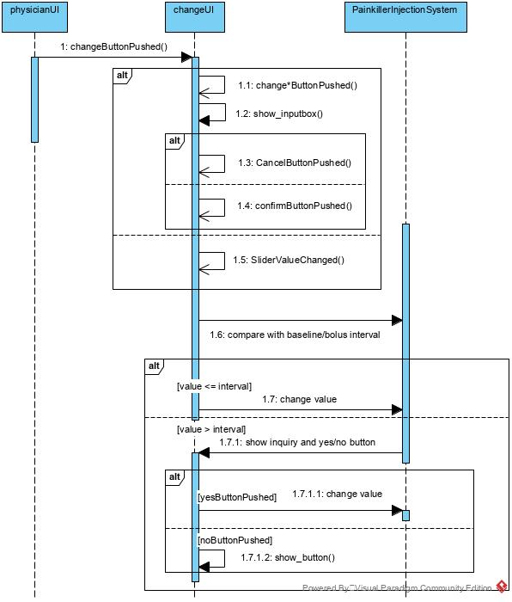

#### S1.2.1: Change baseline and bolus amount with slider

1. In change app, drag slider.
   1. If the value to be set is larger than the recommended limit(baseline/bolus interval), give a warning message, show yes/no button. Store change type and change value.
   2. If the value is not larger than the recommended limit ,change the value directly.

#### S1.2.2: Change limits with slider

Change the value directly.

#### S1.2.3: Change value with keyboard input

* Change * button pushed

1. Show input box & input value.
2. Store change type.

#### S1.2.4: Confirmation

* Confirm button pushed

1. If the value is not a valid number, give error message.
2. For bolus and baseline, if the value to be set is larger than the recommended limit(baseline interval), give a warning message, show yes/no button.
3. Otherwise, change the value directly. Change slider value. If the value exceeds the max value of the slider, set to its max value.

* Yes button pushed.

1. Change value.
2. Change slider for keyboard input changes.

* No/Cancel button pushed

Turn back to main interface.

## S2: Patient UI Implementation

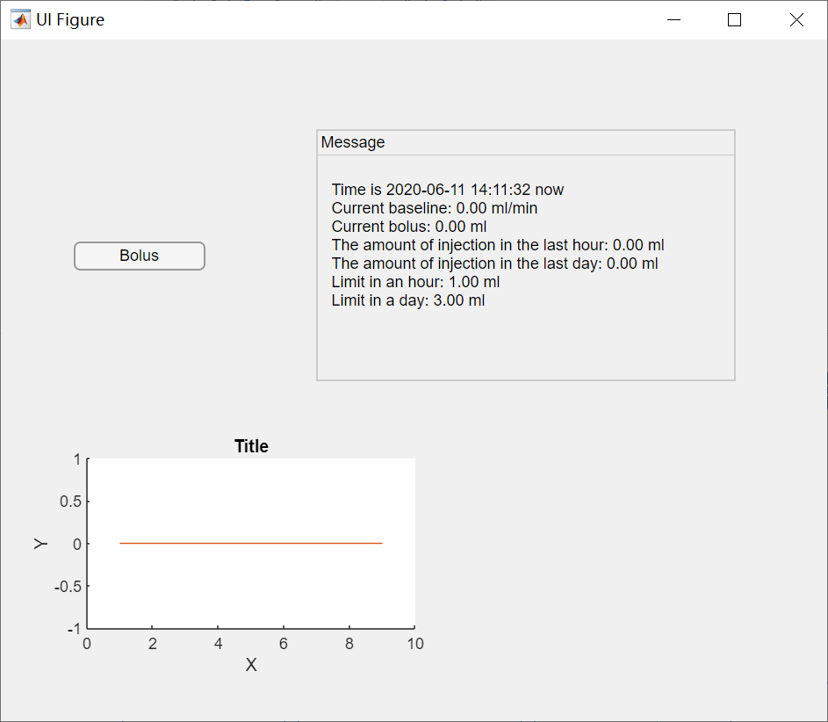

### S2.1: Bolus

If accepted by the processor, inject; otherwise, do nothing.

## S3: Processor implementation

#### S3.1:Initialization

1. Set all the amount to 0, except for intervals:

|  |  |  |
| --- | --- | --- |
| Children | | |
| Weights | Baseline | Bolus |
| 20kg | 0.01ml/min | 0.2ml |
| 30kg | 0.03ml/min | 0.25ml |
| 40kg | 0.05ml/min | 0.3ml |
| Adults | | |
| Weights | Baseline | Bolus |
| 50kg | 0.07ml/min | 0.4ml |
| 60kg | .0.08ml/min | 0.45ml |
| 70kg | 0.09ml/min | 0.5ml |
| 80kg | 0.1ml.min | 0.5ml |

### S3.1:decideButtonPressEffect

If amount in the day + current baseline + current bolus > daily limit

or amount in the hour + current baseline + current bolus > hourly limit, reject.

otherwise, accept.

### S3.2: recordInjectionAmount

1.Record bolus.

a. If length of bolus vector is longer than baseline vector, it means patient used bolus in that minute. Bolus amount has already been recorded.

b. If they are of the same length, record 0.

2.Record baseline.

3.Record day_in and hour_in.

a. time < 60.

Accumulate baseline and bolus in that minute.

b.60 < time < 60 * 24

Accumulate baseline and bolus amount in that minute.

Minus the baseline and bolus amount in the minute an hour ago for hour_in.

c. time > 24*60

Accumulate baseline and bolus amount in that minute.

Minus the baseline and bolus amount in the minute an hour ago for hour_in and minus the baseline and bolus amount in the minute a day ago for day_in.

### S3.3: stopInjection

If hour_in > hourly limit or day_in > daily limit, stop.

### S3.4:showline

If time > 60 * 24

Show the late one-day data.

If time <= 60 * 24

Show all data.