Traceability Report

HuaRongdao

Group 5

Author: 孟奕璇

Table of Contents

System Architecture 2

Software Traceability 2

## System Architecture

The system architecture is shown below:

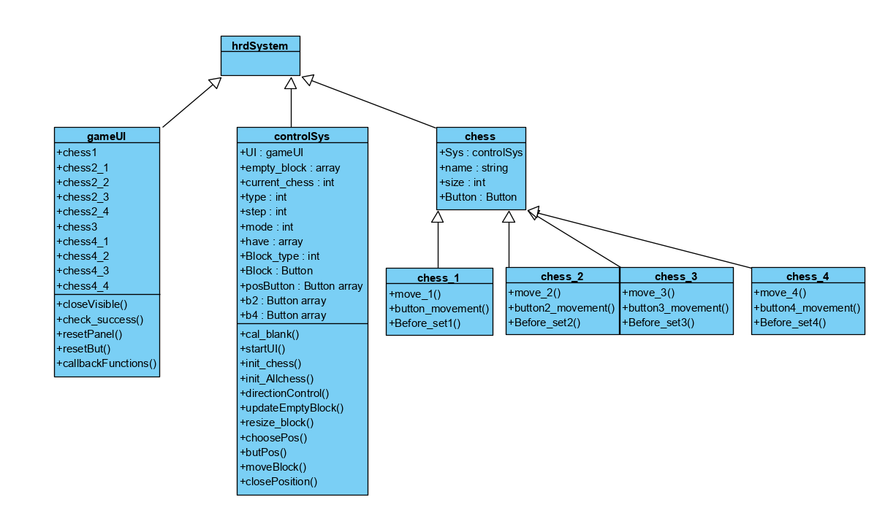

## Software Traceability

|  |  |  |
| --- | --- | --- |
|  | Is implemented by | Is validated by |
| R1 | S1 | T3 |
| R2 | S1, S2 | T1, T2 |
| R2.1 | S1 | T2 |
| R2.2 | S1.1.2 | T1.1 |
| R3 | S1, S2 | T1, T2 |
| R3.1 | S1.1.1, S1.2.2 | T2.1, T2.2 |
| R3.2 | S1 | T2 |
| R3.3 | S1.1.4 | T2.1 |
| R4 | S1 | T1, T2 |
| R4.1 | S1.1.2 | T1.1 |
| R4.2.1 | S1 | T1, T2 |
| R4.2.2 | S1.1.2 | T2.1 |