Group 5

Author: 孟奕璇

User Manual

Elevator

Table of Contents

System Architecture 2

Inside User Manual 2

Outside User Manual 3

## System Architecture

The system architecture is shown below:

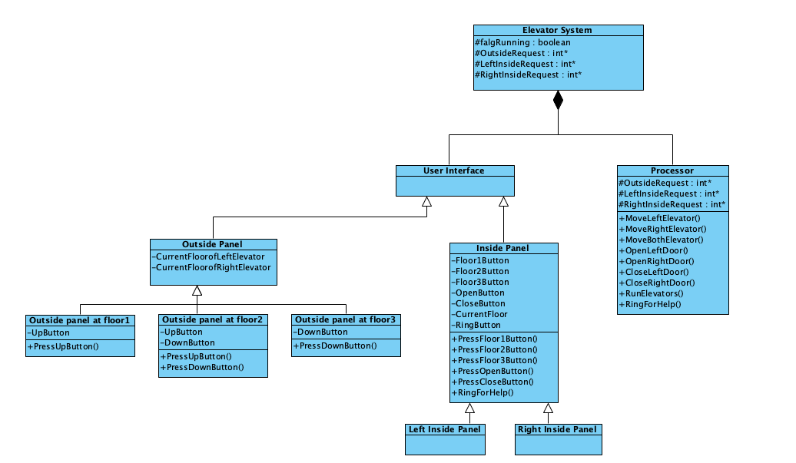

## Inside-elevator User Manual

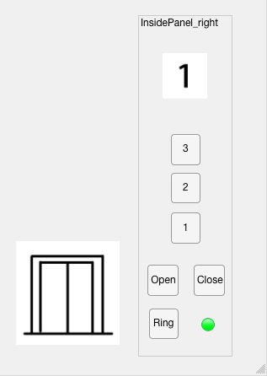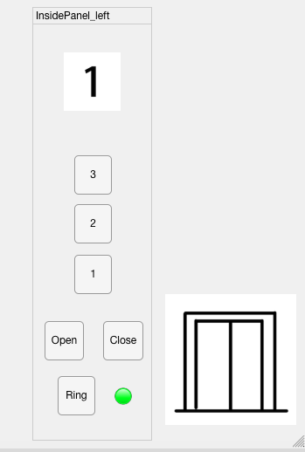The inside panel of elevators has UI which is shown below:

After entering the elevator, the user will have access to the panel inside. The user should press the button on the inside panel to select one’s target floor. The elevator that carries the user will then move to corresponding floor and open the door to let user comes out.

If an emergency happens, the ring button on the inside panel can be pressed, and the signal lamp will turn red, indicating relevant office receives an emergency call. The ring button can be press again and will turn green again, indicating an emergency solved.

## Outside-elevator User Manual

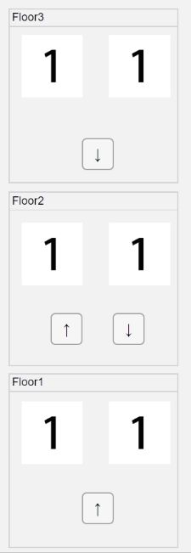

There are panels at each floor physically separated from elevators. User is able to press up or down button to call an elevator. If either elevator is at the same floor as the user, the elevator will open at once, otherwise, one of the elevators will move to the user’s floor to pick him/her up.