Group 5

Author: 龚嘉礼

User Manual

Painkiller Injection System

目录

System Architecture 2

Physician Manual 2

Patient Manual 7

## System Architecture

The system architecture is shown below:

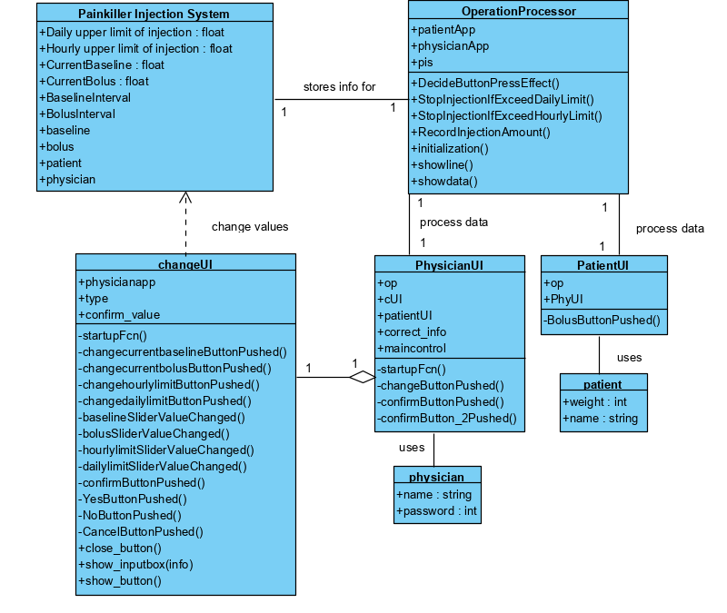

## Physician Manual

The physician has a UI which is shown below:

#### Login

First, you need to login the system with your own name and password, then click ‘confirm’.

The name and password in the initial system:

Name: ‘myx’

Password: 1234

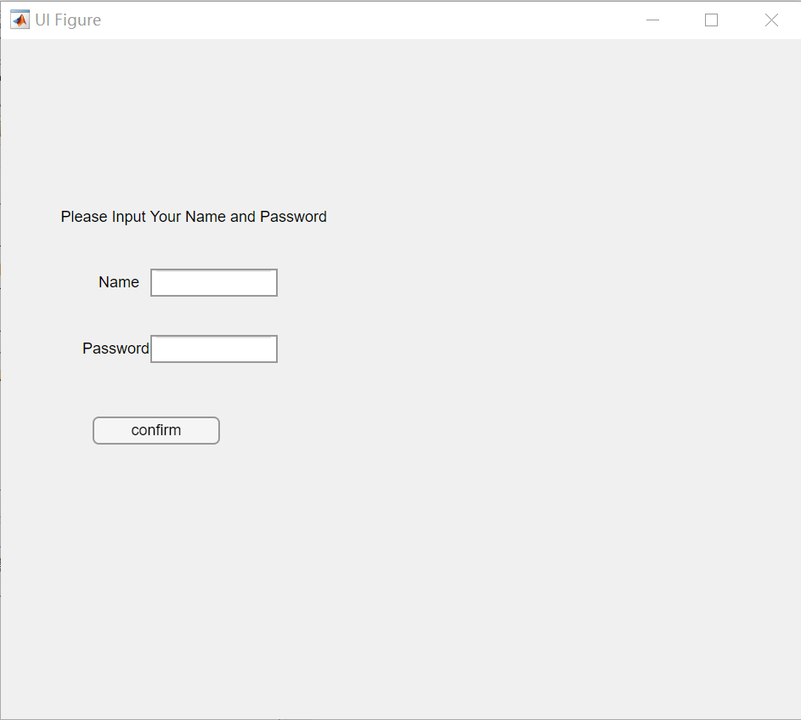

If you entered a wrong name or password, there will be error message.

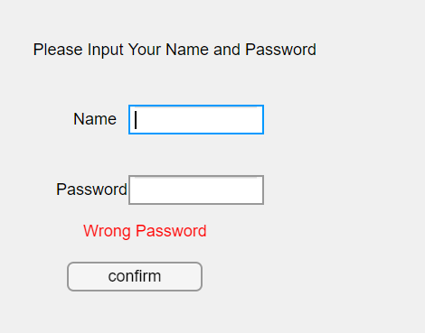

Then you need to input patient’s name and weight, and then click ’confirm’.

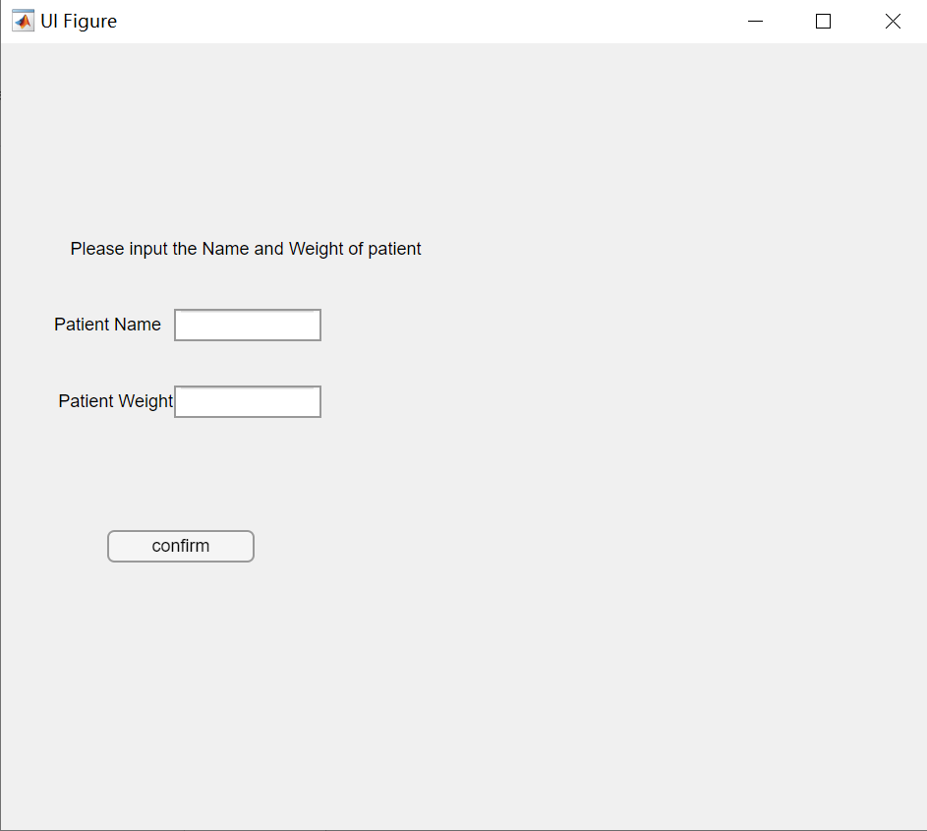

Patient’s weight needs to be valid number from 0 to 600 kg, otherwise, there will be error message.

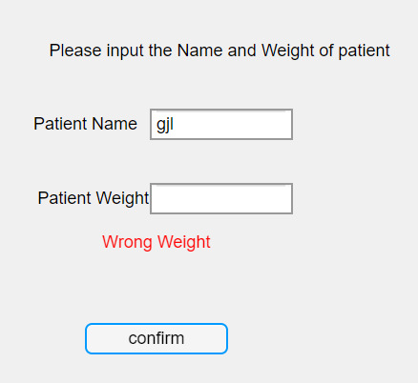

#### Layout of interface

Here is the user interface for physician. In the message box, there are some real time data for the injection as current amount and limits. The initial amount for both baseline and bolus are 0 ml, and the initial hourly limit is 1 ml, the daily limit is 3 ml. In the graph, the red line means bolus and the blue line is baseline. To change the amount and limits, you can press ‘change’ button and there will be a new interface.

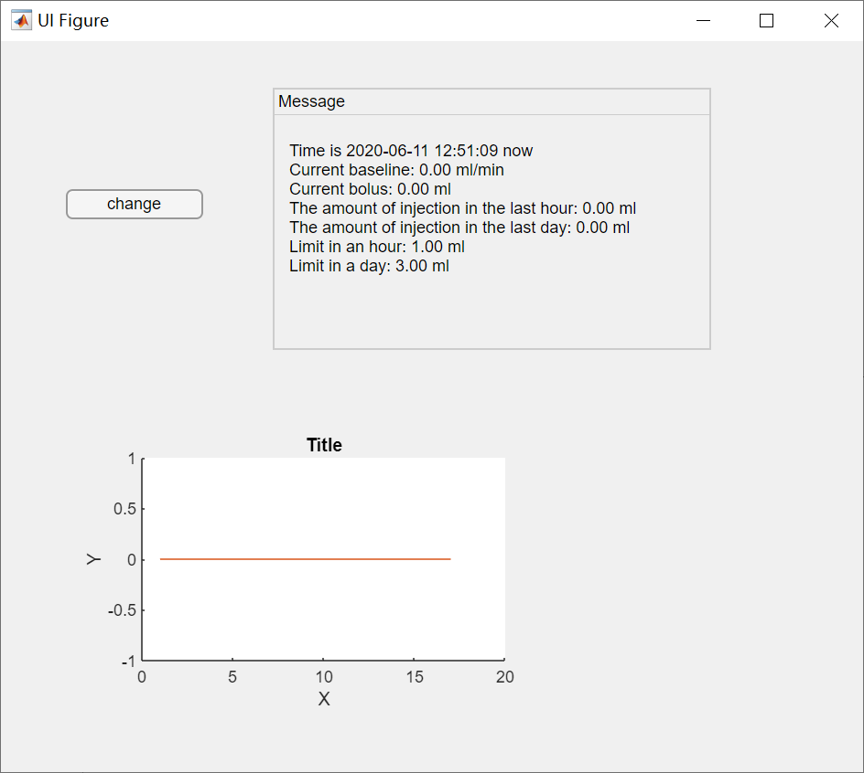

#### Change amount and limits

The changes can be done in the change interface. For convenience, you can drag the sliders to change the value of each item. Or you can press the buttons on the left side and change the value to the keyboard input value.

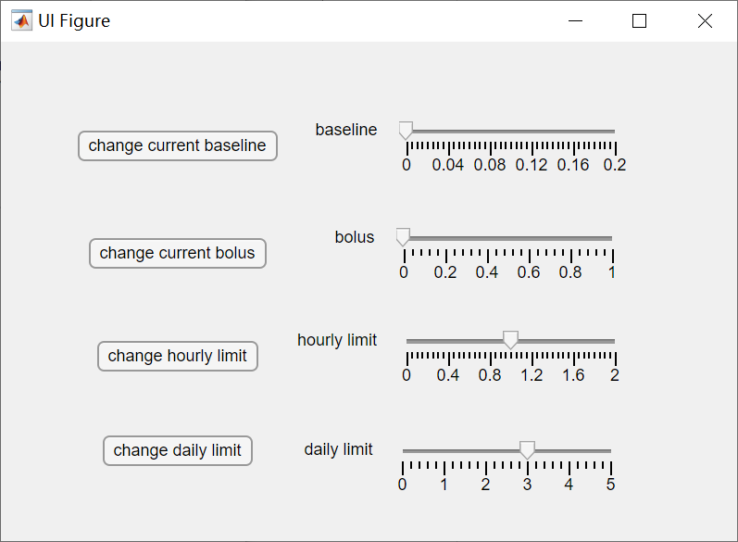

For example when you press ‘change current baseline’ button, the will be a message box which needs you to input value. After clicking ‘confirm’，the value of current baseline will be updated. If you click ‘Cancel’, it will turn back to the initial interface.

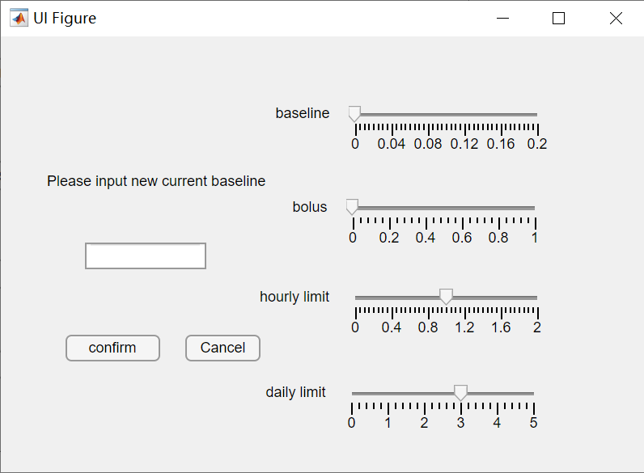

For the sake of safety, when you input a large amount or drag the slider to a large current baseline or current bolus amount, a warning message will appear, the value will be updated only if you click ‘Yes’.

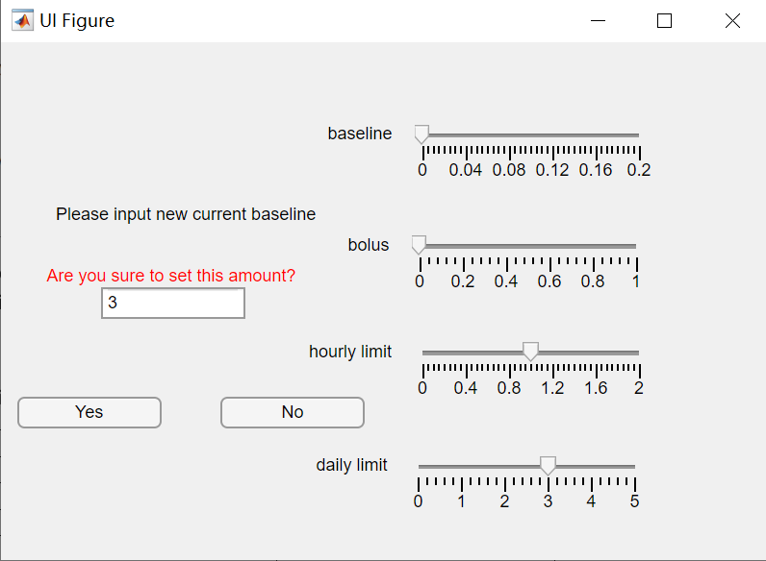

The recommended max injection amount. Values above this amount will invoke the warning.

|  |  |  |
| --- | --- | --- |
| Children | | |
| Weights | Baseline | Bolus |
| 20kg | 0.01ml/min | 0.2ml |
| 30kg | 0.03ml/min | 0.25ml |
| 40kg | 0.05ml/min | 0.3ml |
| Adults | | |
| Weights | Baseline | Bolus |
| 50kg | 0.07ml/min | 0.4ml |
| 60kg | .0.08ml/min | 0.45ml |
| 70kg | 0.09ml/min | 0.5ml |
| 80kg | 0.1ml.min | 0.5ml |

#### Automatic stop

When the total amount injected in an hour reaches the hourly limit or the total amount injected in a day reaches the daily limit, the injection will be stopped automatically. The current baseline value will be set to 0 ml/min. If you want to keep injecting, change the limit and current baseline value.

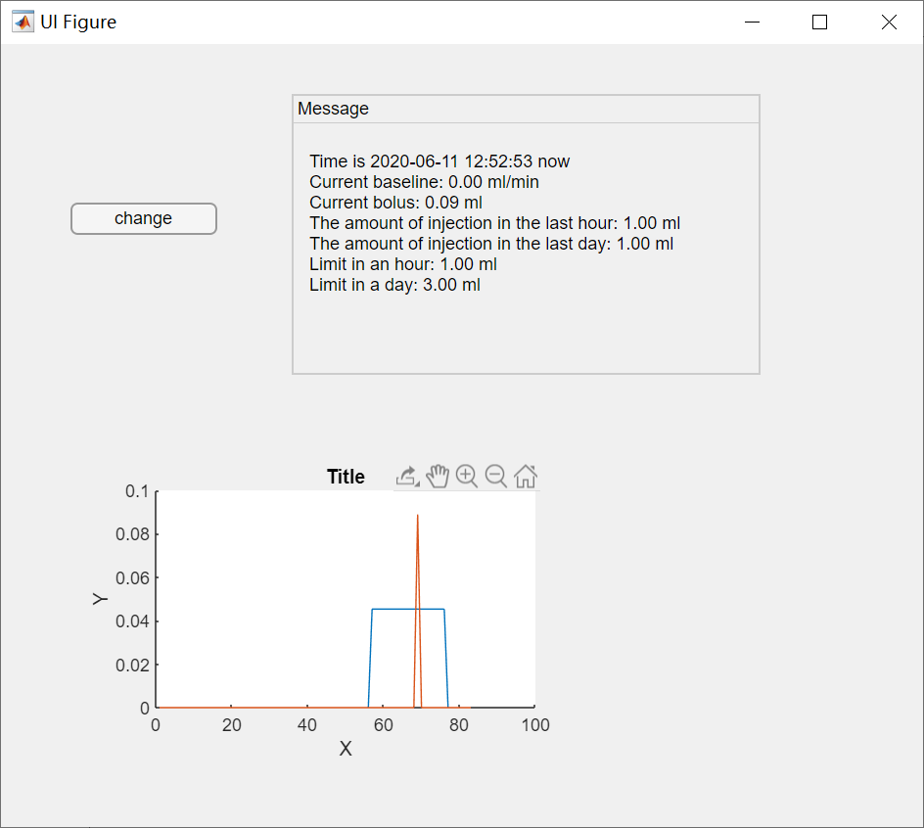

## Patient Manual

#### Layout of the interface

Here is the user interface for patients. In the message box, there are some real time data for the injection as current amount and limits. In the graph, the red line means bolus and the blue line is baseline. The initial amount for both baseline and bolus are 0 ml, and the initial hourly limit is 1 ml, the daily limit is 3 ml. Your physician may change the value for you.

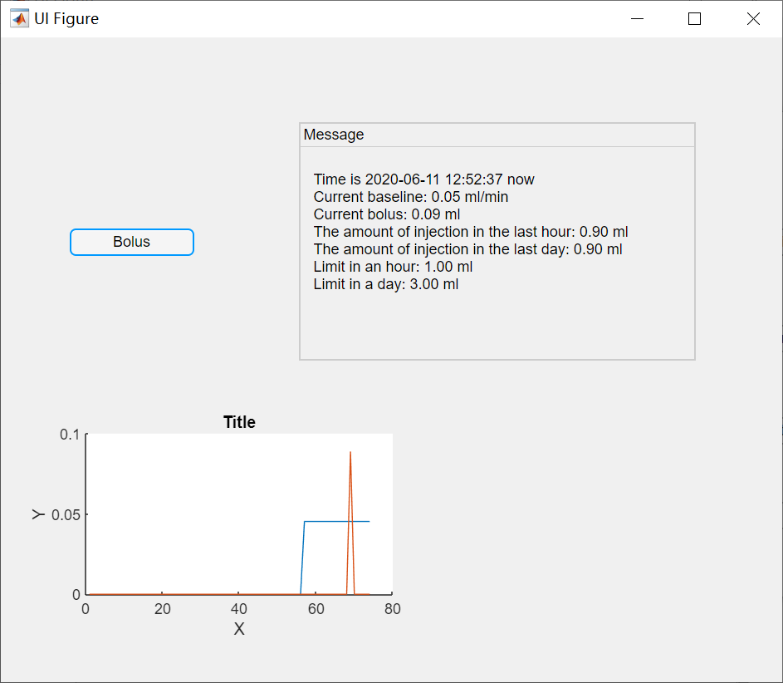

#### Bolus button

When you feel painful, you can press bolus button and then a larger amount of painkiller will be injected, but it is not continual and the amount is set by your physician. The system will judge whether after injection the amount of painkiller will exceed the hourly limit or the daily limit. If it exceeds, the apply for bolus injection will be rejected.

#### Automatic stop

When the total amount injected in an hour reaches the hourly limit or the total amount injected in a day reaches the daily limit, the injection will be stopped automatically. The current baseline value will be set to 0 ml/min.