Group 5

Author: 孟奕璇

Software Specifications

Huarongdao

Table of Contents

System Architecture 2

T1: Unit Test 2

T1.1: Push Single Button Test 2

T2: Integration Test 5

T2.1: Fixed Level Test 5

T2.2: Customized level Test 11

T3: Functional Test 14

T3.1: Use Case “Level1” 14

T3.2: Use Case “Start your own game” 15

T4: Model Checking 15

## System Architecture

The system architecture is shown below:

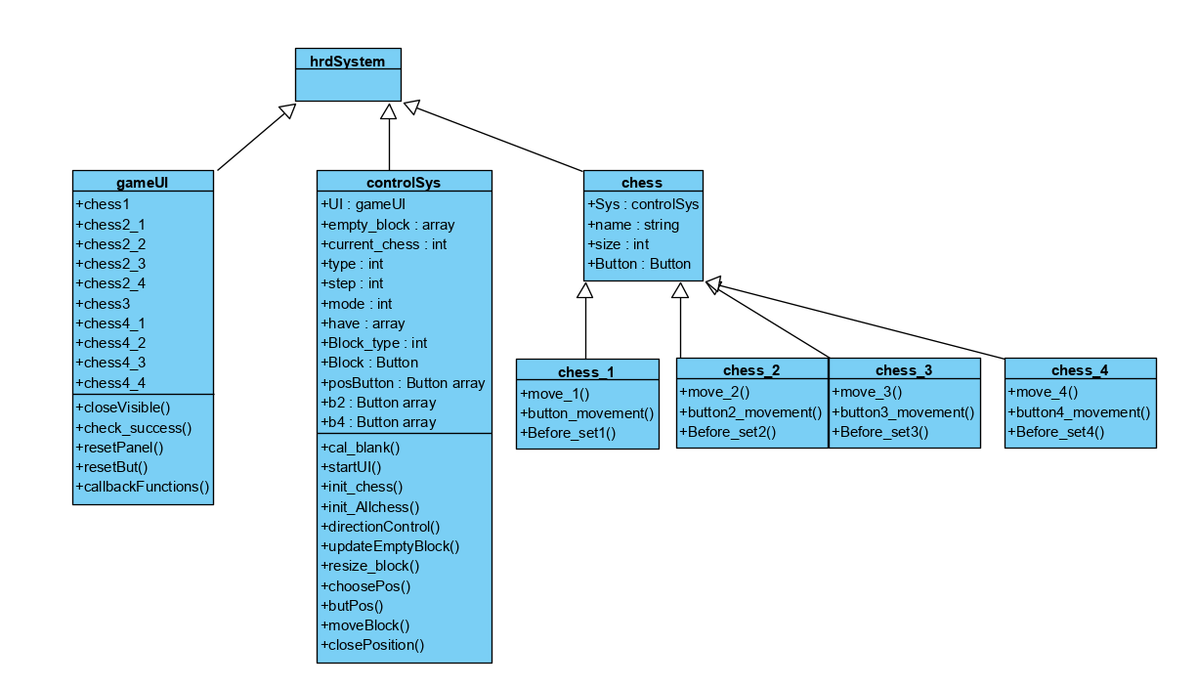

## T1: Unit Test

### T1.1: Push Single Button Test

T1.1.1: Test ButtonPushed() callback functions

function ButtonPushed(app, event) Tcover1.1.1.1

closeVisible(app);

app.chess1.button_movement();

check_success(app);

end

* Coverage Criteria: Statement coverage
* Test case

|  |  |
| --- | --- |
|  | Test Case T1.1.1.1 |
| Coverage Item | Tcover1.1.1.1 |
| Input | Press Caocao Button |
| State | Playing |
| Expected Output | Caocao moves to possible location |

* Test coverage: 1/1=100%
* Test result: 1 passed

function Button_2Pushed(app, event) Tcover1.1.1.2

closeVisible(app);

app.chess2_1.button2_moment();

end

* Coverage Criteria: Statement coverage
* Test case

|  |  |
| --- | --- |
|  | Test Case T1.1.1.2 |
| Coverage Item | Tcover1.1.1.2 |
| Input | Press Zhangfei Button |
| State | Playing |
| Expected Output | Zhangfei moves to possible location |

* Test coverage: 1/1=100%
* Test result: 1 passed

function Button_3Pushed(app, event) Tcover1.1.1.3

closeVisible(app);

app.chess2_2.button2_moment();

end

* Coverage Criteria: Statement coverage
* Test case

|  |  |
| --- | --- |
|  | Test Case T1.1.1.3 |
| Coverage Item | Tcover1.1.1.3 |
| Input | Press Zhaoyun Button |
| State | Playing |
| Expected Output | Zhaoyun moves to possible location |

* Test coverage: 1/1=100%
* Test result: 1 passed

function Button_4Pushed(app, event) Tcover1.1.1.4

closeVisible(app);

app.chess2_3.button2_moment();

end

* Coverage Criteria: Statement coverage
* Test case

|  |  |
| --- | --- |
|  | Test Case T1.1.1.4 |
| Coverage Item | Tcover1.1.1.4 |
| Input | Press Huangzhong Button |
| State | Playing |
| Expected Output | Huangzhong moves to possible location |

* Test coverage: 1/1=100%
* Test result: 1 passed

function Button_5Pushed(app, event) Tcover1.1.1.5

closeVisible(app);

app.chess2_4.button2_moment();

end

* Coverage Criteria: Statement coverage
* Test case

|  |  |
| --- | --- |
|  | Test Case T1.1.1.5 |
| Coverage Item | Tcover1.1.1.5 |
| Input | Press Machao Button |
| State | Playing |
| Expected Output | Machao moves to possible location |

* Test coverage: 1/1=100%
* Test result: 1 passed

function Button_6Pushed(app, event) Tcover1.1.1.6

closeVisible(app);

app.chess3.button3_moment();

end

* Coverage Criteria: Statement coverage
* Test case

|  |  |
| --- | --- |
|  | Test Case T1.1.1.6 |
| Coverage Item | Tcover1.1.1.6 |
| Input | Press Guanyu Button |
| State | Playing |
| Expected Output | Guanyu moves to possible location |

* Test coverage: 1/1=100%
* Test result: 1 passed

function Button_7Pushed(app, event) Tcover1.1.1.7

closeVisible(app);

app.chess4_1.button4_movement();

end

* Coverage Criteria: Statement coverage
* Test case

|  |  |
| --- | --- |
|  | Test Case T1.1.1.7 |
| Coverage Item | Tcover1.1.1.7 |
| Input | Press Soldier1 Button |
| State | Playing |
| Expected Output | Soldier1 moves to possible location |

* Test coverage: 1/1=100%
* Test result: 1 passed

function Button_8Pushed(app, event) Tcover1.1.1.8

closeVisible(app);

app.chess4_2.button4_movement();

end

* Coverage Criteria: Statement coverage
* Test case

|  |  |
| --- | --- |
|  | Test Case T1.1.1.8 |
| Coverage Item | Tcover1.1.1.8 |
| Input | Press Soldier2 Button |
| State | Playing |
| Expected Output | Soldier2 moves to possible location |

* Test coverage: 1/1=100%
* Test result: 1 passed

function Button_9Pushed(app, event) Tcover1.1.1.9

closeVisible(app);

app.chess4_3.button4_movement();

end

* Coverage Criteria: Statement coverage
* Test case

|  |  |
| --- | --- |
|  | Test Case T1.1.1.9 |
| Coverage Item | Tcover1.1.1.9 |
| Input | Press Soldier3 Button |
| State | Playing |
| Expected Output | Soldier3 moves to possible location |

* Test coverage: 1/1=100%
* Test result: 1 passed

function Button_10Pushed(app, event) Tcover1.1.1.10

closeVisible(app);

app.chess4_4.button4_movement();

end

* Coverage Criteria: Statement coverage
* Test case

|  |  |
| --- | --- |
|  | Test Case T1.1.1.10 |
| Coverage Item | Tcover1.1.1.10 |
| Input | Press Soldier4 Button |
| State | Playing |
| Expected Output | Soldier4 moves to possible location |

* Test coverage: 1/1=100%
* Test result: 1 passed

## T2: Integration Test

### T2.1: Fixed Level Test

function button_movement(chess_1) Tcover2.1.1

[num,q]=update_prop(chess_1.Sys,chess_1,1);

up=[num+2,num+7];

down=[num-1,num+4];

left=[num-5,num-4];

right=[num+10,num+11];

if (q==1)

down=[-99,-99];

end

if (q==4)

up=[-99,-99];

end

if ismember(left(1,1),chess_1.Sys.empty_block)==1 && ismember(left(1,2),chess_1.Sys.empty_block)==1

move_1(chess_1,1,-60,num+5,num+6)

return ;

end

if ismember(right(1,1),chess_1.Sys.empty_block)==1 && ismember(right(1,2),chess_1.Sys.empty_block)==1

move_1(chess_1,1,60,num,num+1)

return ;

end

if ismember(up(1,1),chess_1.Sys.empty_block)==1 && ismember(up(1,2),chess_1.Sys.empty_block)==1

move_1(chess_1,2,60,num,num+5)

return;

end

if ismember(down(1,1),chess_1.Sys.empty_block)==1 && ismember(down(1,2),chess_1.Sys.empty_block)==1

move_1(chess_1,2,-60,num+1,num+6)

return;

end

end

function button2_moment(chess_2) Tcover2.1.2

[num,q]=update_prop(chess_2.Sys,chess_2,2);

upDown=[num+2,num-1];

left=[num-5,num-4];

right=[num+5,num+6];

if (q==1)

upDown=[num+2,-99];

end

if (q==4)

upDown=[-99,num-1];

end

if ismember(left(1,1),chess_2.Sys.empty_block)==1 && ismember(left(1,2),chess_2.Sys.empty_block)==1

move_2(chess_2,1,-60,num,num+1)

return ;

end

if ismember(right(1,1),chess_2.Sys.empty_block)==1 && ismember(right(1,2),chess_2.Sys.empty_block)==1

move_2(chess_2,1,60,num,num+1)

return ;

end

if ismember(upDown(1,1),chess_2.Sys.empty_block)==1 && ismember(upDown(1,2),chess_2.Sys.empty_block)==1

chess_2.Sys.UI.UpButton.Visible="on";

chess_2.Sys.UI.DownButton.Visible="on";

return ;

end

if ismember(upDown(1,1),chess_2.Sys.empty_block)==1 && ismember(upDown(1,2),chess_2.Sys.empty_block)==0

move_2(chess_2,2,60,num,upDown(1,1));

end

if ismember(upDown(1,1),chess_2.Sys.empty_block)==0 && ismember(upDown(1,2),chess_2.Sys.empty_block)==1

move_2(chess_2,2,-60,num+1,upDown(1,2));

return;

end

end

function button3_moment(chess_3) Tcover2.1.3

closeVisible(chess_3.Sys.UI);

[num,q]=update_prop(chess_3.Sys,chess_3,3);

up=[num+1,num+6];

down=[num-1,num+4];

leftRight=[num-5,num+10];

if (q==1)

down=[-99,-99];

end

if (q==5)

up=[-99,-99];

end

if ismember(up(1,1),chess_3.Sys.empty_block)==1 && ismember(up(1,2),chess_3.Sys.empty_block)==1

move_3(chess_3,2,60,num,num+5);

end

if ismember(down(1,1),chess_3.Sys.empty_block)==1 && ismember(down(1,2),chess_3.Sys.empty_block)==1

move_3(chess_3,2,-60,num,num+5);

end

if ismember(leftRight(1,1),chess_3.Sys.empty_block)==1 && ismember(leftRight(1,2),chess_3.Sys.empty_block)==1

chess_3.Sys.UI.LeftButton.Visible="on";

chess_3.Sys.UI.RightButton.Visible="on";

end

if ismember(leftRight(1,1),chess_3.Sys.empty_block)==1 && ismember(leftRight(1,2),chess_3.Sys.empty_block)==0

move_3(chess_3,1,-60,num+5,leftRight(1,1));

end

if ismember(leftRight(1,1),chess_3.Sys.empty_block)==0 && ismember(leftRight(1,2),chess_3.Sys.empty_block)==1

move_3(chess_3,1,60,num,leftRight(1,2));

end

end

function button4_movement(chess_4) Tcover2.1.4

closeVisible(chess_4.Sys.UI);

[num,q]=update_prop(chess_4.Sys,chess_4,4);

able=[];

k=1;

actions=[num+1,num-1,num-5,num+5];

if (q==1)

actions(actions==num-1)=-99;

end

if (q==5)

actions(actions==num+1)=-99;

end

for i=1:length(chess_4.Sys.empty_block)

for j=1:length(actions)

if (chess_4.Sys.empty_block(i)==actions(j))

able(k,1)=j;

able(k,2)=actions(j);

k=k+1;

end

end

end

[m,~]=size(able);

if (m==1)

if (able(1,1)==1)

move_4(chess_4,2,able,60,num)

return ;

end

if (able(1,1)==2)

move_4(chess_4,2,able,-60,num)

return ;

end

if (able(1,1)==3)

move_4(chess_4,1,able,-60,num)

return ;

end

if (able(1,1)==4)

move_4(chess_4,1,able,60,num)

return ;

end

end

%Show direction options

if (m==2)

directButton={chess_4.Sys.UI.UpButton,\ Tcover2.1.5

chess_4.Sys.UI.DownButton,\ Tcover2.1.6

chess_4.Sys.UI.LeftButton,\ Tcover2.1.7

chess_4.Sys.UI.RightButton}; Tcover2.1.8

directButton{able(1,1)}.Visible="On";

directButton{able(2,1)}.Visible="On";

end

end

function check_success(app) Tcover2.1.9

if (app.Button.Position(1,2)<=2) &&\

(abs(app.Button.Position(1,1)-60)<=2)

app.SUCCESSLabel.Text="Success!";

app.SUCCESSLabel.Visible="On";

end

end

* Coverage Criteria: Statement coverage
* Test case

|  |  |  |  |  |
| --- | --- | --- | --- | --- |
|  | Test Case T2.1.1 | | | |
| Coverage Item | Tcover2.1.3 | Tcover2.1.7 | Tcover2.1.4 | Tcover2.1.4 |
| Input | Press Guanyu | Press Left | Press Soldier2 | Press Soldier2 |
| State | Playing | Playing | Playing | Playing |
| Expected Output | Give direction options | Guanyu moves left | Soldier2 moves up | Give direction options |

|  |  |  |  |  |
| --- | --- | --- | --- | --- |
|  | Test Case T2.1.1 | | | |
| Coverage Item | Tcover2.1.7 | Tcover2.1.4 | Tcover2.1.4 | Tcover2.1.5 |
| Input | Press Left | Press Soldier3 | Press Soldier3 | Press Up |
| State | Playing | Playing | Playing | Playing |
| Expected Output | Soldier2 moves left | Soldier3 moves up | Give direction options | Soldier3 moves up |

|  |  |  |  |  |
| --- | --- | --- | --- | --- |
|  | Test Case T2.1.1 | | | |
| Coverage Item | Tcover2.1.2 | Tcover2.1.2 | Tcover2.1.5 | Tcover2.1.2 |
| Input | Press Machao | Press Machao | Press Up | Press Huangzhong |
| State | Playing | Playing | Playing | Playing |
| Expected Output | Machao moves up | Give direction options | Machao moves up | Huangzhong moves right |

|  |  |  |  |  |
| --- | --- | --- | --- | --- |
|  | Test Case T2.1.1 | | | |
| Coverage Item | Tcover2.1.2 | Tcover2.1.2 | Tcover2.1.4 | Tcover2.1.4 |
| Input | Press Zhaoyun | Press Zhangfei | Press Soldier4 | Press Soldier4 |
| State | Playing | Playing | Playing | Playing |
| Expected Output | Zhaoyun moves right | Zhangfei moves right | Soldier4 moves down | Give direction options |

|  |  |  |  |  |
| --- | --- | --- | --- | --- |
|  | Test Case T2.1.1 | | | |
| Coverage Item | Tcover2.1.6 | Tcover2.1.4 | Tcover2.1.4 | Tcover2.1.6 |
| Input | Press Down | Press Soldier1 | Press Soldier1 | Press Down |
| State | Playing | Playing | Playing | Playing |
| Expected Output | Soldier4 moves down | Soldier1 moves down | Give direction options | Soldier1 moves down |

|  |  |  |  |  |
| --- | --- | --- | --- | --- |
|  | Test Case T2.1.1 | | | |
| Coverage Item | Tcover2.1.1 | Tcover2.1.2 | Tcover2.1.2 | Tcover2.1.5 |
| Input | Press Caocao | Press Zhaoyun | Press Zhaoyun | Press Up |
| State | Playing | Playing | Playing | Playing |
| Expected Output | Caocao moves left | Zhaoyun moves up | Give direction options | Zhaoyun moves up |

|  |  |  |  |  |
| --- | --- | --- | --- | --- |
|  | Test Case T2.1.1 | | | |
| Coverage Item | Tcover2.1.2 | Tcover2.1.4 | Tcover2.1.4 | Tcover2.1.6 |
| Input | Press Zhangfei | Press Soldier1 | Press Soldier1 | Press Down |
| State | Playing | Playing | Playing | Playing |
| Expected Output | Zhangfei moves right | Soldier1 moves right | Give direction options | Soldier1 moves down |

|  |  |  |  |  |
| --- | --- | --- | --- | --- |
|  | Test Case T2.1.1 | | | |
| Coverage Item | Tcover2.1.1 | Tcover2.1.3 | Tcover2.1.4 | Tcover2.1.4 |
| Input | Press Caocao | Press Guanyu | Press Soldier2 | Press Soldier2 |
| State | Playing | Playing | Playing | Playing |
| Expected Output | Caocao moves down | Guanyu moves down | Soldier2 moves left | Give direction options |

|  |  |  |  |  |
| --- | --- | --- | --- | --- |
|  | Test Case T2.1.1 | | | |
| Coverage Item | Tcover2.1.7 | Tcover2.1.4 | Tcover2.1.4 | Tcover2.1.7 |
| Input | Press Left | Press Soldier3 | Press Soldier3 | Press Left |
| State | Playing | Playing | Playing | Playing |
| Expected Output | Soldier2 moves left | Soldier3 moves left | Give direction options | Soldier3 moves left |

|  |  |  |  |  |
| --- | --- | --- | --- | --- |
|  | Test Case T2.1.1 | | | |
| Coverage Item | Tcover2.1.2 | Tcover2.1.2 | Tcover2.1.2 | Tcover2.1.2 |
| Input | Press Zhaoyun | Press Machao | Press Zhangfei | Press Huangzhogn |
| State | Playing | Playing | Playing | Playing |
| Expected Output | Zhaoyun moves up | Machao moves up | Zhangfei moves up | Huangzhogn moves up |

|  |  |  |  |  |
| --- | --- | --- | --- | --- |
|  | Test Case T2.1.1 | | | |
| Coverage Item | Tcover2.1.4 | Tcover2.1.4 | Tcover2.1.8 | Tcover2.1.4 |
| Input | Press Soldier1 | Press Soldier1 | Press Right | Press Soldier4 |
| State | Playing | Playing | Playing | Playing |
| Expected Output | Soldier1 moves right | Give direction options | Soldier1 moves right | Soldier4 moves right |

|  |  |  |  |  |
| --- | --- | --- | --- | --- |
|  | Test Case T2.1.1 | | | |
| Coverage Item | Tcover2.1.4 | Tcover2.1.8 | Tcover2.1.1 | Tcover2.1.3 |
| Input | Press Soldier4 | Press Right | Press Caocao | Press Guanyu |
| State | Playing | Playing | Playing | Playing |
| Expected Output | Give direction options | Soldier4 moves right | Caocao moves down | Guanyu moves down |

|  |  |  |  |  |
| --- | --- | --- | --- | --- |
|  | Test Case T2.1.1 | | | |
| Coverage Item | Tcover2.1.4 | Tcover2.1.4 | Tcover2.1.7 | Tcover2.1.2 |
| Input | Press Soldier2 | Press Soldier3 | Press Left | Press Zhaoyun |
| State | Playing | Playing | Playing | Playing |
| Expected Output | Soldier2 moves down | Give direction options | Soldier3 moves left | Zhaoyun moves left |

|  |  |  |  |  |
| --- | --- | --- | --- | --- |
|  | Test Case T2.1.1 | | | |
| Coverage Item | Tcover2.1.2 | Tcover2.1.2 | Tcover2.1.2 | Tcover2.1.5 |
| Input | Press Machao | Press Huangzhong | Press Huangzhong | Press Up |
| State | Playing | Playing | Playing | Playing |
| Expected Output | Machao moves left | Huangzhong moves up | Give direction options | Zhaoyun moves up |

|  |  |  |  |  |
| --- | --- | --- | --- | --- |
|  | Test Case T2.1.1 | | | |
| Coverage Item | Tcover2.1.2 | Tcover2.1.4 | Tcover2.1.4 | Tcover2.1.5 |
| Input | Press Zhangfei | Press Soldier4 | Press Soldier4 | Press Up |
| State | Playing | Playing | Playing | Playing |
| Expected Output | Zhangfei moves right | Soldier4 moves up | Give direction options | Soldier4 moves up |

|  |  |  |
| --- | --- | --- |
|  | Test Case T2.1.1 | |
| Coverage Item | Tcover2.1.4 | Tcover2.1.9 |
| Input | Press Soldier4 | Press Caocao |
| State | Playing | SUCCESS |
| Expected Output | DO NOT MOVE | Caocao moves right to aimed position |

* Test coverage: 9/9=100%
* Test result: 1 passed

### T2.2: Customized level Test

function Before_set1(chess_1) Tcover2.2.1

leftDown=[1,2,3,4,7,8,9,11,12,13,14];

[~,n]=size(leftDown);

for j=1:n

k=fix(leftDown(1,j)/5);

q=mod(leftDown(1,j),5);

chess_1.Sys.posButton{1,j}.Position(1,1)=k*60+47.5;

chess_1.Sys.posButton{1,j}.Position(1,2)=(q-1)*60+47.5;

chess_1.Sys.posButton{1,j}.Visible="on";

end

end

function Before_set2(chess_2) Tcover2.2.2

list2=[];

for i=1:19

if (ismember(i,chess_2.Sys.have)||ismember(i+1,chess_2.Sys.have))

continue

end

if (mod(i,5)==0)

continue

end

list2=[list2;[i,i+1]];

end

[m,n]=size(list2);

for j=1:m

k=fix(list2(j,1)/5);

q=mod(list2(j,1),5);

chess_2.Sys.posButton{1,j}.Position(1,1)=k*60+17.5;

chess_2.Sys.posButton{1,j}.Position(1,2)=(q-1)*60+47.5;

chess_2.Sys.posButton{1,j}.Visible="on";

end

end

function Before_set3(chess_3) Tcover2.2.3

list3=[];

for i=1:19

if (i+5>20)

continue

end

if (ismember(i,chess_3.Sys.have)||ismember(i+5,chess_3.Sys.have))

continue

end

list3=[list3;[i,i+5]];

end

[m,~]=size(list3);

for j=1:m

k=fix(list3(j,1)/5);

q=mod(list3(j,1),5);

if (q==0)

q=5;

k=k-1;

end

chess_3.Sys.posButton{1,j}.Position(1,1)=k*60+47.5;

chess_3.Sys.posButton{1,j}.Position(1,2)=(q-1)*60+17.5;

chess_3.Sys.posButton{1,j}.Visible="on";

end

end

function Before_set4(chess_4) Tcover2.2.4

list1=[];

for i=1:20

if ismember(i,chess_4.Sys.have)

continue

end

list1=[list1,i];

end

[~,m]=size(list1);

for j=1:m

k=fix(list1(1,j)/5);

q=mod(list1(1,j),5);

if (q==0)

q=5;

k=k-1;

end

chess_4.Sys.posButton{1,j}.Position(1,1)=k*60+17.5;

chess_4.Sys.posButton{1,j}.Position(1,2)=(q-1)*60+17.5;

chess_4.Sys.posButton{1,j}.Visible="on";

end

end

function check_success(app) Tcover2.2.5

if (app.Button.Position(1,2)<=2) &&\

(abs(app.Button.Position(1,1)-60)<=2)

app.SUCCESSLabel.Text="Success!";

app.SUCCESSLabel.Visible="On";

end

end

* Coverage Criteria: Statement coverage
* Test case

|  |  |  |  |  |
| --- | --- | --- | --- | --- |
|  | Test Case T2.2.1 | | | |
| Coverage Item | Tcover2.2.1-4 | -- | Tcover2.1.4 | Tcover2.1.4 |
| Input | Press minor button1 | Press Play | Press Soldier4 | Press Soldier4 |
| State | Placing | Playing | Playing | Playing |
| Expected Output | Character button placed | Start game | Soldier4 moves up | Give direction options |

|  |  |  |  |  |
| --- | --- | --- | --- | --- |
|  | Test Case T2.2.1 | | | |
| Coverage Item | Tcover2.1.5 | Tcover2.1.4 | Tcover2.1.4 | Tcover2.1.5 |
| Input | Press Up | Press Soldier3 | Press Soldier3 | Press Up |
| State | Placing | Playing | Playing | Playing |
| Expected Output | Soldier4 moves up | Soldier3 moves up | Give direction options | Soldier3 moves up |

|  |  |  |  |  |
| --- | --- | --- | --- | --- |
|  | Test Case T2.2.1 | | | |
| Coverage Item | Tcover2.1.4 | Tcover2.1.4 | Tcover2.1.5 | Tcover2.1.2 |
| Input | Press Soldier2 | Press Soldier2 | Press Up | Press Huangzhong |
| State | Playing | Playing | Playing | Playing |
| Expected Output | Soldier2 moves up | Give direction options | Soldier2 moves up | Huangzhong moves right |

|  |  |
| --- | --- |
|  | Test Case T2.1.1 |
| Coverage Item | Tcover2.2.5 |
| Input | Press Caocao |
| State | SUCCESS |
| Expected Output | Caocao moves right to aimed position |

* Test coverage: 5/5=100%
* Test result: 1 passed

## T3: Functional Test

### T3.1: Use Case “Level1”

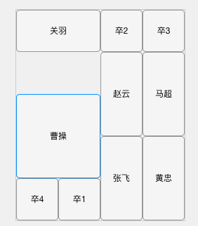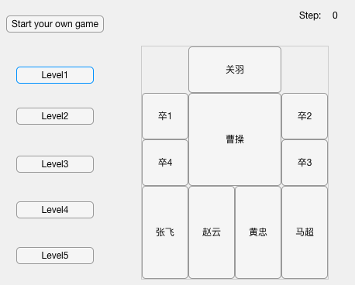

Level1 initial UI After Caocao’s 2nd move

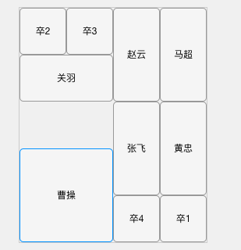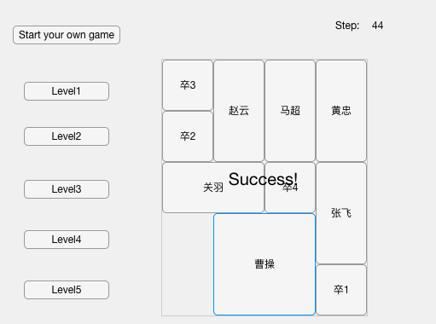

After Caocao’s 3rd move Levels succeed

### T3.2: Use Case “Start your own game”

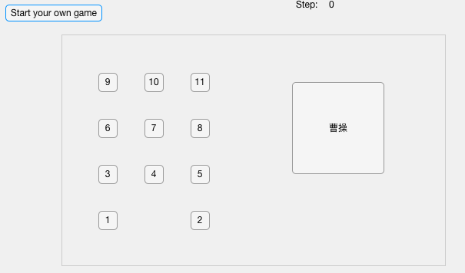

Initial UI for place character buttons in customized positions

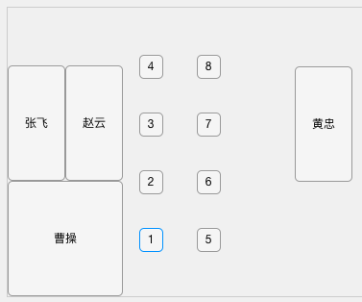 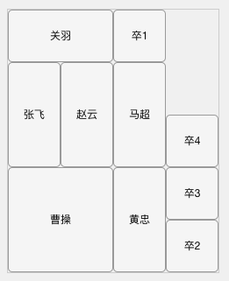

UI when first three characters are placed After all characters are placed

## T4: Model Checking