Group 5

目录

System Architecture 2

Player Manual 2

Layout of mode1 user interface 2

Layout of mode2 user interface 3

## System Architecture

The system architecture is shown below:

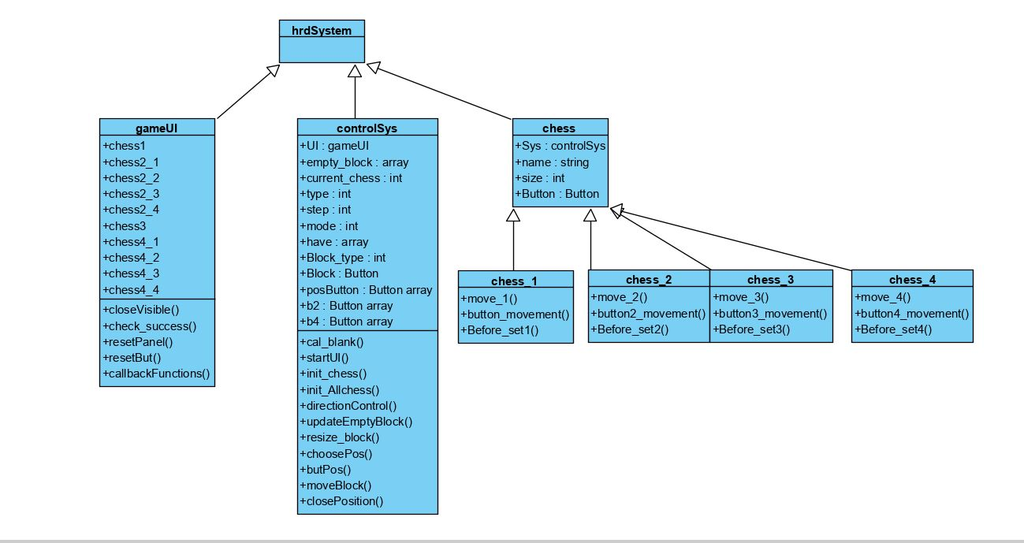

## Player Manual

Player can use this Huarongdao app to play the class huarongdao game whose goal is to make Caocao escape from the center of bottom by moving the all the chessman under rules.

The rule of moving chessman is that player can only move the chessman in four directions including up, down, left and right. If other chessman are near the current chessman in one of these four directions, the chessman cannot move to that direction.

## Layout of mode1 user interface

There are two types of UI which is shown below:

There are 5 level buttons on left side which is used to choose different level. Start your own game button are used to switch the mode of game. The game panel with 242 width and 302 height at the right side contains 10 components which is the chessman of Huarongdao. The step label in the upper right corner indicate the number of steps used so far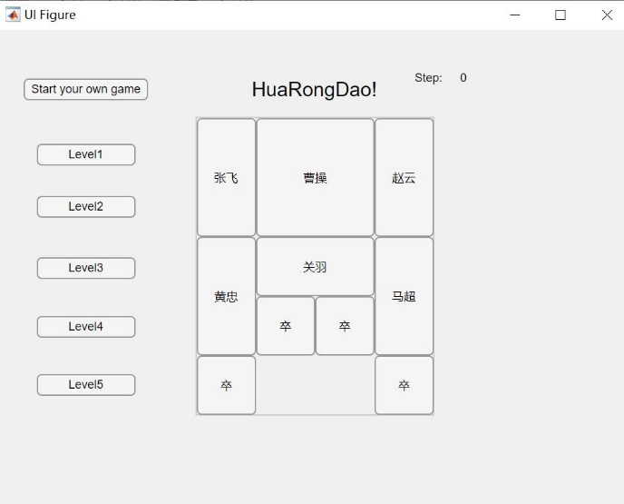.

## Layout of mode2 user interface

The big panel is the place for player to design their own game. The chessman at the right is the current chessman to place in the main panel. The small button with number from 1 to 12 is the button whose position indicate the legal position of current chessman. The return button is used to return to UI of mode1. The “play!” button is used to set the current board as initial state of game and allow player to start game which only appear when all chessman are placed to the legal position. The “start your own game” can clear all chessman which has been set and restart placement.

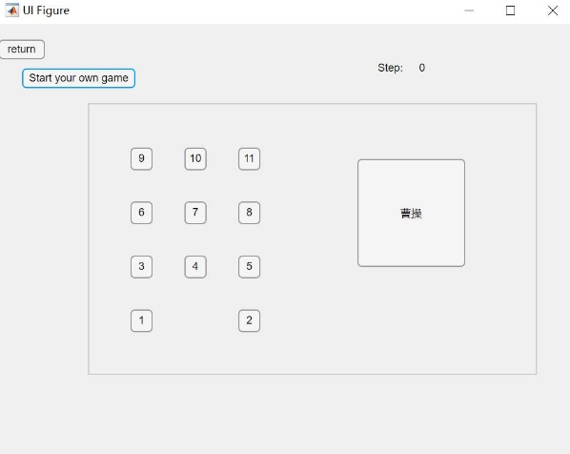 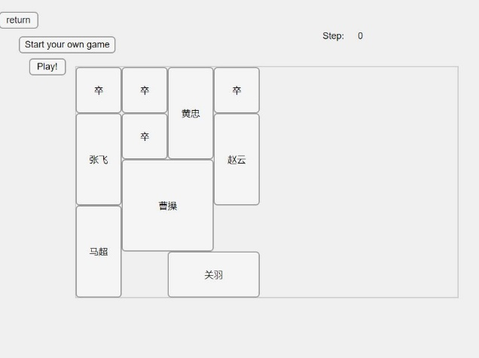

#### Play with the Built-in Level

First, player need to press the level button to choose which level to play. After that, every chessman will be set to the initial position of this Level. Player can move the chessman can be moved by pressing the corresponding button.

If there are more than one possible movement for the pressed chessman. The direction button will show up. Player can press the direction button to choose the movement.

Player can see the number of used steps at upper right corner of UI.

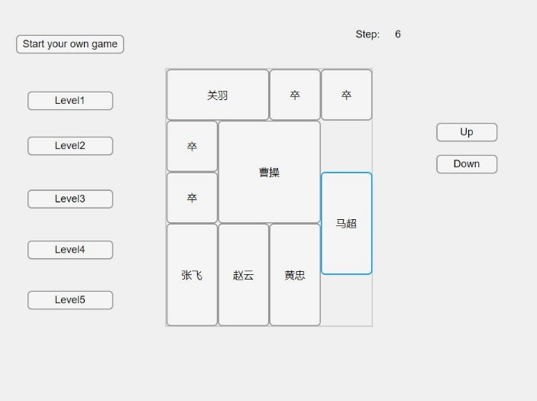

#### Layout of interface

Here is the user interface for physician. In the message box, there are some real time data for the injection as current amount and limits. The initial amount for both baseline and bolus are 0 ml, and the initial hourly limit is 1 ml, the daily limit is 3 ml. In the graph, the red line means bolus and the blue line is baseline. To change the amount and limits, you can press ‘change’ button and there will be a new interface.

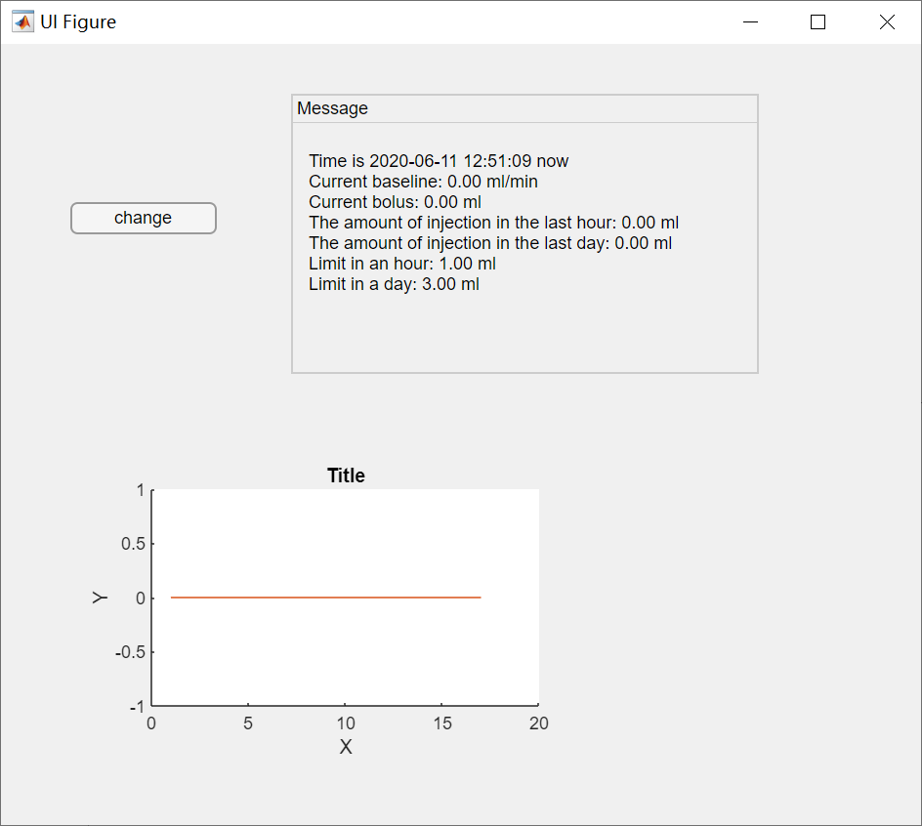

#### Change amount and limits

The changes can be done in the change interface. For convenience, you can drag the sliders to change the value of each item. Or you can press the buttons on the left side and change the value to the keyboard input value.

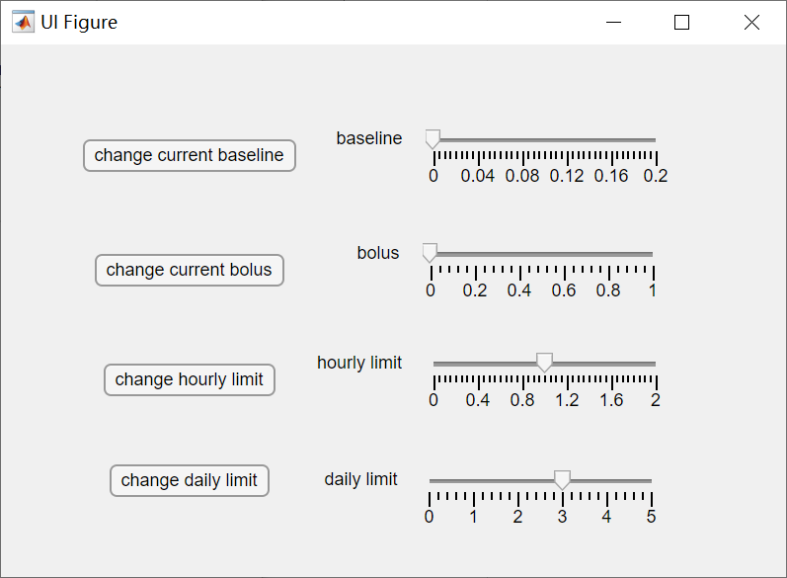

For example when you press ‘change current baseline’ button, the will be a message box which needs you to input value. After clicking ‘confirm’，the value of current baseline will be updated. If you click ‘Cancel’, it will turn back to the initial interface.