**Project 4 License Plate Reading**

1. **Objective**

License Plate Reading is an application of computer video image recognition technology in vehicle license plate recognition. License plate recognition is widely used in highway vehicle management, and in electronic toll collection systems, it is also the main means of identifying vehicle identity in conjunction with DSRC technology.

The license plate recognition technology requires that a license plate in motion can be extracted and recognized from a complex background. The license plate extraction, image pre-processing, feature extraction, license plate character recognition and other technologies can be used to identify the vehicle license plate and color information. The recognition rate for letters and numbers can reach 99.7%, and the recognition rate for Chinese characters can reach 99%.

In order to perform license plate recognition, the following basic steps are required:1.License Plate Detection:Extract the license plate.Locate and segment license plate positions in pictures;2.Character Segmentation and Recognition: Extract characters from license plates and recognize the characters by using given templates;3.License plate character recognition:recognize the divided characters and finally form the license plate number.

In general, license plate positioning is to completely segment the license plate area from a vehicle image with a complex background. It is to solve practical problems in image processing. There are various methods. The most common localization technologies are currently : edge detection, color segmentation, wavelet transform, genetic algorithm and artificial neural network technology, etc.

In this project.We want to use traditional image processing method to finish the license plate reading.We want to get the results as figure 1 and figure 2.

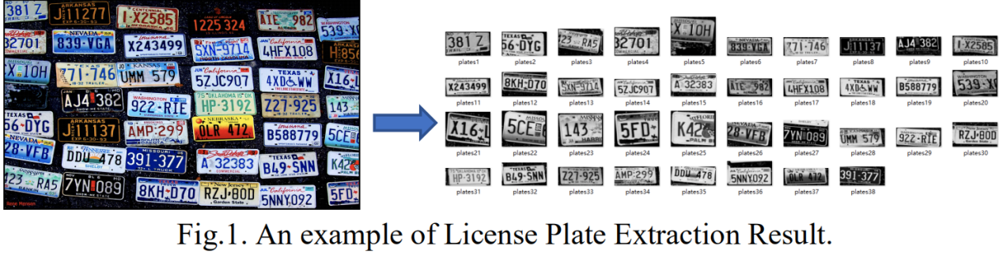

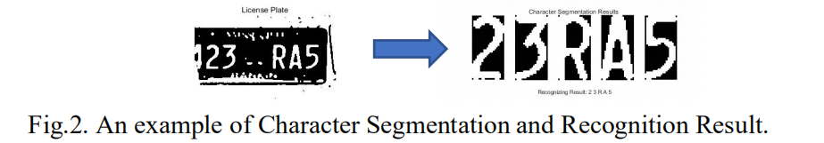

1. **Method**

**Pre-processing:**

1. **Morphological Image Processing**

The basic morphological operations (erosion and dilation) are used to find the region of interest. The image is dilated and eroded with some structuring element and morphological gradient is used in order to detect the edges in the image.

Morphological image processing is a collection of non linear operations related to shape or morphology of features in an image. The operation is based on the relative ordering of the pixels not on their values. The morphology is performed using the structuring element which is also a binary image. Basic operations for the image morphology are erosion and dilation.Its effect is shown in the figure 3 and 4.

Erosion:The erosion operation extracts the minimum value of pixels covered by the kernel.

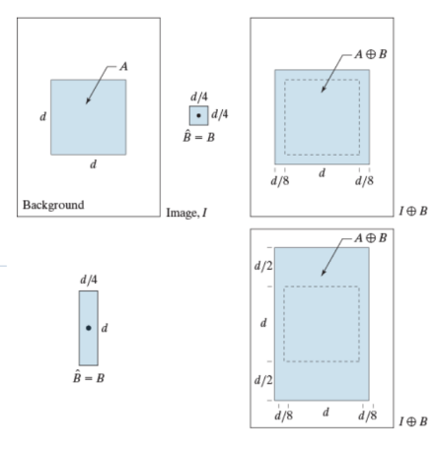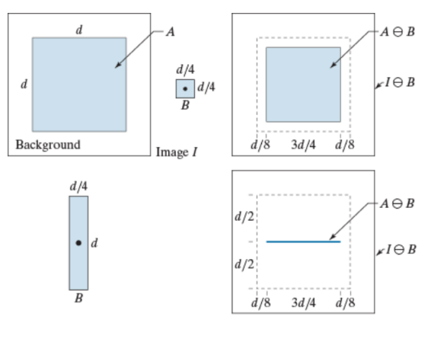 Fig.3.Erosion Operation Fig.4.Dilation Operation

Opening Operation:erosion and then dilation.The opening operation can be used to remove the isolated points outside the target, eliminate small objects, separate objects in slender places, and smooth the boundaries of larger objects without significantly changing their area.

Closing Operation:dilation and then erosion.The closing operation can remove holes in the target and exclude small black holes (black areas).

Hole Filling：Morphological algorithm:

(Stop when )

1. **Hough and Radon transform**

Hough transform is mainly to use the transformation between picture space and Hough space to map a curve or line with a shape in the rectangular coordinate system where the picture is located to a point in Hough space to form a peak, so that the problem of detecting any shape will be detected. This translates into the problem of calculating peaks. That is, the straight line on the picture becomes a point when converted into Hough space, and it is formed by the intersection of multiple straight lines. The peak value of our statistics is the number of the intersection line of the intersection point.In polar coordinates, the Hough transform is shown in the figure 5.

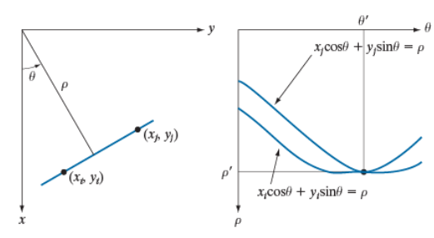

Fig.5. Hough transform

Algorithm of vehicle license plate tilt correction based on Hough transform:In this project,We hope to perform skew correction on the segmented picture to improve the accuracy of character recognition.Steps are as follows:

1. Image preprocessing,remove discrete noise points;
2. Use edge detection to enhance horizontal lines in the image;
3. Use Hough transform to detect the border of the license plate;
4. Determine the tilt angle of the border line;
5. Rotate according to the tilt angle;6.Obtain a corrected image.

Radon transform: Normal representation for a line:;The projection of along an arbitrary line in the -plane(Radon transform):



An example of a radon transform is shown in the figure 6.

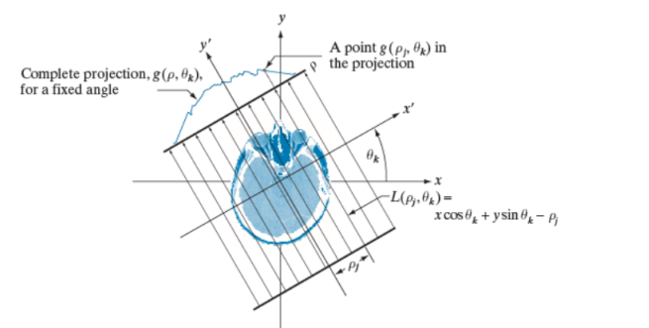

Fig.6.Radon Transform

1. **Vertical projection**

The projection of the corresponding direction of the image is to take a straight line in that direction, count the number of black points of the pixels on the image perpendicular to the straight line (axis), and accumulate the sum as the value of that position on the axis; the cutting based on the image projection is to divide After the image is mapped to this feature, the cutting position (coordinates) of the image is determined based on this feature, and the original image is cut using this coordinate to obtain the target image.

In this project,we hope to use the characteristics of vertical projection to separate and cut the license plate number.We can see the projection result as shown in the figure 6.

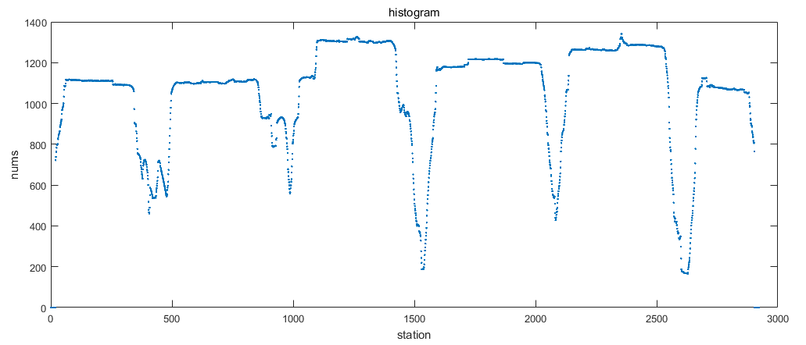

Fig.6. vertical projection results

By analyzing the vertical projection results, we can find the location information of the edge at the peak.

In character segmentation,the main task of the horizontal projection analysis of the binary license plate image is to calculate the starting (rising point), ending (falling point) position, character height (peak width), and character center of the characters on each license plate from the obtained projection histogram. Distance (peak center position), character spacing (bottom width), and the position of the top and bottom borders of the character. Finally, we find the maximum height of license plate characters and remove the upper and lower border of license plate.

1. **Connected Region**

Connected region generally refers to the image region composed of foreground pixels with the same pixel value and adjacent position.Connected region analysis is to find and mark each connected region in an image.Generally, the object of connected region analysis is a binary image.In the image, the smallest unit is a pixel, and there are 8 adjacent pixels around each pixel. There are two common adjacencies: 4 adjacencies and 8 adjacencies.Such as figure 7 and 8.In figure 8,If we use 4 adjacent,

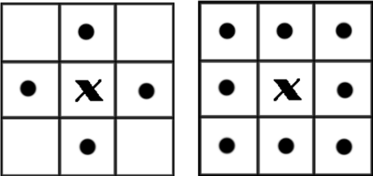 

Fig.7.Adjacent Pixels Fig.8.Connected region

we can get three connected areas,but if we use 8 adjacent,we only get two connected areas.Then,Let each single connected region form a labeled block, and then we can get the geometric parameters of these blocks, such as contour, circumscribed rectangle, centroid, invariant moment and so on.

In our project,we use the function of Matlab:bwlabel.It traverses the image once, and records the equivalent pairs of continuous blocks and tags in each row (or column), and then marks the original image again by equivalence.

1. **Project Flow:**

**A)Preprocessing**

Convert the image to gray scale image, and then set appropriate threshold to change the image to binary image;Denoising with Gaussian function;Use erosion operation and opening operation for images to make edges clear.

1. **License Plate Detection&Segmentation**
2. Using vertical projection to find License plate edge information
3. Find each license plate area by region connection method

Then,we can get many Independent license plate from image.

1. **Skew correction**

Using Hough and Radon transform to correct the skew of independent license plate, which is convenient for character cutting

1. **Character Segmentation**

1) Using region connectivity to recognize the character part and cut it

2)Using the projection operation to determine the char position information

1. **Character Recognition**

compare the cut independent letters with the characters in the template library to match the most similar letters.One important point:Letters and backgrounds may be black or white in a binary diagram.

1. **Result and Discussion**
2. **Preprocessing**

First, we preprocess the image,the parameters of the morphological operation will affect the final effect.Improper parameters during corrosive operation will reduce the number of license plates detected.In this project,we use hole filling to get better connected areas.Our result such as figure 9.

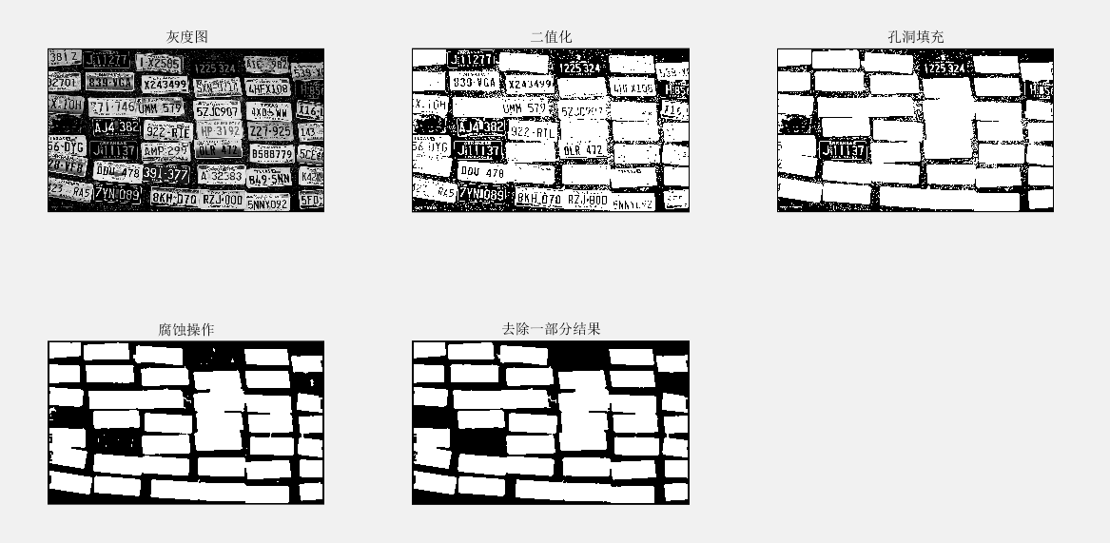 Fig.9.Pre-processing

**B)License Plate Detection&Segmentation**

1)We use two method to cut the license plate image.First:Using vertical projection to find License plate edge information. We can get the We can get the pixel accumulation value in the horizontal and vertical directions.Such as figure 10. Then,We know from experience that the edge of the license plate is near the few minimums points.

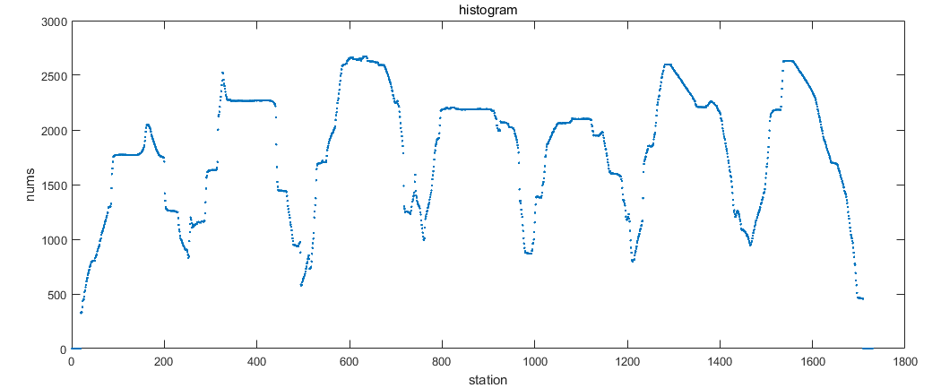

Fig.10.Vertical pixel cumulative value distribution

In this method,We can get all license plate areas(N=42).Such as figure 11. Although this method can roughly cut out the entire license plate area,It still has some problems.Some license plates are not very complete.This is because this method is a global cutting method,we cannot flexibly target individual license plates.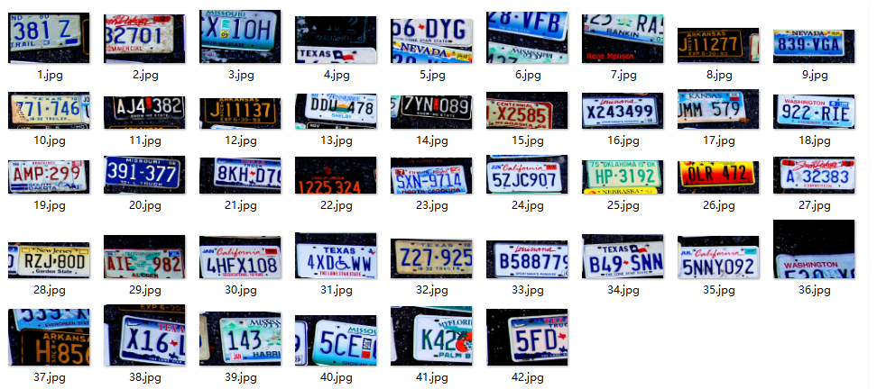

Fig.11 Result

We are optimized for the limitations of the global cutting of the projection algorithm.For each independent license plate,we find its position in the original image and set a window to include it.Then,we use the projection algorithm again in the window. This method will greatly improve the results.The results and Improvement shown in figure 12 and 13.

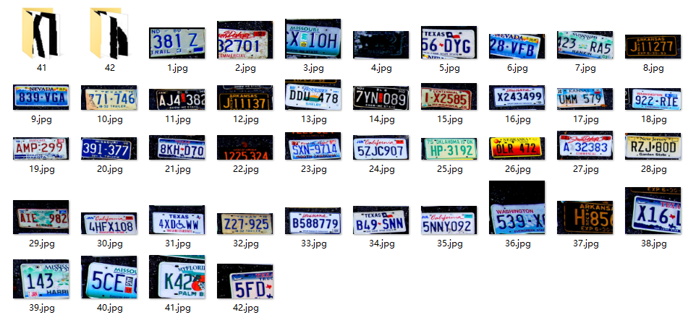Fig.12 Result

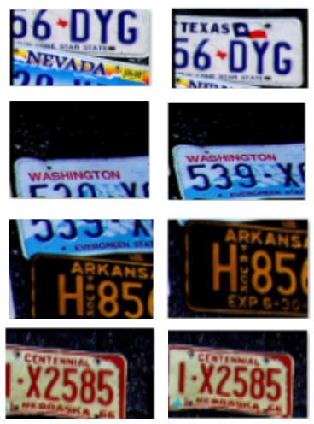

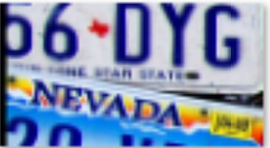

Fig.13 Some improvements

2)The second method is based on connected regions,due to the noise of the original image and the color and graphics of the license plate are complicated. Through improvement, we have reached 36 from 30 license plates.The result in figure 14.

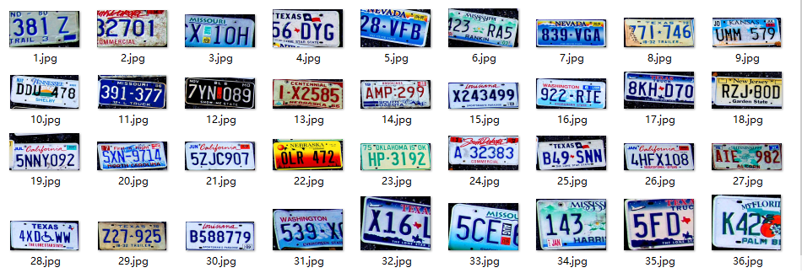

Fig.14 Connected regions Method

We can find that although fewer license plates are recognized, the license plates obtained based on the connected area are relatively neat than the first method.

**C)Skew correction**

After getting an independent license plate,if we perform character recognition directly, the result will not be very satisfactory.This is because the angle of the independent license plate may not be horizontal.Then,we use Hough or Radon transform to correct the skew of independent license plate.After discussion, we get the following results.

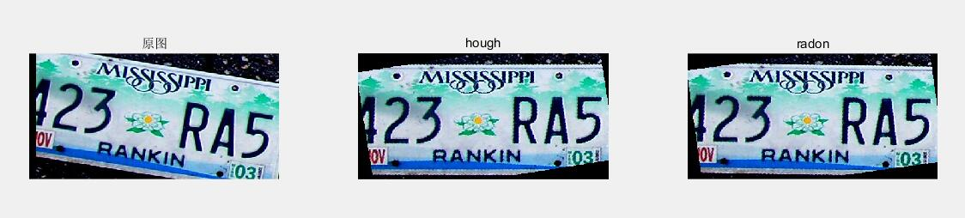

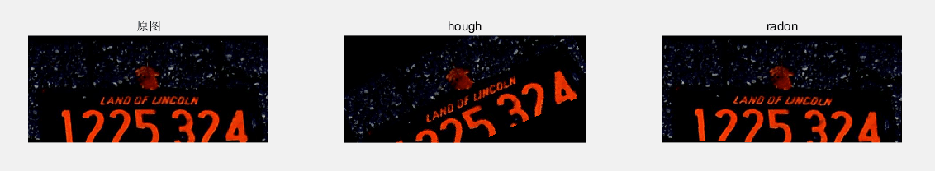

Fig.15 Skew correction

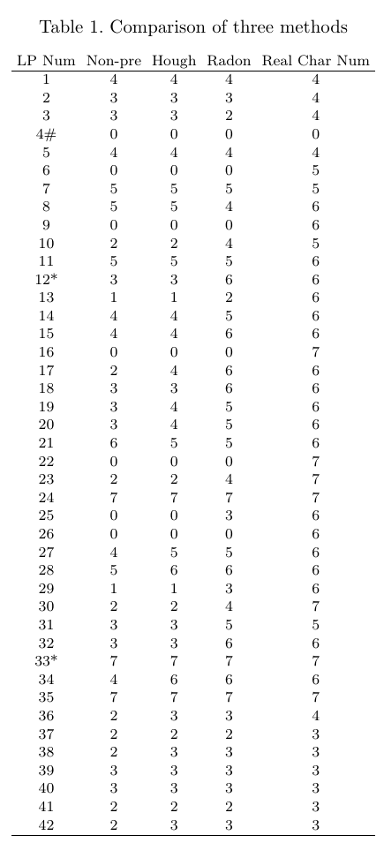

In table 1,We discussed the impact of angle correction on final recognition.(LP Num is license plate number; Non-pre is unprocessed results;* is requires license plate detection in project 4;License plate sorting is column first)

**D)Character Segmentation&Recognition**

The result is as follows:

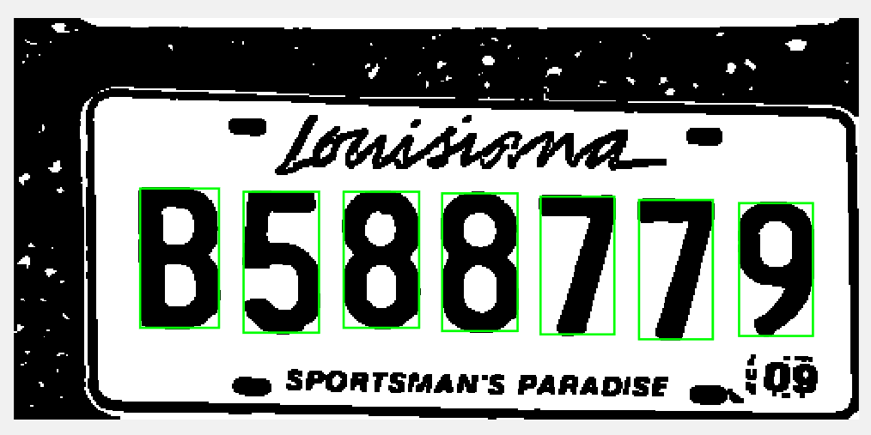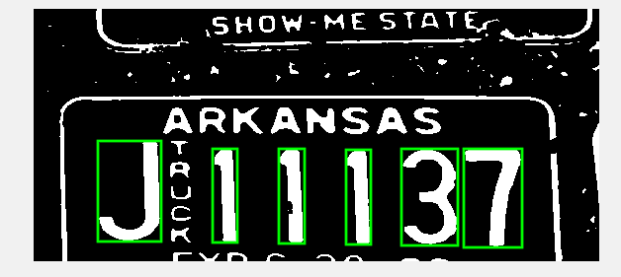

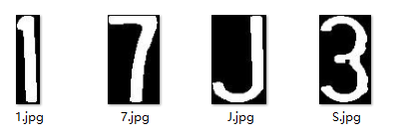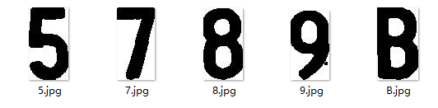

Fig.16 Final Results

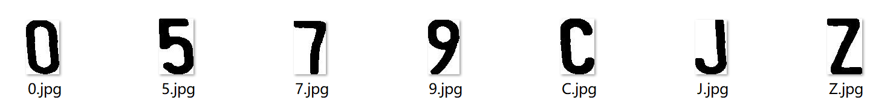

Fig.17 Result

**Tips:**

When we perform template matching, because we don't know whether the characters and background in a specific license plate are black or white, the template library has a background black and the characters are white. So when we match, we need to match twice. We use the original image to match, and then reverse the image and select the more matching result.

**Comparison of accuracy:**

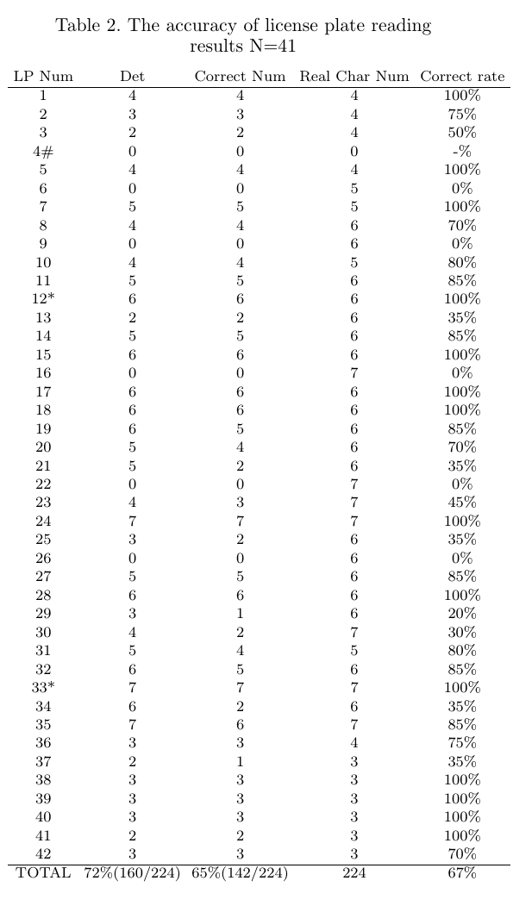

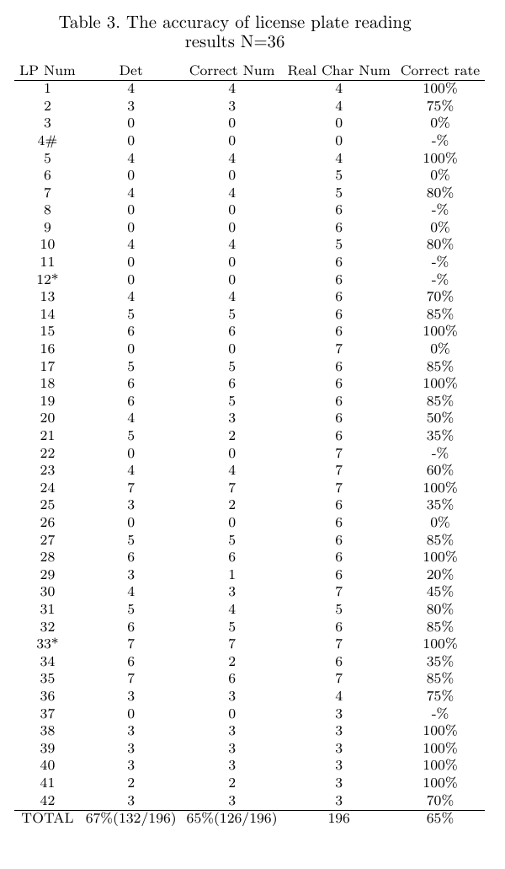

Table 2 is the result of projection method;Table 3 is the connected area method.(Det is number of characters detected in a single license plate;Correct Num is the correct number of detected characters)