For the current cvdevaluator web service, both cvdevaluator.com/api/ or api.cvdevaluator.com should work.

* Register (SIGNUP)

api.cvdevaluator.com/api/account/register

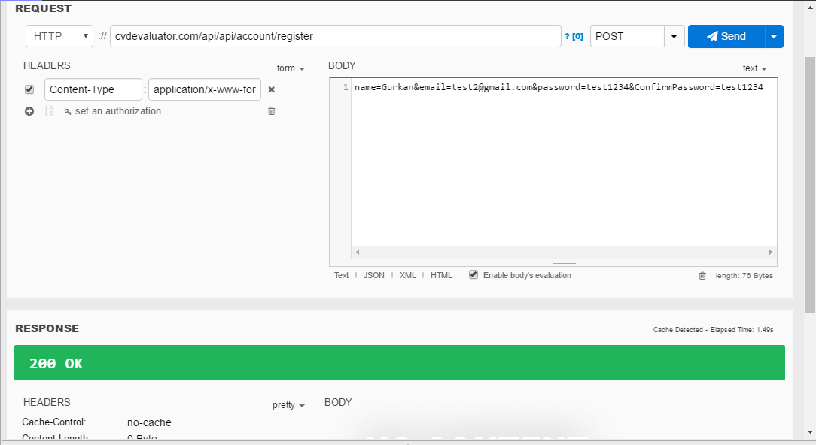

* Token (LOGIN)

api.cvdevaluator.com/token

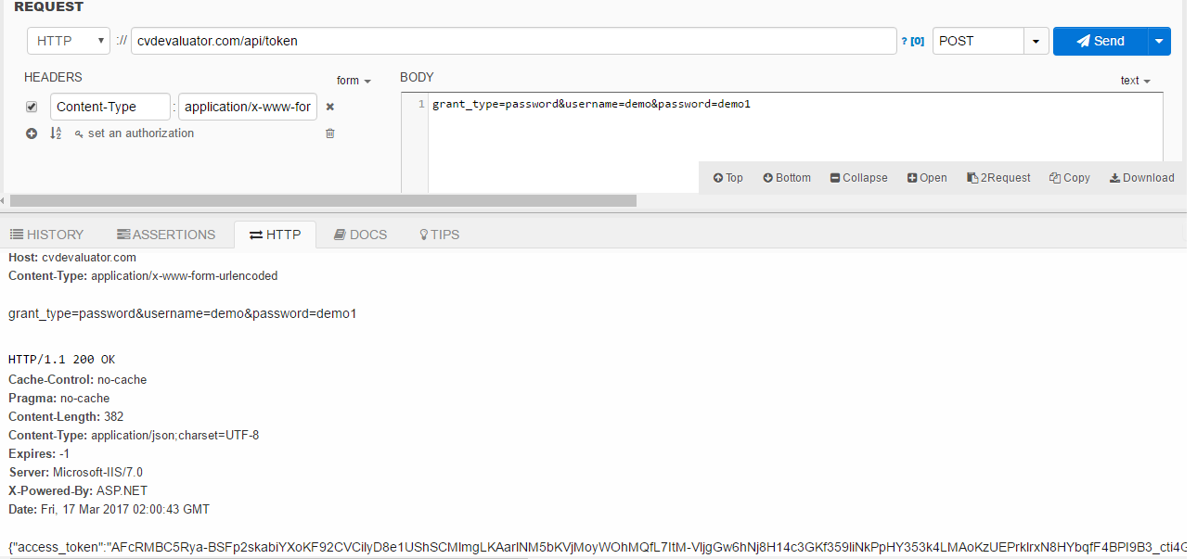

You will need the Bearer value in rest of the calls

* “Values” with parameters below for Compute

bool isPAH, int gender, int age, int SBP, int DBP, string inputs

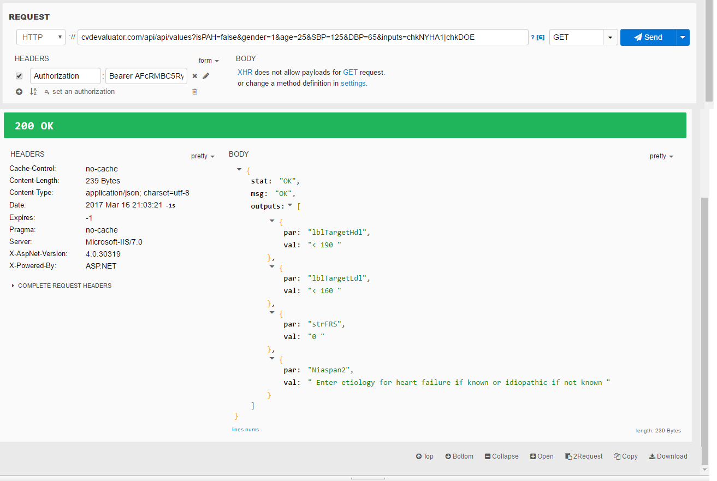

Below is the possible output parameters.

"lblTargetHdl":

"lblTargetLdl":

"strFRS":

"lblTargetSBP":

"lblTargetDBP":

"Niaspan1":

"Niaspan2":

"Niaspan3":

"Niaspan4":

"Niaspan5":

"strischemic":

"strCHFandAF":

"Output_Tansyon":

"outputLifevest":

"strValvular":

"outputSAH":

"outputCOAG":

"outputContrain":

"strStatin":

"strStatinIntolerance":

"outputICD":

"strreferral":

"strRef1":

"strRef2":

* “Values” without parameters returns the list of saved evaluations
* “Values” with ID parameter returns the specific saved evaluation for the given ID
* “Values” with parameters below saves the evaluation to database

string name, bool isPAH, int gender, int age, int SBP, int DBP, string inputs