FLEX lox2272/loxP Inversion — NGS Analysis Pipeline

Background
The FLEX (Flip-Excision) construct carries a 2xYFP reporter cassette in antisense orientation, flanked by two pairs of incompatible lox sites in inverted orientation: loxP and lox2272. Cre recombinase inverts (flips) the cassette into sense orientation by recombining either the loxP pair or the lox2272 pair. Because loxP and lox2272 are incompatible (different 8 bp spacers: loxP = AGCATACAT; lox2272 = AGGATACTTT), they cannot cross-recombine — each pair acts independently.

Construct Architecture and Molecular States

Construct layout
The pFLEX construct contains four lox sites arranged as two nested inverted pairs. The 2xYFP reporter cassette sits in antisense orientation between them.

5'--[lox2272->]A--L1--[loxP->]B--988bp antisense 2xYFP--[<-lox2272]C--L2--[<-loxP]D--3'

L1 and L2 are 50 bp linkers. loxP and lox2272 cannot cross-recombine, so each pair acts independently. In the starting state, both pairs are inverted - Cre can only invert, not excise.

How Cre produces two distinct final products
Path 1 — lox2272-flip then loxP excision
Step 1 (A-C inversion): A[lox2272->] -- SENSE YFP -- B'[<-loxP] -- L1_RC -- C[<-lox2272] -- L2 -- D[<-loxP]
Step 2 (B'-D excision): A[lox2272->] -- SENSE YFP -- B'[<-loxP] <-- LOCKED
L1 stays on the linear molecule. Junction retains the 8 bp segment CGCTGAC. => 584 bp amplicon.

Path 2 — loxP-flip then lox2272 excision
Step 1 (B-D inversion): A[lox2272->] -- L1 -- B[loxP->] -- L2_RC -- C'[lox2272->] -- SENSE YFP -- D[<-loxP]
Step 2 (A-C' excision): A[lox2272->] -- SENSE YFP -- D[<-loxP] <-- LOCKED
L1 is excised into the circle. Junction lacks CGCTGAC. => 579 bp amplicon (5 bp shorter).

Product | Junction | Amplicon | Detected by
Unflipped | antisense 2xYFP intact | ~928 bp | Unflip PCR
Locked Path 1 (lox2272-flip) | retains CGCTGAC | ~584 bp | Flip PCR
Locked Path 2 (loxP-flip) | lacks CGCTGAC | ~579 bp | Flip PCR

Why two separate PCRs are required
The post-anchor junction sequence is identical in unflipped and lox2272-flip reads — both have the same upstream flanking of site A. A single probe cannot distinguish them. The two-PCR design solves this at the amplification step: REV_UNFLIP only extends on unflipped molecules; REV_FLIP only extends on flipped molecules (it binds within the sense YFP, which is absent in the unflipped state). Flip reads are then classified into lox2272-flip vs loxP-flip by k-mer scoring of the 60 bp post-anchor window, exploiting the presence or absence of CGCTGAC.

Experimental Conditions
Code | Condition | Cre delivery | n (bio reps)
c51 | Negative control | None | 2
c51c39 | Positive control | Agrobacterium | 2
c30c41 | PVC (normal) | PVC — empty vector | 2
pFLS2 | PVC pFLS2 overexpression | PVC — pFLS2::Cre | 2 (reps 1,3)
pUBQ10 | PVC pUBQ10 overexpression | PVC — pUBQ10::Cre | 2 (reps 2,3)

Primers and Key Sequences

PCR Primers
Primer | Sequence (5' to 3') | Used in | Length
Forward (shared) | CCACTGACGTAAGGGATGACGCACAATC | Both reactions | 28 bp
Reverse — unflip | GGGCGACACCCTGGTGAACCG | Unflip PCR | 21 bp
Reverse — flip | GCCCTCGAACTTCACCTCGGCG | Flip PCR | 22 bp

Anchor Sequence
A 58 bp anchor sequence immediately downstream of the FWD primer is shared by all three molecular states (unflipped, loxP-flip, lox2272-flip). It is used to locate the read orientation and to define the start of the classification window.
Anchor (58 bp):
CCACTATCCTTCGCAAGACCCTTCCTCTATATAAGGAAGTTCATTTCATTTGGAGAGG

Junction Probe Sequences
Classification uses a two-step motif + edit-distance strategy. lox2272-flip is detected by searching for the 7-mer CGCTGAC (≤ 1 mismatch) in a ±5 bp window around the post-anchor junction start. If the motif is absent, loxP-flip is called when the Levenshtein edit distance between the 30 bp post-anchor head and the loxP reference is ≤ 3. Edit distance (allowing substitutions and indels) correctly handles reads where a small indel at the junction start would cause Hamming distance to be spuriously inflated. Reads failing both tests are unclassified.
State | 30 bp post-anchor head | Key motif | Amplicon
lox2272-flip | ACACGCTGACGGCCGCGTATTTTTACAACA | CGCTGAC (pos 3–9) | 584 bp
loxP-flip | ACAACGGCCGCGTATTTTTACAACAATTAC | absent | 579 bp

Distinguishing feature: lox2272-flip retains the 7-mer `CGCTGAC` immediately before `GGCCGCG`; loxP-flip lacks this segment entirely. The motif search in a ±5 bp window correctly handles lox2272 reads whose anchor was detected ~5 bp late. Edit distance (rather than Hamming) is used for loxP confirmation because Nanopore indels at the junction start cause a frameshift that inflates Hamming distance — two confirmed loxP reads had Hamming = 37/30 but edit distance = 3.

Pipeline Overview
Step 1: Size filter
- Unflip PCR reads: 800–1,050 bp (expected ~928 bp)
- Flip PCR reads: 480–680 bp (expected 579 or 584 bp)

Step 2: FWD primer detection and strand normalisation
- Hamming search (≤ 4 mismatches) on both the read and its reverse complement
- The strand on which FWD falls earliest defines canonical orientation

Step 3: Anchor detection
- Hamming search (≤ 8 mismatches) for the 58 bp anchor in the window immediately after FWD
- Unflip reads that pass anchor detection are counted as confirmed unflipped molecules

Step 4: Junction classification — motif + edit distance (flip reads only)
- Step 4a (lox2272): search for CGCTGAC (≤ 1 mismatch) in a ±5 bp window around the post-anchor start. Found → lox2272-flip.
- Step 4b (loxP): if motif absent, compute Levenshtein edit distance between the 30 bp post-anchor head and the loxP reference. ≤ 3 edits → loxP-flip; else unclassified.

Results

Table 1 — Per-sample read counts and flip classification
Total reads (unflip) and Total reads (flip) are raw read counts from each PCR reaction. Unflip (N) = reads passing size filter + FWD primer + anchor in the unflip reaction. lox2272-flip: CGCTGAC motif (≤ 1 mm, ±5 bp window). loxP-flip: edit distance ≤ 3 on 30 bp post-anchor head. See Pipeline for details.
Condition | Rep | Total  (unflip) | Total  (flip) | Unflip (N) | loxP-flip | lox2272-flip | Total flip | %loxP | %lox2272
Neg | 1 | 5,470 | 5,482 | 4,484 | 0 | 1,566 | 1,566 | 0.00% | 100.00%
Neg | 2 | 5,466 | 3,988 | 4,706 | 0 | 92 | 92 | 0.00% | 100.00%
Agro (+ctrl) | 1 | 5,473 | 5,467 | 4,729 | 1 | 4,573 | 4,574 | 0.02% | 99.98%
Agro (+ctrl) | 2 | 5,457 | 5,463 | 4,692 | 0 | 4,352 | 4,352 | 0.00% | 100.00%
PVC (normal) | 1 | 5,461 | 5,463 | 4,548 | 0 | 3,441 | 3,441 | 0.00% | 100.00%
PVC (normal) | 2 | 5,472 | 5,467 | 4,612 | 3 | 2,601 | 2,604 | 0.12% | 99.88%
PVC pFLS2 | 1 | 5,493 | 5,478 | 4,551 | 0 | 4,291 | 4,291 | 0.00% | 100.00%
PVC pFLS2 | 3 | 5,479 | 5,473 | 4,636 | 0 | 4,364 | 4,364 | 0.00% | 100.00%
PVC pUBQ10 | 2 | 5,448 | 5,470 | 4,599 | 0 | 4,143 | 4,143 | 0.00% | 100.00%
PVC pUBQ10 | 3 | 5,462 | 5,478 | 4,601 | 0 | 4,347 | 4,347 | 0.00% | 100.00%

Note on Neg rep1: The negative control replicate 1 shows an anomalously high lox2272-flip count (1,566 reads) compared with replicate 2 (92 reads). This discrepancy likely reflects a sample-level issue (e.g. low-level Cre contamination or sample swap) and should be confirmed by re-sequencing or re-planting.

Table 2 — Junction alignment to lox2272-flip reference (non-Neg conditions)
Condition | lox2272-flip reads (pooled) | Avg identity to reference | Min per-position identity
Agro (+ctrl) | 8,925 | 99.7% | 97.9% (pos 60)
PVC (normal) | 6,042 | 99.7% | 97.9% (pos 60)
PVC pFLS2 | 8,655 | 99.7% | 97.4% (pos 60)
PVC pUBQ10 | 8,490 | 99.8% | 97.5% (pos 60)

Figure 1 — Total flipped read counts per condition
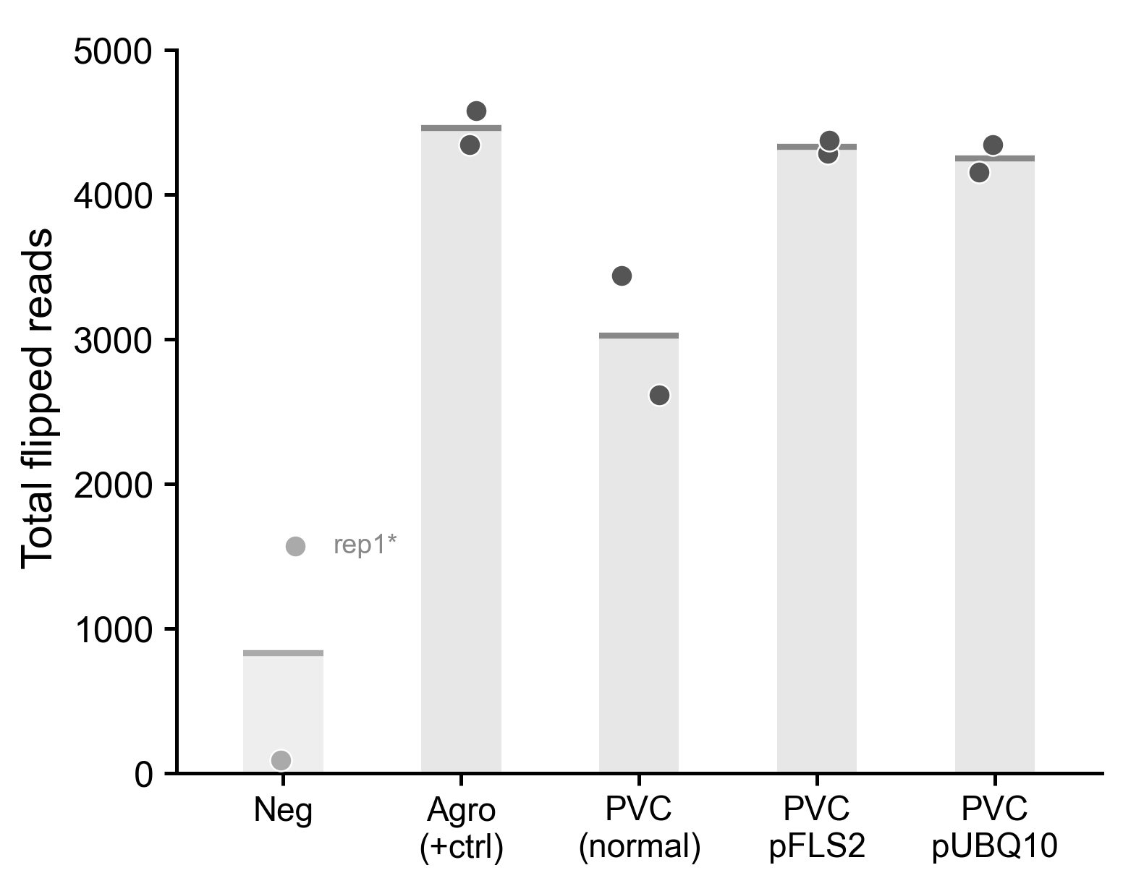
Figure 1. Total flipped reads (lox2272-flip + loxP-flip) per condition (individual replicates shown, bar = mean). Neg rep1* is anomalously high and treated as an outlier (see text).

Figure 2 — Per-position junction identity to reference
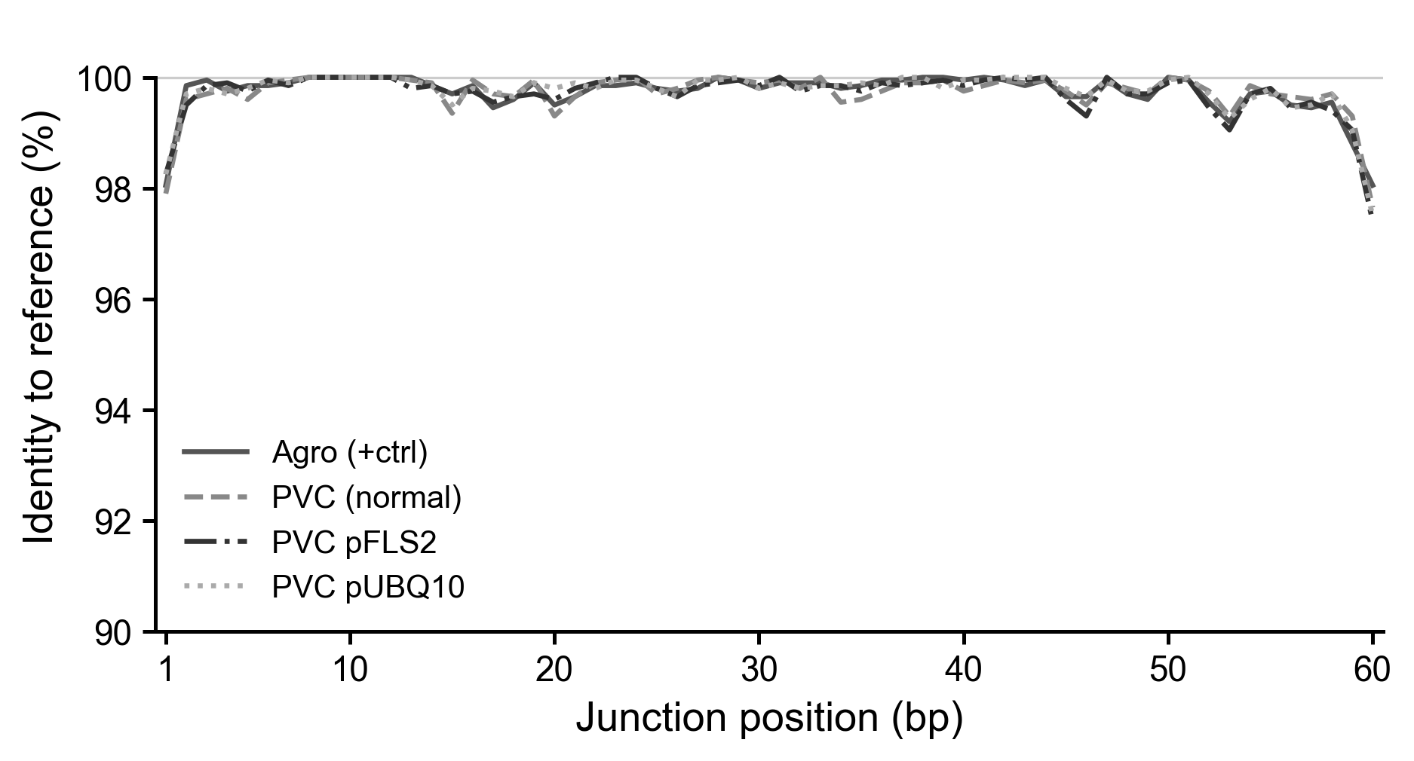
Figure 2. Per-position base identity (%) of lox2272-flip reads to the 60 bp reference junction, pooled across both replicates per condition. All four conditions overlap closely (avg 99.7–99.8%).

Figure 3 — Flip read composition per replicate
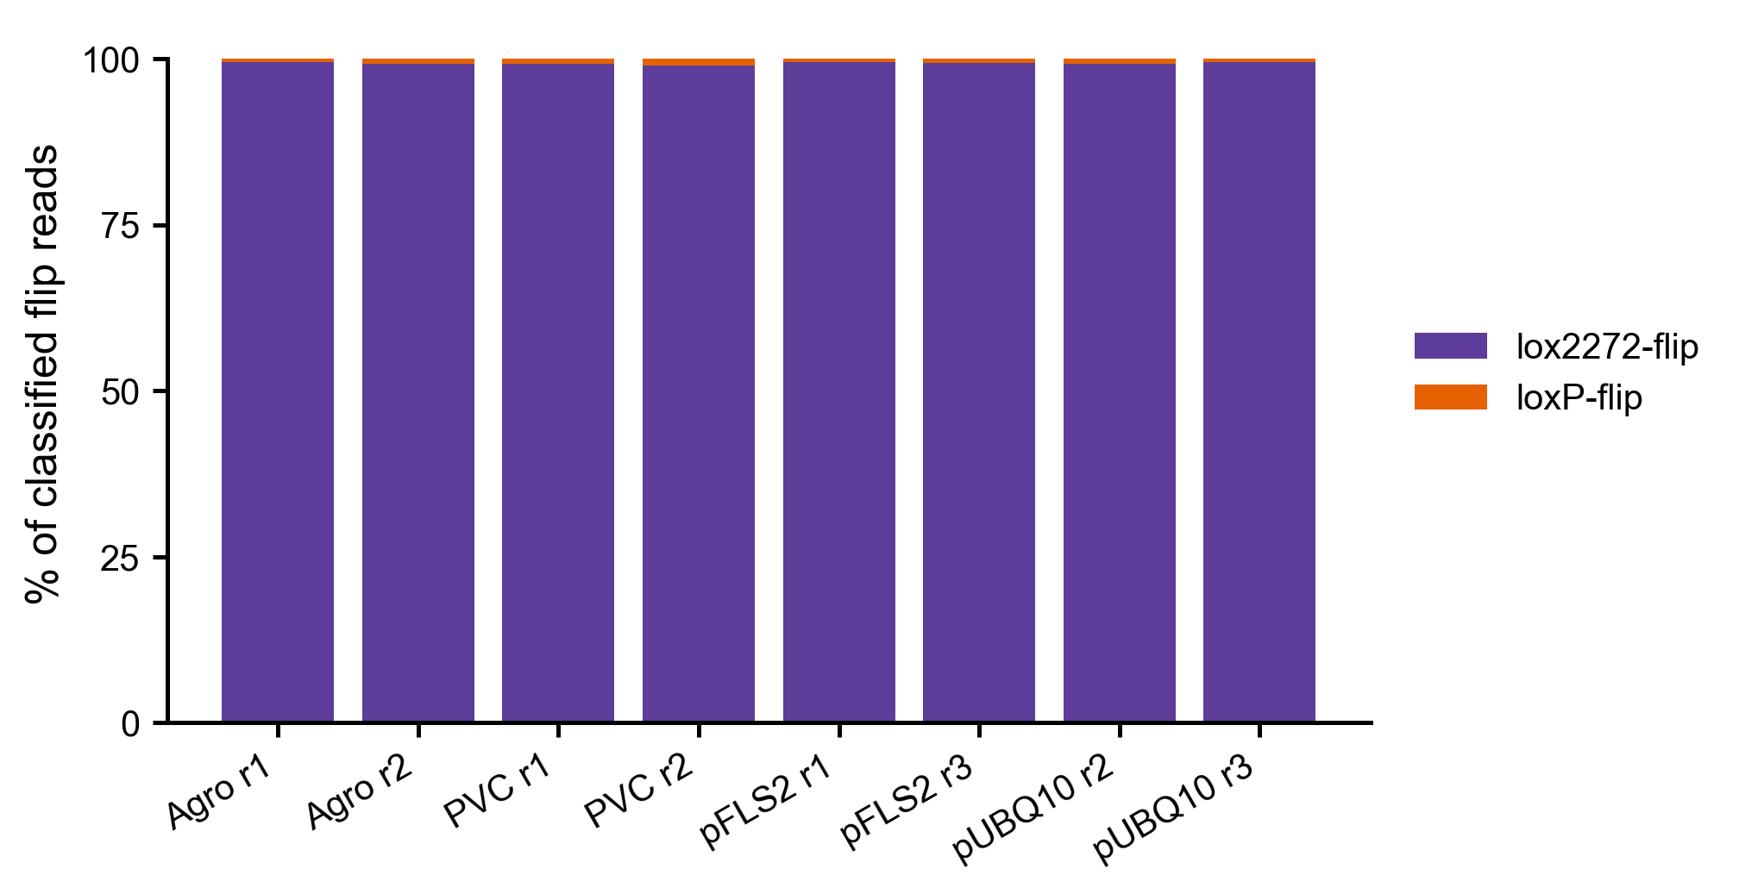
Figure 3. Proportion of flip reads classified as lox2272-flip (purple) vs loxP-flip (orange) per replicate (non-negative conditions only). lox2272-flip accounts for ≥99% of all classified flip events.

Figure 4 — lox2272-flip percentage per condition
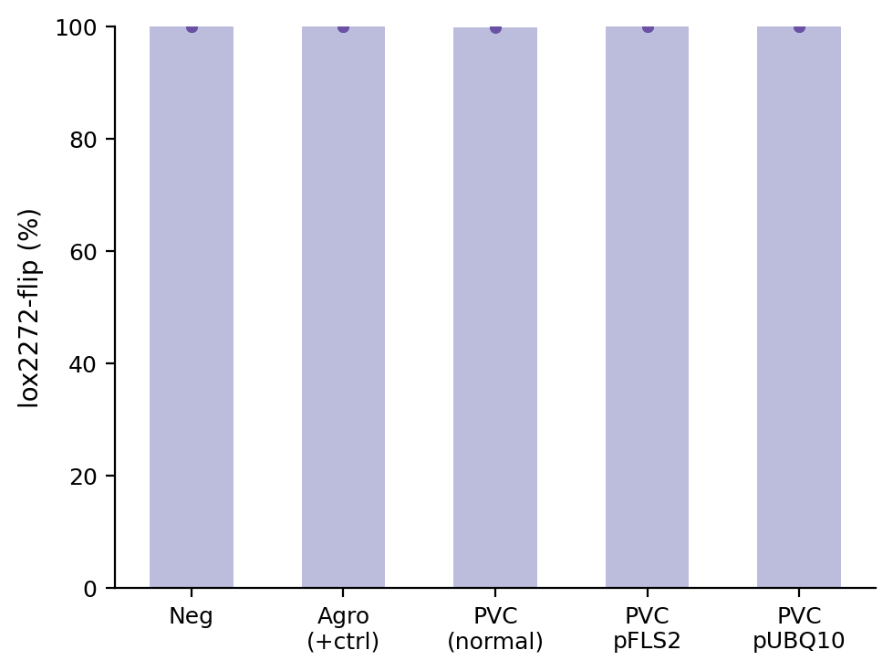
Figure 4. lox2272-flip as a percentage of all classified flip reads (individual replicates, bar = mean; y-axis 0–100%). All conditions are consistently >99%.

Figure 5 — loxP-flip percentage per condition
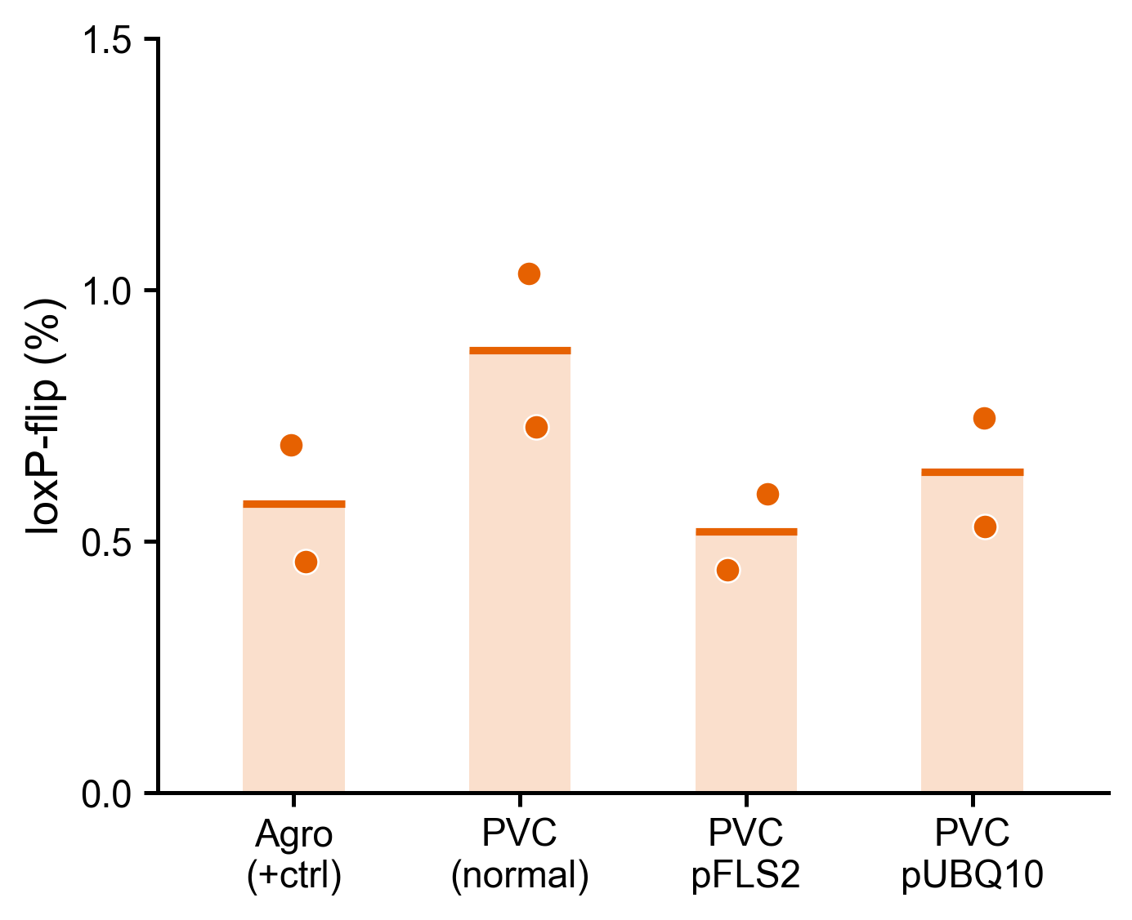
Figure 5. loxP-flip as a percentage of all classified flip reads (individual replicates, bar = mean; y-axis starts at 0). loxP-flip accounts for 0.0–0.1% of flip events across all conditions.

Figure 6 — lox2272-flip junction alignment
Figure 6. Nucleotide alignment of the most common lox2272-flip junction sequence per condition (most frequent read shown). Last 20 bp of the 35S anchor through the first 20 bp of 2×YFP (184 bp total). Annotation bars: 35S promoter, lox2272 junction (spacer), TMV UTR, 2×YFP. All conditions share an identical consensus junction sequence. A=#8dd3c7, T=#fb8072, G=#ffffb3, C=#bebada.

Key Findings
- lox2272-mediated inversion dominates across all conditions and replicates (99.9-100.0% of classified flip reads), suggesting strong preference for lox2272-site recombination in this FLEX construct.
- loxP-flip is extremely rare: 0-3 reads per sample (0.0–0.1%). These counts are at the noise floor and do not differ meaningfully between conditions.
- Agro (+ctrl), PVC pFLS2, and PVC pUBQ10 show high and consistent flip read counts (~4,100–4,580 per replicate), similar to the Agrobacterium positive control.
- PVC (normal) shows intermediate counts (~2,600–3,440), suggesting lower Cre delivery efficiency without the FLS2 or UBQ10 promoter-driven boost.
- Neg rep2 shows the expected near-zero flip signal (92 reads), confirming the pipeline correctly identifies unflipped molecules. Neg rep1 is anomalous and should be re-examined.
- Junction sequences in all four non-Neg conditions match the lox2272-flip reference with average 99.7% per-position identity, confirming correct Cre-mediated inversion at the expected lox2272 site.

