

**DOMBIVLI SHIKSHAN PRASARAK MANDAL’S**

**K.V. PENDHARKAR COLLEGE OF**

**ARTS, SCIENCE AND COMMERCE (AUTONOMOUS)**

**DOMBIVLI (E)-421203**

**A PROJECT REPORT ON**

*“DARKTRADER”*

**DEVELOPED BY:**

ADITYA SANJAY RATHIVADEKAR

THIRD YEAR OF COMPUTER SCIENCE

**UNDER THE GUIDANCE OF**

**PROF.** **RUPALI JAWALE**

**SUBMITTED TO**

**UNIVERSITY OF MUMBAI**

**2023-2024**



**CERTIFICATE**

**THIS IS TO CERTIFY THE FOLLOWING STUDENT HAVE SUCCESSFULLY COMPLETED THE PROJECT OF**

**DARKTRADER**

**AS PER THE SYLLABUS AND THAT IT FORMS A PART OF THE REQUIREMENTS FOR COMPLETING THE BSC DEGREE IN COMPUTER SCIENCE**

**ACADEMIC YEAR 2023-2024**

**NAME OF STUDENT: ADITYA SANJAY RATHIVADEKAR**

**ROLL NO: 234831**

**UNDER THE GUIDANCE OF**

**PROF. RUPALI JAWALE**

**Project Guide Head of Department Examiner**

**(Prof. Smita Sonawane) Computer Science**

Date:- _____________

ACKNOWLEDGEMENT

IT IS MATTER OF GREAT PLEASURE AND PROUD PRIVILEGE TO BE ABLE TO PRESENT THIS PROJECT ON “DARKTRADER”.

THE COMPLETION OF THE PROJECT WORK IS A MILESTONE IN STUDENT LIFE AND ITS EXECUTION IS INEVITABLE IN THE HANDS OF GUIDE. I AM HIGHLY INDEBTED THE PROJECT GUIDES PROF.MRS. RUPALI JAWALE. HER INVALUABLE GUIDANCE AND APPRECIATION FOR GIVING FORM AND SUBSTANCE TO THIS REPORT. IT IS DUE TO HER ENDURING EFFORTS, PATIENCE AND ENTHUSIASM, WHICH HAS GIVEN A SENSE OF DIRECTION AND PURPOSEFULNESS TO THIS PROJECT AND ULTIMATELY MADE IT SUCCESS.

I WOULD LIKE TO TENDER OUR SINCERE THANKS TO ALL THE H.O.D.

PROF. MRS. RUPALI JAWALE AND ALL THE TEACHERS FOR THEIR COOPERATION. I WOULD LIKE TO EXPRESS MY SINCERE THANKS TO MY FRIENDS.

I WOULD LIKE TO EXPRESS OUR DEEP REGARDS AND GRATITUDE TO THE PRINCIPAL DR. K.R. JAGDEO**.**

I WOULD LIKE TO THANK TO NON-TEACHING STAFF AND MY FRIENDS WHO HAVE HELPED ME ALL THE TIME IN ONE WAY OR THE OTHER.

**DECLARATION**

I hereby declare that the project work entitled “DARKTRADER” submitted to,

the D.S.P.M’S K .V. PENDHARKAR COLLEGE, is a record of an original

work done by me, under the guidance of Prof. Mrs. RUPALI JAWALE

Dept. Of Computer Science, and this project work is submitted in the partial

fulfilment of the requirements for the award of the degree of Computer

Science. The results embodied in this thesis have not been submitted to any

Other University or Institute for the award of any degree.

**Mr. Aditya Sanjay Rathivadekar**

**(TY.BSC CS)**

***Abstract***

DARKTRADER emerges as a game-changing platform in the realm of online trading, offering a comprehensive suite of features and functionalities aimed at empowering traders with the tools they need to thrive in dynamic financial markets. Built upon a foundation of cutting-edge technology and data-driven insights, DARKTRADER facilitates informed decision-making through its intuitive user interface and robust analytical capabilities.

From conducting technical analysis and backtesting strategies to predicting stock prices and monitoring real-time market data, users are equipped with the resources necessary to navigate complex trading environments with ease. Moreover, DARKTRADER leverages the power of machine learning to deliver personalized trading recommendations, tailored to individual trading preferences and risk tolerances.

By integrating educational resources and fostering a collaborative community, DARKTRADER not only empowers traders to achieve their financial goals but also cultivates a culture of continuous learning and improvement.

With its unwavering commitment to innovation and user satisfaction, DARKTRADER stands poised to redefine the landscape of online trading platforms, setting new standards for accessibility, functionality, and performance.

**INDEX**

|  |  |  |
| --- | --- | --- |
| **Sr.No** | **Description** | **Page No** |
| 1. | **Introduction**   * 1. Introduction   2. Objective   3. Purpose   4. Scope | 6 |
| 2. | **Literature Review**   * 1. Existing System (Previous History)   2. Drawbacks of Existing System | 8 |
| 3. | **Requirement Specification**   * 1. Problem Definition   2. Requirement Specification   3. Planning and Scheduling   4. Software and Hardware Requirement   5. Preliminary Product Description   6. Conceptual Models | 9 |
| 4. | **System Design Details**   * 1. Water-Fall Model   2. System Architecture Diagram   3. Activity Diagram   4. Class Diagram   5. Use case Diagram   6. Data Flow Diagram   7. Database Structure   8. Languages & Tools Used | 13 |
| 5. | **Code Implementation** | 19 |
| 6. | **System Design Details**   * 1. Test Cases   2. Screenshots | 20 |
| 7. | **Conclusion and Future Scope** | 21 |
| 8. | **References** | 23 |

**Chapter 1: Introduction**

**1.1 Introduction:**

In the dynamic landscape of financial markets, staying ahead of the curve is paramount for traders seeking success. DARKTRADER emerges as a beacon of innovation in this arena, offering a comprehensive trading platform tailored to meet the diverse needs of traders worldwide. This chapter provides an overview of DARKTRADER, outlining its objectives, purpose, scope, description, and key features.

**1.2 Objective:**

DARKTRADER aims to empower traders with cutting-edge tools and insights to navigate financial markets effectively. By providing a user-friendly platform equipped with advanced features, our objective is to facilitate informed decision-making and enhance trading performance.

**1.3 Purpose:**

The purpose of DARKTRADER is to revolutionize the trading experience by offering a holistic platform that caters to the needs of traders at every level of expertise. Whether users are novices looking to learn the ropes or seasoned professionals seeking advanced analytics, DARKTRADER endeavors to provide the tools and resources necessary for success.

**1.4 Scope:**

DARKTRADER encompasses a wide range of services aimed at empowering traders in their decision-making process. From technical analysis tools to predictive analytics and real-time data, the platform offers a comprehensive suite of features designed to meet the diverse needs of traders across various asset classes and markets.

* 1. **Description:**

DARKTRADER is a trading website that combines cutting-edge technology with user-friendly design to offer a seamless trading experience. Built on the principles of innovation and accessibility, the platform provides users with an array of tools and resources to analyze markets, develop trading strategies, and execute trades with confidence.

**1.6 Key Features of DARKTRADER:**

Technical Analysis: Advanced charting tools and technical indicators for in-depth market analysis.

Backtesting: Simulation of trading strategies using historical market data to evaluate performance.

Prediction of Stock Prices: Machine learning algorithms for forecasting future price movements with accuracy.

Real-time Stock Prices: Access to timely and accurate price data to stay informed about market developments.

Blog: Educational content and market insights to help users enhance their trading knowledge and skills.

**Chapter 2: Literature Review**

**2.1 Previous History:**

The evolution of trading platforms has been marked by significant advancements in technology and data analysis. Traditional trading platforms provided basic functionalities for executing trades and accessing market data. However, they often lacked robust analytical tools, leaving traders to rely on external resources for technical analysis and strategy development.

In recent years, there has been a proliferation of advanced trading platforms offering a wide array of technical analysis tools, backtesting capabilities, and algorithmic trading functionalities. These platforms have aimed to cater to the growing demand for sophisticated tools among both retail and institutional traders. However, while many of these platforms have brought valuable features to the table, they often suffer from limitations such as complex user interfaces, limited customization options, and lack of integration between different tools.

**2.2 Drawbacks of Existing System:**

Despite the progress made in the development of trading platforms, several drawbacks persist in many existing systems:

1. **Complexity:** Some trading platforms suffer from overly complex user interfaces and workflows, which can be overwhelming for users, particularly those new to trading.
2. **Limited Integration:** Many platforms offer disparate tools for technical analysis, backtesting, and news aggregation, leading to inefficiencies in workflow and decision-making.
3. **Data Quality and Accessibility:** Access to high-quality historical market data is essential for effective backtesting and analysis. However, some platforms may have limitations in data availability or provide data of questionable quality.
4. **Scalability:** As trading strategies become more sophisticated, the scalability of trading platforms becomes increasingly important. Some platforms may struggle to handle large volumes of data or complex trading algorithms efficiently.
5. **Security Concerns:** With the increasing prevalence of cyber threats, ensuring the security of trading platforms and safeguarding user data and assets is paramount. Some platforms may have vulnerabilities that expose users to risks such as hacking or unauthorized access.

**Chapter 3: Requirement Specification**

**3.1 Problem Definition:**

The existing landscape of trading platforms presents several challenges for traders, hindering their ability to navigate financial markets effectively. These challenges include:

Complexity: Many trading platforms are overly complex and difficult to navigate, particularly for novice traders. This complexity can lead to frustration and hinder users' ability to make informed decisions.

Lack of Comprehensive Tools: Existing platforms may lack essential tools for technical analysis, backtesting, and prediction of stock prices. Without access to these tools, traders may struggle to analyze market trends and identify profitable opportunities.

Security Concerns: Security vulnerabilities in trading platforms pose a significant risk to users' sensitive information and assets. These concerns undermine trust in the platform and deter traders from fully engaging with it.

Limited Accessibility: Some trading platforms may not be accessible to all users, particularly those with disabilities or limited technological proficiency. This lack of accessibility excludes a significant portion of potential traders from participating in the market.

* 1. **Requirement Specification:**

**Functional Requirements:**

**Technical Analysis Tools:**

DARKTRADER should provide users with advanced technical analysis tools, including customizable charting options, a wide range of technical indicators, and drawing tools for trend analysis.

**Backtesting Functionality:**

The platform should offer robust backtesting capabilities, allowing users to simulate trading strategies using historical market data. This feature enables traders to evaluate the performance of their strategies and make data-driven decisions.

**Prediction of Stock Prices:**

DARKTRADER should leverage machine learning algorithms and predictive analytics to forecast stock prices accurately. This functionality provides users with valuable insights into future market movements, enabling them to anticipate trends and adjust their strategies accordingly.

**Real-time Stock Prices:**

The platform must provide users with access to real-time stock prices, ensuring that they stay updated on market developments and price movements. Timely and accurate data is essential for informed decision-making in trading.

**Blog Section:**

DARKTRADER should include a dedicated blog section offering educational resources, market insights, and trading tips. This feature helps users enhance their trading knowledge and stay informed about relevant market trends and developments.

**Non-Functional Requirements**:

**Usability:**

The platform should be user-friendly and intuitive, with clear navigation and an intuitive interface that caters to traders of all levels of expertise.

**Security:**

DARKTRADER must prioritize the security of users' sensitive information and assets, implementing robust security measures to protect against unauthorized access and data breaches.

**Performance:**

The platform should be reliable and responsive, with fast loading times and minimal downtime to ensure a seamless trading experience for users.

**Accessibility:**

DARKTRADER should be accessible to all users, including those with disabilities or limited technological proficiency, by adhering to accessibility standards and providing alternative accessibility features.

**3.3 Planning and Scheduling**

Research (November): In November, the project initiated with an intensive research phase. The primary objective was to gain a profound understanding of the trading platform landscape, identify market needs, and delineate clear objectives for DARKTRADER. Extensive exploration of existing literature, trading platforms, and user requirements laid a robust foundation for subsequent phases.

Documentation (December): December witnessed a shift towards comprehensive documentation. Recognizing the significance of a well-documented project plan, I outlined tasks, milestones, and deadlines crucial for DARKTRADER's success. This documentation encompassed detailed descriptions of system architecture, design decisions, and dependencies, ensuring clarity and guidance for the development phase.

Coding (January): With the advent of January, the project transitioned into the coding phase. Tasks were delineated into smaller units to enhance manageability and efficiency. Adhering to software development best practices, I employed version control systems, maintained coding standards, and conducted regular code reviews. Component testing was integrated into this phase to facilitate early issue detection and resolution.

Testing (February): The final leg of the project in February was dedicated to rigorous testing. The objective was to validate every facet of DARKTRADER, encompassing functionality, performance, security, and user experience. An extensive set of test cases was prepared, and requisite data procured to facilitate thorough testing. Emphasis was placed on continuous integration and automation to augment testing efficiency and ensure the delivery of a robust and reliable trading platform.

**3.4 Software and Hardware Requirements**

Software Requirements:

Operating System: Any modern operating system capable of running Python and supporting web technologies, such as Windows, macOS, or various Linux distributions.

Python: Version 3.6 or higher is required, given its compatibility with Flask, the web framework utilized for server-side development.

Flask: Flask is utilized for creating and deploying the server-side components of DARKTRADER. Ensure the latest version compatible with your Python installation is utilized.

Data Science Libraries: Essential libraries including NumPy and pandas for data manipulation, scikit-learn for machine learning algorithms, and model evaluation, and NLTK for natural language processing.

Web Technologies: Basic knowledge of web technologies (HTML, CSS) might be beneficial for customizing the web application interface, although not strictly required due to Flask's high-level functionalities.

Version Control: Git is indispensable for version control and collaboration during the development process.

Integrated Development Environment (IDE): Any IDE or code editor that supports Python development, such as PyCharm, Visual Studio Code, or Jupyter Notebooks.

Dependency Management: Utilize pip or conda for managing Python libraries and dependencies efficiently.

Database (Optional): If persistent storage of data or models is required, a database system compatible with Flask, such as SQLite or PostgreSQL, can be integrated.

Hardware Requirements:

Processor: A multi-core CPU (Intel i5/i7/Ryzen 5/Ryzen 7 or equivalent) is recommended for efficient multitasking and computation.

Memory: A minimum of 8GB RAM is required, while 16GB or more is recommended for handling large datasets and intensive computations effectively.

Storage: An SSD (Solid State Drive) with at least 20GB of free space is necessary for storing the operating system, software installations, and project files. Additional space may be required for datasets.

Internet Connection: An internet connection is essential for accessing web-based resources, documentation, deploying the Flask application, and possible cloud integrations.

Graphics Card (Optional): A dedicated GPU is not required for this project unless deep learning models or extensive data visualizations are employed.

**3.5 Preliminary Product Description:**

DARKTRADER is a dynamic trading platform designed to empower users with advanced tools and insights for navigating financial markets. With a user-friendly interface and customizable options, it offers features such as technical analysis, backtesting, stock price prediction, real-time data access, and educational content. Robust security measures ensure the safety of user data, while the platform's performance and reliability guarantee seamless trading experiences. Accessibility is prioritized, catering to users of all backgrounds and abilities. In essence, DARKTRADER aims to revolutionize trading by providing a comprehensive and user-centric platform for success in today's markets.

**3.6 Conceptual Models:**

**Data Preprocessing Model**: This model ensures the integrity of incoming trading data by performing essential preprocessing steps. It cleans and standardizes raw data, removing unnecessary characters, converting text to lowercase, and tokenizing it into individual components. This standardized data serves as the foundation for subsequent analysis.

**Feature Extraction Model**: Following preprocessing, the system employs a feature extraction model to transform the data into a numerical format suitable for analysis by machine learning algorithms. Techniques like TF-IDF are utilized to quantify the significance of various features within the dataset, providing valuable insights into market trends and patterns.

**Machine Learning Model**: At the heart of DARKTRADER lies the machine learning model, trained on preprocessed and transformed data. Various algorithms, including regression, classification, and clustering techniques, are employed to analyze market data, predict trends, and inform trading decisions.

**Evaluation Model**: This conceptual model assesses the performance of the machine learning model using metrics such as accuracy, precision, recall, and F1 score. It ensures the reliability and effectiveness of the model in analyzing market data and guiding trading strategies.

**User Interaction Model**: Integrated into a user-friendly web application, this model defines how traders interact with the DARKTRADER platform. Traders can input trade parameters, view real-time market data, and execute trades seamlessly through an intuitive interface, enhancing user experience and facilitating informed decision-making.

**Feedback and Adaptation Model**: This model enables the platform to learn from user feedback and adapt to changing market conditions. By continuously updating the machine learning model based on user inputs and market dynamics, DARKTRADER remains agile and responsive, ensuring its effectiveness and relevance over time.

**Chapter 4: System Design Details**

**4.1 Water-Fall Model**

This Model was proposed by “Winston Royce”. It is also called as a classic life cycle. It suggests systematic sequential approach for software development. Water-Fall model is the absolute first model that is utilized in Software Development Life Cycle (SDLC).

In this model, the result of one phase is the contribution for the following phase. Advancement of the following phase begins just when the past phase is finished. First, requirement gathering is done and the design stage begins and so it goes on with rest of the stages.

**Relative effort for the various activities**

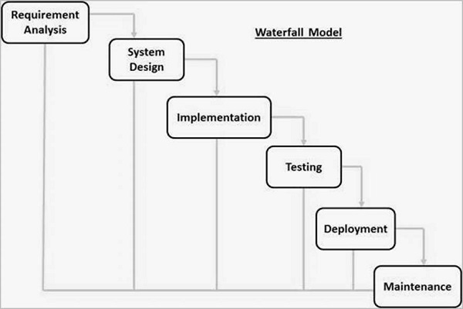This depicts the relative effort spent on the various activities up to delivery of the system. From this data a very clear trend emerges, the so-called 40-20-40 rule: 40% of the effort is spent on actually programming (coding) the system, while the preceding phases (requirements engineering and design) consume 20% and testing each contain 40% of the total effort.

**4.2 System Architecture Diagram**

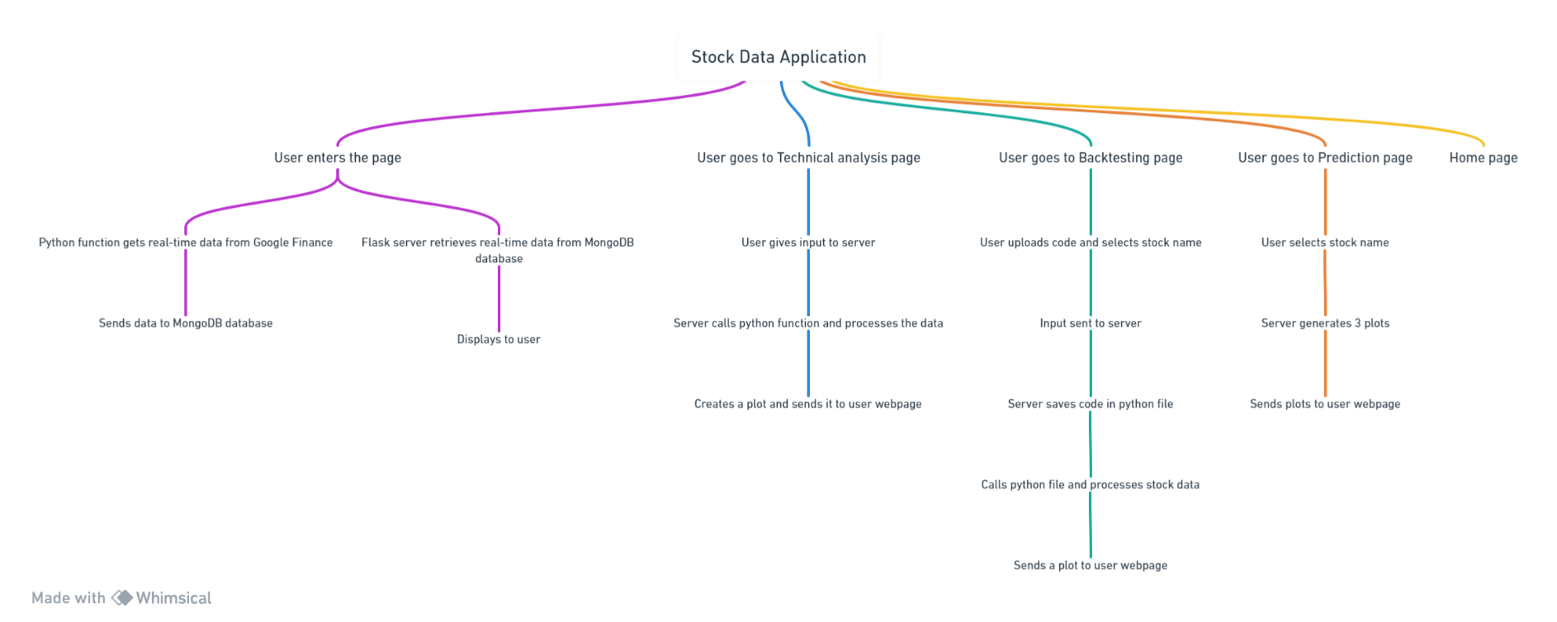

**4.3 Data Flow Diagram**

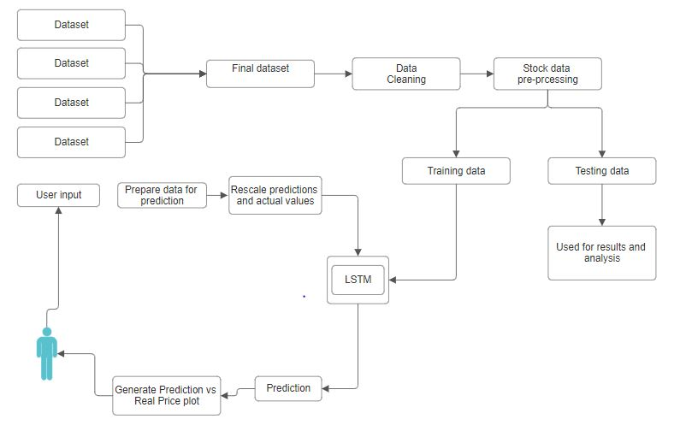

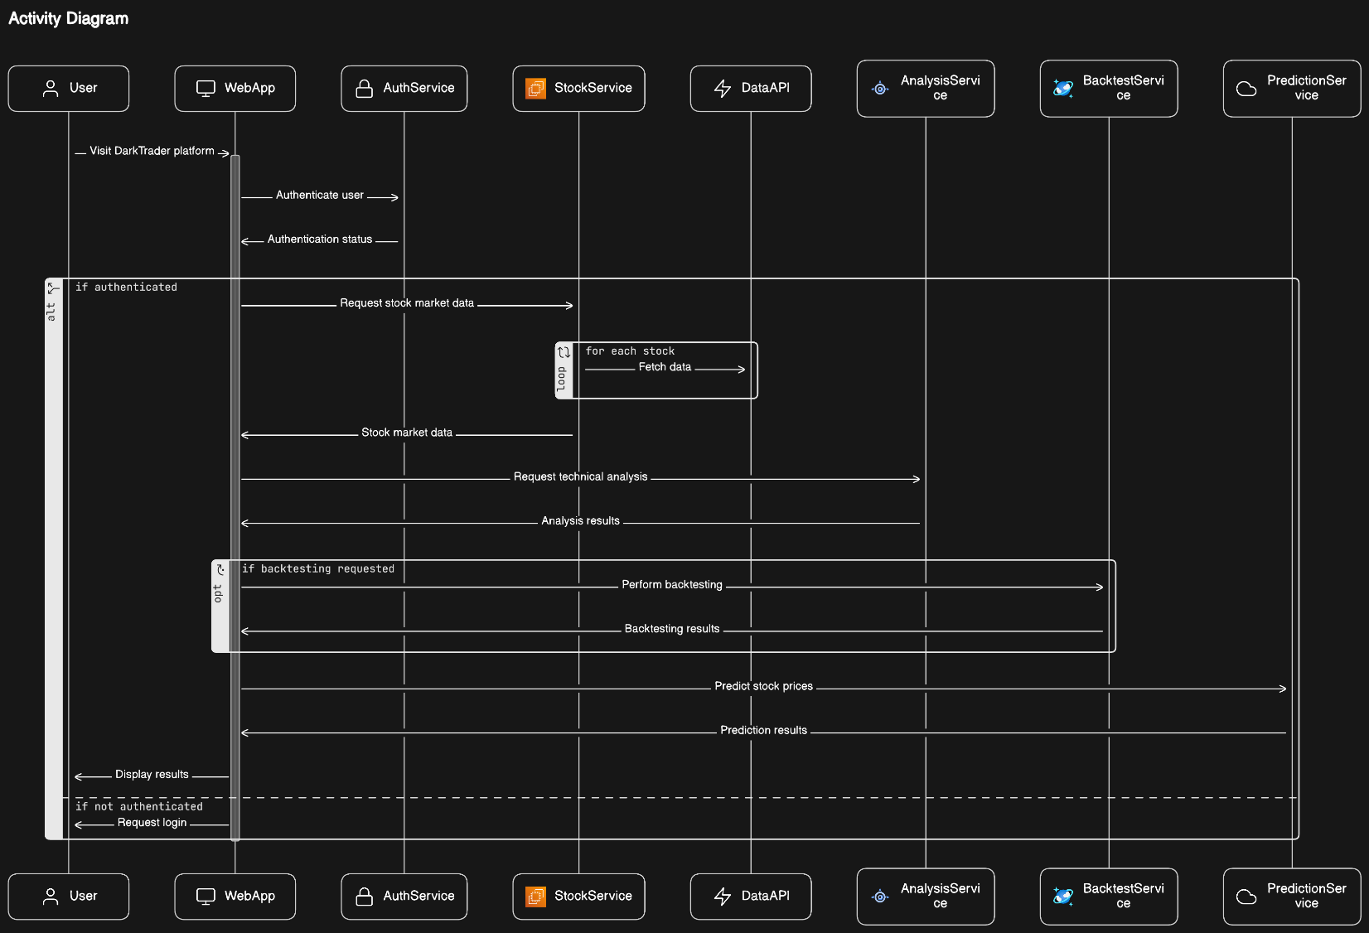**4.4** **Activity Diagram**

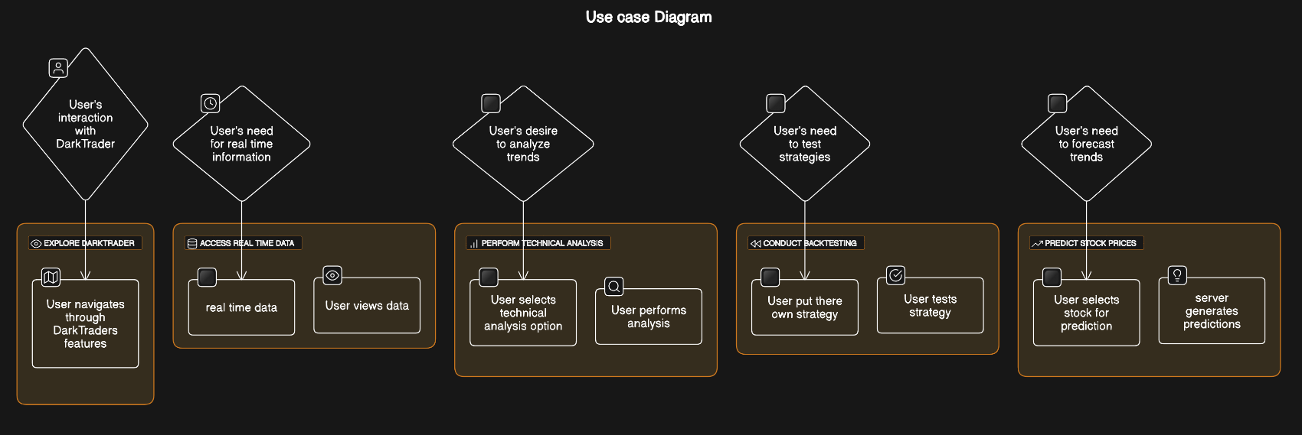**4.5** **Use case Diagram**

* 1. **Languages & Tools Used**

DARKTRADER leverages a combination of languages and tools to deliver its functionalities seamlessly. The key languages and tools employed in the development of DARKTRADER include:

**Python:**

Python serves as the primary programming language for developing the backend logic and algorithms of DARKTRADER. It is used for data preprocessing, feature extraction, machine learning model training, and other server-side functionalities.

**Flask:**

Flask, a lightweight web framework for Python, is utilized to build the server-side components of DARKTRADER. It facilitates the development of RESTful APIs, request handling, and routing, enabling smooth communication between the frontend and backend components.

**MongoDB:**

MongoDB, a NoSQL database, is chosen as the database management system for DARKTRADER. It provides a flexible and scalable solution for storing and managing trading data, user profiles, and system configurations.

**HTML:**

HTML (Hypertext Markup Language) is used for creating the structure and content of the web pages in DARKTRADER. It defines the layout, text, images, and other elements that users interact with when using the platform.

**CSS:**

CSS (Cascading Style Sheets) is employed to enhance the visual presentation and styling of the web pages in DARKTRADER. It controls aspects such as colors, fonts, layout, and responsiveness, ensuring a visually appealing and user-friendly interface.

**JavaScript:**

JavaScript is utilized to add interactivity and dynamic behavior to the web pages of DARKTRADER. It enables features such as real-time updates, form validation, and interactive charts, enhancing the overall user experience.

**Chapter 5: Code Implementation**

**Chapter 6: Results**

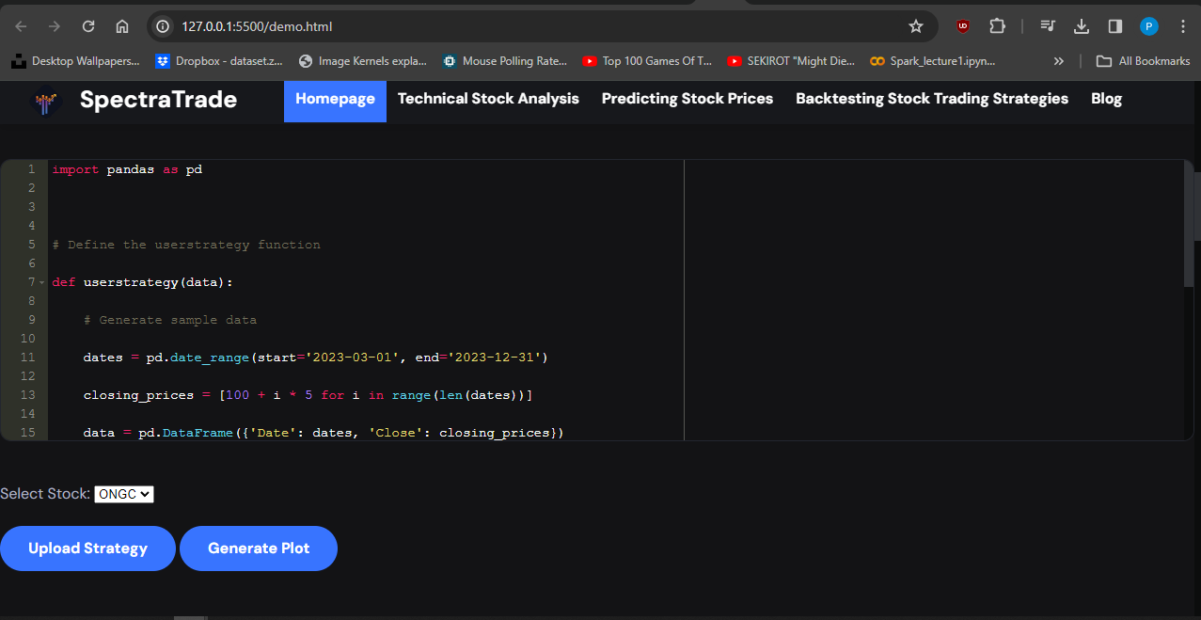

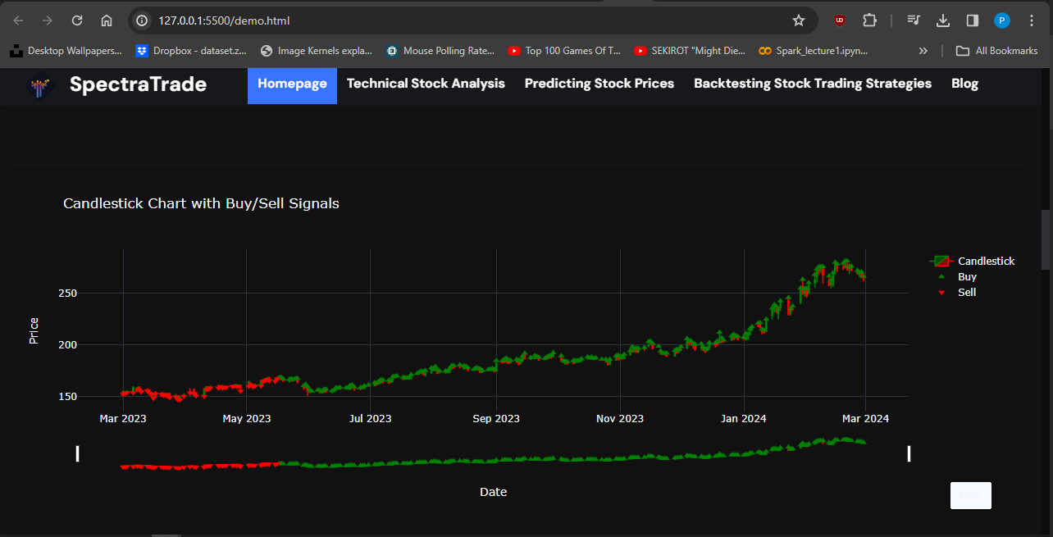

**Chapter 7:** **Conclusion and Future Scope**

**Conclusion:**

In conclusion, DARKTRADER represents a significant advancement in the realm of online trading platforms, providing traders with powerful tools and insights to navigate financial markets effectively. Through its user-friendly interface, robust analytical capabilities, and personalized trading recommendations, DARKTRADER empowers users of all levels to make informed decisions and execute trades with confidence. The platform's integration of machine learning algorithms, data science techniques, and real-time market data ensures a dynamic and responsive trading experience. By fostering a collaborative community and offering educational resources, DARKTRADER not only facilitates trading success but also promotes continuous learning and growth among its user base.

**Future Scope:**

Looking forward, DARKTRADER holds immense potential for further development and expansion in the ever-evolving landscape of online trading platforms. One avenue for future enhancement lies in the refinement and augmentation of its analytical capabilities. By incorporating advanced machine learning algorithms, sentiment analysis techniques, and predictive modeling tools, DARKTRADER can offer deeper insights into market dynamics and emerging trends, empowering traders to make more informed decisions.

Additionally, DARKTRADER can focus on enhancing the user experience by investing in user interface improvements, interactive visualization tools, and customizable features. By providing a seamless and intuitive trading environment, the platform can attract and retain a wider user base while catering to the diverse needs and preferences of traders.

Furthermore, the development of a dedicated mobile application for DARKTRADER presents an exciting opportunity to extend its reach and accessibility. A mobile app would enable users to access trading tools, real-time market data, and personalized recommendations on-the-go, facilitating convenience and flexibility in trading activities.

**Chapter 8:** **References**

Flask, Pallets Projects [flask.palletsprojects.com/en/2.1.x/](http://flask.palletsprojects.com/en/2.1.x/).

MongoDB [docs.mongodb.com/](http://docs.mongodb.com/).

Python Software Foundation [docs.python.org/3/](http://docs.python.org/3/).

NumPy Project [numpy.org/doc/](http://numpy.org/doc/).

Pandas [pandas.pydata.org/pandas-docs/stable/](http://pandas.pydata.org/pandas-docs/stable/).

scikit-learn developers, [scikit-learn.org/stable/documentation.html](http://scikit-learn.org/stable/documentation.html).

neural network <https://youtu.be/PuZY9q-aKLw>