**Verify changes**

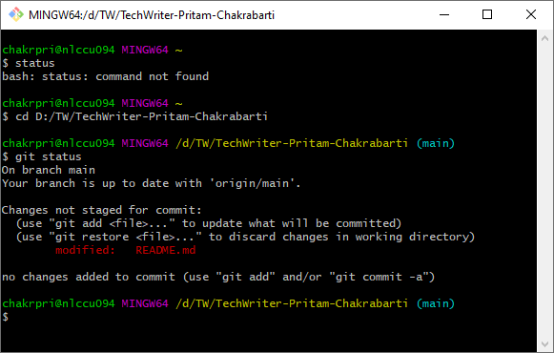

**Commit changes**

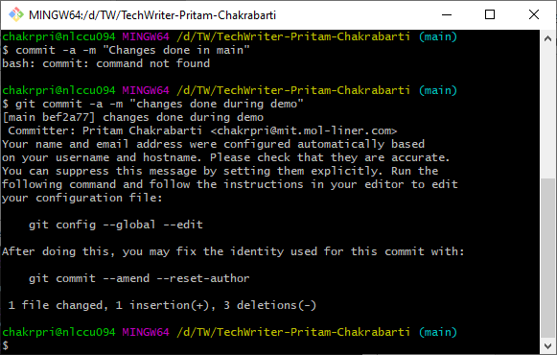

**Push the change (from Local mapped Folder to Git)**

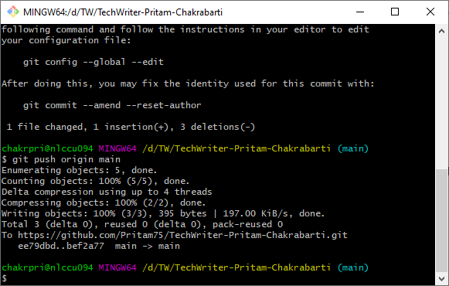

|  |  |
| --- | --- |
| **Before** | **After** |
|  |  |