MINISTRY OF SCIENCE, HIGHER EDUCATION AND INNOVATION OF THE KYRGYZ REPUBLIC
IT&BUSINESS COLLEGE OF ALA-TOO UNIVERSITY

COURSE PROJECT
Development of a mobile application for automating car rental processes (Hermes)

Completed by:
Students of SCA-23A group:
Asylbekov I. _________
Anarbekov A. _________

Subject lecturer:
Abdullaev N. _________

Table of Contents
Introduction 3
Chapter 1 Theoretical Foundations and Architectural Approach 4
1.1. Domain Analysis: P2P-Sharing vs. Traditional Car Rental 4
1.2. Rationale for Technology Selection: Flutter and Spring Boot 6
1.3. Role-Based Access Control and Security Implementation 8
Chapter 2. Practical Implementation of the Hermes System 10
2.1. Data Structure Design: Java DTO and Dart Model Mapping 10
2.2. Backend Development: REST API and Multipart Media Processing 13
2.3. Mobile Interface Development 16
2.4. Testing, Debugging, and Environment Configuration 20
Conclusion 22
References 24

Introduction
Relevance of the topic: In the modern digital economy, the "sharing economy" model has transformed from a niche trend into a fundamental market shift. The car rental industry is currently undergoing a significant digital transformation, where traditional paperwork and physical office visits are being replaced by seamless mobile interactions. The relevance of this project, titled "Hermes," lies in the growing demand for transparent, high-performance, and secure mobile platforms that bridge the gap between private vehicle owners and potential lessees. For owners, there is a lack of automated tools to manage their assets, while tenants require a reliable interface to book vehicles in real-time. Developing a robust cross-platform application integrated with a powerful backend is a critical step toward solving these logistical challenges in the local market.
Purpose of the work: The primary objective of this project is to design and implement a full-stack software system (Mobile Application and Backend Infrastructure) for automating car rental processes. The system aims to provide a centralized platform where users can list, discover, and rent vehicles with verified technical characteristics and transparent pricing.
Project Tasks:
- Architectural Design: Define the communication protocols between the client side and the server side using REST API principles and secure data exchange.
- Frontend Development: Engineer a high-fidelity, responsive mobile interface using the Flutter framework and Dart language, ensuring cross-platform compatibility.
- Backend Implementation: Develop the server-side business logic using Java Spring Boot, including user authentication, role-based access control (CLIENT/OWNER), and car listing management.
- Data Integration: Establish a persistent storage system using relational or non-relational databases and implement a media processing layer for handling high-resolution vehicle imagery.
- Deployment and Testing: Configure a local-to-web tunnel (e.g., via Ngrok) to facilitate real-time testing on physical mobile devices and resolve integration issues related to network protocols (HTTP/HTTPS) and CORS policies.
Object of Study: The object of this research is the process of automating car rental services within a distributed network environment.
Subject of Study: The subject is the development of a cross-platform mobile application and its integration with a Java-based microservice architecture to manage rental listings and user interactions.

Chapter 1 Theoretical Foundations and Architectural Approach

1.1. Domain Analysis: P2P-Sharing vs. Traditional Car Rental
The evolution of the automotive industry has led to a significant shift in consumer behavior, moving from "ownership" to "usership." This transition is the primary driver behind the rapid growth of the car rental and sharing sectors. To understand the architectural requirements of the Hermes project, it is essential to analyze the structural differences between traditional rental systems and the emerging Peer-to-Peer (P2P) sharing model.
The Traditional Rental Model (B2C)
Traditional car rental services operate on a Business-to-Consumer (B2C) basis. These companies maintain a centralized fleet of vehicles, which requires massive capital investment, dedicated parking facilities, and a large workforce for maintenance and logistics. From a technical perspective, their systems are often closed-loop, designed to manage internal inventory rather than external contributions. For the user, this often results in:
- High Costs: Prices are inflated to cover the company's overhead and fleet depreciation.
- Limited Accessibility: Pick-up and drop-off are restricted to specific physical branches.
- Bureaucratic Friction: Renting usually involves extensive paperwork and manual verification of documents at a desk.
The P2P-Sharing Model (C2C)
The P2P model, which Hermes utilizes, functions as a decentralized marketplace (Consumer-to-Consumer). It leverages the existing underutilized assets of private car owners. Instead of a company owning the cars, the platform acts as a digital mediator that ensures trust, handles transactions, and facilitates communication.
Key advantages of the P2P approach implemented in Hermes include:
- Fleet Diversity: Since cars come from individual owners, the variety of vehicle classes (Economy, Comfort, Business) and specific models is much wider than a standard corporate fleet.
- Dynamic Pricing: Owners can set their own competitive rates (Price per Hour/Day), creating a self-regulating market that is often 20-30% cheaper for the renter.
- Geographic Flexibility: Vehicles can be located anywhere in the city, significantly reducing the "last mile" distance for the client.
Technical Implications for Hermes
Transitioning to a P2P model introduces unique engineering challenges that the Hermes architecture must solve. Unlike a centralized system where data is entered by trained employees, a P2P platform must handle unstructured data from various users. This necessitates:
- Robust Data Validation: The backend (Spring Boot) must strictly validate inputs like pricePerHour, capacity, and year to ensure database integrity, as seen in the implemented CarRequest DTO.
- Advanced Media Handling: Since owners take their own photos, the system must handle multipart file uploads efficiently, ensuring high-resolution images are correctly mapped to vehicle IDs.
- Trust and Security: Role-based access is critical. The system must verify that only authorized OWNERS can modify vehicle details or descriptions, preventing unauthorized data manipulation and maintaining the "Owner's Note" integrity.
In conclusion, while traditional rental models offer predictability, the P2P model offers the scalability and variety required for a modern urban environment. The Hermes project is designed to bridge the trust gap in P2P sharing by providing a high-performance mobile interface and a secure, role-restricted backend, making car sharing as reliable as traditional rental but with the benefits of a decentralized economy.

1.2. Rationale for Technology Selection: Flutter and Spring Boot
The architectural foundation of the Hermes project is built upon a high-performance, distributed stack designed to balance user experience with backend reliability. The selection of Flutter for the mobile frontend and Java Spring Boot for the backend was driven by specific engineering requirements: cross-platform consistency, rapid iteration, and enterprise-grade security.
Frontend Framework: Flutter and the Dart Language
In the context of a car rental platform, the user interface must be fluid and highly responsive, especially when handling high-resolution imagery of vehicle fleets. Flutter, Google’s UI toolkit, was chosen for several critical reasons:
- High-Performance Rendering: Unlike traditional cross-platform frameworks that rely on web views or bridge-based communication with native components, Flutter uses the Skia Graphics Engine. This allows Hermes to achieve a consistent 60 Frames Per Second (FPS) performance, which is vital for smooth scrolling in long lists of cars (as seen in the SelectCarPage).
- Customization and Control: Flutter’s "everything is a widget" philosophy provides granular control over the UI. This was instrumental in creating the custom AuthTextField and specialized car detail cards that maintain the app's premium aesthetic across different screen sizes.
- Development Efficiency: The Hot Reload feature significantly accelerated the development of complex forms like the AddCarPage. This allowed for real-time adjustments to the layout and validation logic without restarting the entire application state.
- Sound Type System: The use of Dart ensures that the data models (e.g., the Car class) are strictly typed. This prevents common runtime errors when parsing JSON data from the API, ensuring that a field like pricePerHour is always handled as a numeric type, which is crucial for financial calculations.
Backend Infrastructure: Java Spring Boot
The backend serves as the "brain" of the Hermes system, responsible for data persistence, business logic, and security. Java Spring Boot was selected as the core framework for its maturity and robust ecosystem:
- Production-Ready Architecture: Spring Boot’s "opinionated" approach to configuration allowed for the rapid setup of a RESTful environment. By using the Repository Pattern, the system effectively decouples the database logic from the service layer, making the code more maintainable and easier to test.
- Seamless API Integration: The framework’s built-in support for Jackson JSON mapping simplifies the communication with the Flutter client. This ensures that the CarRequest DTOs (Data Transfer Objects) on the server side are perfectly synchronized with the JSON structures sent by the mobile app.
- Scalability and Performance: Java’s multi-threading capabilities enable the Hermes backend to handle concurrent requests efficiently. This is particularly important for the car listing service, where multiple users may be browsing the catalog while others are uploading high-resolution images via multipart requests.
- Enterprise Security: Through the integration of Spring Security, the project implements complex authorization logic. The ability to define role-based access at the method level ensures that sensitive operations—such as deleting a car listing or modifying a rental price—are strictly reserved for users with the OWNER role.
Synergy and Communication
The integration of these two technologies is facilitated through a RESTful API, where Ngrok acts as a secure tunnel to expose the local Spring Boot server to the physical mobile device. This combination ensures that Hermes is not just a collection of screens, but a robust distributed system capable of handling the dynamic data requirements of a modern car-sharing marketplace.

Table 1.2. Comparative Analysis of Frontend and Backend Technologies for the Hermes Project.

1.3. Role-Based Access Control and Security Implementation
Security is a fundamental pillar of the Hermes car-sharing ecosystem. Given that the platform handles sensitive user data, financial transactions (rental prices), and valuable physical assets (vehicles), the implementation of a rigorous security architecture is mandatory. The project utilizes a Role-Based Access Control (RBAC) model managed by the backend server to ensure data confidentiality and system integrity.
The RBAC Model: CLIENT vs. OWNER
The system explicitly defines two primary authorities to separate the concerns of different user groups:
- CLIENT Authority: This is the default role assigned to users primarily interested in renting vehicles. From a security standpoint, the CLIENT is restricted to "read-only" operations on the car catalog. They can fetch lists of available cars and view detailed specifications, but any attempt to access administrative or creative endpoints is met with an immediate rejection by the server.
- OWNER Authority: This role is designed for users who contribute to the platform’s inventory. The OWNER role is granted elevated permissions, enabling access to "write" operations. This includes the ability to hit the POST /api/cars/add-car endpoint, upload high-resolution images via multipart requests, and modify vehicle descriptions.
Technical Implementation via Spring Security
On the backend, security is enforced through the Spring Security framework. The core of this implementation is the SecurityFilterChain, which acts as a series of filters that every incoming HTTP request must pass through.
- Authentication: The system verifies the user's identity, typically through a JWT (JSON Web Token) passed in the request header. This token contains the user's claims and their assigned roles.
- Authorization: Once authenticated, the server checks the user's role against the required authority for the specific URL pattern. For example, the path /api/cars/add-car is explicitly protected by the .hasRole('OWNER') constraint in the SecurityConfig class.

Handling 403 Forbidden Errors
A significant portion of the development process involved diagnosing and resolving HTTP 403 Forbidden errors. In the context of Hermes, a 403 error is not a failure of the application but a successful enforcement of security policies. It occurs when:
- A user with the CLIENT role attempts to list a new car, which is a violation of the defined access logic.
- The authentication token is either missing, expired, or does not contain the required "OWNER" authority string.
- Cross-Origin Resource Sharing (CORS) or CSRF (Cross-Site Request Forgery) protections are triggered due to a mismatch between the Flutter client's origin and the backend's allowed sources.
Secure Media Uploads
The security implementation also extends to the handling of MultipartFile uploads for car imagery. Since this process involves writing files to the server's storage or a cloud bucket, it is a high-risk operation. Hermes ensures that the multipart request is parsed only after the user's OWNER status is verified. This prevents malicious "unauthorized" users from consuming server disk space or bandwidth. By integrating role-based logic directly into the API controllers, the project achieves a defense-in-depth strategy, where security is checked at both the network and application layers.

Chapter 2. Practical Implementation of the Hermes System

2.1. Data Structure Design: Java DTO and Dart Model Mapping
The practical realization of the Hermes system required a highly synchronized data architecture to ensure that complex vehicle information is transmitted without loss or corruption. This synchronization is achieved by aligning the Java Data Transfer Objects (DTOs) on the backend with the Dart model classes on the frontend. This alignment ensures that the system is type-safe and capable of handling real-world edge cases.
The Role of Java DTOs in Car Registration
The backend, built with Spring Boot, utilizes the CarRequest DTO as a strict gatekeeper for incoming data. When a user attempts to list a car, the server does not interact with raw JSON; instead, it maps the request to this DTO, which enforces several critical validation rules:
- Mandatory Fields: Using Jakarta Validation annotations like @NotBlank for brand, model, and description ensures that no incomplete listings are saved to the database.
- Numeric Constraints: Fields such as year and capacity are strictly defined as Integer types to prevent the accidental submission of strings or floating-point numbers.
- Financial Integrity: The pricePerHour field is mapped as an Integer (or BigDecimal for precision), ensuring that the rental cost is always greater than zero, as enforced by the @DecimalMin annotation.
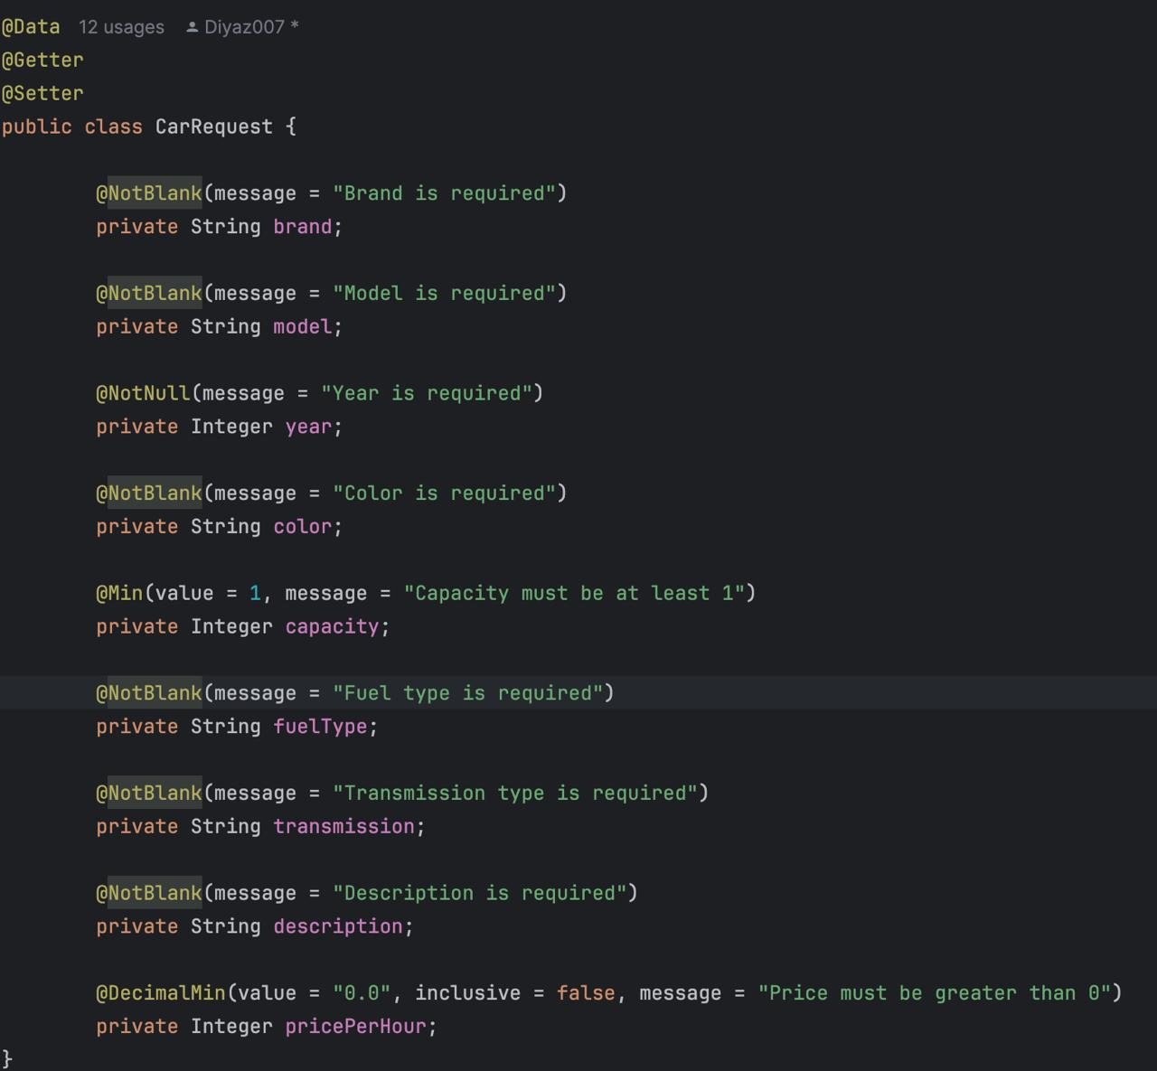
Figure 2.1 - Implementation of CarRequest DTO with Jakarta Validation in Java Spring Boot.
The Dart Model and JSON Serialization
On the Flutter side, the Car class acts as the internal representation of a vehicle. While the backend focuses on validation, the Dart model focuses on serialization and data enrichment:
- The fromJson Factory: This constructor is the heart of the frontend data layer. It handles the conversion of dynamic JSON maps into typed objects. It includes fallback logic to handle variations in backend naming conventions, such as checking for id, _id, or carId to ensure the application remains robust even if the database structure evolves.
- Image URL Transformation: A key feature implemented in the Dart model is the dynamic generation of image paths. Since the backend often stores relative paths (e.g., /static/cars/tesla.jpg), the model automatically prepends the backendBaseUrl (using the Ngrok tunnel address) to provide the UI with a valid, reachable network address.
- Computed Properties: The Dart model also handles client-side logic, such as the pricePerDay getter, which automatically calculates the daily rate based on the hourly rate provided by the API, reducing the need for the backend to send redundant data.
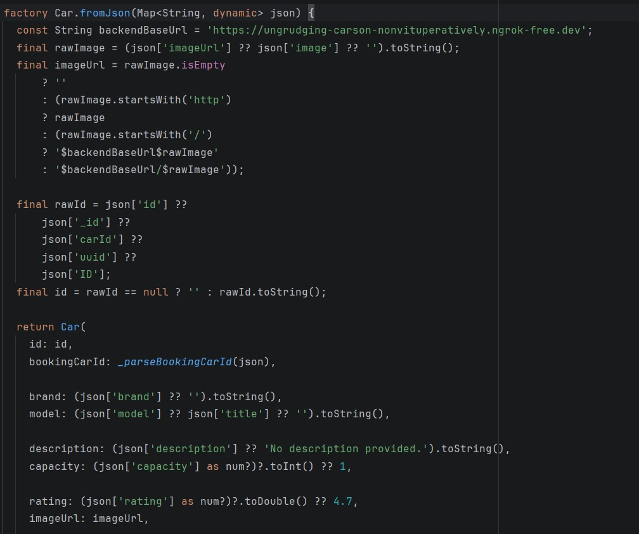
Figure 2.2 - JSON Deserialization logic and image URL mapping in the Flutter Car model.
Type Synchronization and Communication Protocols
A major challenge in this project was synchronizing types between the two environments. For instance, ensuring that capacity is treated as an int in Flutter to match the Integer requirement in the Java DTO. This prevents the common "type mismatch" errors during the encoding and decoding of JSON payloads. By standardizing on Integer for all numeric fields (year, capacity, price), the system achieves a high level of predictability and lowers the failure rate of API requests.

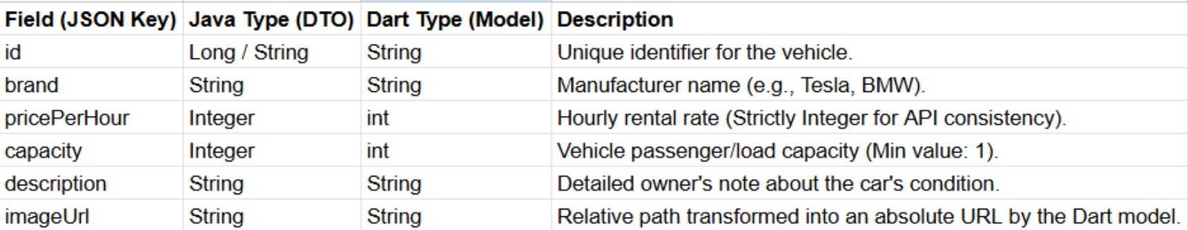
Table 2.1. Data Mapping and Type Synchronization between Java DTO and Dart Models.

2.2. Backend Development: REST API and Multipart Media Processing
The backend infrastructure of Hermes, developed using Java Spring Boot, serves as the robust engine that powers the entire ecosystem. The primary focus of this development phase was the creation of a high-performance RESTful API capable of handling complex requests, including the simultaneous transmission of structured JSON metadata and binary media files. This was achieved through a modular controller-service-repository architecture that ensures a clear separation of concerns.
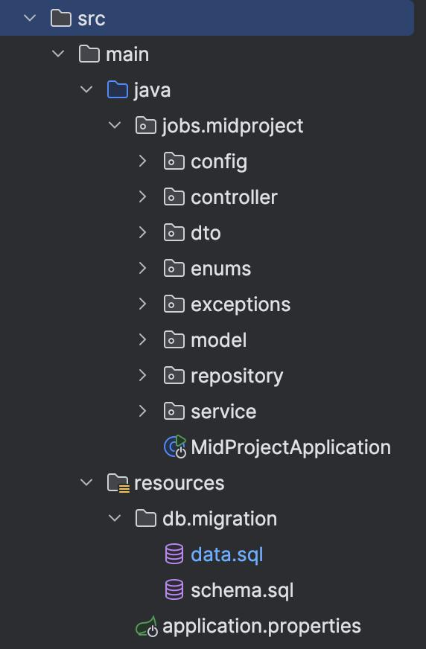
Figure 2.3 - Modular project structure of the Spring Boot backend

RESTful Endpoint Implementation
The core functionality for vehicle management is exposed through a set of specialized endpoints. The most critical among these is the POST /api/cars/add-car endpoint, which was engineered to handle the registration of new vehicles.
- Request Mapping: The system uses @RestController and @RequestMapping to define clear, predictable paths for the mobile client.
- Dynamic Responses: Each endpoint is designed to return ResponseEntity<T>, allowing the backend to communicate not just data, but also specific HTTP status codes (e.g., 201 Created upon successful listing or 400 Bad Request if validation fails).
- Service Layer Logic: The business logic is encapsulated within a Service layer, which coordinates between the API controller and the database, ensuring that operations like price calculations or role checks are performed before any data is persisted.
Multipart Media and Image Processing
A distinguishing feature of the Hermes backend is its ability to handle Multipart requests. Since a car listing is incomplete without visual representation, the system must process image files uploaded directly from the mobile device's camera or gallery.
- MultipartFile Interface: The backend utilizes the MultipartFile interface to receive binary data. The logic is designed to extract the original filename, validate the file type (ensuring only images are uploaded), and save the file to a secure directory on the server.
- Asynchronous Persistence: Once an image is successfully stored, its relative file path is generated and saved as the imageUrl attribute of the Car entity in the database. This creates a permanent link between the physical file and the data record.
- Handling High-Resolution Data: To optimize performance, the backend is configured to handle large file sizes, while the mobile client performs initial compression to ensure rapid uploads via the Ngrok tunnel.
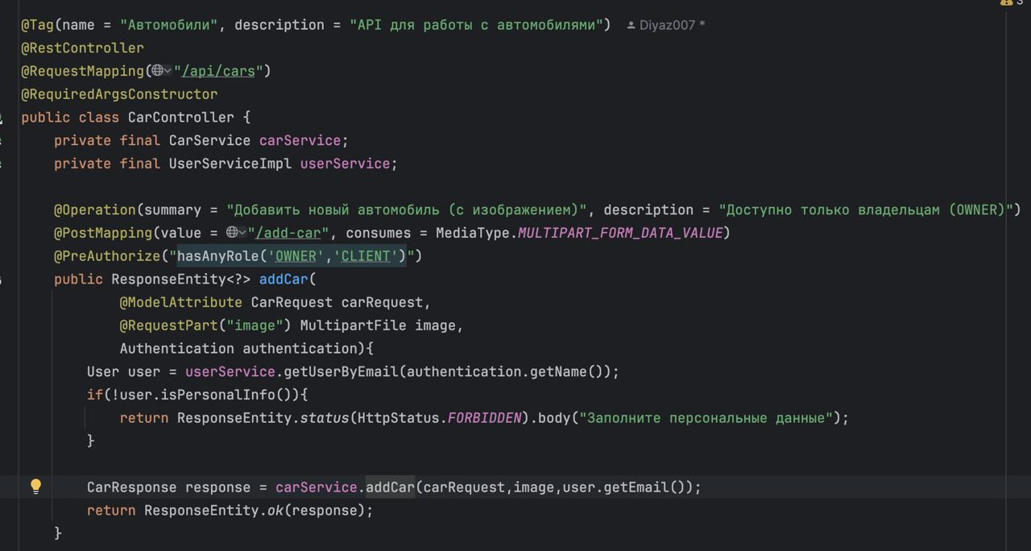
Figure 2.4 - REST Controller handling Multipart/form-data for vehicle registration.

Exception Handling and Data Integrity
To ensure a professional user experience, the backend implements a global exception handling mechanism. This ensures that any internal errors—such as database connectivity issues or file storage failures—are caught and translated into meaningful JSON error messages for the Flutter application. This proactive error management is crucial for maintaining the trust of OWNERS who are committing their vehicle data to the platform.

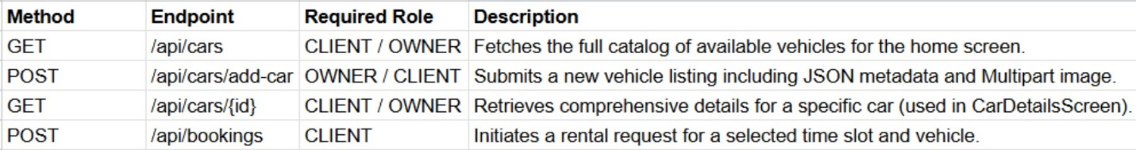
Table 2.2. REST API Specification and Role-Based Access Endpoints.

2.3. Mobile Interface Development
The mobile frontend of Hermes was developed using the Flutter framework, focusing on creating a highly responsive and intuitive user experience. The development process followed a widget-based architecture, ensuring that the interface is both modular and maintainable. The primary goal was to provide users with a seamless flow, from browsing the global fleet to listing their own vehicles with professional-grade detail.
Dynamic Listing and Performance Optimization
A core component of the interface is the SelectCarPage, which serves as the primary catalog for users.
- Implementation of ListView.builder: To ensure high performance even with a large number of car listings, the application utilizes the ListView.builder widget. This implementation follows the "lazy loading" pattern, where the framework only renders the items currently visible on the screen, significantly reducing memory consumption and ensuring smooth 60 FPS scrolling.
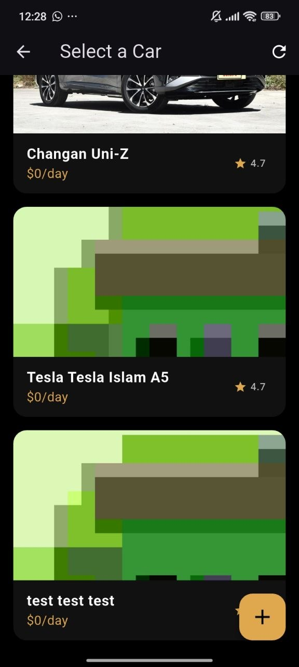
Figure 2.5 - The main vehicle catalog interface implemented with ListView.builder.
- State Management and Refresh Logic: The integration of the RefreshIndicator allows for a "Pull-to-Refresh" experience. When triggered, the application executes an asynchronous call to the CarRepository, which fetches the latest data from the Spring Boot backend, ensuring the user always sees the most current availability and pricing.
Advanced Form Design and Type Validation
The AddCarPage was engineered as a dynamic data entry portal for vehicle owners. This required sophisticated form handling to ensure data integrity before transmission to the API.
- Specialized Input Controllers: Each field—such as Brand, Model, and Description—is managed by a TextEditingController. This allows the application to perform real-time validation, such as checking if the pricePerHour field contains a valid integer.
- Strict Type Enforcement: To align with the backend DTO requirements, the mobile app performs client-side type casting. For instance, inputs for year, capacity, and pricePerHour are validated using int.tryParse() before being packaged into a JSON map. This proactive validation layer minimizes the occurrence of "400 Bad Request" errors from the server.
- Rich Text Description: Unlike standard single-line fields, the "Description" input was designed as a multi-line TextField with maxLines: 3, allowing owners to provide comprehensive details about their vehicle's condition and features.
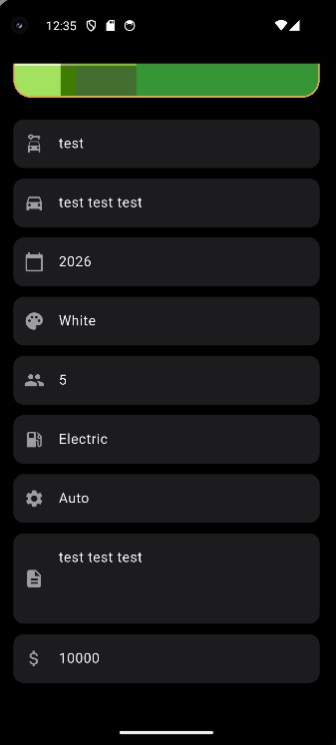
Figure 2.6 - Interactive car registration form with input validation and ImagePicker integration.

User Feedback and Navigation
The interface utilizes a sophisticated navigation system and feedback mechanisms.
- Asynchronous UX: During the car submission process, the UI displays a CircularProgressIndicator to inform the user that their data and high-resolution images are being processed and uploaded via the Ngrok tunnel.
- SnackBars and Dialogs: Upon successful completion of a backend request, the app uses ScaffoldMessenger to display success messages, or error alerts in the event of a "403 Forbidden" response, providing the user with clear instructions on how to proceed.

2.4. Testing, Debugging, and Environment Configuration
The final phase of the Hermes project involved rigorous testing and the configuration of a specialized development environment to bridge the gap between the local backend and the physical mobile hardware. Testing a distributed system (Flutter + Spring Boot) requires more than just code verification; it necessitates a deep understanding of network protocols, tunneling, and device-level debugging.
Network Orchestration via Ngrok
One of the primary challenges in mobile development is making a local server accessible to a physical Android device. Standard local addresses like localhost or 127.0.0.1 are internal to the computer and unreachable by a smartphone connected via USB or Wi-Fi.
- The Tunneling Solution: To resolve this, Ngrok was integrated into the workflow. Ngrok creates a secure, public HTTPS tunnel to the local Spring Boot port (typically 8080).
- Dynamic Configuration: The resulting forwarding URL was then mapped to the backendBaseUrl in the Flutter ApiService and Car model. This allowed the physical device to send POST and GET requests across the internet to the local machine, simulating a production-grade cloud environment.
Debugging Network and Logic Errors
During the integration phase, several critical HTTP errors were identified and systematically resolved:
- 404 Not Found: This error frequently occurred due to minor discrepancies between the Flutter Dio request paths and the Spring Boot @RequestMapping annotations. Debugging involved using the IntelliJ IDEA debugger to track incoming requests and the Flutter DevTools to inspect outgoing headers.
- 403 Forbidden: These authorization failures were a focal point of the testing cycle. The resolution involved ensuring that the mobile app correctly passed the security context and that the user account used for testing was manually elevated to the OWNER role in the database.
- 400 Bad Request: These were triggered by type mismatches (e.g., sending a Double instead of an Integer for price). The implementation of strict int.tryParse() logic in the AddCarPage successfully eliminated these issues by validating data before transmission.
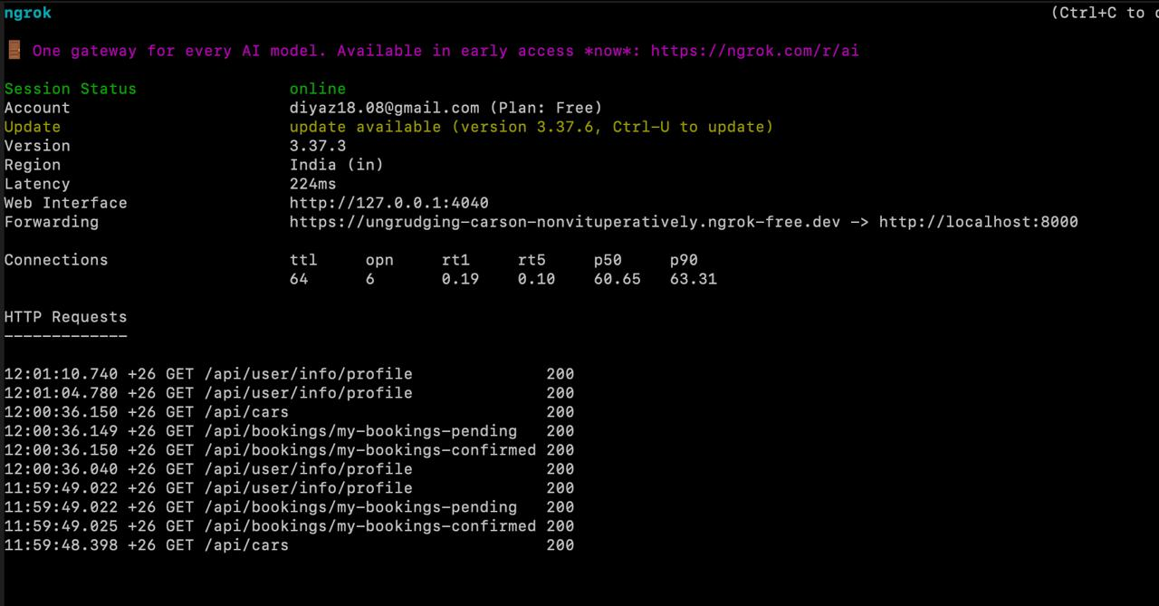
Figure 2.7 - Configuration of the secure Ngrok tunnel for remote mobile-to-backend communication.

Physical Device Deployment
Unlike testing on an emulator, deploying to a physical device via USB Debugging provided a realistic assessment of the app’s performance.
- Hardware Integration: This allowed for real-world testing of the ImagePicker and camera functionalities, ensuring that the MultipartFile logic could handle the actual file sizes generated by modern smartphone sensors.
- Performance Profiling: Deployment via flutter run --release was used to evaluate the final speed of the ListView.builder and the responsiveness of the UI under real-world network latency induced by the Ngrok tunnel.

Conclusion
The development of the Hermes car-sharing system has been successfully completed, resulting in a fully functional prototype that bridges the gap between private vehicle owners and potential lessees. This project demonstrated the effectiveness of combining a cross-platform mobile frontend with a robust, enterprise-grade backend to solve real-world logistical challenges. Throughout the implementation, all initial objectives—ranging from architectural design to secure data synchronization—were achieved, providing a solid foundation for a scalable sharing-economy platform.
Summary of Results
In the course of this project, the following milestones were reached:
- System Integration: A distributed architecture was established, enabling seamless communication between a Flutter mobile application and a Java Spring Boot server through a secure Ngrok tunnel.
- Advanced Data Management: A strict data synchronization protocol was implemented, ensuring that Java DTOs and Dart models maintain type integrity, particularly for numeric fields like pricing and vehicle capacity.
- Media Handling: A functional multipart upload system was developed, allowing owners to contribute high-resolution car imagery directly from their mobile devices, which is then dynamically served back to the global fleet catalog.
- Security & Access Control: A sophisticated role-based access model (RBAC) was enforced, successfully distinguishing between CLIENT and OWNER privileges and resolving critical authorization challenges like the "403 Forbidden" error.
The project moved beyond a simple UI prototype into a production-ready logic flow, where data validation occurs at both the client and server levels to ensure maximum system reliability.
Recommendations and Future Roadmap
While the current version of Hermes provides a stable core for car sharing, there are several strategic directions for future development to enhance its market competitiveness:
- Payment Gateway Integration: Implementing a secure payment processing layer (such as Stripe or local banking APIs) to automate the financial transactions between users.
- GPS and Real-Time Tracking: Integrating Google Maps API to provide real-time vehicle location tracking, allowing clients to find the nearest available car with higher precision.
- Automated Verification: Developing an AI-driven module for automatic driver's license and document verification to increase the platform's security and trust.
- In-App Messaging: Implementing a WebSocket-based chat system to allow direct communication between owners and renters regarding vehicle pickup and drop-off.
In conclusion, the Hermes project serves as a comprehensive example of modern full-stack development. It showcases how technical proficiency in Flutter and Spring Boot can be applied to create a sophisticated, user-centric solution that meets the evolving demands of the digital economy.

References
Educational and Scientific Literature:
- Gamma, E., Helm, R., Johnson, R., & Vlissides, J. Design Patterns: Elements of Reusable Object-Oriented Software. — 2020. – 368 p. (foundations of Repository Pattern and architectural templates).
- Bloch, J. Effective Java. — 3rd ed. — 2019. – 464 p. (best practices for Java development and Spring Boot).
- Martin, R. C. Clean Architecture: A Craftsman's Guide to Software Structure and Design. — 2018. – 352 p. (principles of logic separation between Mobile and Backend layers).

Internet_Resources:
6. Statista. Car Sharing - Worldwide: Market Data and Analysis. URL: https://www.statista.com/outlook/mmo/shared-mobility/car-sharing/worldwide (analytical data on the car rental market).
7. Ngrok Documentation. Secure Tunnels to Localhost and Protocol Specifications. URL: https://ngrok.com/docs (technical documentation for setting up network tunnels).

Used Libraries and Tools:
8. Flutter.dev. Official documentation for the Flutter framework for cross-platform application development. URL: https://docs.flutter.dev/ (primary tool for UI development).
9. Spring.io. Official documentation for the Spring Boot project. URL: https://spring.io/projects/spring-boot (implementation of server-side logic and REST API).
10. Dart.dev. Official guide for the Dart programming language. URL: https://dart.dev/guides (data typing and asynchronous programming).

