C:\Users\pwjva\Documents\GitHub\CMMITools\BASE_install\

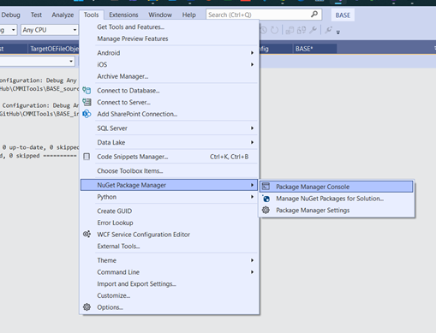

Password in Password File