C:\Users\pwjva\Documents\GitHub\CMMITools\BASE_install\
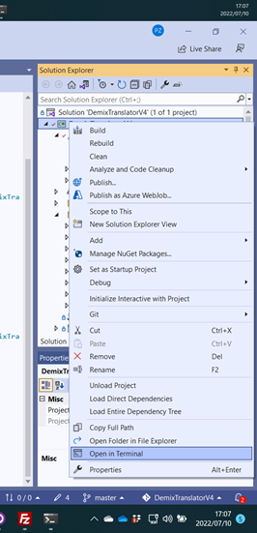
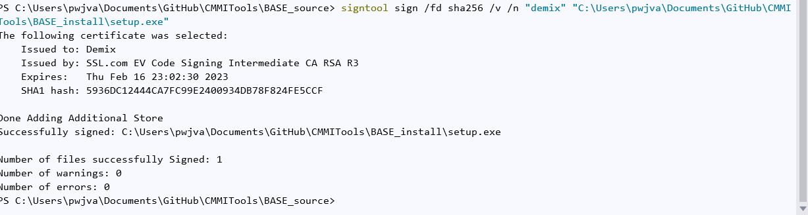
Password in Password File

