**Repairer portal**

*Bug =>* NEW-2290

* Duped information – high prio:
  + Does not show email address of duped
  + Does not show postalcode, is highly needed
* Additional phonenumbers are not shown -- @Marleen, geen idee of we dit hebben uitgevraagd (no idea if we asked this out) – Low prio

*Improvements*

* When the repairer is NOT using a supersaas agenda, the buttons for planning a repair or delivery appointment should not be visible. Currently it is visible
* For leakage detection should show a buttom “Upload leakage detection report” to make it easier / quicker
* Duped information: No comma’s in address line
* For leakage detection uploading damage photo should not be required – is already part of report
* Add appointment type”Investigation” (NL”Onderzoek”)
* Deed of assignment: a button to change the name of person signing. For example: duped is not home but the daughter / wife or so
* Document types: Alphabetical order needed
* Notes
  + No need to choose Party
  + Type of notes: Alfabetical order needed
* Deed of assignment look & feel is messy:
  + doesn’t show city
  + Many capitals are missing
  + Polistype shows English word instead of dutch ( “building”)
  + Damage date is shown US format should be EU (DD/MM/YEAR)
  + Typo’s in text!!
* Calculation
* Calculation type mentioned in english instead of dutch
* For leakage detection Plan of approach should not be a required field
* Because location in intake was only english, it also shows english location here. Should be dutch
* Construction needs to be out of the screen
* Free price services: the repairer fills in 50 euro, the system calculates 5% margin for repairer = 65 euro. Then the calculation should only show the 65 and not the 50 (that’s what you see right now). Additionally now it shows 50 and total 3* 65. Should only show 65 and 3*65!

*Language*

* When adding an appointment the appointment type is shown in English (when logged in as dutcH) => is fixed in QA envt, need extra deploy in Acc envt
* Ipad: when using landscape, signing the deed of assignment is not possible as you cannot scroll down. For portrait it does work – LOW Prio
* Leakage detection: when the repairer uploads leakage detection report + post-calculation the dossier should go to “Review investigation report” instead of review post-calculation and only after doing that you review the post calculation – High prio => was not mentioned before => here NEW-827, you can see that only “Review investigation reports » was mentioned but no further implementation for it

**Intake**

*Bug*

* Damage description Locations is still in English – medium prio => NEW-2293
* We created a dossier for client Zicht (Lekdetectie). In the dossier for contact info of client you see nothing while we have an email address and number filled in the Client attributes. Dossier number: 34A22100069 – low prio => NEW-2295

*Improvement*

* When finalising the intake you get 2 options: New intake or Close. You also want a button “Go to dossier”

**Dossier coordination**

*Bugs*

* Review investigation report button (tab documents) does not work – does not lead anywhere – High prio => it’s not a bug because no requirement behind it, see more NEW-742
* Expertise report – High prio => NEW-2306
  + Dossier date: Needs to be dutch format (DD/MM/YEAR)
  + Dossier coordinator: shows email address should be name (First name, last name)
  + Policy: Shows English name instead of dutch “Building”
  + Damage date: Needs to be dutch format (DD/MM/YEAR)
  + Workorder information: everything is mentioned in english and should be dutch
  + VAT misses %: should be 21%
  + Amount should be Excluding VAT, so should mention Amount excl. VAT), =>not clear
  + Should mention VAT amount => not mentioned in the layout
  + Total amount should mention incl. VAT = Total incl. VAT
  + Total damage amount 1x with VAT and 1x Without VAT
  + Ten name van (named to) shows address CED instead of CED name
  + Factuurnummer is empty: should show invoice number of fincom
  + Uiterste factuurdatum is empty. Should show payment date from Fincom
* Adjust margins (not needed for leakage detection) doesn’t work well. When adjusting the percentage the calculation line adjusts and becomes empty – High prio => NEW-2222
  + Column Margin is missing, now you cannot see which margin is used
  + Improvement: Euro sign should be before the amount

**FINCOM integration**

* Margin client does not show the service prices in fincom: 34A22100068 - BLOCKING
  + Supplier MDM: the services appear multiple times, 1x with price 1x without price
  + The original sales pricelist is correct so it seems an issue on the Supplier MDM side

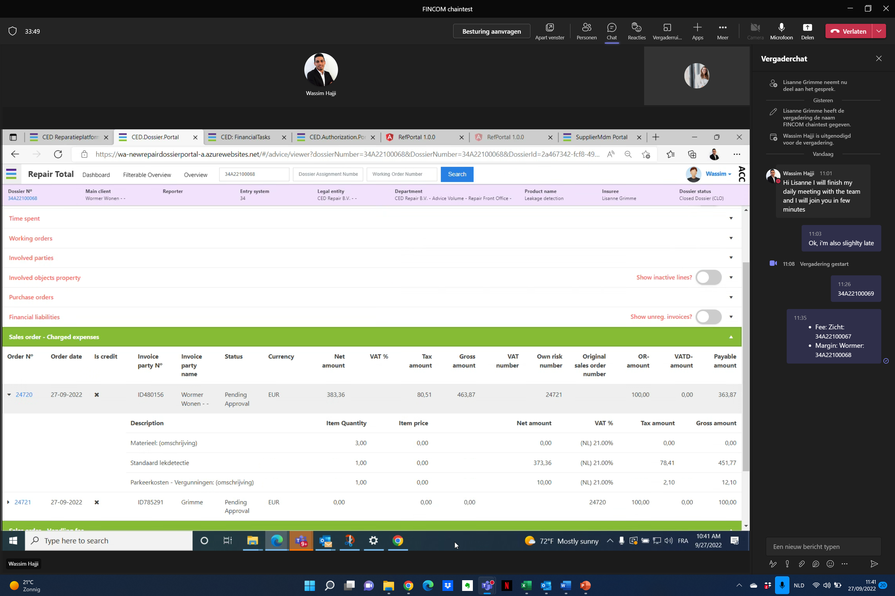

**Data entry**

* Zicht appears 2x (one time with capital and comma, one time without): Client MDM
* Parking costs appear as 21%. According to Margien this should be 0%: FINCOM

**Discussion point FINCOM**

* Leakage detection dossier 34A22100069 when reviewing the calculation it shows BTW verlegd. So no VAT for purchase which is incorrect.Because this is only applicable for the Contractors and not Sub-contractors like AB Lekdetectie. Need to be able to do settings per client if BTW verlegd yes or no – BLOCKING
  + In FINCOM we also see no VAT which means BTW Verlegd (VAT reversed charge)
  + All suppliers are sub-contractors in FINCOM and ruling in FINCOM is that reversed VAT charge is applicable to all sub-contractors 🡪 While Business says only applicable to contractors
* Engin: FINCOM is correct. Best to double check those with no VAT reversed charge if that’s correct

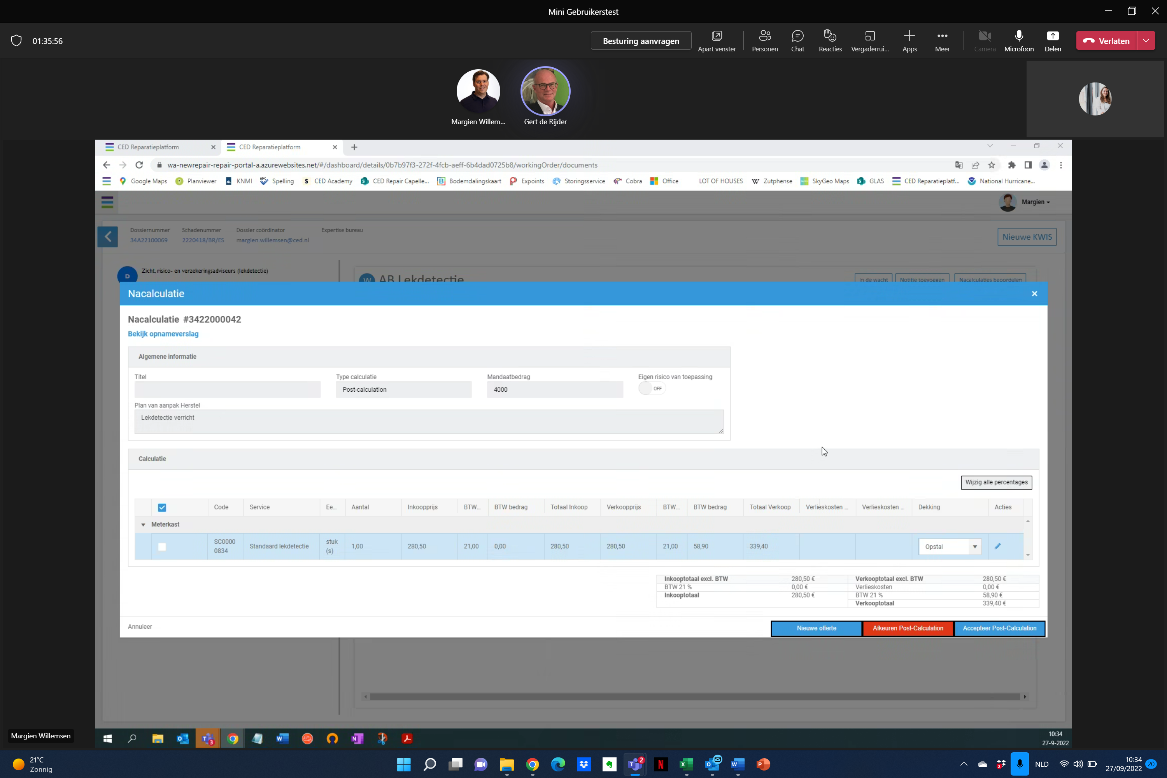

**Discussion point BA**

* A leakage detection dossier get’s automatically status In execution (because there’s no agenda for AB Lekdetection). However, when adding an appointment ( opname because there’s no appointment type Investigation) it goes to status to visit and then you need to make a pre-calc which should not be required
  + Engin: Appointment should be a dummy appointment which does not influence the flow
* When approving post-calculation for leakage detection the dossier is directly closed and a fee invoice is sent (assumption – or only when creatin a report?). Then when there’s additional assignment for repair, you re-open dossier – finalise WO. Will there be an additional fee invoice?
  + Engin: yes fee invoice is sent when dossier is closed
  + When creating another WO after re-opening, the extra WO FEE will be differently calculated so there is no double charge
* Temporary situation: Leakage detection in new repair and Repair assignment in Mendix. How are the fee invoices done correctly?
  + Fee clients are not going to NEW-repair for now until we go 100% to NEW-Repair