1. Create (POST /pet)

Positive Scenario
- Test Case: Create a new pet with valid data.
- Request:
{
"id": 1,
"category": {
"id": 2,
"name": "Tom"
},
"name": "cat",
"photoUrls": [
"string"
],
"tags": [
{
"id": 0,
"name": "string"
}
],
"status": "available"
}
–-
Response:
{
"id": 1,
"category": {
"id": 2,
"name": "Tom"
},
"name": "cat",
"photoUrls": [
"string"
],
"tags": [
{
"id": 0,
"name": "string"
}
],
"status": "available"}
- Expected Response Status Code: 200
- Validations: Check if the returned pet object has the correct details.
—----

Negative Scenario
- Test Case: Try to create a pet with missing required fields.
- Request:
Unfortunately Swagger does not seem to work as it should
I have posted
{
"id": 0,
"category": {
"id": 0
},
"name": "doggie",
"photoUrls": [
"string"
],
"tags": [
{
"id": 0,
"name": "string"
}
],
"status": "available"
}

Where I have missing required fields and yet the response got 200….

2. Read (GET /pet/{petId})

Positive Scenario

CURL
curl -X 'GET' \
'https://petstore.swagger.io/v2/pet/3' \
-H 'accept: application/json'

Response:
{
"id": 0,
"category": {
"id": 0,
"name": "string"
},
"name": "doggie",
"photoUrls": [
"string"
],
"tags": [
{
"id": 0,
"name": "string"
}
],
"status": "available"
}
- Test Case: Retrieve a pet that exists.
- Request: GET /pet/123
- Expected Response Status Code: 200

- Validations: Check if the pet details are correct.
—

Negative Scenario
CURL:
curl -X 'GET' \
'https://petstore.swagger.io/v2/pet/3333' \
-H 'accept: application/json'

Response:
Error: response status is 404

{
"code": 1,
"type": "error",
"message": "Pet not found"
}
—------

3. Update (PUT /pet)

Positive Scenario

CURL:
curl -X 'PUT' \
'https://petstore.swagger.io/v2/pet' \
-H 'accept: application/json' \
-H 'Content-Type: application/json' \
-d '{
"id": 3,
"category": {
"id": 0,
"name": "string"
},
"name": "doggie",
"photoUrls": [
"string"
],
"tags": [
{
"id": 0,
"name": "string"
}
],
"status": "available"
}'

Response:
{
"id": 3,
"category": {
"id": 0,
"name": "string"
},
"name": "doggie",
"photoUrls": [
"string"
],
"tags": [
{
"id": 0,
"name": "string"
}
],
"status": "available"
}

Code: 200

Negative Scenario
Seems like PUT is not working as it should
Putting a query with no ID specified, it populates random ID pointing nowhere and code is 200, which is incorrect.
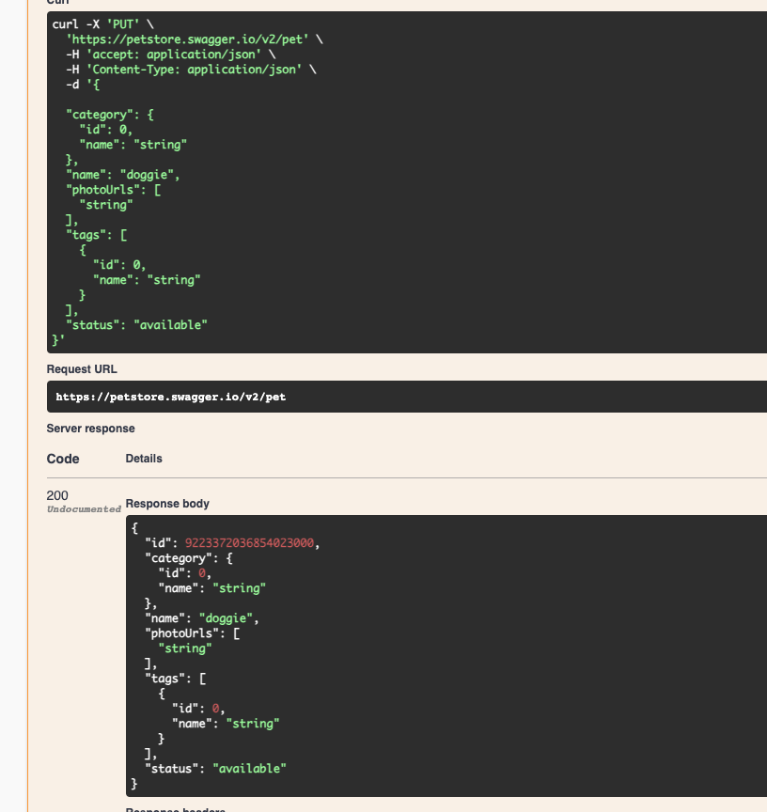

4. Delete (DELETE /pet/{petId})

Positive Scenario

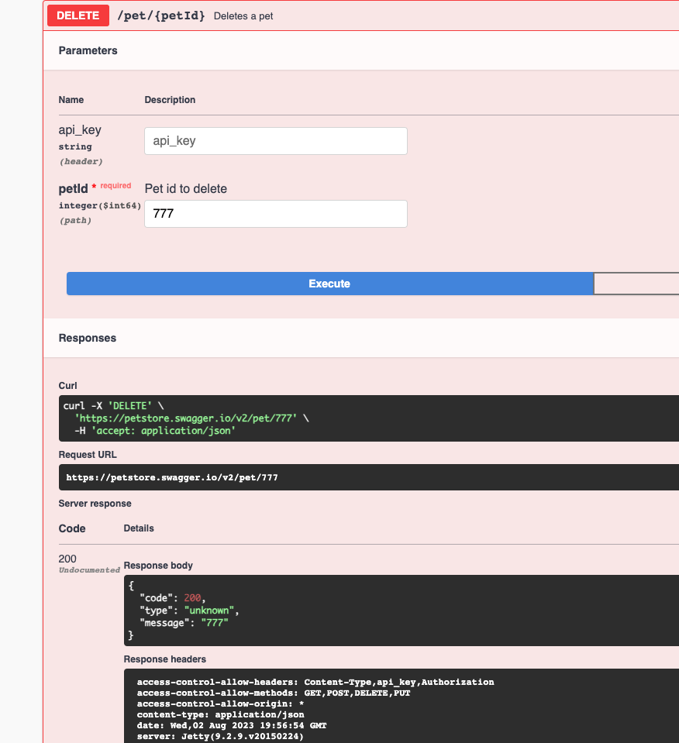

- Test Case: Delete an existing pet.
- Request: DELETE /pet/123
- Expected Response Status Code: 200
- Validations: Check if the response confirms the deletion.

Negative Scenario
- Test Case: Try to delete a pet that doesn't exist.
- Request: DELETE /pet/99999
- Expected Response Status Code: 404
- Validations: Check if the response includes a "not found" error message.
