Simple image:

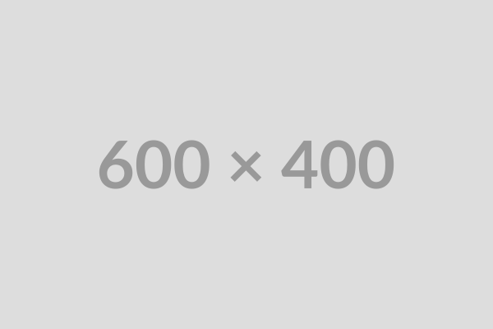

Image with dimensions:



Image with title:



Paragraph after image