
NEIGHBORHOOD
LEADER PROGRAM

Updating the list of active NLs – 23 May 2025
Purpose
Everyone that is given a list of voters to contact, must be entered into the list of active NLs in the NLP Services database. We enforce this rule to ensure we assign turfs to the correct person, to ensure we spell the NL’s name correctly, and to keep track of assigned turfs. We track who signs up and gets a turf in the NLP Services database.
The list of active NLs is maintained in MyCampaign. MyCampaign has the advantage of being linked to the VoterFile and keeps address and contact information current. Since MyCampaign does not offer an automated method of coordinating databases, the process of synchronizing MyCampaign with the NLP Services is manual. This document describes how to do this synchronizing process.
Step 1: Adding or Deleting an NL from the list
When adding or deleting a person from the list of active NLs, you start by using a “Quick Look Up” for their record in MyCampaign. Be sure to select the option for “All people” as the person may be associated with a different county. If the person is new, the click the button for “Search My Voter File” to find their voter registration record. If registered, you can select the “Copy Contact” option. Otherwise, select the “Add New Contact” and create the record manually.
Then verify that the NLP Activist Code is set. Either set it or delete it as appropriate. The name of the AC is not fixed. Verify which code is used for the current election. 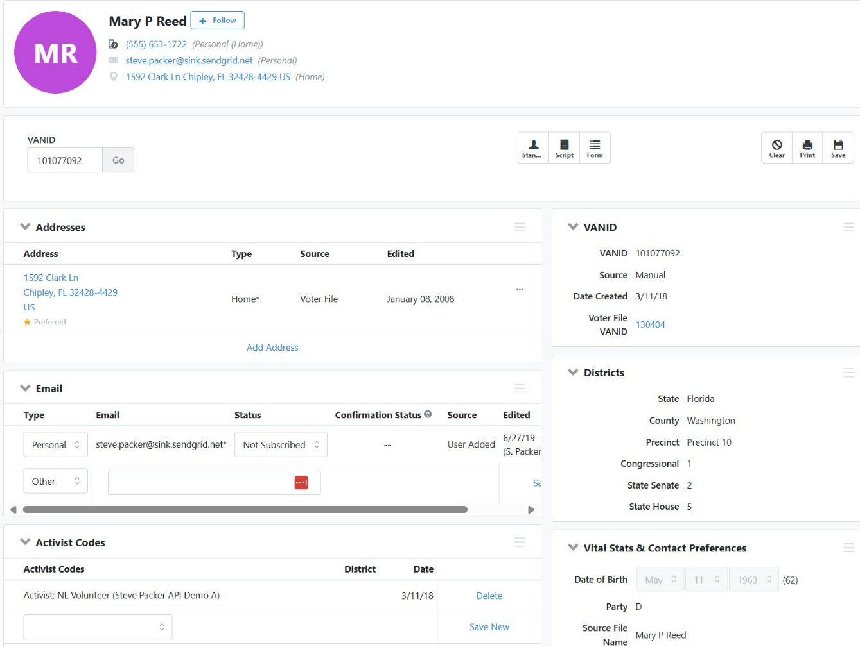
Check that the NL has the election specific activist code assigned.
If the activist code is not present, select the proper code from the drop-down list.
₊₊
Step 2: Create a new list
Create a new list with the state, county and activist code selected. This will produce a list of all the existing potential NLs.
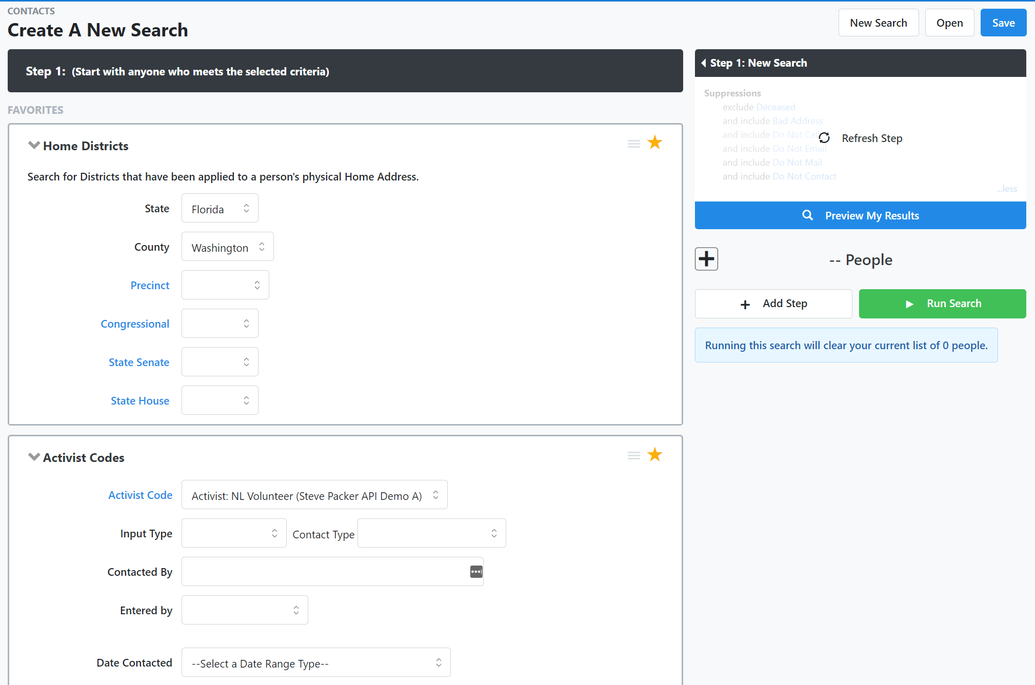
Then click “Run Search”.
Select the appropriate activist code. There may be more than one code.
Select the state and county.

Step 3: Save the list
Select the “Save List As” function.
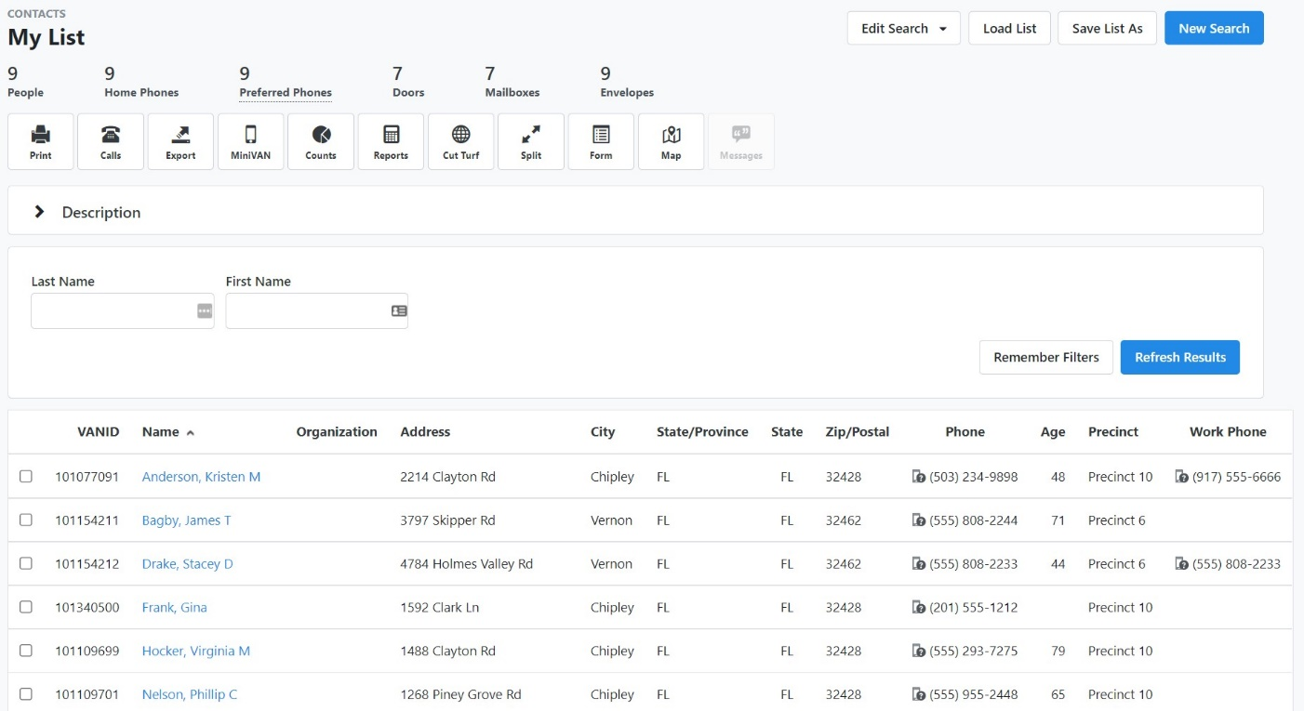
Select the “Save List As” function.

On the page to save the list, select the button for “Saved List”. Look for and select the county folder. It will have the county name followed by _NLs. This is the required folder for NLP Services to find your list of Active NLs. Then pick a name that you can remember.
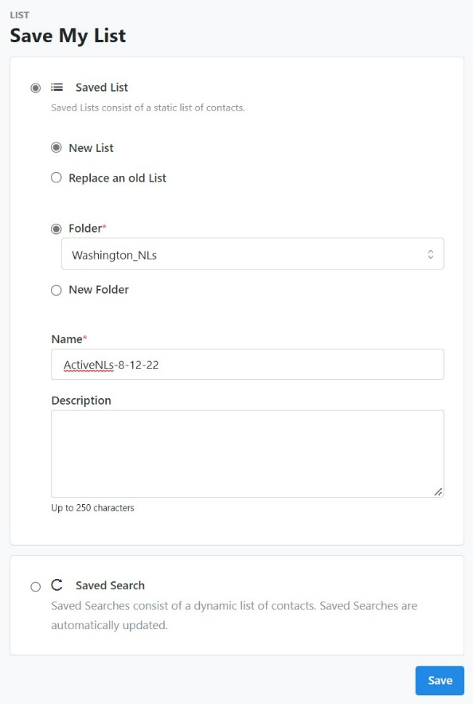
Then click “Save”.

Choose your county folder and name your file.
select the button for “Saved List”. You can select either new list or replace an old list.

Step 4: Sync the Active NL list
First click the “Manage NLs” tab and then click the link “Sync a new list of active NLs.”
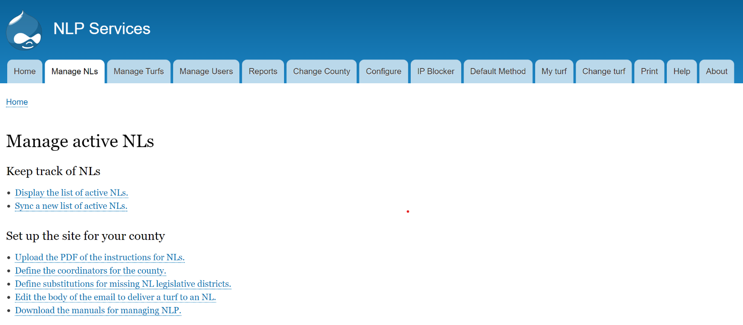

Then Choose the file to upload and click upload.
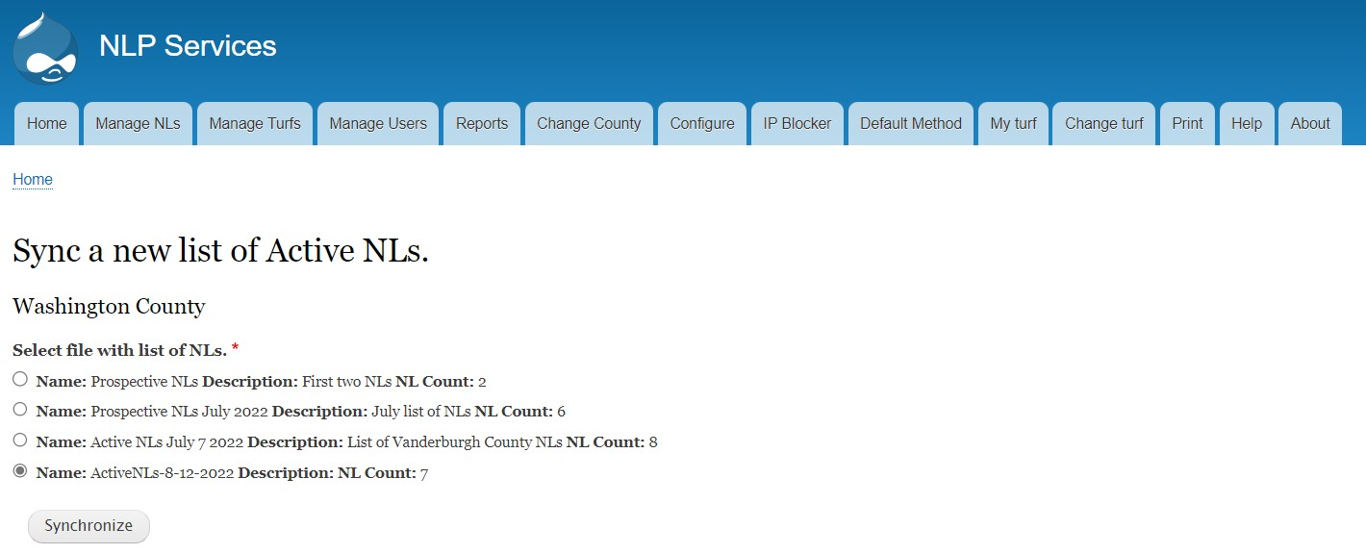
If successful, you will see a notice at completion:
Choose the file you created and then click “Synchronize”.
The list of active NLs is successfully updated.
7 records processed.

VoteBuilder is very forgiving of errors in the contact information for records in MyCampaign. NLP Services will perform additional checks to help verify the information and reject any records that will impact on the user experience for our NLs. The information provided will help identify the errors and provide information to correct those errors in MyCampaign.
Errors reported by NLP Services
- Missing email. Every NL must have an email address. This email address is used to change a forgotten password.
- Unique email. Email addresses can’t be shared by NLs. Occasionally, people do share an email account but for the purposes of NLP, one of them needs to get a unique email address.
- Missing legislative districts. The legislative districts are calculated by VoteBuilder based on the USPS standard address. This address database has geolocation associated with it and the location is used to calculate the districts. If the address is corrupted or missing, it must be corrected before the NL record is accepted.
- Duplicate or merged record in MyCampaign. MyCampaign permits the creation of duplicate records for a single volunteer and the merge operation can destroy the record used by NLP Services. Both problems need to be corrected.
Missing Legislative districts
The database of geolocation for a USPS standard address is not perfect and occasionally results in a record without legislative districts. This does not happen often, but corrections are necessary to provide the NL with turf. Click on the tab for Manage NLs and look for the link for ” Define substitutions for missing NL legislative districts.” That link gives you the page to define the legislative districts for an NL when VoteBuilder does not have them. Then resync the list of active NLs and the substitutions will be used.
Duplicate records
There are many ways that duplicate records are created and some of them are out of our control. It is prudent to verify that the record where you sent the activist code for an active NL is the primary one used by NLP Services. If a duplicate was inadvertently used, then clear the activist code from that record and find the primary. Then set the activist code for an active NL in the correct record.
Note: It is not necessary to merge the duplicate record as it can simply be ignored. You can remove the duplicate but be careful to ensure you mark the record known to NLP as the primary.
Merged records
Duplicate records are removed from the MyCampaign database by performing a merge of records. The merge function will preserve the primary record and destroy the other record during the merger operation. MyCampaign will always assume the newest record is the primary one and preserve it unless the other one is selected. Unfortunately, the oldest record is almost always the one known to NLP Services. So, the merger operation needs to be set up carefully to preserve the correct record.
If a merger operation has destroyed the record used by NLP Services, the NLP Services database must be updated to change all references of the old record to the remaining record. The rejected NL error message with give you a hint as to the old and new IDs. Both VoteBuilder and NLP Services use an ID to uniquely identify an NL. This ID is called VANID in MyCampaign. NLP Services uses the name MCID but regardless of the name, the number must be the same.
Note: Don’t confuse the VANID in the VoterFile with the VANID in MyCampaign. They are not the same number.
To fix the database in NLP Services, click the Manage NLs tab and look for the link to “Reassign the ID associated with an NL”. Click the link and enter the old and new VANIDs.

