
NEIGHBORHOOD
LEADER PROGRAM

Defining the county coordinators – 17 June 2025
The primary function of the NLP County Coordinator is to help the Neighborhood Leaders (NL) complete the task of contacting the Democratic voters on their assigned turf. Specifically, the coordinator will check if an NL is having difficulty getting their turf packet or if they have not reported results after the election. The goal is to get at least 80% volunteer NLs in the county to complete their canvass and report results.
The NL is sent an email with instructions to click on a link to the NLP Services site. At the site, the NL will log in with their username and password. The first login will familiarize the NL with the login process which is used later to record the results of their canvass. And the display will provide a link for a printable copy of the list of voters which can be used for the canvass.
The instructions also include the contact information for the coordinator. The NL might either call or send an email if they have questions. Generally, it is uncommon for NLs to ask for help but occasionally, they will ask about getting slate cards.
Slate Cards
The process for getting slate cards to NLs is different for each county. Some direct NLs to a central place to pick up a bundle, some have meetings to pass out bundles, and others deliver them. Whatever the process, the coordinator should be aware of the process and expect calls for help.
And, for some election cycles, the NL will be given additional or alternate material to give to the voter. This material should be delivered in the same manner as slate cards.
Reporting Results
We encourage NLs to report results soon after a voter contact as the information about voter contacts is valuable to our Democratic candidates. And the reporting should be completed so we can assess the effectiveness of the program.
Specifying the coordinator for the NL
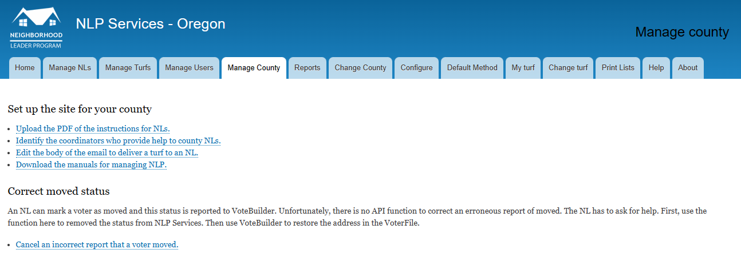
First click the “Manage County” tab and then click the link “Identify the coordinators who provide help to county NLs.

On the Define Coordinators page, you will see a table of active NLs, any of which can be assigned as a coordinator. We use the list of active NLs to ensure we have the correct contact information from MyCampaign. Coordinators do not have to participate as a Neighborhood Leader but most do.
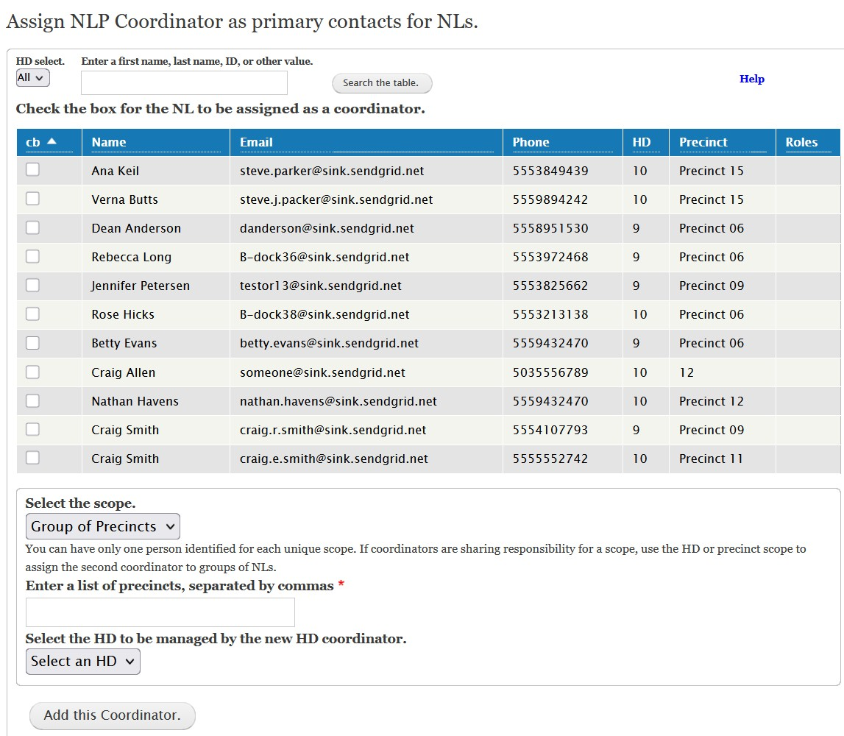
Select the scope of the coordinator’s role: county, house district, or list of precincts. If appropriate, select the house district and precincts the coordinator will manage.
Select the coordinator from the list of NLs.
Change or narrow the list of NLs displayed by selecting a house district or searching for a name.
At least one coordinator must be assigned to send an email to an NL with instructions for their turf. One person should be assigned as the coordinator for the county and this person will be identified as the contact person for all NLs. For large counties, coordinators can be assigned for each state house district. This is intended to match the common practice of having house district leaders in the county party infrastructure. For house districts with many active NLs, the district can be divided into sets of precincts.
The NLs will be informed of their contact person by first checking if a precinct coordinator is assigned. If not, then the house district coordinator will be identified. If there is no house district coordinator, then the county coordinator is identified.
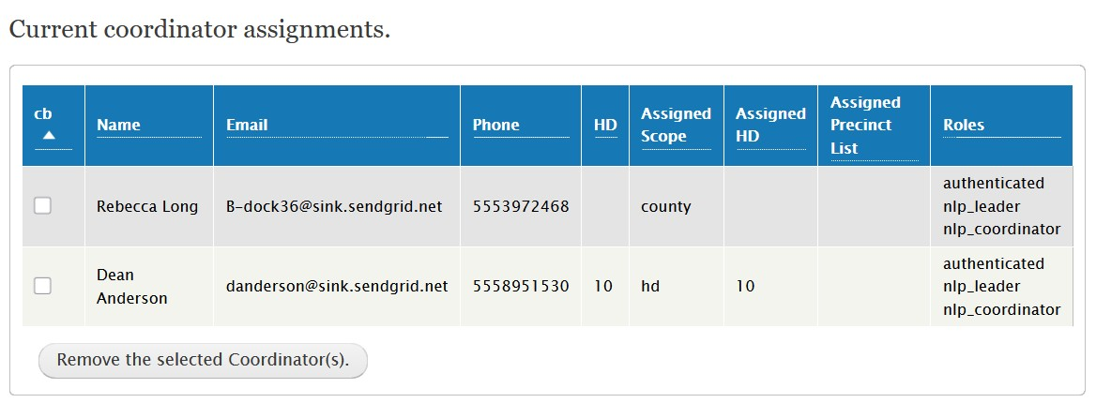
You can remove a designated coordinator that is no longer participating as a coordinator.

You can use this form to remove the assignment of a coordinator. When you assign a coordinator, the function also assigns the NLP Coordinator role to the volunteer. The role permits access to a variety of functions to manage NLs. The role is not removed when an assignment is removed. The role is not removed because some volunteers help with managing turfs but are not responsible for managing NLs.
Use the Manage Users tab and click on the link to remove the coordinator role.

