
NEIGHBORHOOD
LEADER PROGRAM

Cutting Turf for a Neighborhood Leader (NL) – 17 June 2025

Introduction:
The Neighborhood Leader Program (NLP) is intended to increase Democratic voter turn-out and provide support for Democratic candidates through person-to-person contact by volunteer Neighborhood Leaders with their neighbors.
The duties of the NLs are simple:
- Contact a minimum of 35 Democratic voter households in their neighborhoods using a walk or call list provided by the NLP Coordinator.
- Engage these voters using a script provided on the walk/call sheets, record voter responses and distribute campaign literature and county party slate cards.
- On the weekend before the election, call those who have not turned in their ballot to remind them to take the ballot to a ballot-collection place.
- Go online and enter the result of your canvas. Alternatively, return completed walk sheets to the county party office or to your coordinator.
The Neighborhood Leader Program is managed by one or more NLP Coordinators. This role may be performed by more than one person, depending on the experience of the coordinators. The duties are as follows:
- Recruit NLs to participate in the program.
- Cut turf for each enrolled NL and provide the walksheet, the slate card and the instructions
- Follow up with the NLs to encourage them to make voter contact.
- Gather results of voter contact and ensure that each NL reports their results.
This manual will train you how to:
- Locate your Neighborhood Leader on a map
- Cut their turf
- Save a list of the NL’s assigned voters
- Create a printable walksheet
- Check in the turf (needed for NL online report of results)

Requirements:
- VAN account with appropriate permissions
- Ability to cut turf
- PC with Microsoft Edge and Adobe Reader installed
- URL for NLP Services to check in a turf (contact the NLP coordinator if you do not have this URL).

1. Determine the location of a new NL
Do a Quick Look Up of the NL in My Campaign. Click on the “Get Map” link. Familiarize yourself with the geographical location of the NL. You will use this geographical knowledge to associate target voters living nearby. Also remember the precinct where this voter resides. It is a good idea to do this lookup in a separate window or tab in your browser. The window permits referencing this map when you cut the turf.

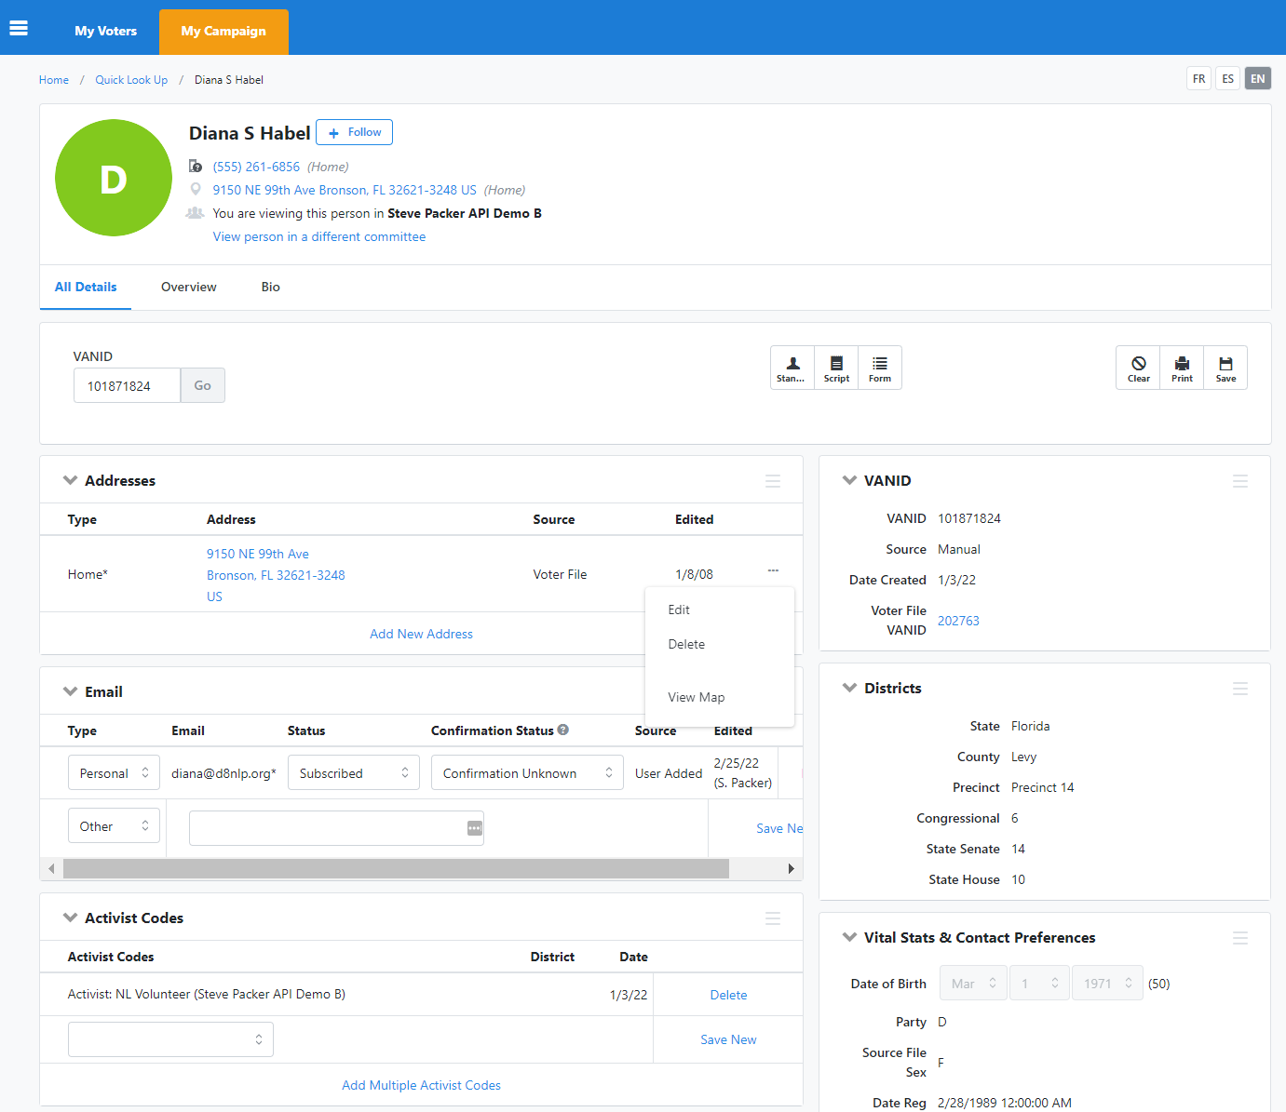
IMPORTANT
Remember the VANID for use later.
Click the … and then click View Map
Be sure you have selected the “My Campaign” tab.

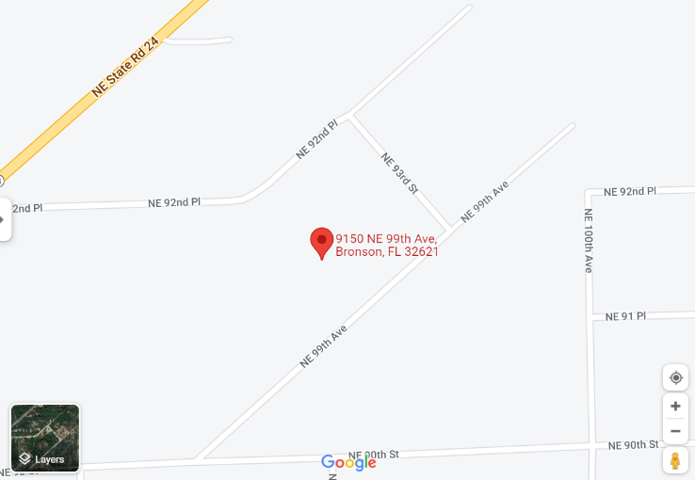
Verify that the activist code for identifying an NL is set. The actual code is county specific but should look like “Active HL 2022”.
Remember the precinct name (Number in Oregon)
If the NL is new and does not have an entry in the My Campaign database, you will have to copy the information from the VoterFile. If the activist code is not set to indicate the person is an NL, set it now. Setting the activist code will have to be followed by creating a new list of active NLs and resyncing the list with NLP Services.

2. Create a Map Region for target voters in the new NL’s precinct
Check your Map Regions and Map Turfs folder to see if Map Regions and Map Turfs already exist for your NLs’ Precincts, and if so, skip this section and go to Step 4. If you cannot find an existing Map Region for an NL, follow the instructions below to Create a new Map Region for them.
Return to the main menu of the VAN and click on “Create A List” link. On the “Create A New Search” page, select the County and the precinct of the NL. Also select the criteria for the target voters. (Note: the criteria may change with each election. However, for the foreseeable future, we will only target Democrats for the NLP.) Then click “Run Search”.

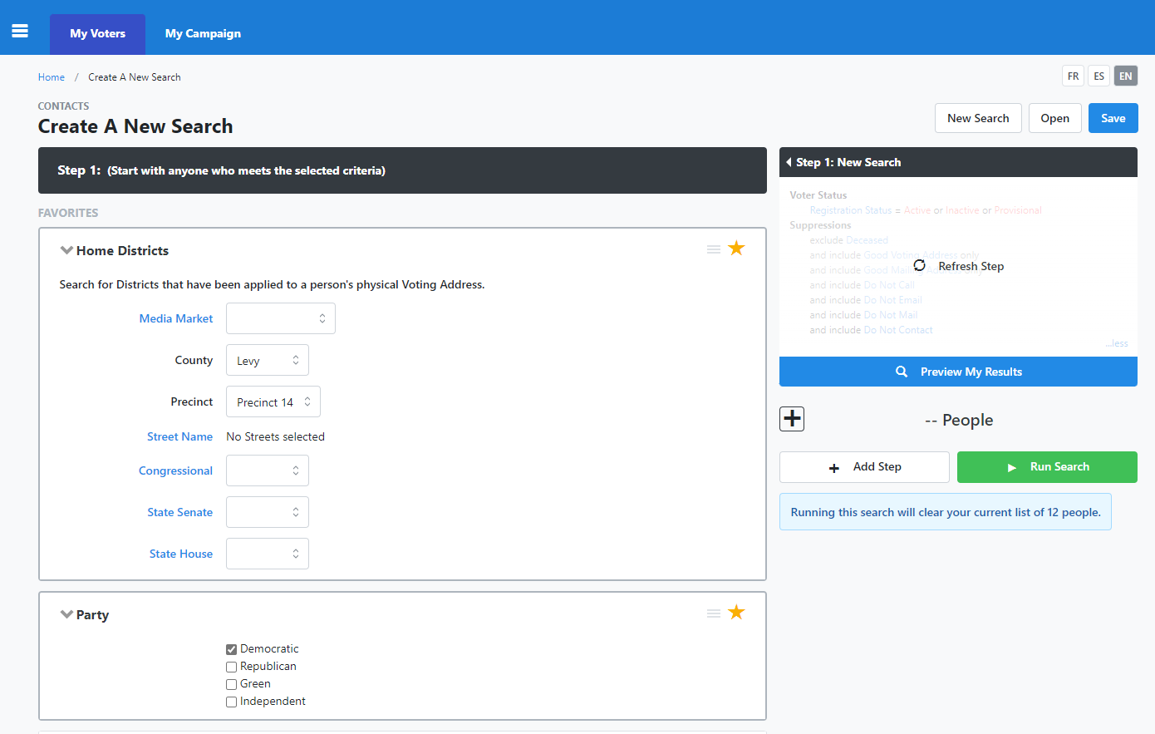
Then click “Preview My Results”.
Select the criteria (Democrat).
Select the county and precinct for the NL, typically near the NLs home.

The search will provide a list of all the target voters in the NL’s home precinct.

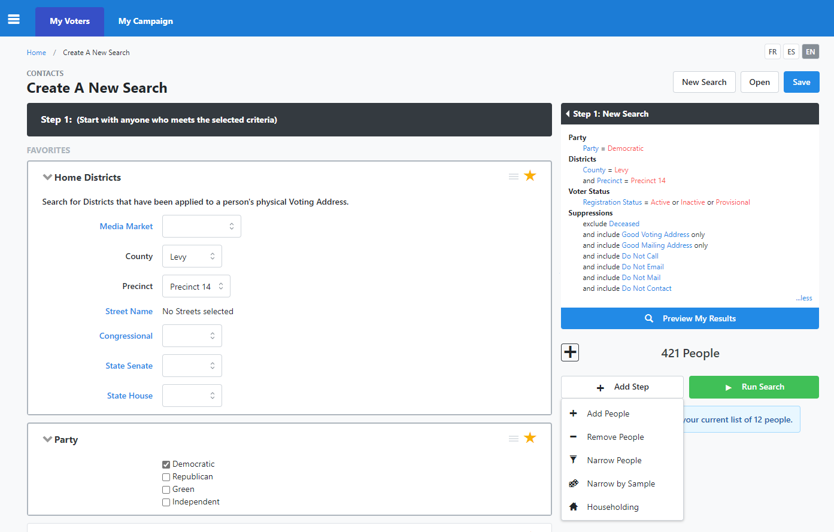
Now click “Add Step” and then “Remove People”.
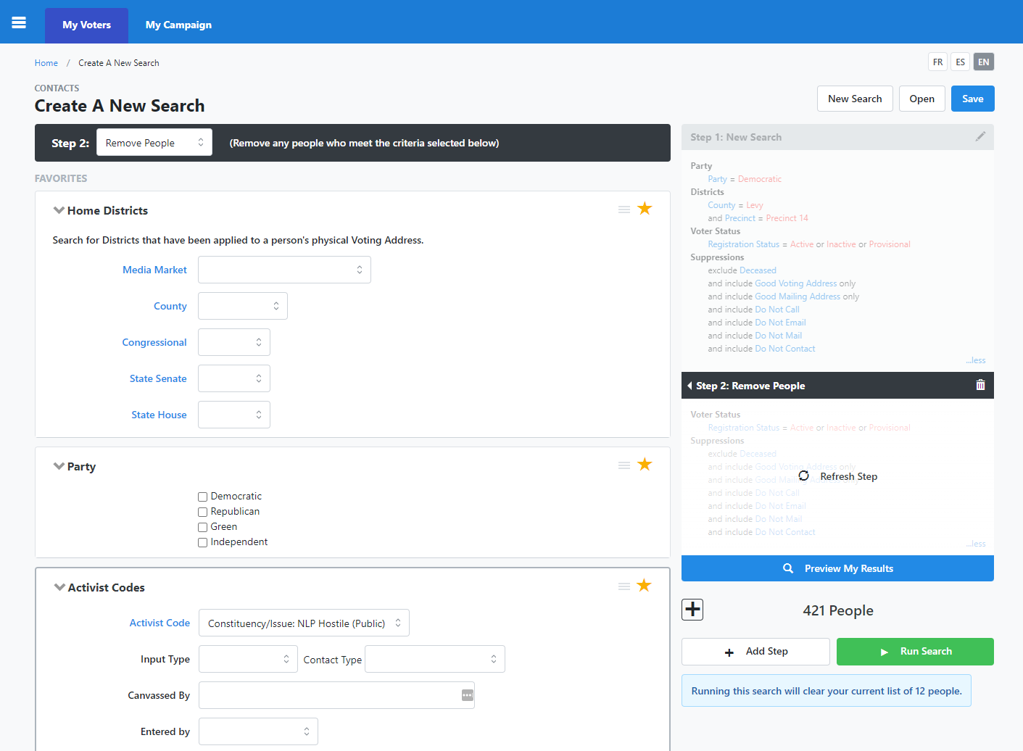
Then click “Run Search”.
Select the NLP Hostile Activist Code.

3. Cut the turf
You should now be at the “My List” page. Click on the “Cut Turf” icon.

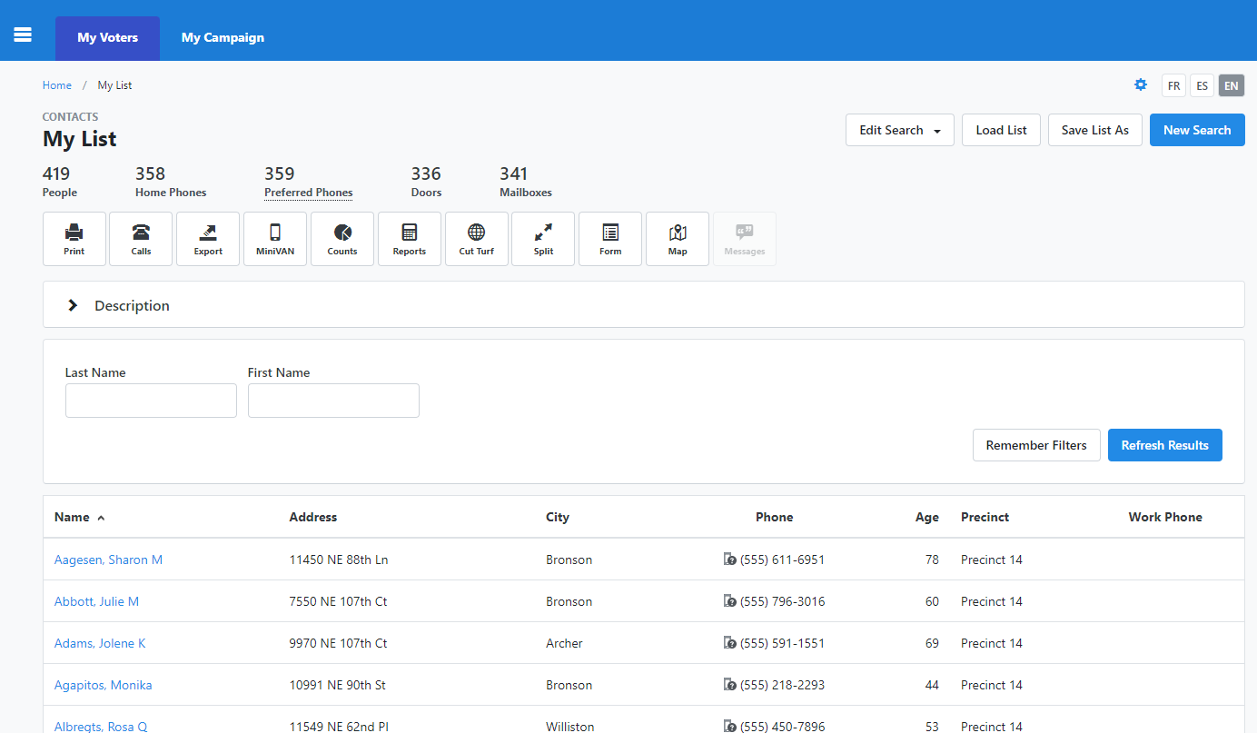
Click the “Cut Turf” icon.

Drawing turf is an art. Distance from the NL is not the only criteria one can use, especially when one has knowledge of the topology and street alignment. With even modest understanding of the area, the streets, and the NL, one can draw a line around target voters that will be a reasonable area to canvass. Occasionally, a spouse will also volunteer as an NL, and the turf should be cut with the nearby neighbors divided so both NLs have a share. A north-south or east-west division sometimes works.
Also, an NL may be located right on or near a precinct line. It is perfectly reasonable to create a second turf for the adjacent precinct to pick up neighbors of the new NL.
Often the new NL will specify the streets and blocks they would prefer to canvass. This is very easy to accommodate when you draw the turf line.

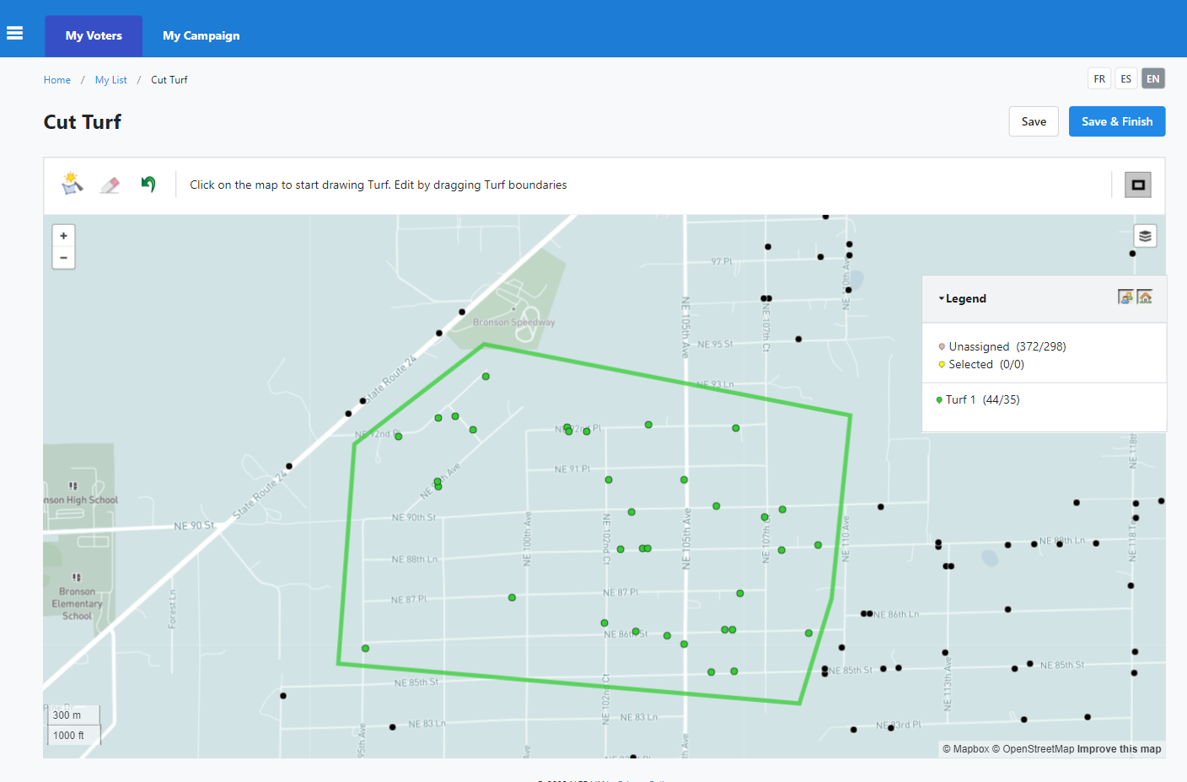
Then click “Save & Finnish.
Check that you have the correct number of households for this NL
Draw the turf.

When satisfied with the turf, click Save & Finish. The “Save My Map Region” dialog box gives you the opportunity to select the folder and create a Region Name. Use the naming convention* for saving the Map Region. This map region will be used later for a subsequent NL in the same precinct. Click “Save”.

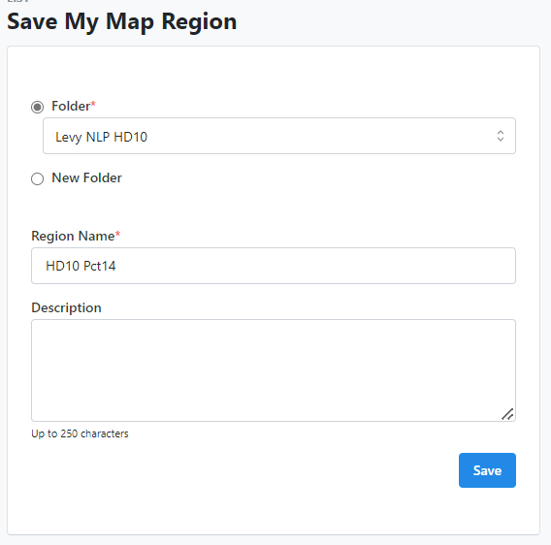
Use the naming convention to remember this Map Region.
Select the appropriate Folder.

(* See File and Folder Naming convention at the end of the document)
Go to step 5.

4. Load an existing Map Region and cut additional turf(s)
Open the folder for your house district. Here you will find the map regions that have already been created. Click on “View Map” and you will resume cutting turf with the region. Using this map, you can create a new turf which will not overlap voters already assigned to another NL.

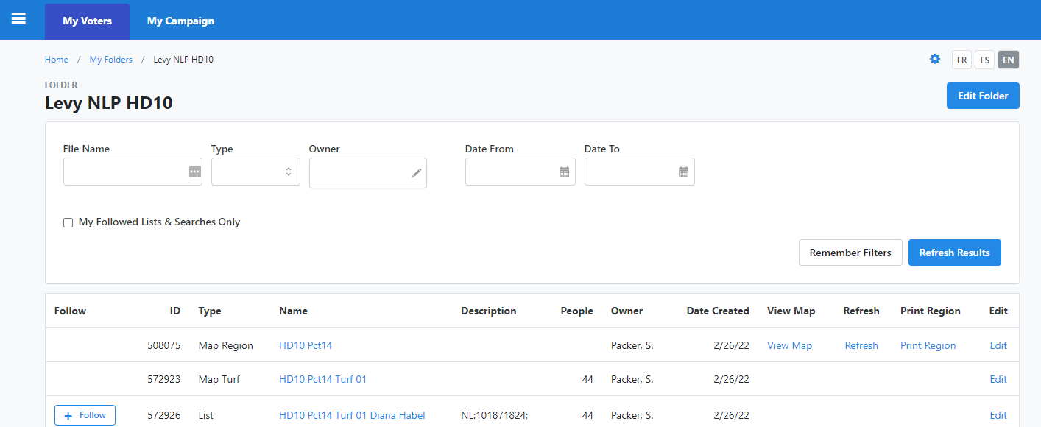
Click the link to view the map.

Cut a second turf and save it as turf2. Then click Save & Finish.

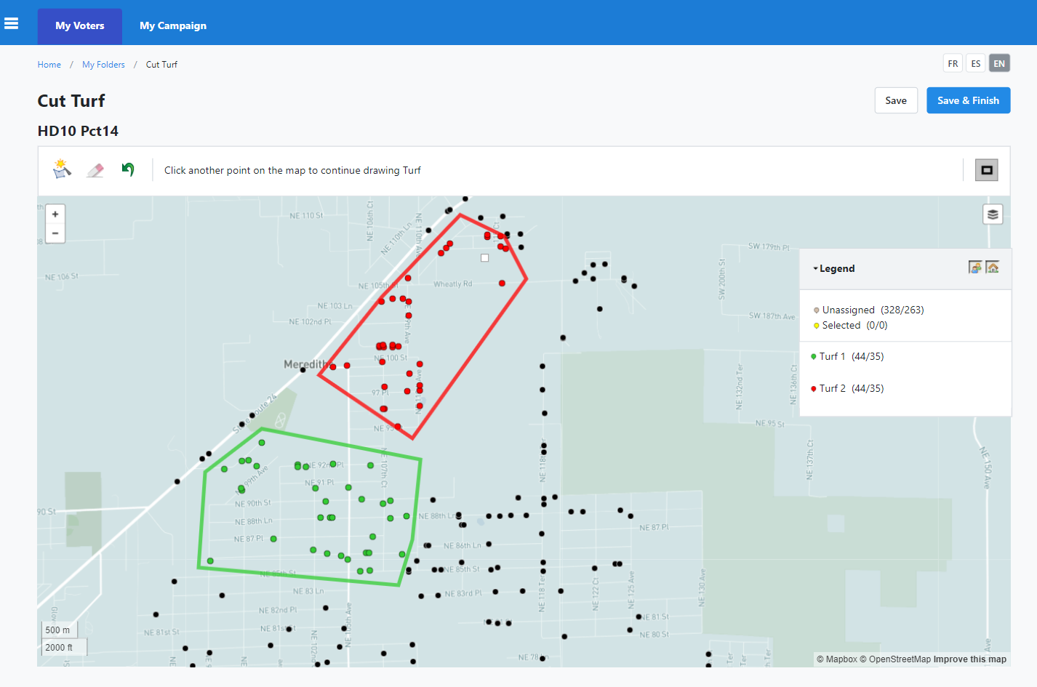
Then click “Save & Finish.
Cut the second turf.
.

5. Load the new turf to prepare for printing
Now Click on Main Menu, then “View My Folders” and select the folder where you saved this list. Here you will see the Map Region and the Turf you created, both with the name you created when you saved the region. Now click the name of the turf to use it as a list.
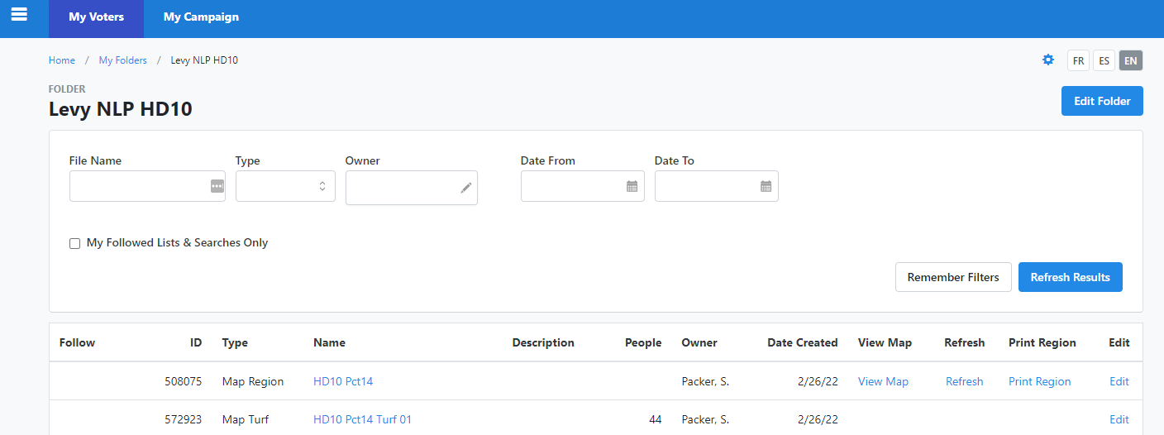
Click on the new turf and it will be loaded as your new list for printing.

6. Print the list
Now click on “Print” to create the printed walk sheets.

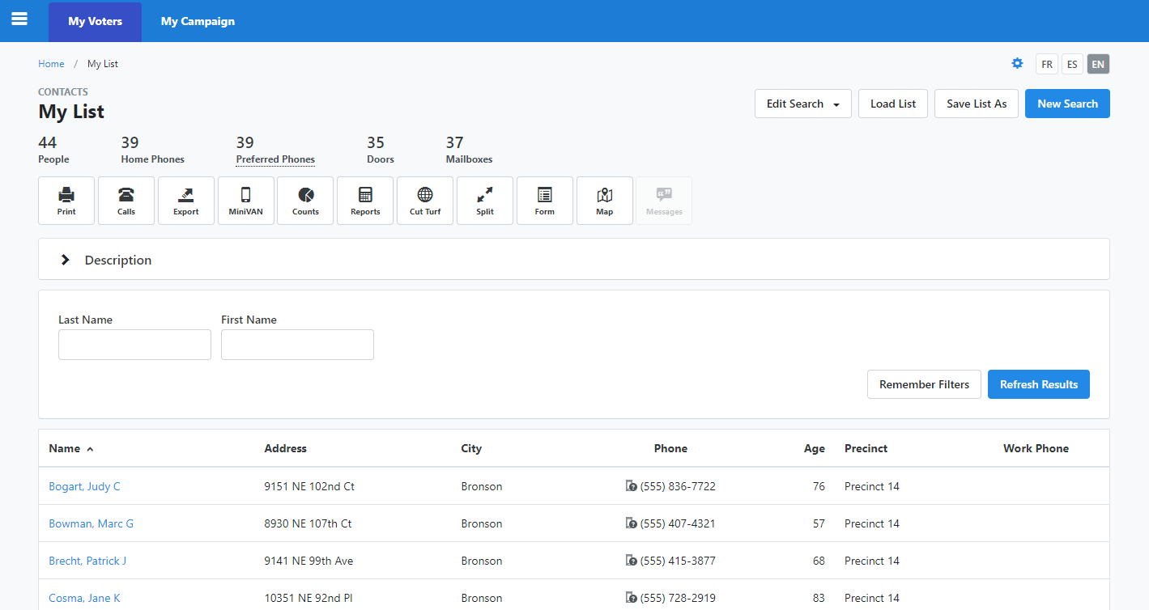
Click “Print” to create a walk sheet.

7. Set up the print options
On the Print screen, select the Report Format and Script. These will be different for each election so be sure to select the current format and script. They should be marked with either a revision number or a date to help you select the right ones. Use the naming convention in the title so the printed sheets can be matched with the NL at the end of the campaign. It can be confusing to have a pile of unmarked sheets when doing data entry.
The sort order should always be Street Name, Street Number, and Apartment. This will make all the walk lists ordered for walking but also ordered for subsequent data entry. The list order will be maintained when we get an online data entry option for the NLs. Clear all the Page Breaks to save paper.
Press Next to get the PDF file. Save this file for either printing yourself or for sending in an email to your NL.
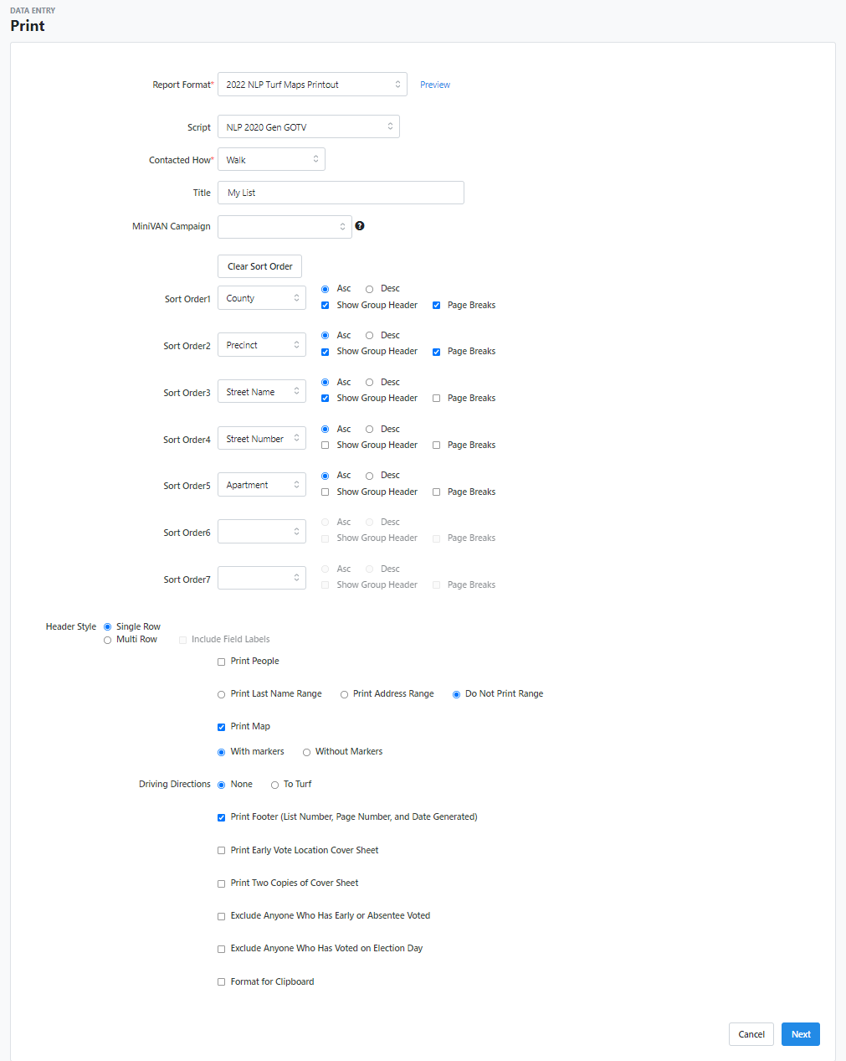
Then click “Next”.
Verify this box is not checked.
Enter a name you can remember. Using something like the naming convention is advisable, i.e., “HD10 Pct14 Turf 01 Diana Habel.
The script and other options should be automatically selected.
Select the report format for this election cycle.

It is very important to review the PDF before printing it. Check the list of voters for error and if the list is not ok, delete the PDF and the list and start over.

8. Save the PDF of the turf to your local system
Go to the home screen and look for the “My PDF Files” and click this link.
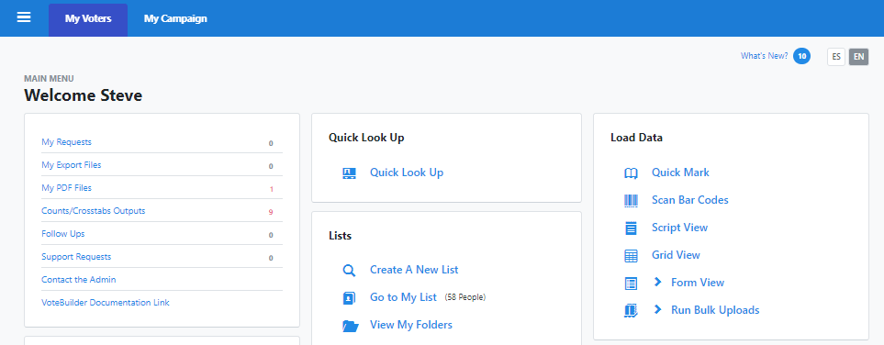
Click here to find your PDF to print or email to your NL.

Then, click on the “Download File” link. The actions taken by the browser will be browser specific. In the case of Internet Explorer, you will see the image of the PDF.

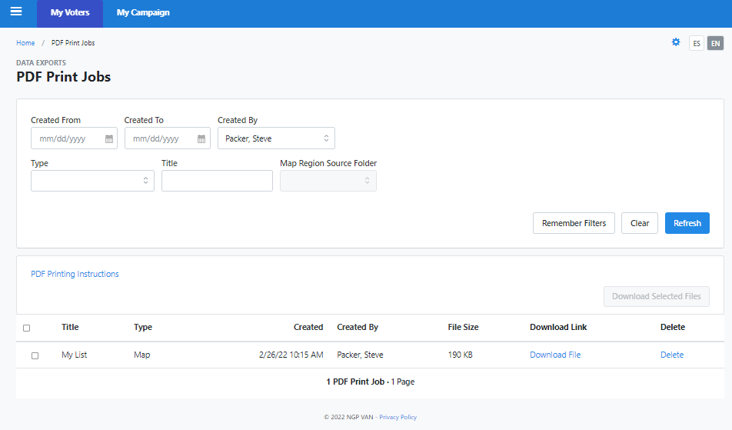
Click here to download the PDF file.

With Edge, the PDF will be displayed in a window. Move the cursor to the bottom of the page to reveal the command popup. Click on the file icon and save the PDF where you can find it later.
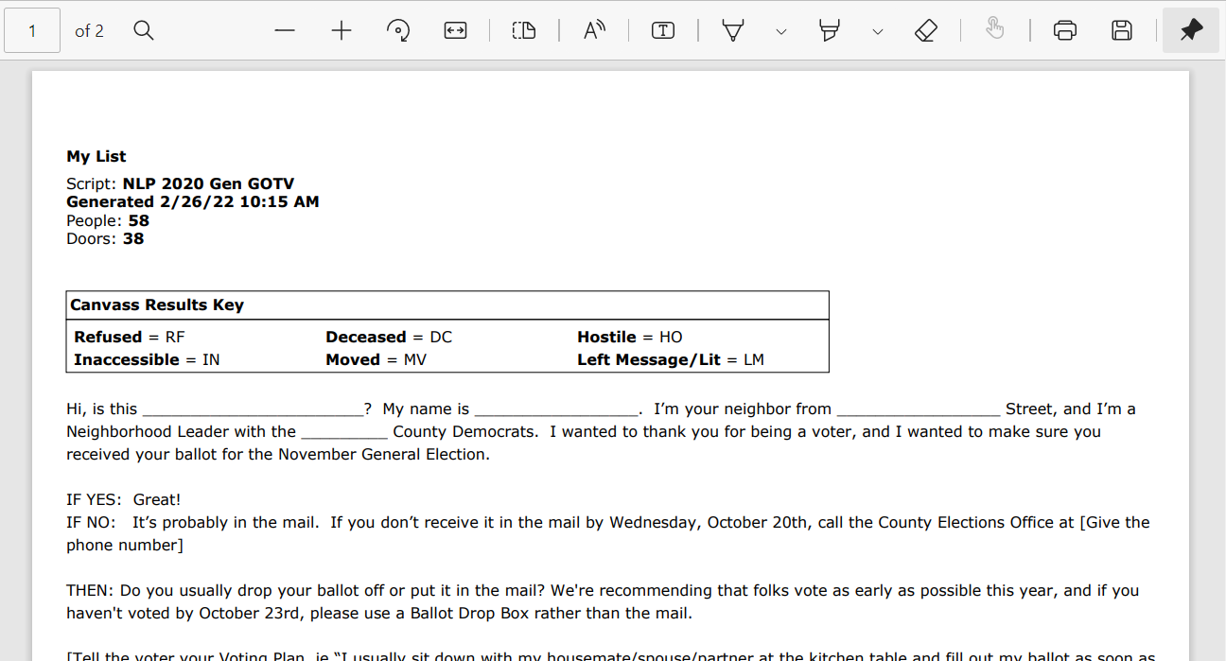
Click the icon to save the file.

9. Sync this new turf with NLP Services
The last step in for creating a turf for an NL is to sync in the turf with the NLP services database. This will make the turf available to the NL and provide a method for the NL to enter the results of the canvass. Click the Manage Turfs tab and then click the link to Sync a turf.

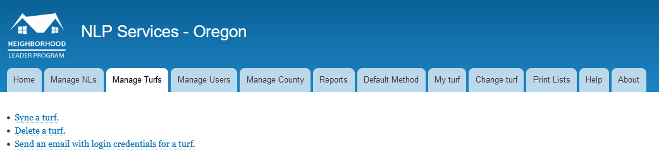
Click the tab for “Manage Turf” and then click the link for “Sync a turf”.
The “Sync a turf page” will display a dropdown menu of folders in which Map Regions and Map Turfs are saved. Choose the folder which contains the Turf you wish to assign to your NL. A list will display of all the Map Turfs in that folder. Find the Map Turf that’s been assigned to your NL, toggle it, and click “Use the selected turf”. The next page allows you to search for the NL you wish to assign the turf. Once you have found the NL you may choose to upload the PDF walksheet saved for the NL. Clicking “Use the selected NL” will enter the turf in the database. If you try to check in a turf twice, you will get an error message.

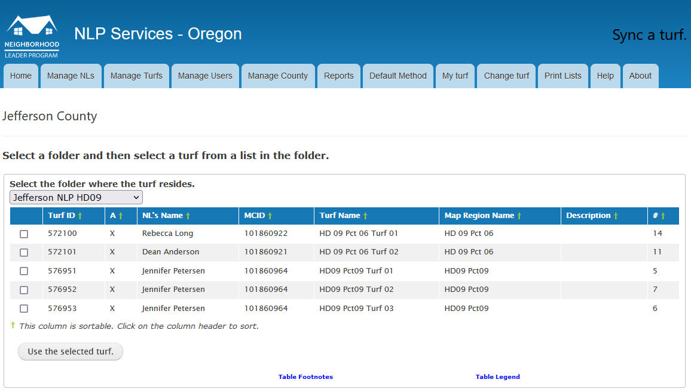
Click the box for the turf you wish to sync.
Select the folder where you saved the turf.
Click the button to proceed to assigning an NL to the selected turf.
Note that the list of turfs includes the name of the NL last assigned to the turf. This should help you keep track of turf and the NL assignments and reduce the need for a private spreadsheet.

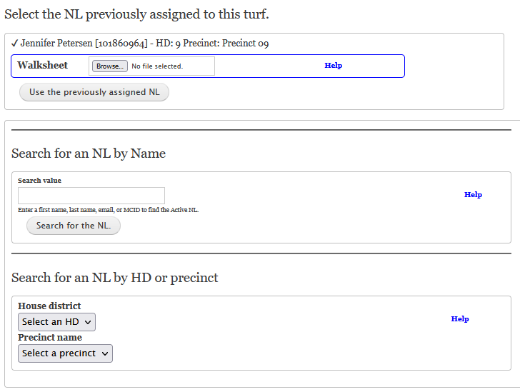
The next page will display a list of possible NLs. You can associate a PDF of a walk sheet with the turf there. Syncing a walksheet is optional and need not be synced if the NL is not canvassing.
You may search for the NL you are assigning the chosen turf by First Name, Last Name, email, or VANID#. The next display is a list of matching NLs. There you can select an NL and attach a walksheet.

You may locate the NL by entering their HD and Pct here and toggling their name from the displayed list.
When a previous assignment is known, you can select that NL here. Attach the saved walksheet and click the button.

Only NLs whose name has been synced in NLP Services may be assigned a turf. If this search page cannot find the NL you wish to assign a turf, contact the NLP coordinator and they will sync the new NL in NLP Services.

Naming Conventions
A key feature of the NLP is a continued relationship between the NL and the voters living in the neighborhood. This relationship will endure for subsequent elections and should make subsequent contact by an NL easier. Thus, we must keep track of the voter assignments for each NL so we can recover them for subsequent elections. The VoterFile provides a feature where we can save any list of voters we create. We use the list to associate the turf with an NL using some sort of naming convention. Such a convention will help subsequent administrators with managing existing NLs. And, when you save a Map Region, the names of the turfs have a pattern that is helpful to use as the name for the list.
Recommended turf name:
HDxx Pctppp Turf nn
(this is the default)
Recommended Map Region name:
HDxx Pctppp, where xx is the HD number and ppp is the precinct number used by VoteBuilder.
Recommended list name:
HDxx Pctppp Turf nn NLname
VoteBuilder has a few restrictions on the naming of map regions and lists. Occasionally, there may be a conflict with another county if the HD and the Precinct are the same. In that rare case, add a letter after the precinct number.

As the NLP grows, we will have large numbers of NLs to manage. Finding a list in a folder with large numbers of map regions and turfs can be very difficult. The VoterFile provides for creation of folders for organizing lists, but these folders cannot be nested. Some convention is needed to create folders where the content is of a manageable size. As the NLP matures, the naming convention for folders will evolve to keep the contents manageable but for now an Oregon House District seems like a reasonable size. Folder holding NLP lists should be named with the county and the house district.
Recommend folder naming convention:
County NLP HDxx where xx is the house district number, County is replaced by the actual county name or abbreviation.

Size of the list for Voter assignments
The default agreement with a new NL is to contact a list of approximately 35 Democratic households. In practice, this is about 50 voters. Most NLs don’t seem to mind that the list is for a few more or less than 35 doors depending on the distribution of available target voters.

Many new NLs request considerably more than 35 households and some request additional names after they experience their first election. Lists are printed out before the election and the NL carries this list to find the voter and record the result of the contact. After the canvass, the results must be entered into the database, either by the NL or some other volunteer.

Lists of more than 100 names are difficult to manage, both from the amount of the paper to print and the eventual automation of the data entry. List sizes should be kept to less than 100 voters. If an NL wants more than 100 voters, then create a second list for them.

Rural (or any unwalkable area) Option
Many areas are too difficult to walk. In these cases, a NLP list can be created for a new NL but the contact will be made by mail. Ideally, this mailing will be the county party slate card printed in a postcard format. This card will have space for a return address sticker and a short note from the NL. Sometime near the end of the voting period, typically when the last reports of ballots received are published, a follow-up phone call can be made to encourage the non-voters to get their ballot in. These two tasks are proving to be just as effective as a personal face-to-face contact. The turf cutting activity is identical to that for a canvas as one will be assigning nearby neighbors to the new NL.

