
NEIGHBORHOOD
LEADER PROGRAM

Notifying an NL of the availability of a turf – 17 June 2025
Important election dates
At the start of a new election cycle, two dates are configured. One is the date of the election, and the other is the first date that county election offices can send out ballots. The latter date is important as it is the target for delivery of slate cards.
Sending a notification of a turf to an NL
Once a turf has been synced (checked in), you can send a notification of the turf to the NL in an email. This email comes from the NLP Services email service and the content of the email is created automatically from a template. The email contains a link to NLP Services login and the NL must use this link to get the printable walk sheet and it identifies the contact information for the coordinator.
Also, a paragraph can be inserted into the mail to personalize the message. This is occasionally useful when the turf has some exceptional characteristics.
NLP services has a generic template that is used as a default. The state party can define a new template that has election specific information. This state template will be used instead of the default template. In addition, a county can create a county specific template that is used for all emails sent by that count. Instructions for editing the body of the email are covered in another document.
Send email to NL
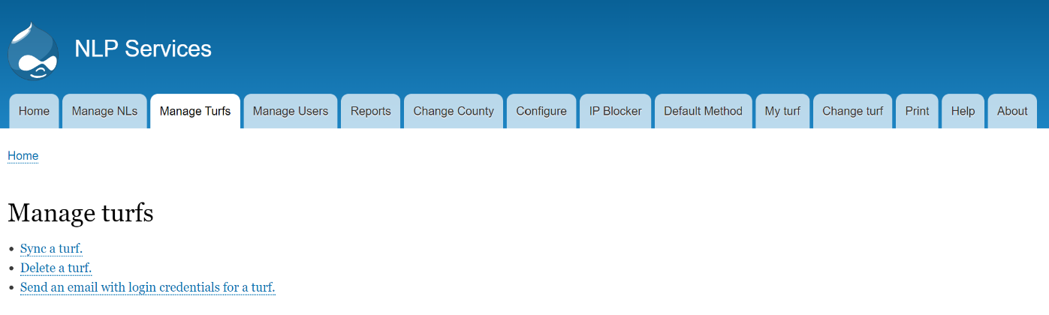
Select the “Mange NLs” tab and then click the link to send the notification email.
After clicking the link, you will see a page to send the email. Select the house district and precinct of the NL and then select recipient from the offered list of NLs with turfs synced. You can also associate a printable walksheet with the turf for the NL to use if they are canvassing. If the NL is sending postcards, the walksheet is not needed. When a turf was synced, a walksheet may have been associated with the turf then. If you use the attachment option here, it replaces the one assigned earlier.
You may also add an additional paragraph for this NL. Occasionally this is useful if you have some unique information for this NL.
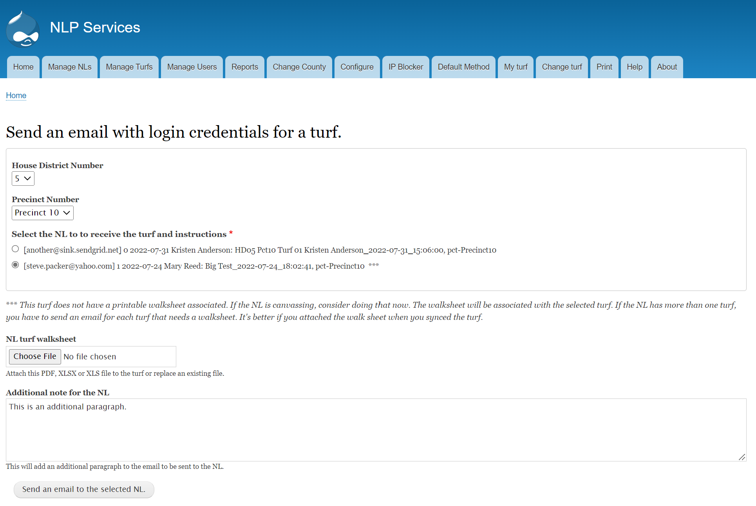
Then click send.
Optionally, specify a printable walksheet and/or add a paragraph with information for this NL
Select the House District and Precinct of the NL and then select the radio button for the NL.
NL instructions
To send the notification email a printable instruction for the canvass must have been uploaded. The instruction document is unique to each county and can be customized both for the county and for the election. A generic document in the docx format is available in NLP Services as a starting point. Typically, this document is uploaded by the state NLP admin.
In some counties, a post card is used when face-to-face contact is difficult or impossible. In those cases, the NL will get a turf with instructions for sending a postcard. Providing instructions for sending postcards is optional for the county.
NL Coordinator
Each email sent to an NL with a turf includes contact information for the coordinator. The coordinator is responsible for resolving issues and getting the NLs to complete their task.
Each county must have at least one coordinator to be able to send out a turf via the NLP Services email notification. There is a separate document describing the process of assigning coordinators for NLs.

Example Email Received by NL
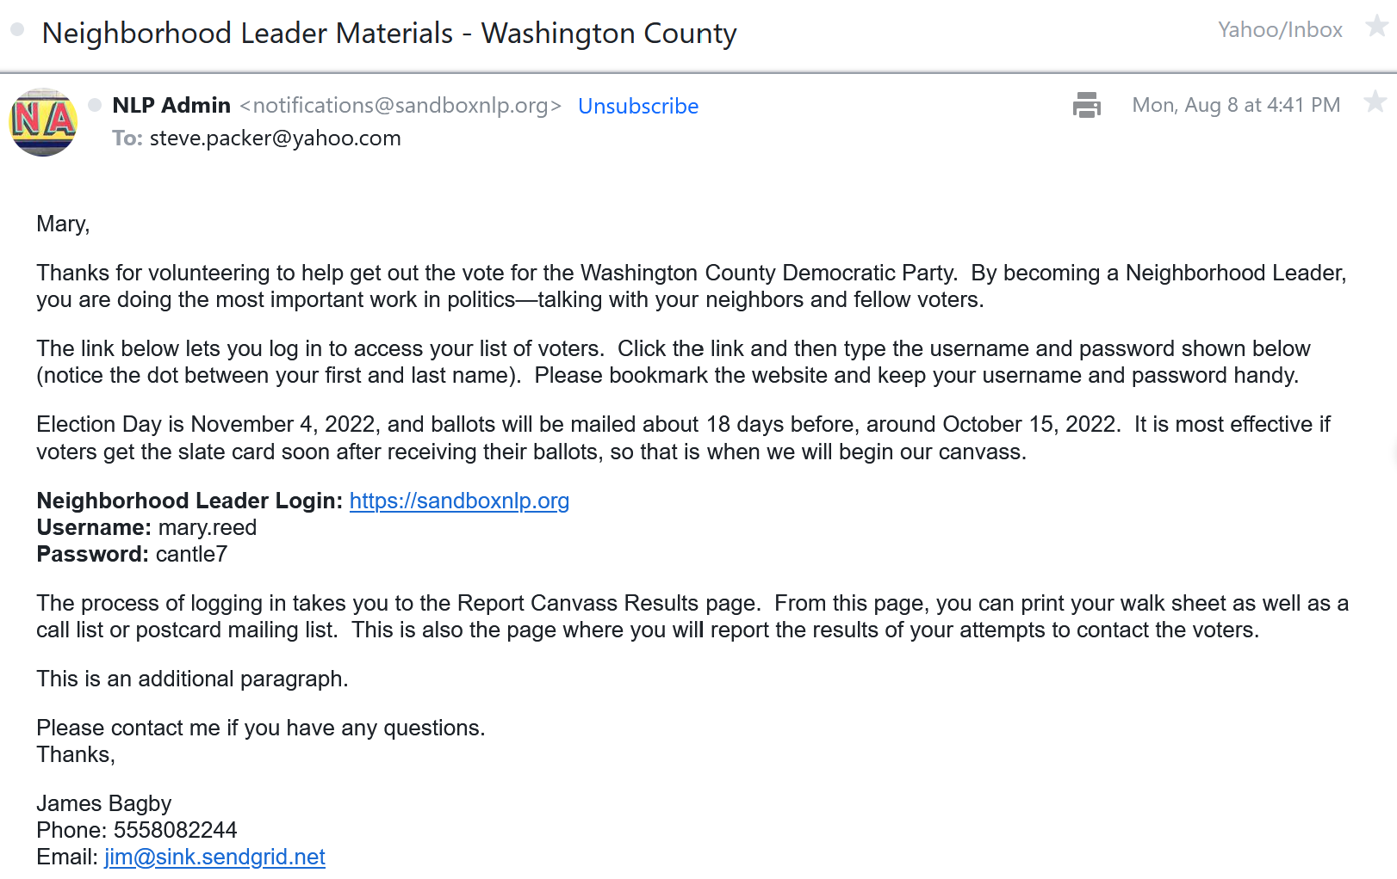
This is an optional paragraph with information specific to this NL.

