
NEIGHBORHOOD
LEADER PROGRAM

Configuring NLP Services – 17 August 2026
NLP Services is a thin layer over VANNGP’s VoteBuilder. It uses the Application Programming Interface (API) to access the functions of VoteBuilder and uses keys provided by VANNGP. The keys are requested from functions in VoteBuilder and you will need one key for each of the county committees participating in the program. And, in most cases, a key will be needed for a separate committee used for NLP. The NLP committee is used to host the activist codes and the survey questions. These are then shared with the participating counties.
In VoteBuilder, look in the main menu for the section called Administration and click the link for Integrations. That reveals a link for API Integrations. Click that link and on the next page, click the button for “Request an API Key”. The popup will give you an option to select the Integration and you will look for “Neighborhood Leader”. The request is sent to your Data Director for approval. If you do not see the Integration, the committee is not yet approved, and you need help from your data director.
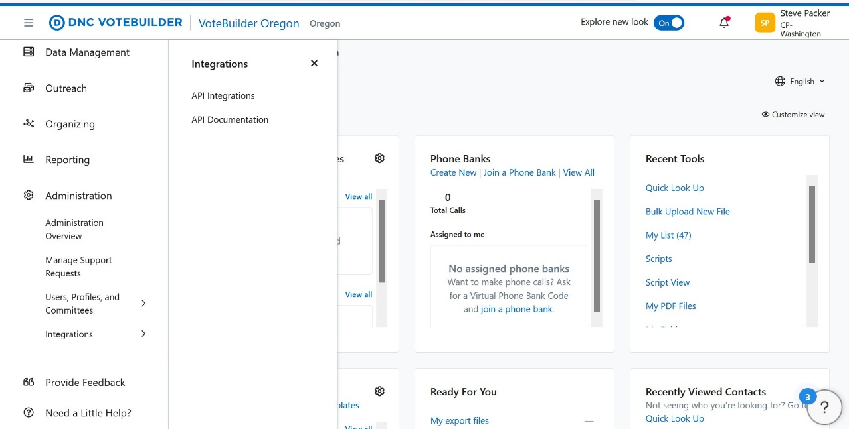
In the main menu, look for the Integrations links.
Then request a key for Neighborhood Leader.
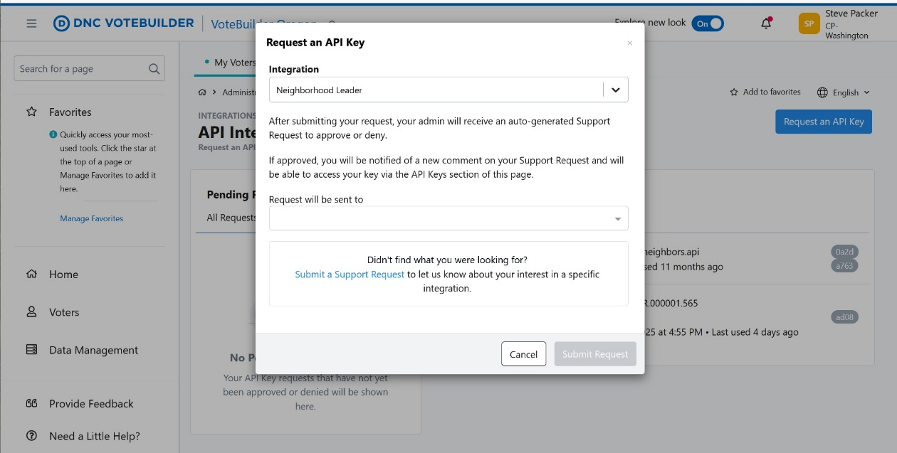
The key will be available on the Integration page and will have information similar to this:
Your Neighborhood Leader API Key
You may be asked to provide the following Application Name to integrate with Neighborhood Leader:
Application Name
DNCMS.0000xx.xxx
Copy the following API Key and use it to set up your Neighborhood Leader integration:
One-Time Neighborhood Leader API Key
yyyyyyyy-yyyy-yyyy-yyyy-yyyyyyyyyyyy

The x and y digits are hexadecimal numbers, and these are to be copied to an yml file.
State Committee:
Name: MyStateName
Url: api.securevan.com/v4
App Name: DNCMS.0000xx.xxx
API Key: yyyyyyyy-yyyy-yyyy-yyyy-yyyyyyyyyyyy
Jefferson:
Url: api.securevan.com/v4
App Name: DNCMS.0000xx.xxx
API Key: yyyyyyyy-yyyy-yyyy-yyyy-yyyyyyyyyyyy
Washington:
Url: api.securevan.com/v4
App Name: DNCMS.0000xx.xxx
API Key: yyyyyyyy-yyyy-yyyy-yyyy-yyyyyyyyyyyy

The yml file is used later to configure NLP Services. The key information must be stored in a safe and secure place.

VoteBuilder setup for NLP
- Create a committee for NLP if it does not already exist. The committee’s name can be anything, but it is a good idea to use something descriptive, like “Neighborhood Leader”. This committee is used to host state-wide information, including the activist codes and survey questions below.
- In the MyCampaign database, create activist codes for NLP Dropout, NLP Not Registered and Active NL xxxx. The xxxx is replaced by something unique for the election. For example, Active NL 26G might be used for the 2026 general election. A new Active NL activist code will be created for each election, and the old ones provide a history of participation for the volunteers. The survey question must be shared with all participating committees.
- Also, in the MyCampaign database, create a survey question for NLP Participation. This survey question is created for each election. The survey question long name should be NLP Participation and the question itself is “Will you participate as an NL for the November election?”. The text is election specific as a new survey question is created for each election. There must be exactly five responses and the Responses must be: Yes, Dropout, Not this election, Asked, Did not respond.
- In the VoterFile database, create two activist codes. One for NLP Hostile and the other for NLP Voter.
- Also, in the VoterFile, create the Pledge to Vote survey question. The question is something like “Can we count on you to vote in November?” and will be election specific. The Reponses must be: Yes, No and Unsure. The survey question must be shared with all participating committees.

Configuring NLP Services

Step 1
Then request a key for Neighborhood Leader.
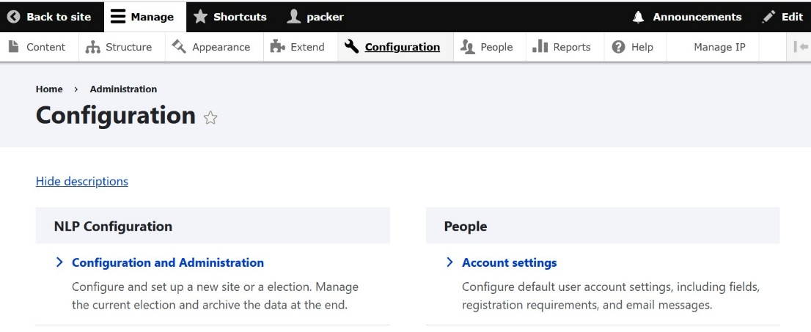
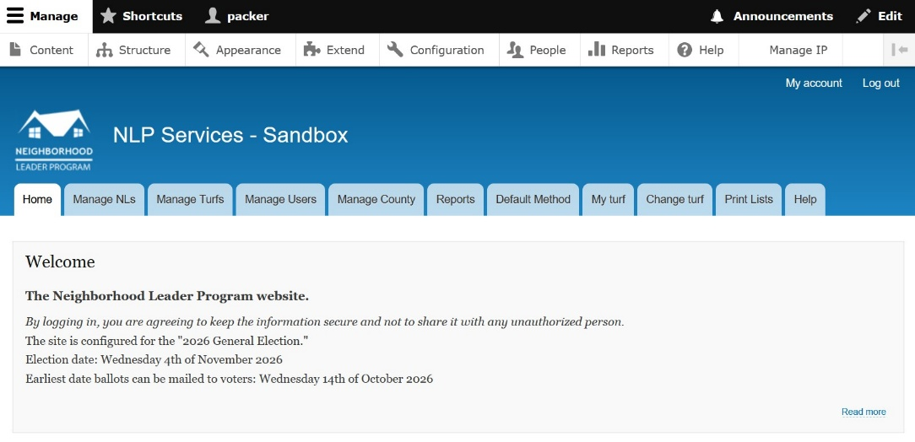

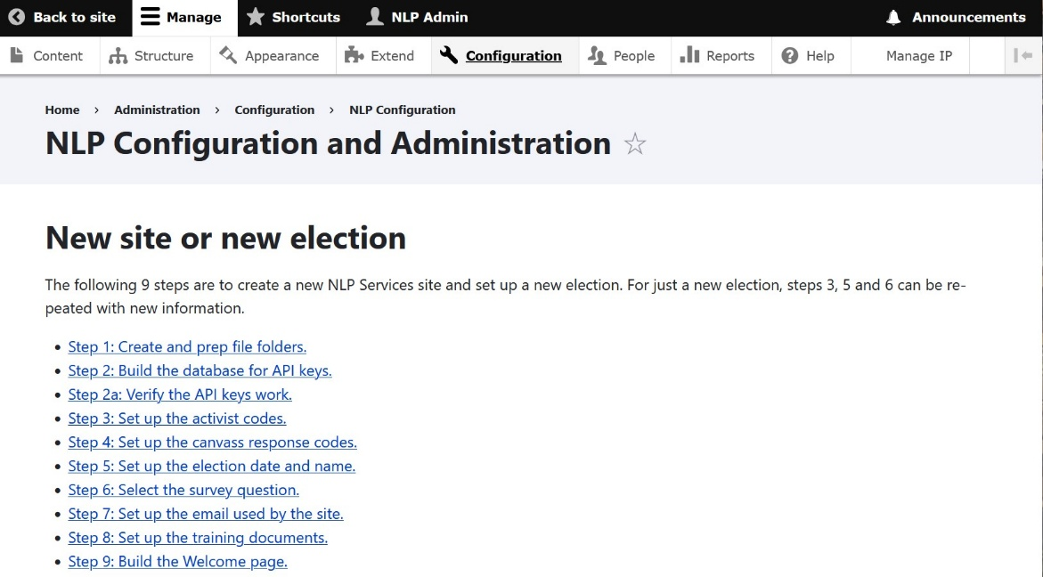
Then request a key for Neighborhood Leader.

Step 1: Build the database for API keys.
This first step is used to encrypt and save the API keys in a safe place, and it will request the file you created above for those keys. It also creates the file structure for the participating county committees. This step can be run again if you add another county committee. However, it is not a good idea to remove a county committee if you have turfs assigned. It’s better to wait for the next election to remove a county committee.
Specify the encryption keys the first time you run this step. Each subsequent run uses the existing encryption keys. Changing the encryption keys requires reloading the login credentials for all the NLP users and is an unnecessary and risky process during an election. The encryption keys are AES-256-CBC Secret Key and AES-256-CBC Secret Key. You must save the values you select in a safe place as they can’t be recovered from NLP Services.

Step 2: Verify the API keys work.
This step verifies that the keys are operational. It’s a good idea to run this step periodically, even when an election is not in progress. VANNGP will invalidate keys if they are not in use so this will reset the use date and preserve the keys for the next election.
The test requires a valid vanid from MyCampaign. The suggested value may exist but if it does not, enter a valid number. Also, each committee needs a folder shared with the API. For each county committee, be sure to have the countyName_NLs folder. And have at least one folder in the VoterFile with a map region and turf saved. These folders will give the best result for the key testing.

Step 3: Set up the election date and name.
The election name and dates are set by the county elections. The early voting date is the first time any voter can cast a ballot whether by mail or in person. This date is an important target for voter contacts.

Step 4: Set up the activist codes.
The activist codes were created in the VoterFile and MyCampaign as directed above. Some are created once for the program and some are specific to an election. This function is used to configure NLP Services with the activist codes used for this election.

Step 5: Set up the canvass response codes.
Canvass response codes are defined by VoteBuilder and any variations likely need technical review. Selecting only the recommended values is highly encouraged. This step needs to be run only once unless the site is moved to a new server or has to be rebuilt.

Step 6: Select the survey questions.
This step informs NLP Services of the two election specific survey questions. One is the Pledge to Vote and the other is the NLP Participation. These questions are unique to each election. And, they are specific to the election cycle field when you create the questions.

Step 7: Set up the email used by the site.
NLP Services uses three email accounts. The first is used to communicate with the Neighborhood Leaders and should be not often changed. NLs should have this email in their address book to avoid various SPAM filters. The configuration information is gotten from the email provider. You need to have the email server URL, the port, the email address and the password. NLP Services uses this email to both send and receive emails.
The other two emails are used only to receive information from scripts to extract information from the VoterFile. The first is to get nightly reports of activity from NLs using MiniVAN. The second is information about early voting. Both require significant involvement of the State Data Director to implement the scripts.

Step 8: Set up the training documents.
The various documents available for the use and maintenance of NLP Services are moved to be able to download. This function needs to be run only once for a new site.

Step 9: Build the Welcome page.
The welcome page is built with the information from the election dates and name. This function is need only once for an election unless the name or date are changed.

Archive an election

These functions are used to capture the information saved in the NLP Services database and provide a method of creating a backup in case there is a need to restore the site. It is a good idea to run all these functions at the end of an election and save the export results somewhere safe.
The purge is destructive and removes all the login credentials for NLs. This purge is needed to remove the credentials of NLs who do not return for subsequent elections. When the list of active NLs is synced for a new election the credentials for returning NLs are restored. You should export the credentials first if you do not want to lose the NL credentials.
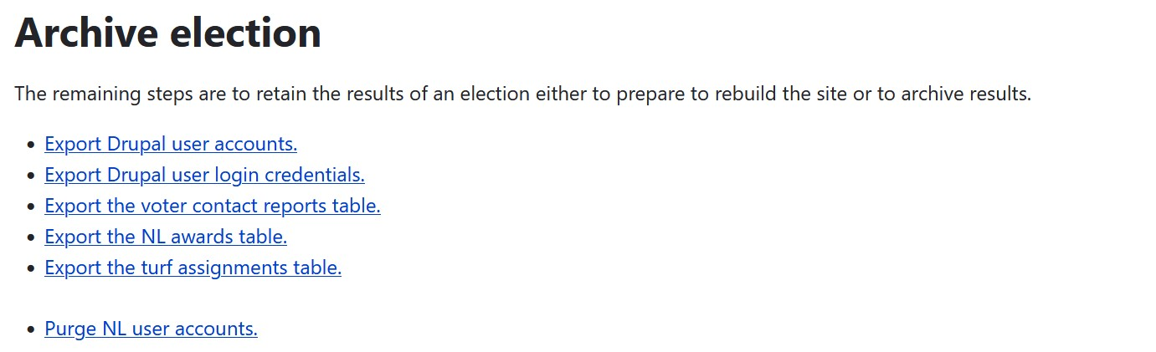

Election maintenance functions
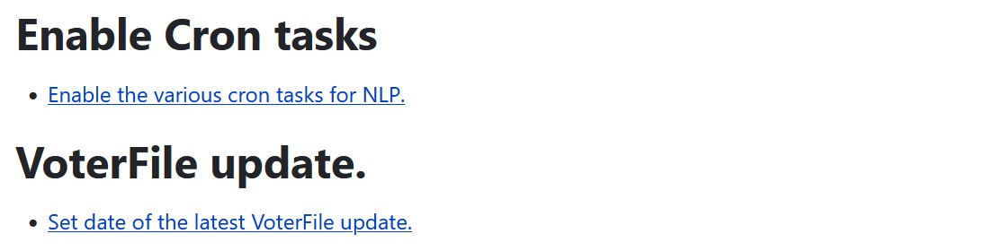
There are three operational cron tasks and three experimental task to track functional errors with the API. The three tasks are to process incoming emails and they can be enabled if the email credentials are configured. The remaining tasks are experimental and should not be selected.

Operational cron tasks
Enable processing of minivan emails for this election.
Enable processing of matchback emails for this election.
Enable forwarding of emails to coordinators for this election.
When enabled, the cron task will look for incoming email and process the data they contain. In the case of the emails for coordinators, the content is forwarded to the appropriate coordinator associated with the email sender.
The emails for MiniVAN should be configured and enabled if any of the NLs are using MiniVAN for canvassing. Enabling the matchback emails should start just before the first ballots are sent out for vote-by-mail.

VoterFIle update
The VoterFile is updated periodically by the state and DNC. These updates have the potential to change the voters in assigned turfs. Informing NLP Services of the update gives an opportunity to identify voters who have moved and prevent invalid voter contact responses in the database.

