**[G H RAISONI COLLEGE OF ENGINEERING](https://ghriet.raisoni.net/index.php)**

**AND MANEGEMENT, PUNE**

An Autonomous Institute & Affiliated to

Savitribai Phule Pune University



**Department of Information Technolo0gy**

**Academic Year (2021-22)**

**Mini Project report on:**

**“Phishing Website Junction”**

**Submitted By:**

|  |  |
| --- | --- |
| Name | Roll No. |
| Rohit Sangole | TITA35 |
| Swayam Terode | TITA45 |
| Sanskar Jangam | TITA36 |
| Ganesh Hegade | TITA11 |

**Guided By: Prof. Deepika Ajalkar Mam & Prof. Poonam Dhamal Mam**



Department of Information Technology

**CERTIFICATE**

This is to certify that project work entitled “WEB PHISHING” carried out by **Rohit Sangole , Swayam Terode , Ganesh Hegade , Sanskar Jangam** under the guidance's of Prof. Poonam Dhamal and Prof. Deepika Ajalkar of Department of Information Technology from G. H. Raisoni College of Engineering and Management Wagholi, Pune (412207) has been satisfactorily completed by the Team and worthy of acceptance for the Certification of Accomplishment.

**Prof. Deepika ajalkar Dr.Poonam Gupta Prof. Poonam Dhamal**

(Project guide) (HOD IT department) (Project guide)

Date-21/11/22

**INDEX**

**Content Page .No**

**1. Abstract --------------------------------------------------------- 4**

**2. Introduction--------------------------------------------------------5**

**3. Problem Statement------------------------------------------------5**

**4. Objective------------------------------------------------------------5**

**5. Methodology--------------------------------------------------------6**

**6. Architecture diagram and explanation------------------------6**

**7. ER diagram---------------------------------------------------------8**

**8. Frontend ------------------------------------------------------------8**

**9. Backend-------------------------------------------------------------15**

**10. Hardware & Software Requirements-----------------------17**

**11. Advantages & Disadvantages --------------------------------18**

**12. Conclusion--------------------------------------------------------18**

**13. Reference----------------------------------------------------------19**

1. **ABSTRACT**

In our modern era where the internet is ubiquitous, everyone relies on various online resources for news. Along with the increase in the use of social media platforms like Facebook, Twitter, etc. news spread rapidly among millions of users within a very short span of time. The hacking has been and very interesting subject in recent times and hence it plays a major role in the new era for the purpose of phishing and hacking. The website basically contains all the Phishing pages like Facebook, Whats app, Instagram, gmail , spotify. The website have been created using the HTML, CSS and Javascript.

**2. INTRODUCTION**

Phishing is a common tactic that cyber criminals use to steal personal and financial information from you. Phishing messages usually take the form of an email or phone call from a cyber criminal who is pretending to be someone they are not, such as your bank. Cyber criminals have become increasingly sophisticated in their phishing campaigns. Arm yourself with the following tips so that you can be vigilant about staying cyber secure. Phishing is a type of social engineering attack often used to steal user data, including login credentials and credit card numbers. It occurs when an attacker, masquerading as a trusted entity, dupes a victim into opening an email, instant message, or text message. The recipient is then tricked into clicking a malicious link, which can lead to the installation of malware, the freezing of the system as part of a ransomware attack or the revealing of sensitive information.

**3.PROBLEM STATEMENT**

Phishing website junction using html and css javascript

**4. OBJECTIVE**

The main objective of the project are

* The goal of this attack is mostly due to the bad intentions of the attacker.
* This may include shutting down the system, gaining the funds, money, harming the third-party victim in any possible way.
* Phishing is of the simplest kind of cyberattack but still effective and dangerous as the phishers try to exploit the users directly, which does not involve exploiting the technical vulnerability.
* Nowadays, everyone has access to the Internet, and Digital Evolution is taking place; one should have proper knowledge of this kind of Attack to avoid any kind of loss in the future.

**5. METHODOLOGY**

Firstly we prepare a plan for the designing and implementation for the project. The rough design was prepared . then the work for the project was distributed in frontend and backend . The work then was combined to single platform for functionality test.

Then we have use different social media website and templates for forming our main website and we have connected the login ID and password field to our main database. So when the user tries to insert any data in the following website then we will directly get their id and password without and hesitation.

**6. ARCHIETECTURE DIAGRAM & EXPLANATION**

**SYSTEM ARCHITECTURE-**

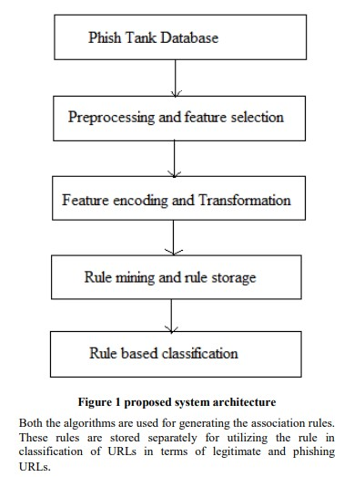

**i) Static Search** The architecture of Static part of fake news detection system is quite simple and is done keeping in mind the basic machine learning process flow. The system design is shown below and self- explanatory. The main processes in the design are

* **SYSTEM ARCHITECTURE**

ii) Phishing Tank database- The second search field of the site asks for specific keywords to be searched on the net upon which it provides a suitable output for the percentage probability of that term actually being present in an article or a similar article with those keyword references in it.

iii) Rule mining and rule storage-The third search field of the site accepts a specific website domain name upon which the implementation looks for the site in our true sites database or the blacklisted sites database. The true sites database holds the domain names which regularly provide proper and authentic news and vice versa. If the site isn’t found in either of the databases then the implementation doesn’t classify the domain it simply states that the news aggregator does not exist.

**7. ER DIAGRAM**

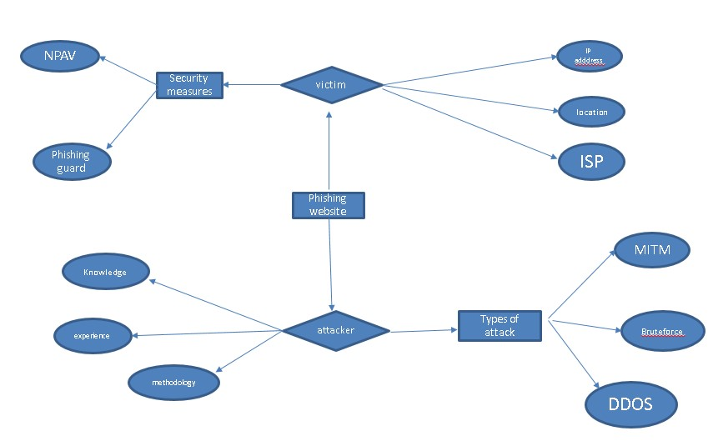

**8.Frontend**

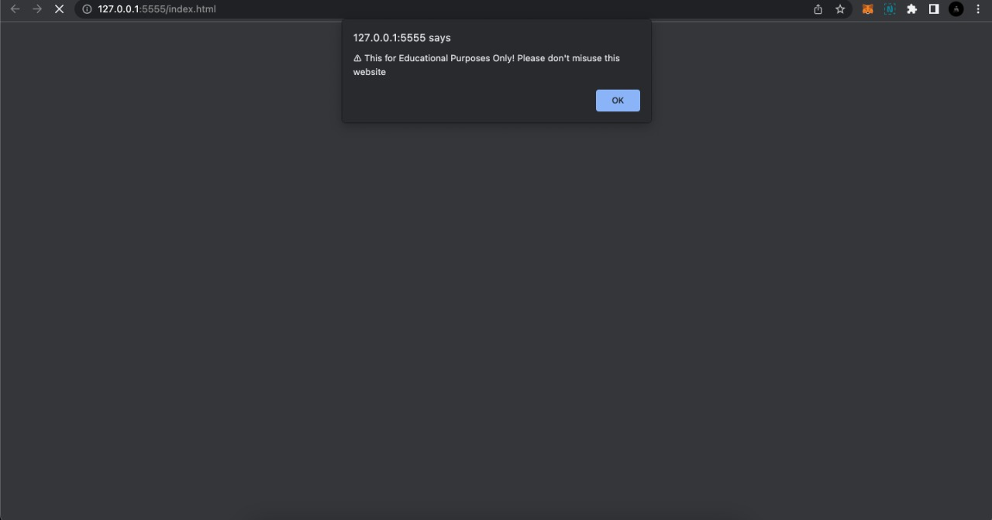

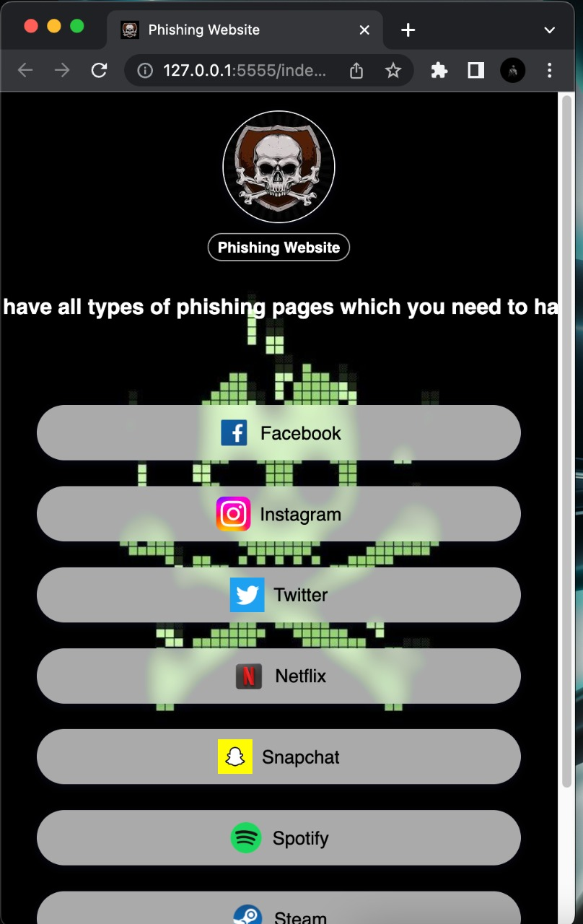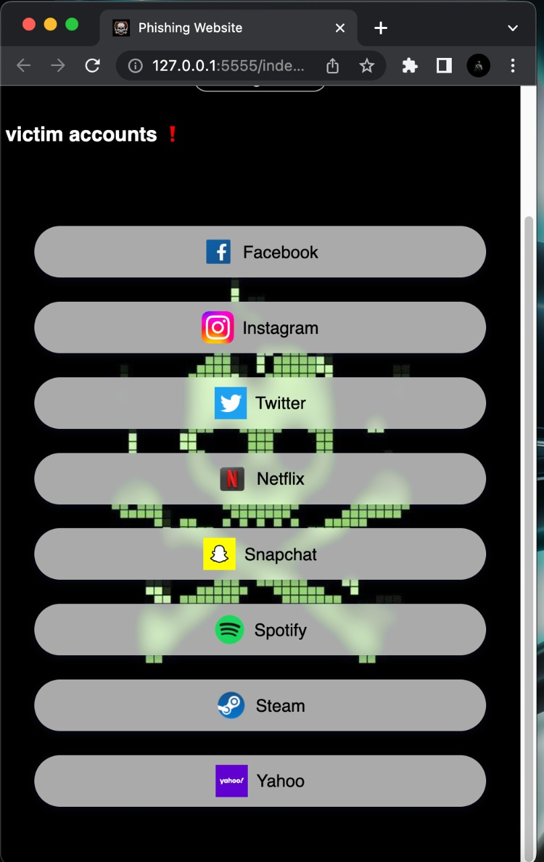

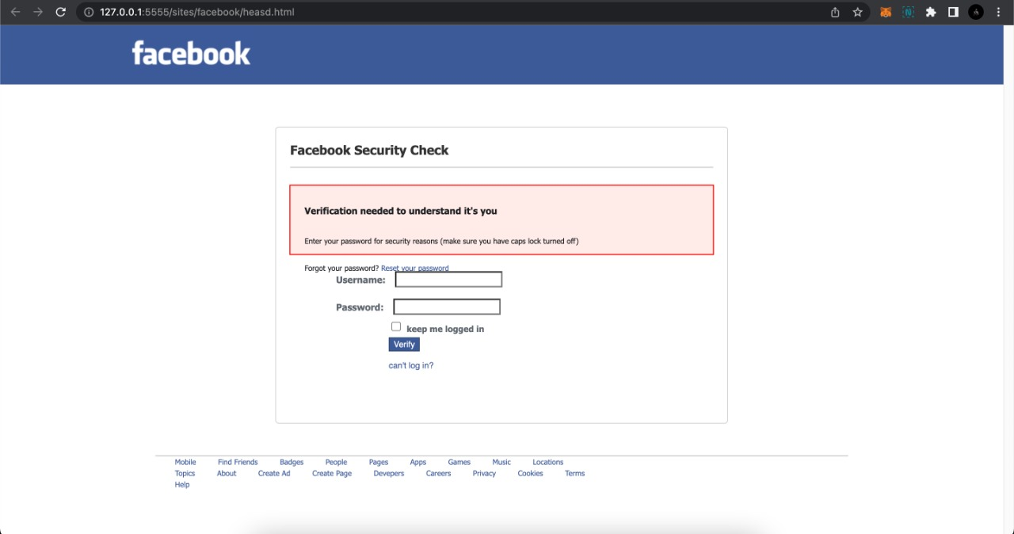

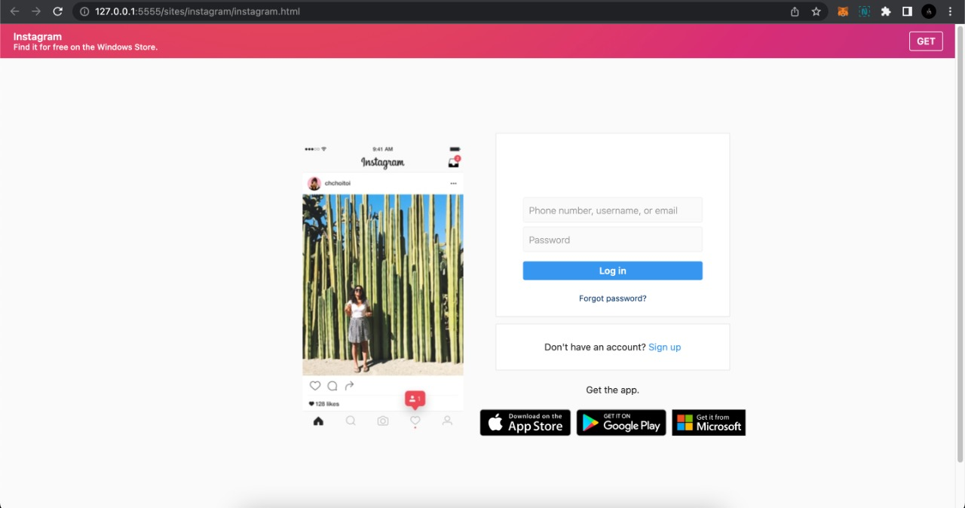

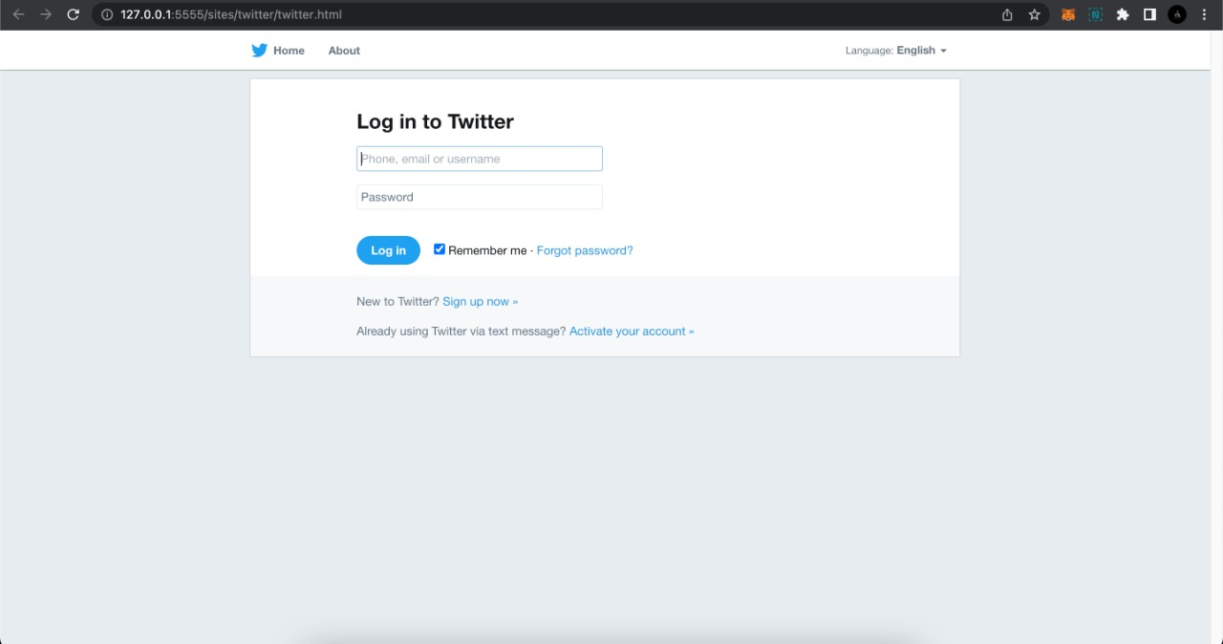

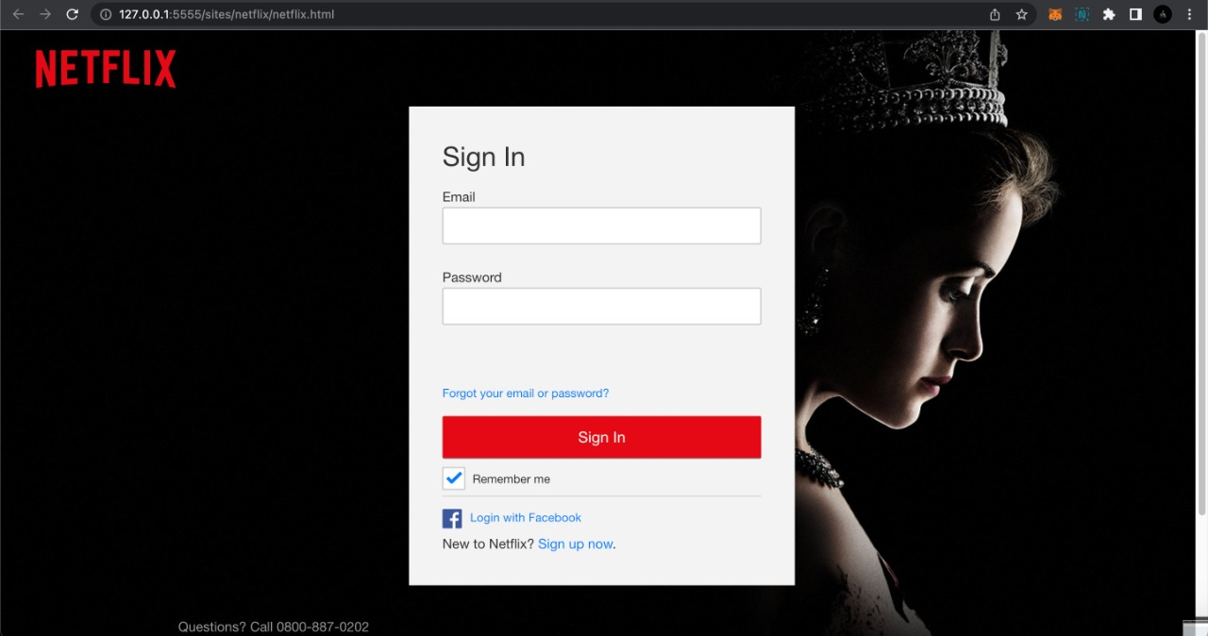

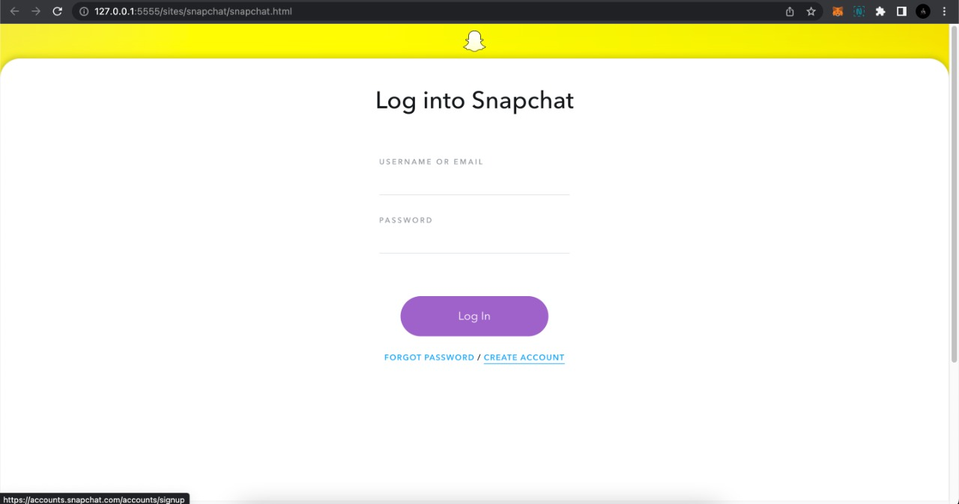

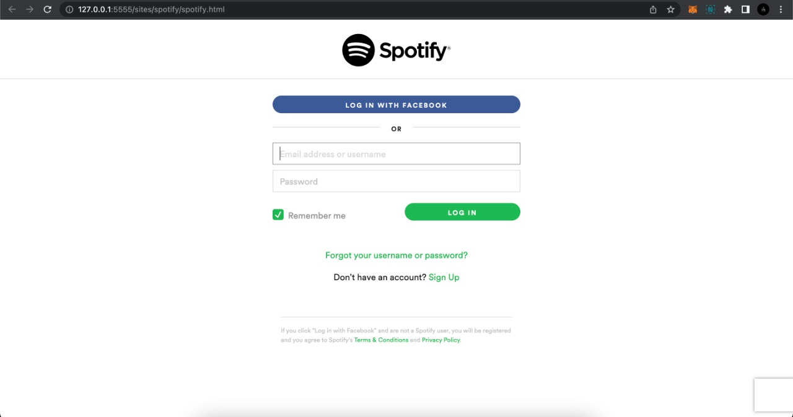





**9.Backend**

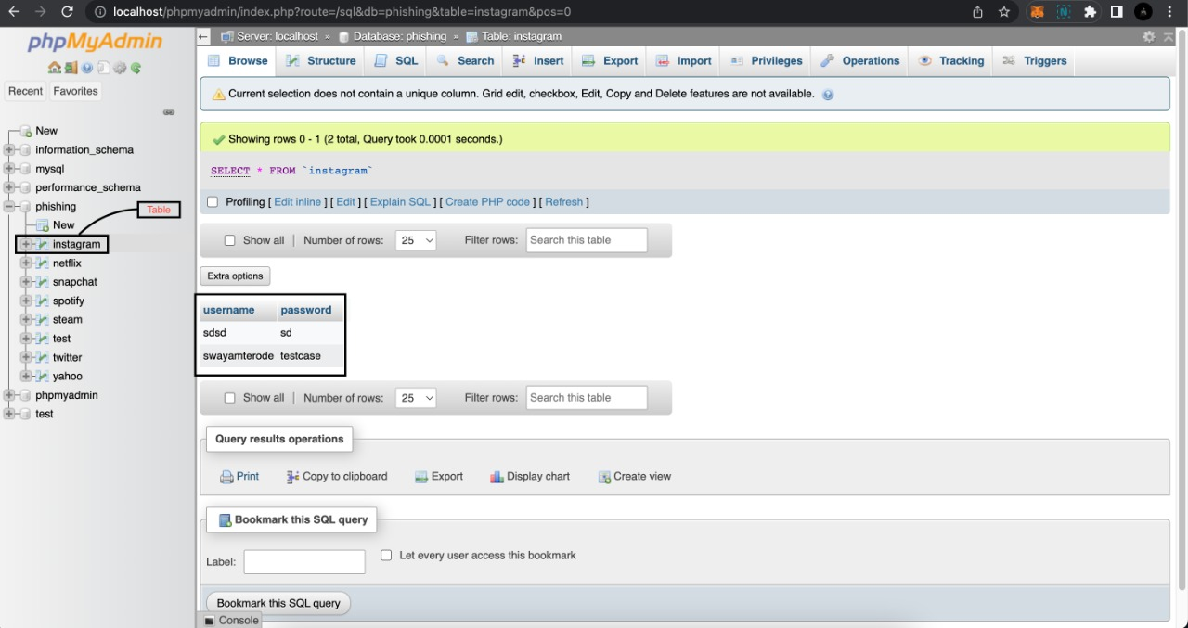

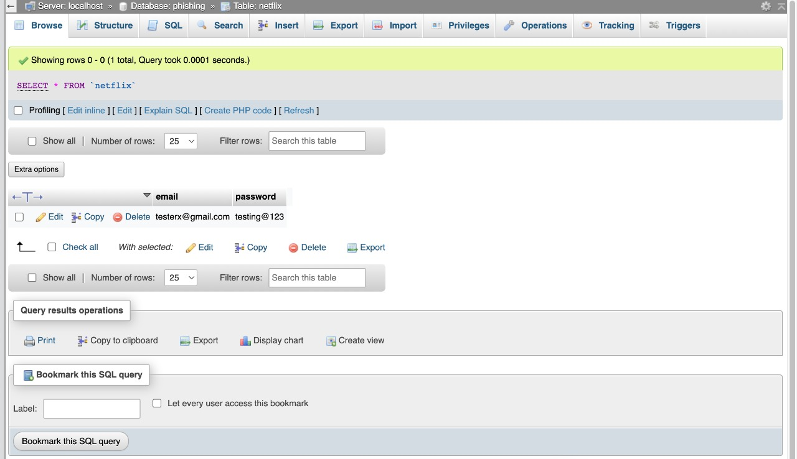

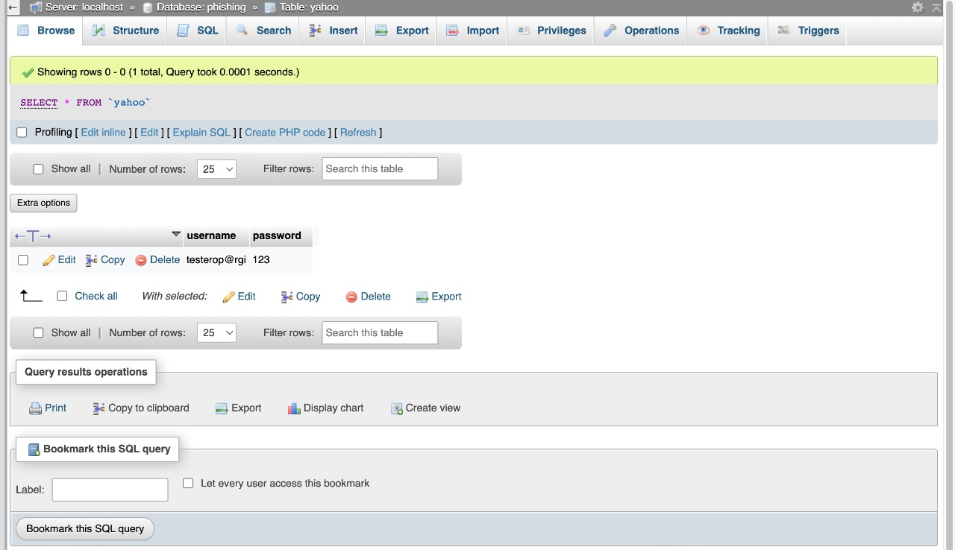

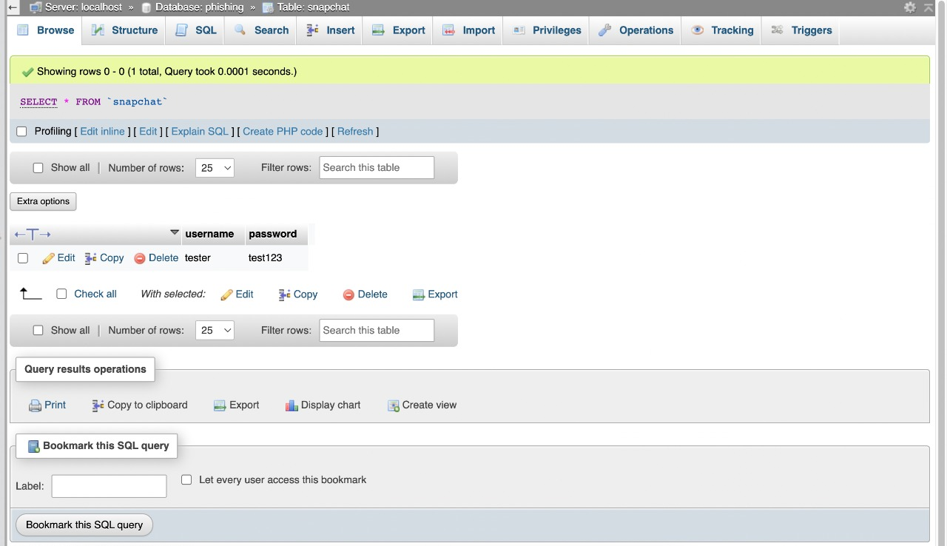

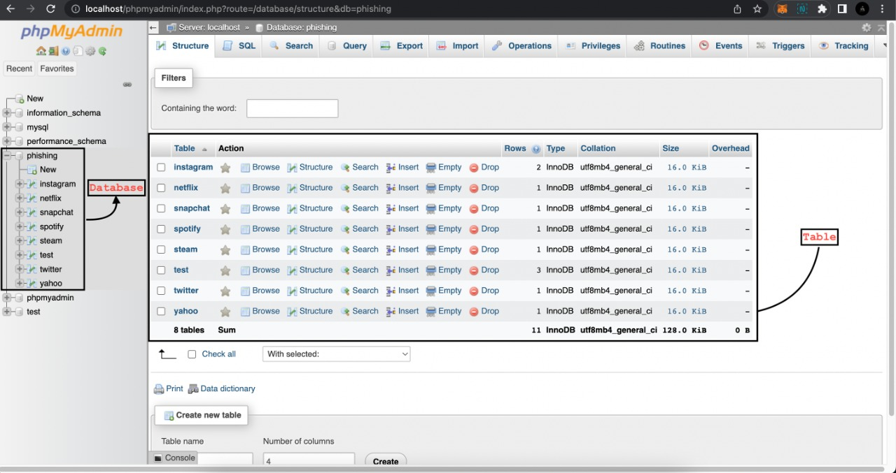

**10. HARDWARE AND SOFTWARE REQUIREMENTS**

Hardware Requirements-

* RAM- 8 GB
* Storage-1 Tb
* Graphic Card- NVIDIA 1660ti or older version
* Processor- Intel I3 and older or upgraded versions

Software Requirements-

* Operating System- Windows 7 or upgraded version
* Python IDLE
* Vscode
* XAMPP Server: XAMPP is one of the widely used cross-platform web servers, which helps developers to create and test their programs on a local webserver. It was developed by the Apache Friends, and is open source. It consists of Apache HTTP Server, MariaDB, and interpreter for the different programming languages like PHP and Perl.

**11. ADVANTAGES & DISADVANTAGES**

**Advantages-**

* This project will be very useful to detect weather the following user account is true or fake and this can cause a main difference in the reality.
* Hackers can classifies using this prokect
* Facebook uses the same algorithm to detect weather the news is fake or not .

**Disadvantages**-

* The disadvantages of this project is that It does not provide 100 % accuracy for the phishing
* There might be some errors during the time of detecting the account links
* The accuracy of the project will depend on the amount of practice set we provide to the machine that me the quality of training.

**12. CONCLUSION**

Phishing website is used to gather all the information about the victim and we can hack all the essentials details about the victim and we can gather login ID and passwords. In the phishing website Junction we have many types of Phishing website for example facebook, Instagram, spotify, steam, gmail, protonmail and many other phishing website have been attached in a single website.

**11. REFERENCE**

[1] Kai Shu, Amy Sliva, Suhang Wang, Jiliang Tang, and Huan Liu, “Fake News Detection on Social Media: A Data Mining Perspective”

arXiv:1708.01967v3 [cs.SI], 3 Sep 2017

[2] Kai Shu, Amy Sliva, Suhang Wang, Jiliang Tang, and Huan Liu, “Fake News Detection on Social Media: A Data Mining Perspective”

[3] https://www.geeksforgeeks.org/

[4] https://www.javatpoint.com/

[5] https://www.phishing.org/phishing-resources

[6] https://www.cybrary.it/course/phishing/

[7] https://www.udemy.com/